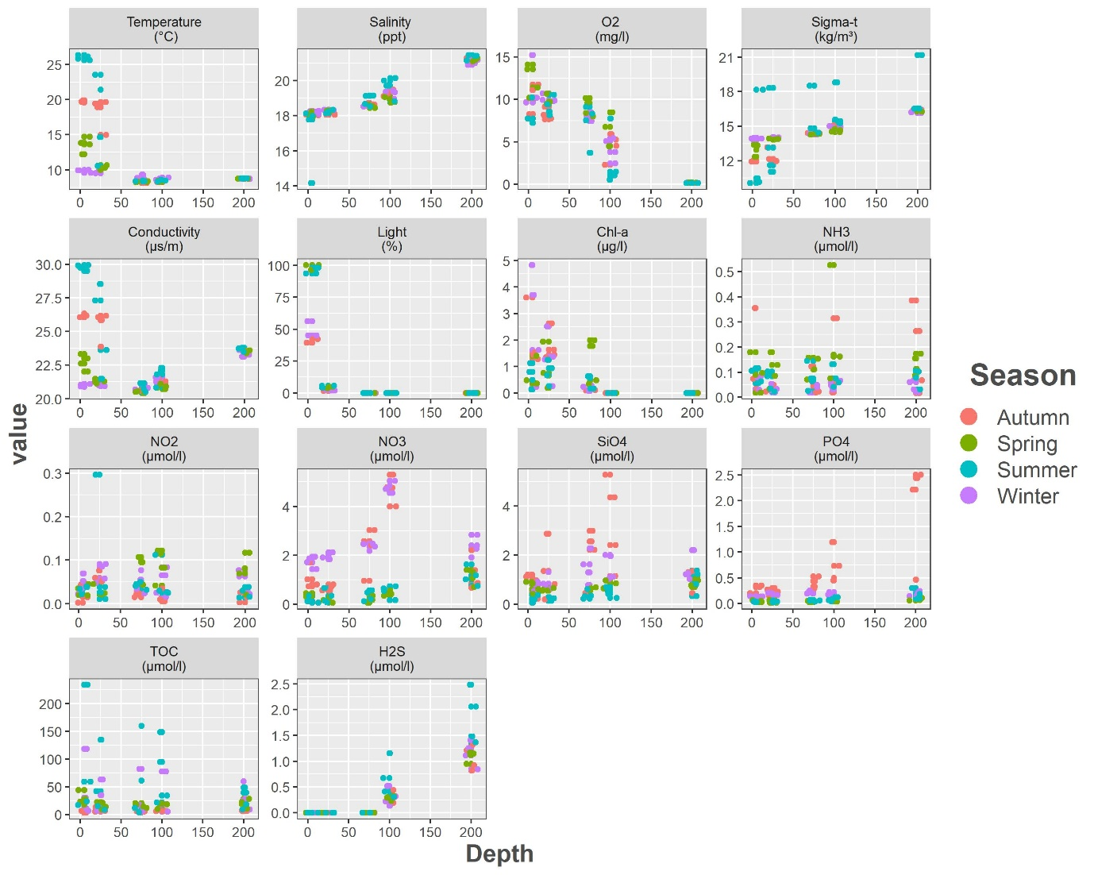
Figure S1. Variation in environmental parameters based on depth and season. O₂-Oxygen, Chl-a-Chlorophyll a, NH₃-Ammonia, NO₂-Nitrite, NO₃-Nitrate, Si-Silicate, PO₄-Phosphate, TOC-Total organic carbon, H₂S-Hydrogen Sulfide

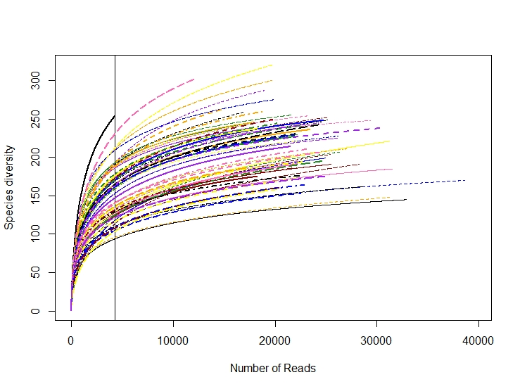
Figure S2. Rarefaction curve generated with 88 samples. The minimum sample count achieved over the 88 samples was indicated with vertical line.

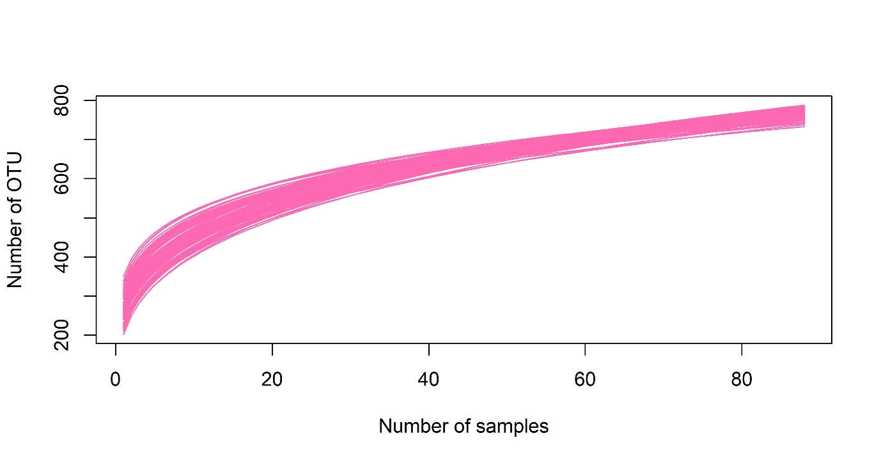
Figure S3. Rarefaction curves of the species diversity as a function of the number of sampling sites. Full lines represent the number of sampling sites based on simulation of 88 sites with 999 iterations.

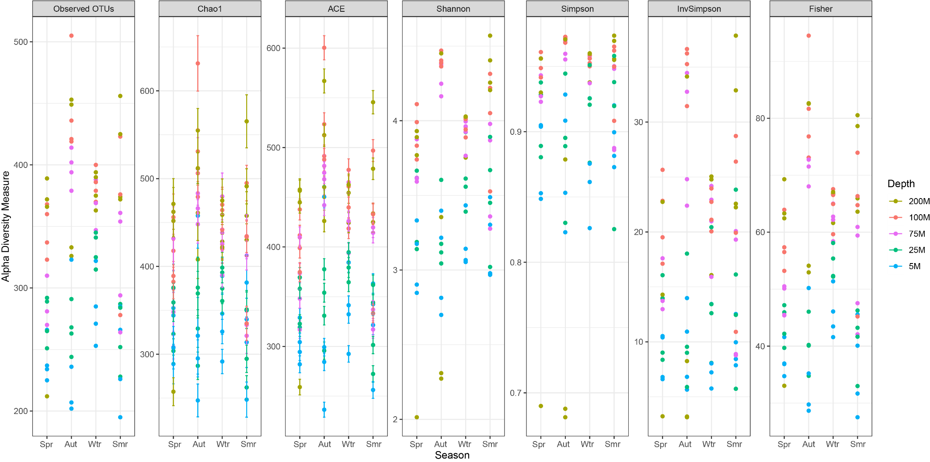
Figure S4. Alpha diversity measures based on depths and seasons. Spr- Spring, Aut-Autumn, Wtr-Winter, Smr-Summer

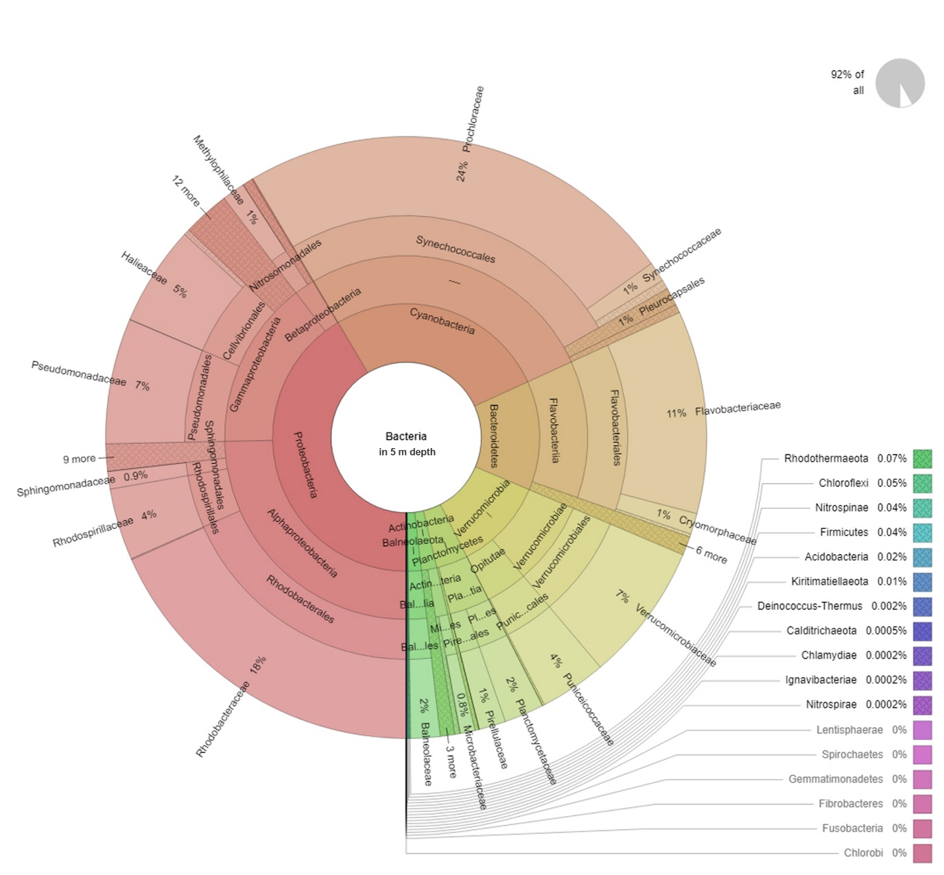
Figure S5. Taxonomic distributions and OTU abundance of samples obtained from 5 meters depth.

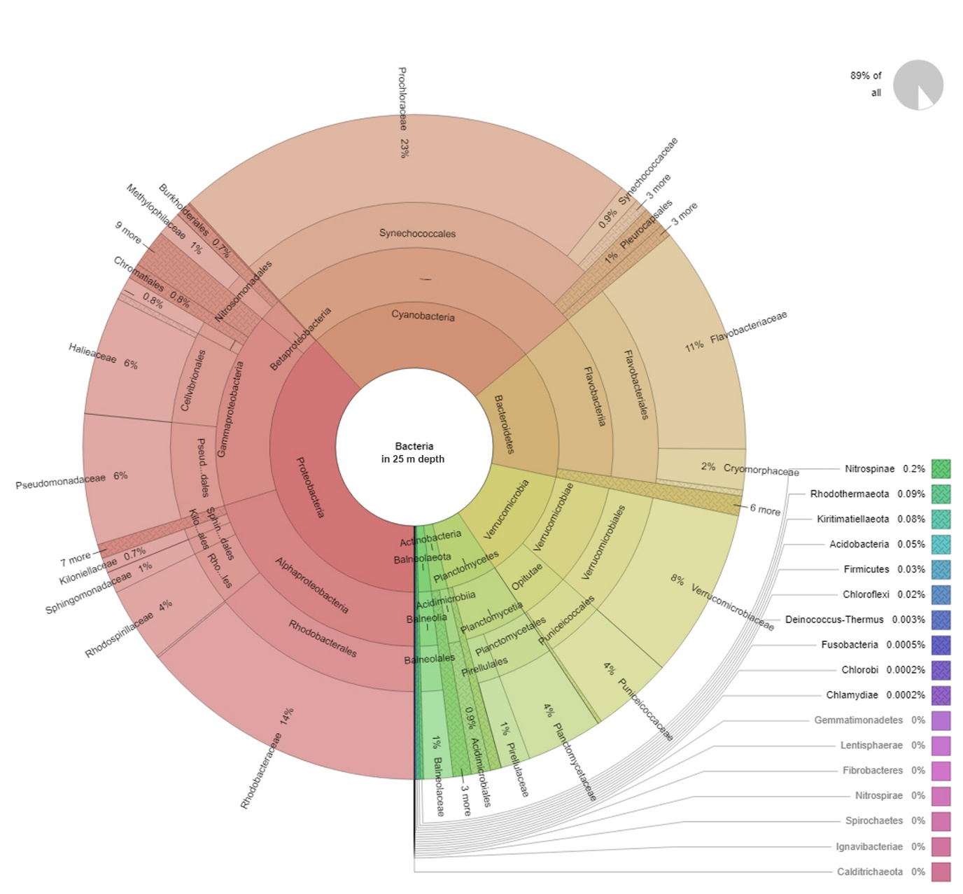
Figure S6. Taxonomic distributions and OTU abundance of samples obtained from 25 meters depth.

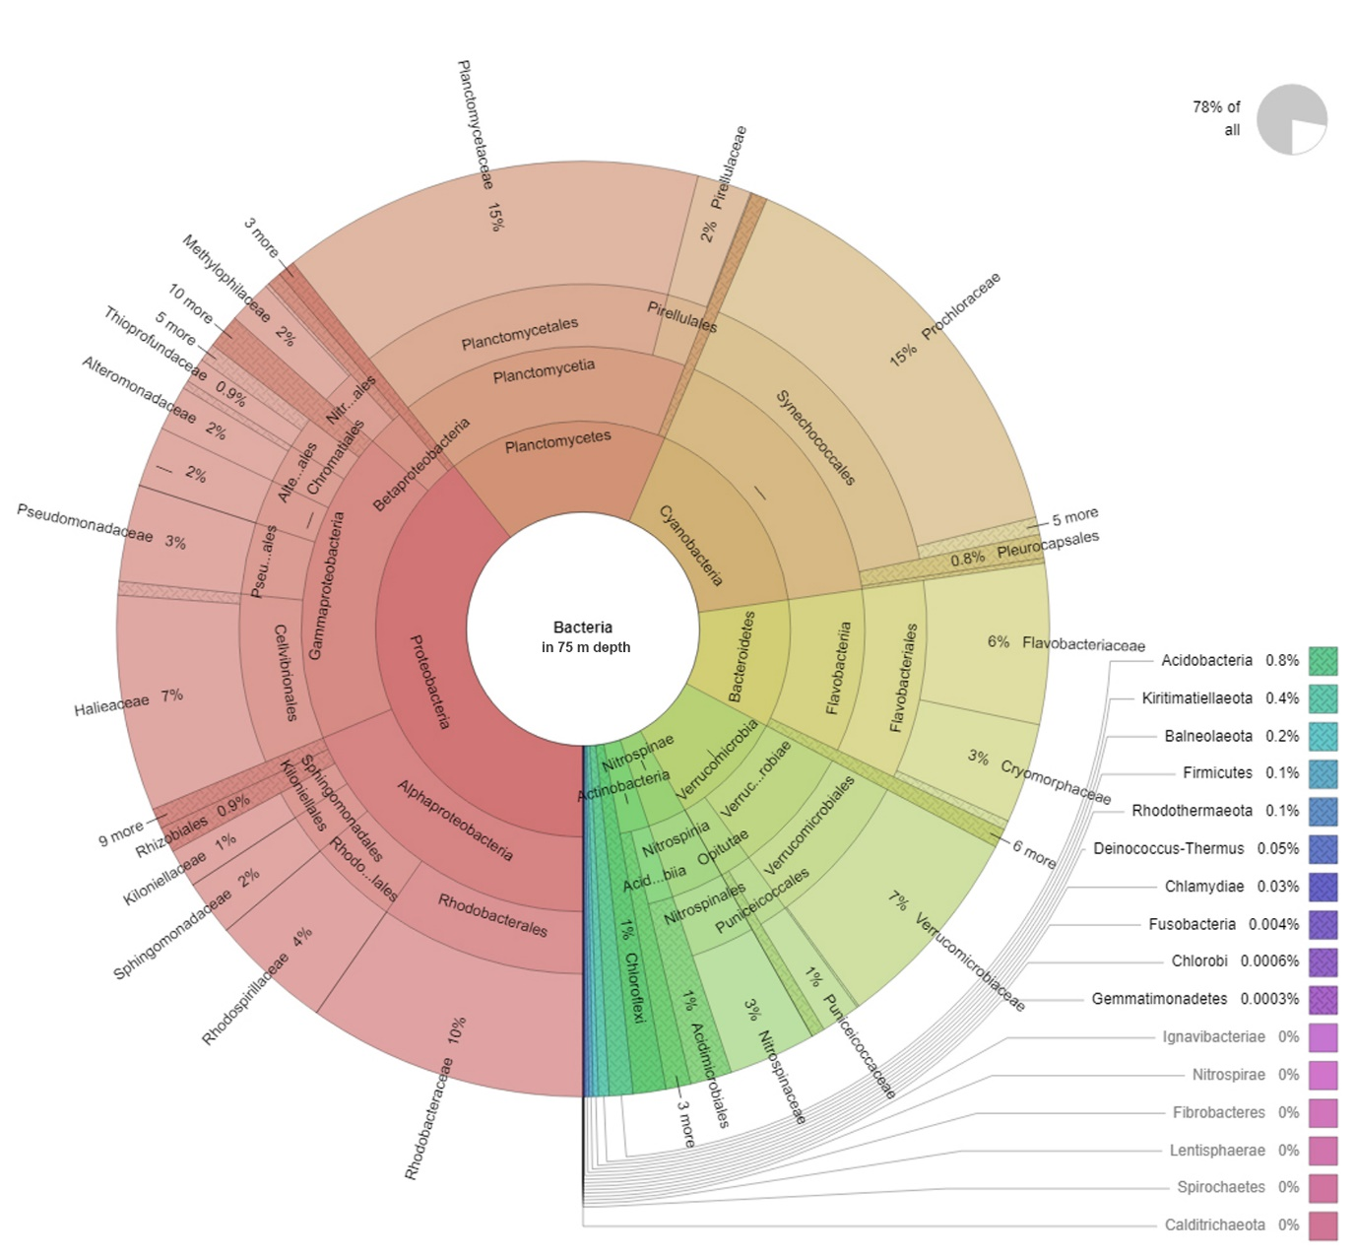
Figure S7. Taxonomic distributions and OTU abundance of samples obtained from 75 meters depth.

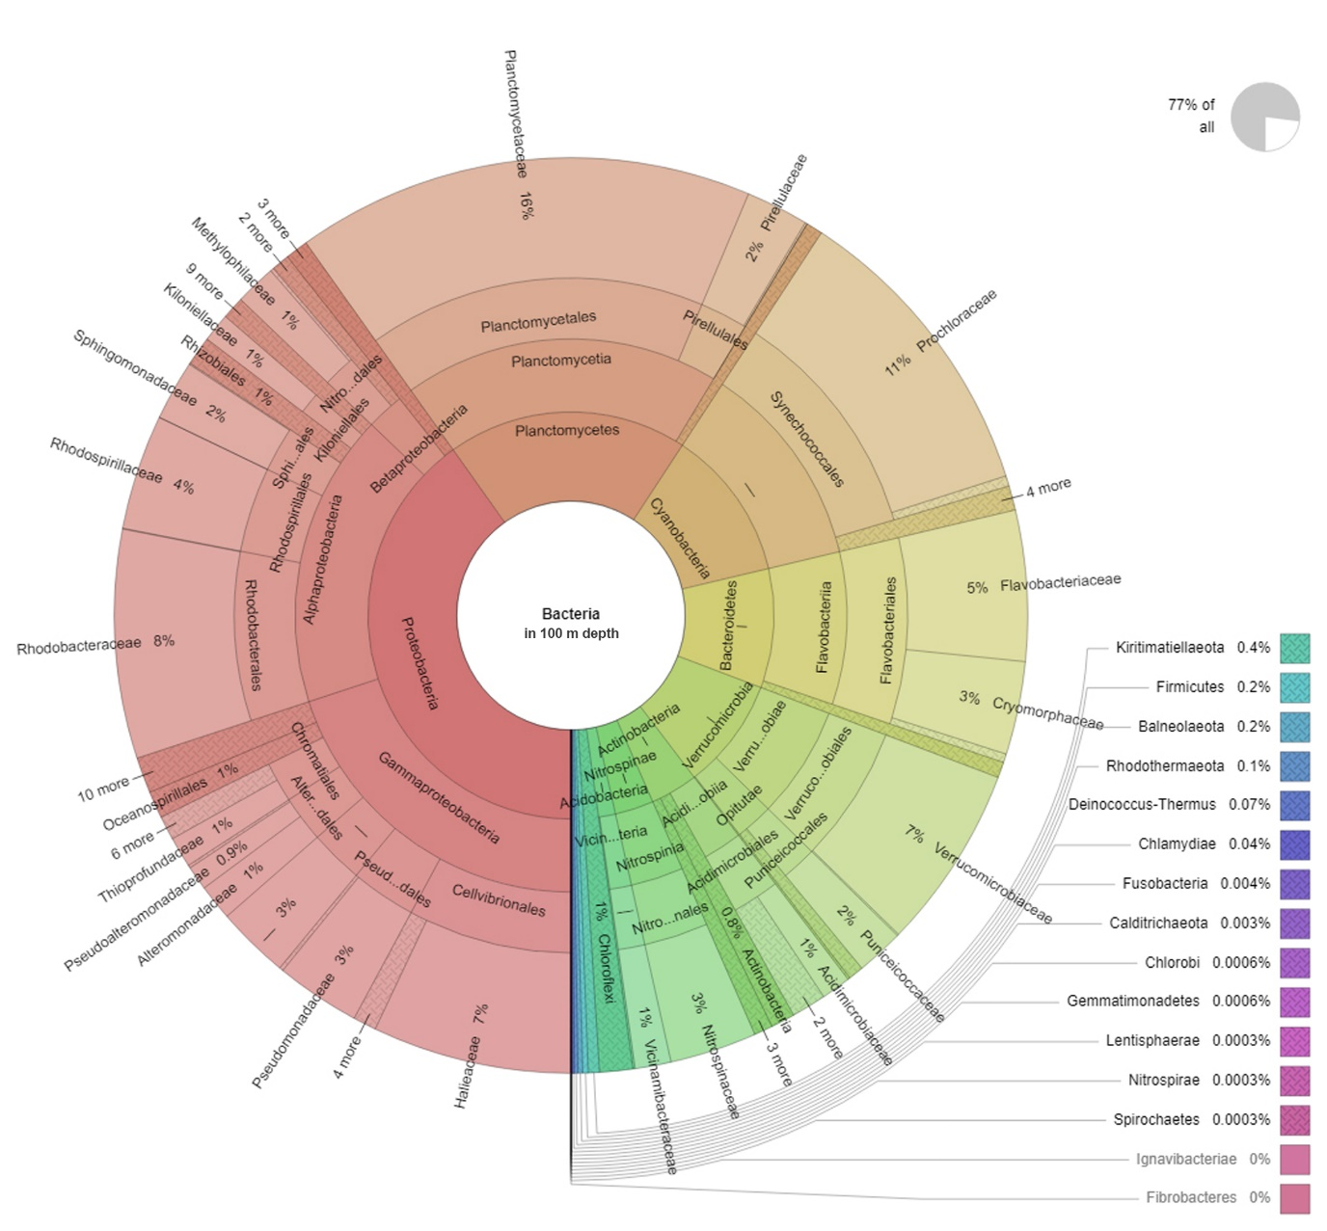
Figure S8. Taxonomic distributions and OTU abundance of samples obtained from 100 meters depth.

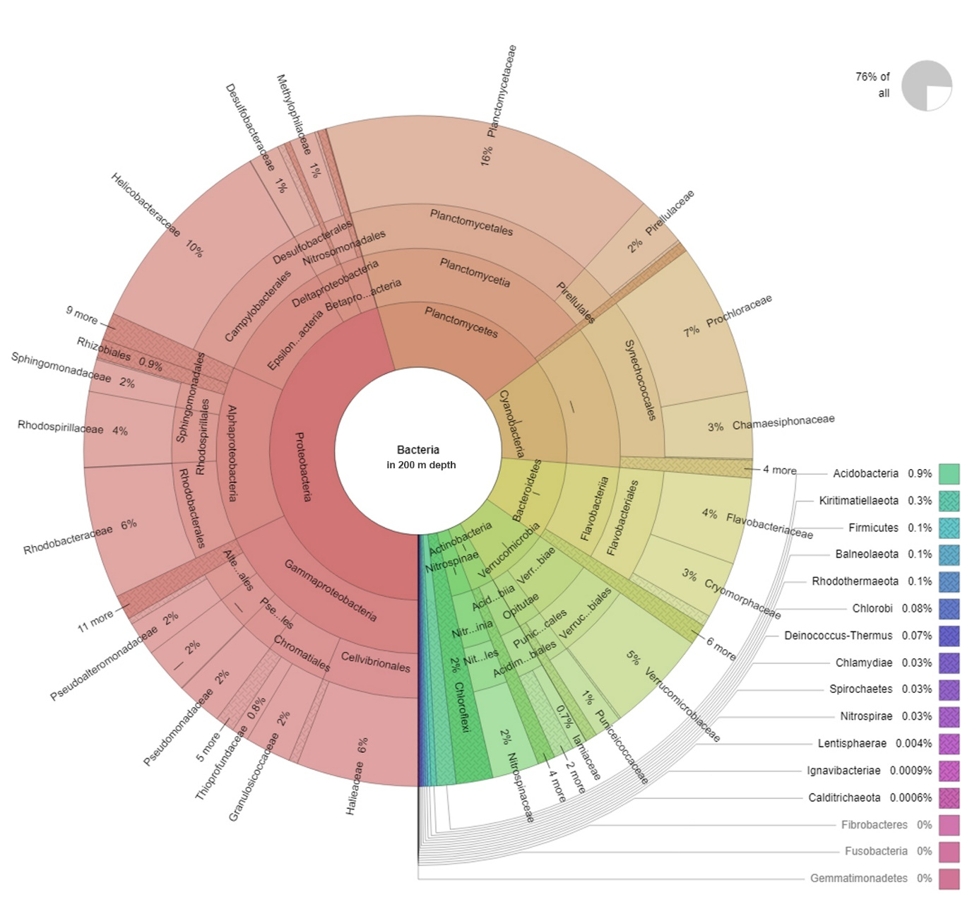
Figure S9. Taxonomic distributions and OTU abundance of samples obtained from 200 meters depth.

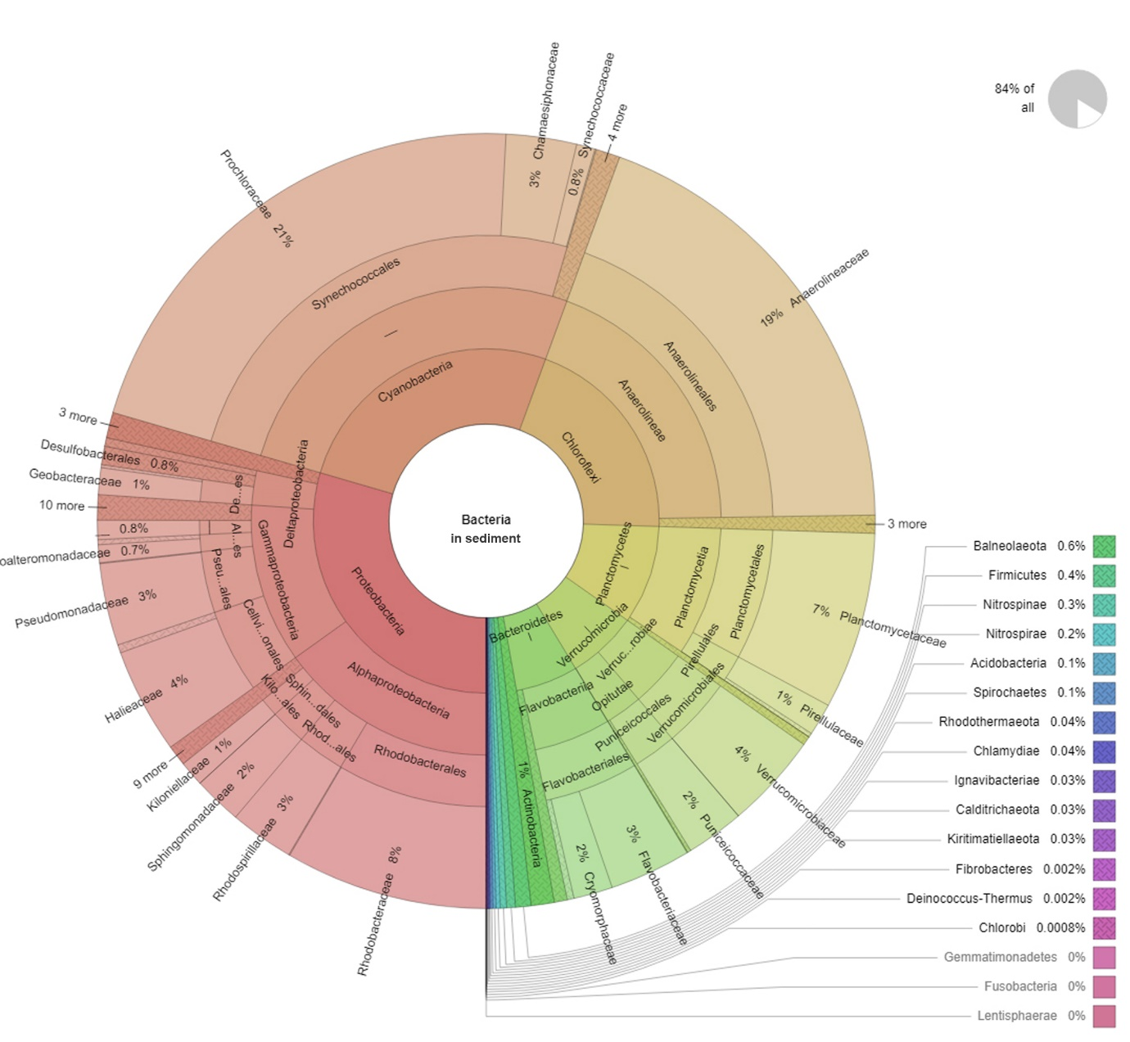
Figure S10. Taxonomic distributions and OTU abundance of samples obtained from sediment.

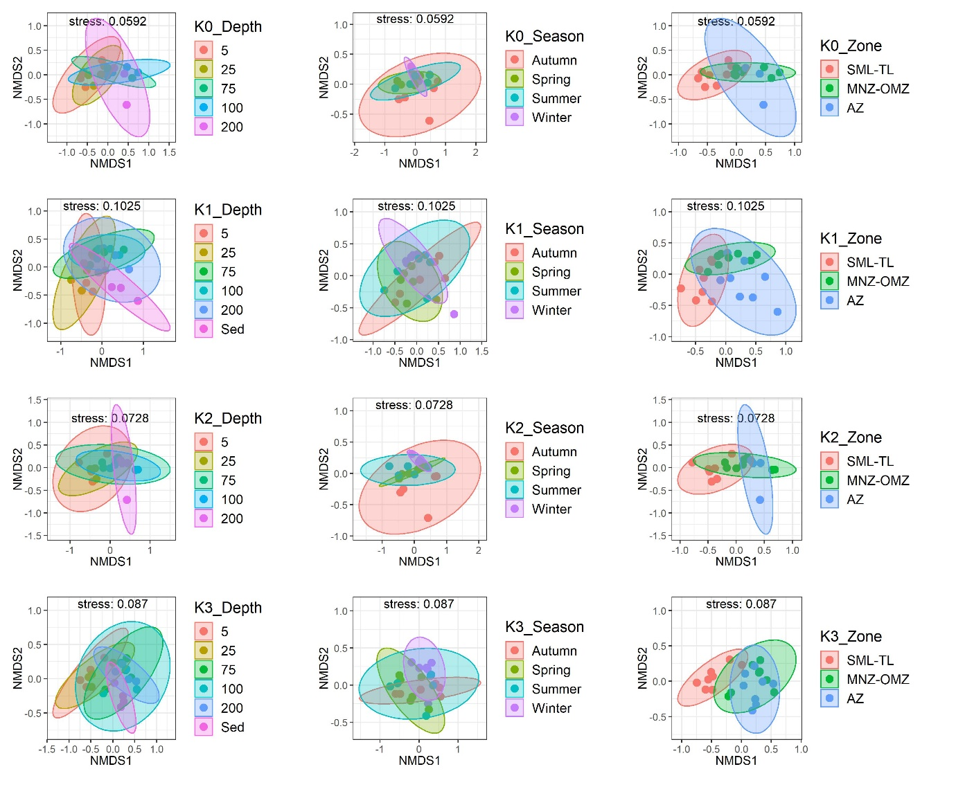
Figure S11. Two-dimensional Nonmetric multidimensional scaling (NMDS) ordination of microbial communities at different season, depth, and zone in each sampling station. SML-Surface mixed layer, TL-Thermocline layer, MNZ- Mineralization/Nitrification Zone, OMZ-Oxygen minimum zone, AZ-Anoxic zone

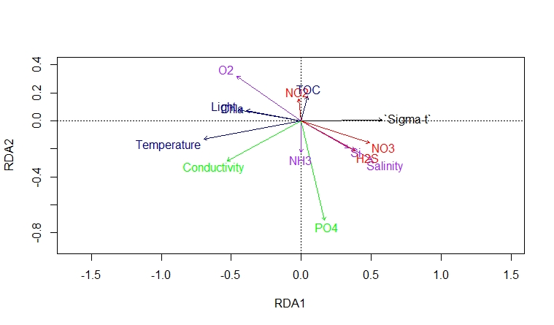
Figure S12. Redundancy analysis (RDA) of bacterial community composition resulting from environmental parameters.

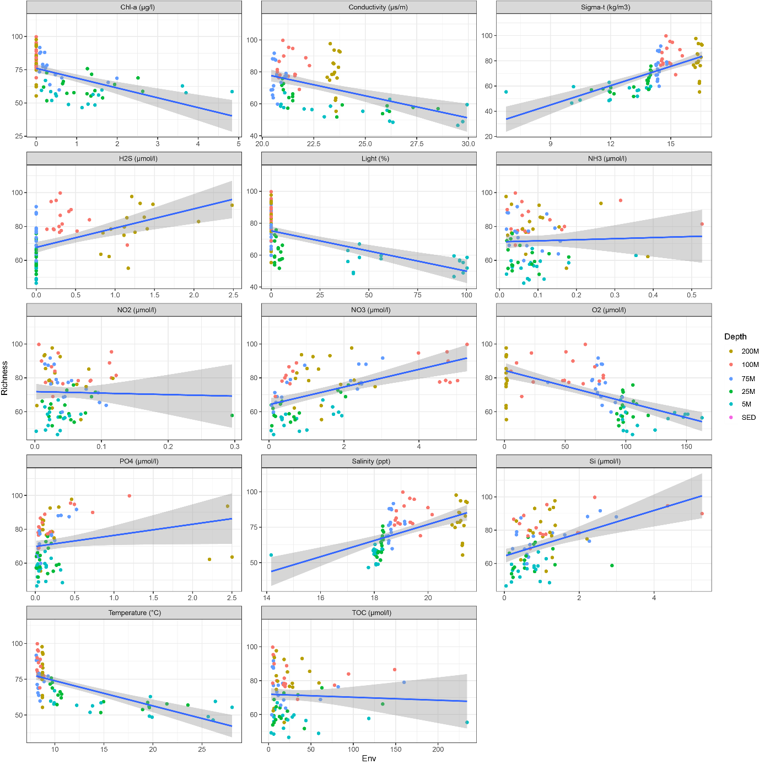
Figure S13. Correlation between environmental parameters and depth. Chl-Chlorophyll a, H₂S-Hydrogen Sulfide, NH₃-Ammonia, NO₂-Nitrite, NO₃-Nitrate, O₂-Oxygen, PO₄-Phosphate, SiO₄-Silicate, Temp-Temperature, TOC-Total organic carbon.

