Supplementary Materials for

Hugoniot measurements of calcite from 200 to 1000 GPa: implications for the planetary atmosphere chemistry by the shock-induced degassing

Yuhei Umeda^{1, 2}, Keiya Fukui¹, Toshimori Sekine^{1, 3}, M. Guarguaglini⁴, A. Benuzzi-Mounaix⁴, Nobuki Kamimura¹, Kento Katagiri¹, Ryosuke Kodama^{1, 2}, Takeshi Matsuoka¹, Kohei Miyanishi⁴ A. Ravasio⁴, Takayoshi Sano², and Norimasa Ozaki^{1,2}

¹Graduate School of Engineering, Osaka University, Osaka, Japan
²Institute of Laser Engineering, Osaka University, Osaka, Japan
³Center for High Pressure Science & Technology Advanced Research, Shanghai, China
⁴Ecole Polytechnique, Paris, France
⁵Riken, Spring-8, SACLA, Japan

Corresponding author: yuhei-umeda@eie.eng.osaka-u.ac.jp
Figure S1. Hugoniot relation of calcite.
The P-u_{p} (a) and U_{s}-u_{p} (b) determined in this study as light blue diamonds and compared with the SESAME model as orange solid line. The error bars in this study are the same as the symbol size.
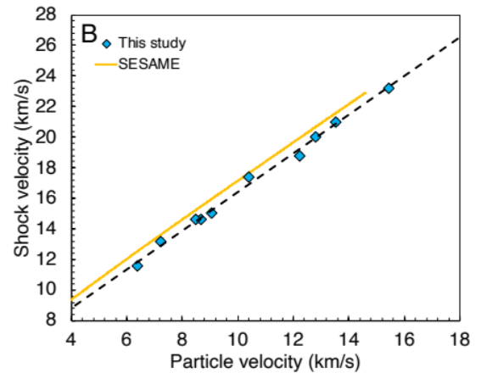
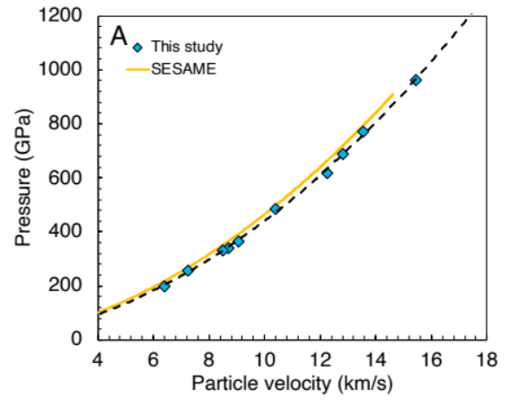

Table S1. The experimental conditions and shock Hugoniot data for Calcite (CaCO₃) and quartz (Qz).

