Molecular Detection of M. bovis via Mpb70 Gene Amplification by PCR from Blood Samples

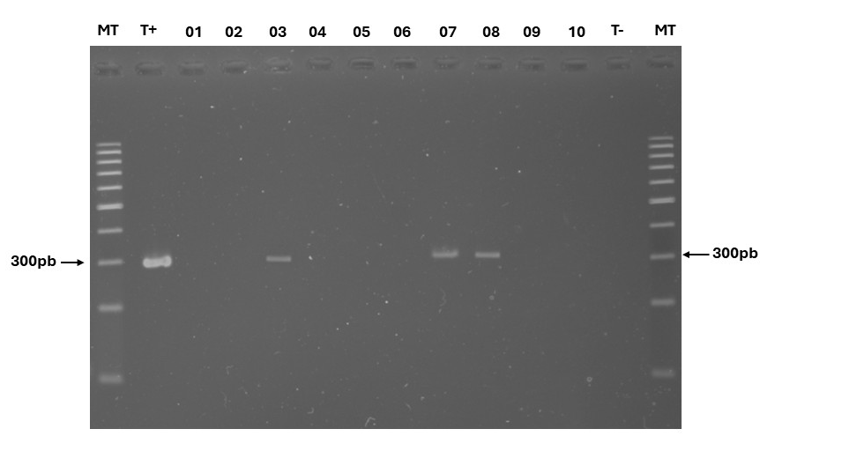
Figure SIII (1): Agarose gel electrophoresis of PCR-amplified Mpb70 gene from Mycobacterium bovis in bovine blood samples. 2% agarose gel stained with ethidium bromide and visualized under UV light. MT: DNA ladder (Thermo Scientific™ GeneRuler™100 pb DNA Ladder). T+: Positive control (M. bovis strain DNA). Lanes 03, 07, and 08 show positive amplification.
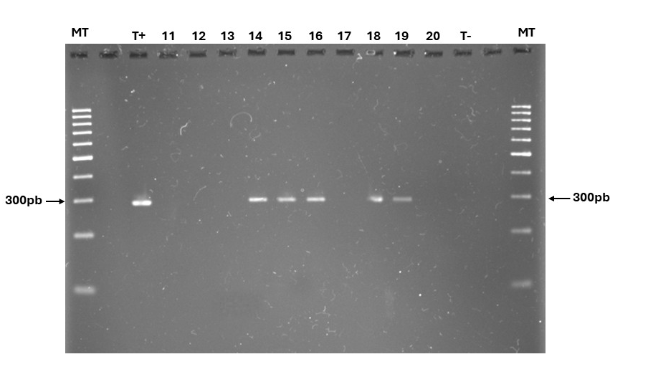
Figure SIII (2) : Agarose gel electrophoresis of PCR-amplified Mpb70 gene from Mycobacterium bovis in bovine blood samples. 2% agarose gel stained with ethidium bromide and visualized under UV light. MT: DNA ladder (Thermo Scientific™ GeneRuler™100 pb DNA Ladder). T+: Positive control (M. bovis strain DNA). Lanes 14, 15, 16, 18 and 19 show positive amplification.

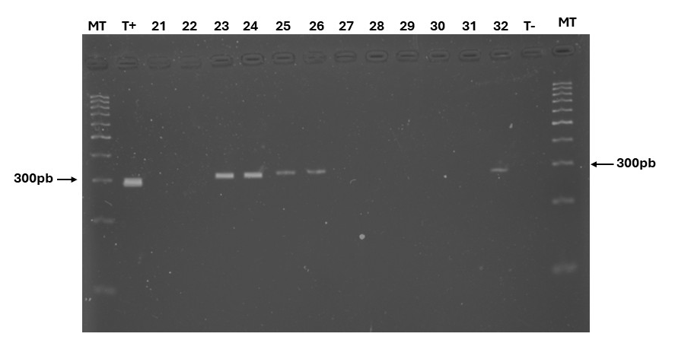
Figure SIII (3) : Agarose gel electrophoresis of PCR-amplified Mpb70 gene from Mycobacterium bovis in bovine blood samples. 2% agarose gel stained with ethidium bromide and visualized under UV light. MT: DNA ladder (Thermo Scientific™ GeneRuler™100 pb DNA Ladder). T+: Positive control (M. bovis strain DNA). Lanes 23, 24, 25, 26 and 32 show positive amplification.

