Structural and Functional Insights into Ubl Domain-Mediated Regulation of SARS-CoV-2 PLpro
Rimanshee Arya,^{a, b}, Janani Ganesh,^{a, b}, Vishal Prashar,^{a,b*} and Mukesh Kumar^{a, b*}
ª Protein Crystallography Section, Bhabha Atomic Research Centre, Mumbai, India-400085.
^{b} Homi Bhabha National Institute, Anushakti Nagar, Mumbai, India-400094.
(*) corresponding author: vishalp@barc.gov.in, mukeshk@barc.gov.in

Supplementary information

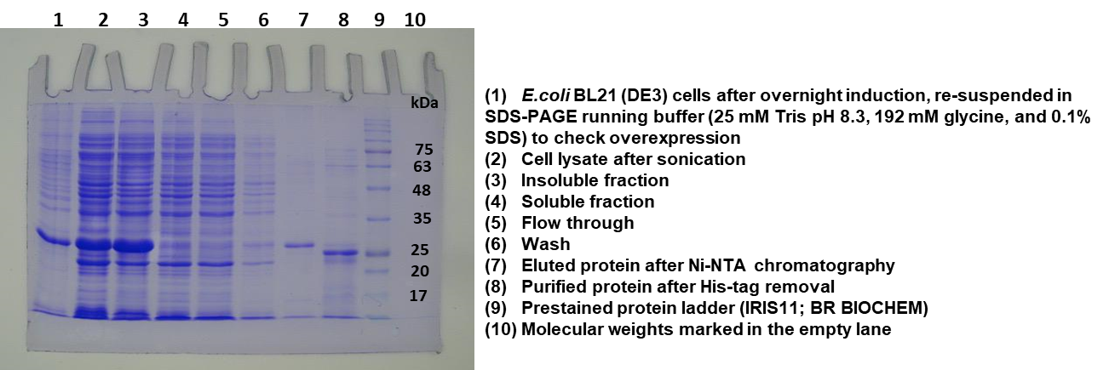
Supplementary Figure 1: Purification of SARS-CoV-2 PLpro TR using Ni-NTA affinity chromatography. Lanes 1–8 represent samples collected at various steps during expression and purification, Lane 9 contains the molecular weight markers. Proteins were visualized on a 12% SDS-PAGE gel.

