Supplementary materials 2

Comparison DG / REF means for all subtests:
METHOD

The means of the WISC-V subtests were compared using inferential Student t-tests for the DG/REF subgroup

RESULTS
The SIM and VOC scores, which contribute to the VCI calculation, were higher in the DG group compared to the reference population, whereas scores on the other subtests (except for PUZ) were lower than those of the reference population (Table 2-1).
Table 2-1 : DG scores for all main subtests, and results of the comparison with the reference population.
 |  | DG |  |  |  |  |  | T.TEST (DG/REF)
subtest |  | mean | 0.95 confidence interval |  |  |  |  | df |  | T |  | significance
SIM | Similarities | 11.5 | [ | 11,1 | ; | 11,9 | ] | 247 | 8.2 |  | ***
VOC | Vocabulary | 11.1 | [ | 10,8 | ; | 11,5 | ] | 247 | 5.9 |  | ***
BD | Block Design | 9.3 | [ | 9,0 | ; | 9,7 | ] | 247 | -3.9 |  | ***
VP | Visual Puzzle | 9.9 | [ | 9,5 | ; | 10,2 | ] | 247 | -0.8
MR | Matrix Reasoning | 9.6 | [ | 9,3 | ; | 10,0 | ] | 247 | -2.2 |  | *
FW | Figure Weights | 9.7 | [ | 9,3 | ; | 10,0 | ] | 247 | -1.8 |  | .
DS | Digit Span | 8.6 | [ | 8,3 | ; | 9,0 | ] | 247 | -8.1 |  | ***
FS | Picture Span | 9.5 | [ | 9,2 | ; | 9,9 | ] | 247 | -2.6 |  | **
COD | Coding | 8.0 | [ | 7,6 | ; | 8,3 | ] | 247 | -11.1 |  | ***
SYM | Symbol search | 8.6 | [ | 8,3 | ; | 8,9 | ] | 247 | -8.3 |  | ***
significance: |  | *** for p<.001 ** for .001<p<.01 * for .01<p<.05 . for .05<p<.1

Analyses of DG heterogeneity in cognitive profiles
METHOD

Heterogeneity was assessed by analyzing standard score differences between WISC-V subtests and indexes, comparing them to critical values from the WISC-V manual (Table B6 and B7 of the WISC-V administration and scoring manual). The proportion of DG children exceeding these thresholds was calculated and compared to expected values (15% for inter-subtest and inter-index differences, 5% for positive-direction differences) to refine the analysis.

RESULTS

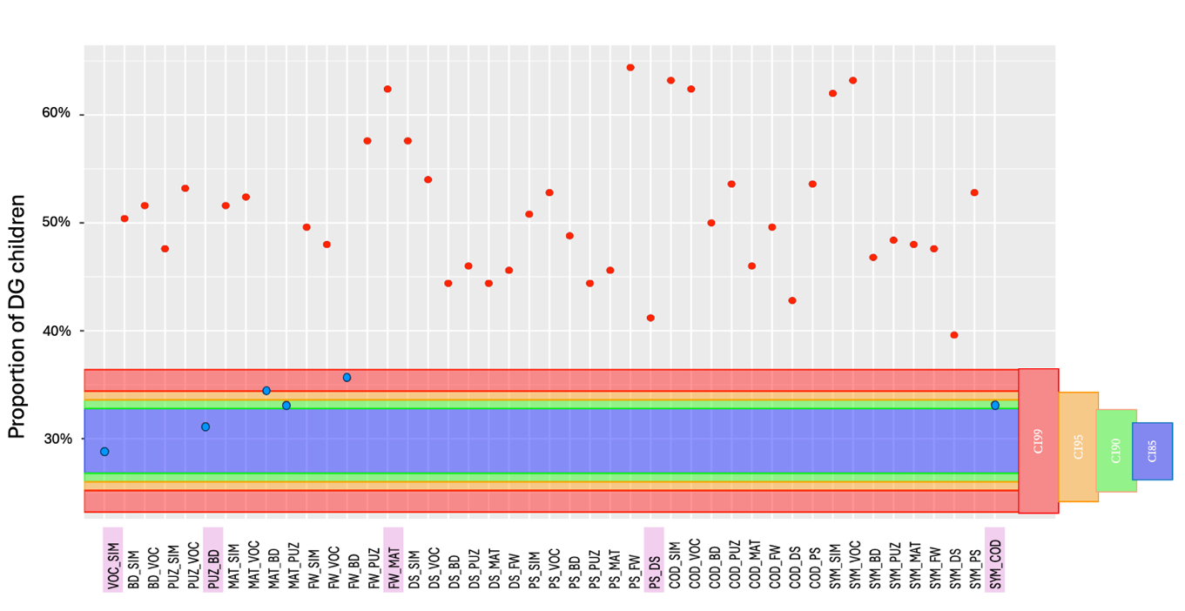Figure 2-1 : Proportion of DG children for whom the difference between the standard scores of two subtests is greater in absolute value than the critical value expected in the reference population with a two-sided uncertainty of 15%. The colours represent the confidence intervals of the expected number of subjects for 248 subjects observed at 85% (blue band), 90% (green band), 95% (orange band) and 99% (red band) respectively.

Eighty per cent of the subtest pairs exceeded the upper limit of the .99 confidence interval (CI99) (39/45 points outside the dark grey zone; Figure 2-1). In addition, for each of the differences between subtest pairs that exceed the upper limit of the confidence interval, we can see that between 40% and 65% of DG children display heterogeneity.
The .95 confidence intervals for the cumulative percentages of differences between indexes (VCI-VSI, VCI-FRI, VCI-WMI and VCI-PSI) are clearly higher than those expected at the 5th percentile (i.e. respectively [13;23], [12;22], [15;25], [20;32]). We can conclude that the DG group shows heterogeneity in the differences between indexes involving the VCI.

