Supplementary materials 4

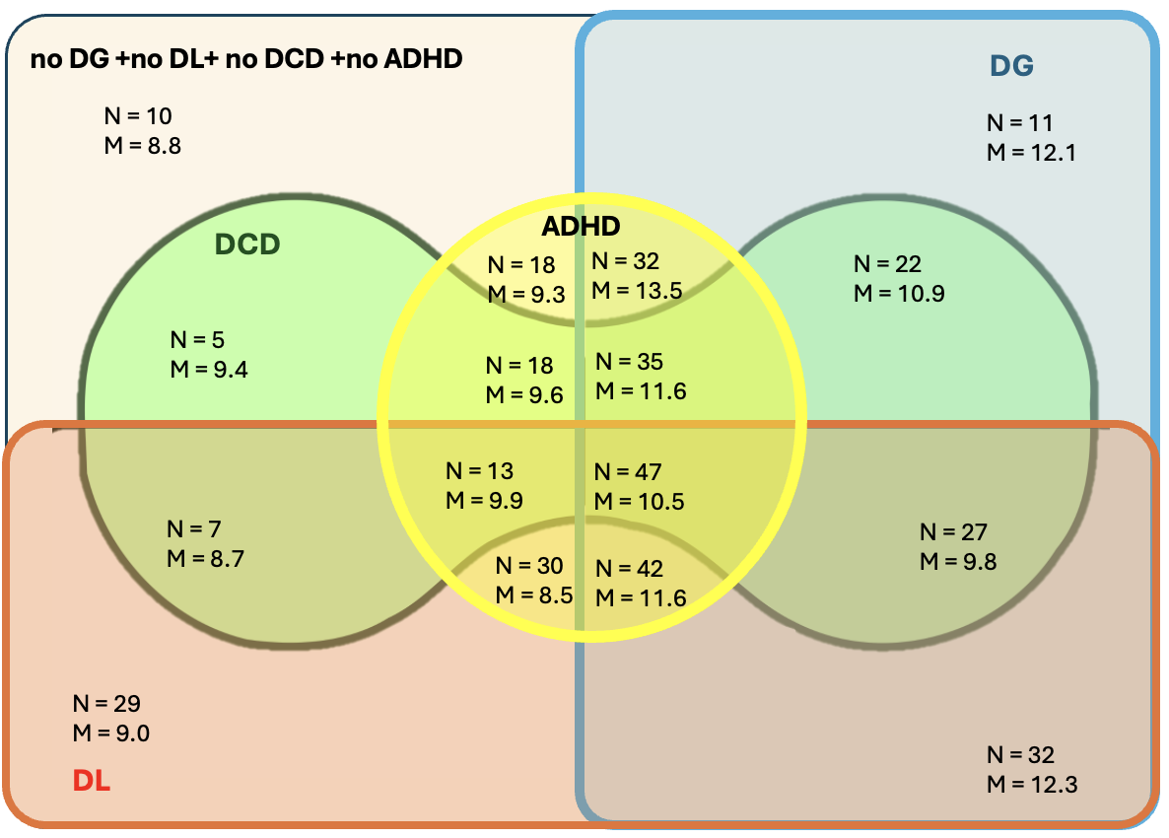
Figure 4-1: sample distribution according to diagnoses M=mean on SIM subtest; N= subgroup size. The vertical blue separation (left/right) represents the DG/noDG distribution. The horizontal orange separation (bottom/top) corresponds to the DL/noDL distribution. The circular yellow separation (inside/outside) indicates the ADHD/noADHD distribution. The ovoid green separation (inside/outside) reflects the DCD/noDCD distribution.

