Supplementary materials 3

Comparisons on means for each subtest between groups

METHOD

STEP 2: Effect of DG on the scores to the subtests
The means of the WISC-V subtests were compared using inferential and Bayesian Student t-tests for the DG/noDG subgroup. The Bayes Factor (BF) quantifies the strength of the evidence for a standardized mean difference between the two groups.

STEP 3: Effects of DL, DCD and ADHD on subtest scores showing significant difference DG /no DG and BF>3
The means of the WISC-V subtests and indexes of the various pairs of subsamples (DL/noDL; DCD/noDCD; ADHD/noADHD) were compared using inferential and Bayesian Student's t-tests.

RESULTS

All results are summarised in Table 3-1.

STEP 3: Effects of DL, DCD and ADHD on subtest scores showing significant difference DG /no DG and BF>3

DL/noDL
Frequentist analyses show that DL children had lower standard scores than noDL on the VCI subtests (SIM and VOC)). No significant difference was found for the COD subtest.
Bayesian analyses show that, for the SIM scores, the comparison between DL/noDL provided substantial evidence (3<BF_{SIM}= 9<10). For the VOC scores we found strong evidence (10<BF_{VOC}= 17<30) for a subgroup difference.

DCD/noDCD
Frequentist analyses show that DCD children had lower standard scores than the noDCD for the COD subtest; comparisons on the VCI subtests (SIM and VOC) were not significant.
Bayesian analyses show that, for the COD scores, the comparison between TDC/noTDC provided decisive evidence (BF_{COD}= 10⁴>100) for a subgroup difference.

ADHD/noADHD mean comparison
Frequentist analyses show that ADHD children had higher VOC scores than the noADHD
Comparisons for subtests SIM and COD were not significant.
Bayesian analyses show that, for the VOC scores, the comparison between ADHD/noADHD provided decisively strong evidence (10<BF_{VOC}= 28<30) for a subgroup difference.

Table 3-1: summary of results for steps 2 (DG/noDG comparison) and 3 (DL/noDL; DCD/noDCD; ADHD/noADHD comparisons).In step 2: When T-Test comparison is significant: mean of each subgroup followed by T value, significance (sign) and Bayes factor (BF); else, noted no SD. In step 3:colored in grey when the application condition is not met (step 2 has shown a significant difference and a Bayes factor>3) otherwise: comparison of the means of the two subgroups: When the comparison by T-Test is significant and: mean of each subgroup followed by T value, significance (sign) and Bayes factor (BF); else, noted no SD (when T-Test comparison is not significant)
 |  |  | STEP 2 |  |  |  |  | STEP 3
 |  |  | DG/noDG |  |  |  |  | DL/noDL |  |  |  | DCD/noDCD |  |  |  | ADHD/ noADHD
 |  |  | means | T |  | sign | BF | means | T | sign | BF | means | T | sign | BF | means |  | T | sign | BF
 |  | VCI
 | SIM | similarities | 11.5/9.1 | -8.2 |  | *** | 10 ¹² | 10.4/11.3 | 3.0 | ** | 9 | noSD |  |  |  | noSD
 | VOC | vocabulary | 11.1/9.4 | -5.5 |  | *** | 10 ⁵ | 10.2/11.2 | 3.2 | *** | 17 | noSD |  |  |  | 11.0/9.9 |  | -3.4 | *** | 28
 |  | VSI
 | BD | Block Design | noSD
 | VP | Visual Puzzles | noSD
 |  | FRI
 | MR | Matrix Reasoning | noSD
 | FW | Figure Weights | 9.7/8.9 | -2.4 |  | * | <3
 |  | WMI
 | DS | Digit Span | noSD
 | PS | Picture Span | 9.5/8.8 | -2.4 |  | * | <3
 |  | PSI
 | COD | Coding | 8.0/9.0 |  |  | *** | 44 | noSD |  |  |  | 7.5/9.5 | 5.1 | *** | 10 ⁴ | noSD
 | SYM | Symbol Search | 9.1/9.8 |  |  | * | <3
significance: |  |  |  |  | *** for p<.001 ** for .001<p<.01 * for .01<p<.05 . for .05<p<.1

In summary, the VOC scores were higher when children had DG or ADHD than when they had not. The COD scores were impaired when children had DG or DCD. The SIM scores were higher in DG than in noDG, whereas they were impaired in DL (Figure 4).

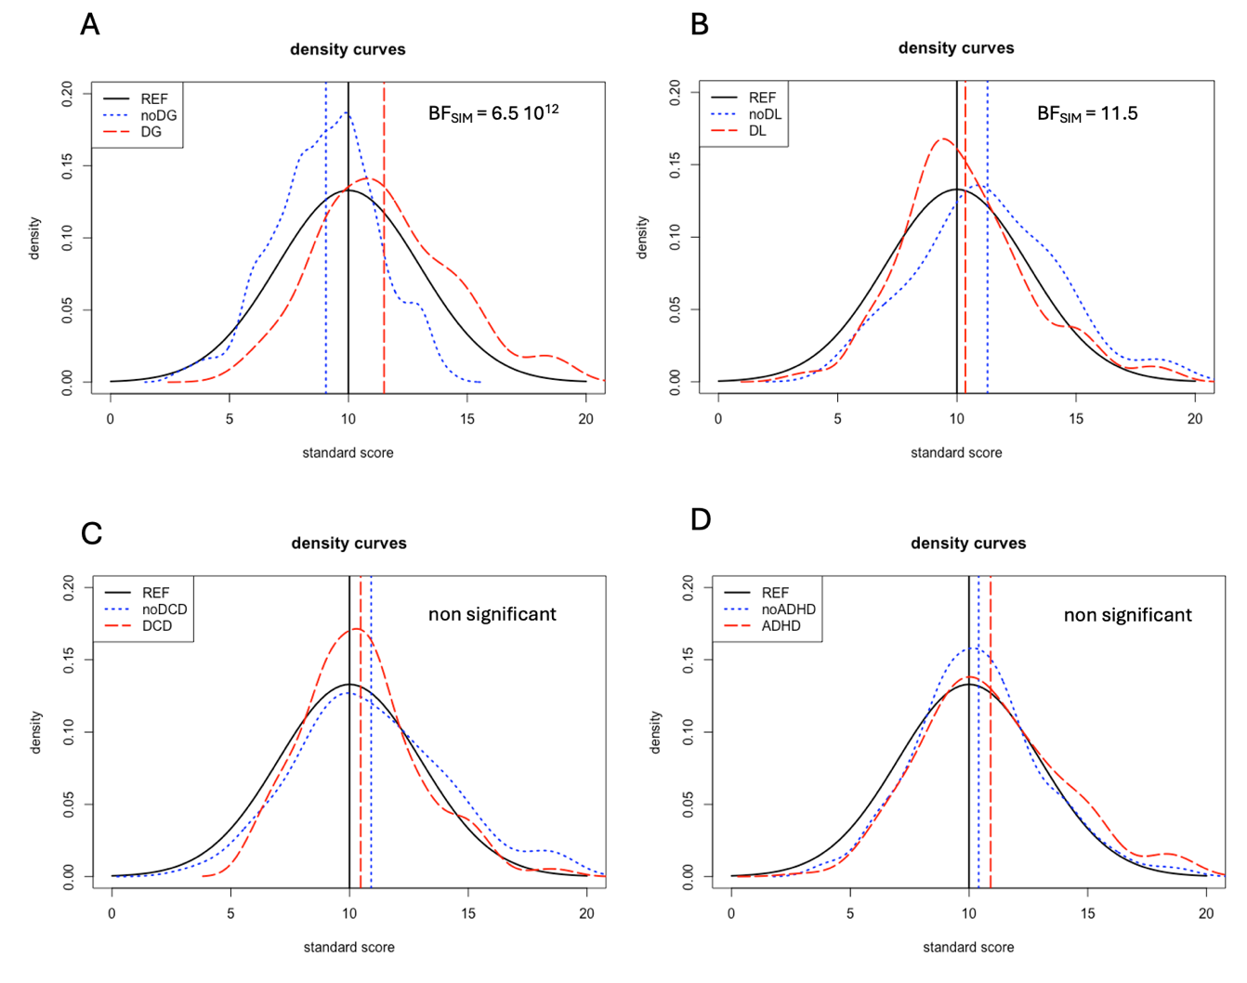
Figure 4 : Density curves of the distribution of measurements of SIM subtest for the referent population (black line) between with trouble (red line) without Trouble (blue line)
A : comparison DG/noDG ; B : comparison DL/noDL ;C : comparison DCD/noDCD ; D : comparison ADHD/noADHD

