International Journal of Biometeorology
Supplementary material
Projected typical allergic diseases prevalence under changing environments based on multiple machine learning models
Fengxia Hu ^{1,2#}, Yizhou Li ^{2#}, Xiaoyu Zhang ², Qian Wang ², Jin Zhang^{3*}, Junqin Liang ²∗
¹ Department of Postgraduate, Xinjiang Medical University, Xinjiang 830054, China;
² Department of Allergy, People’s Hospital of Xinjiang Uygur Autonomous Region，Xinjiang 830001, China;
³ ENT Department, People’s Hospital of Xinjiang Uygur Autonomous Region，Xinjiang 830001, China.
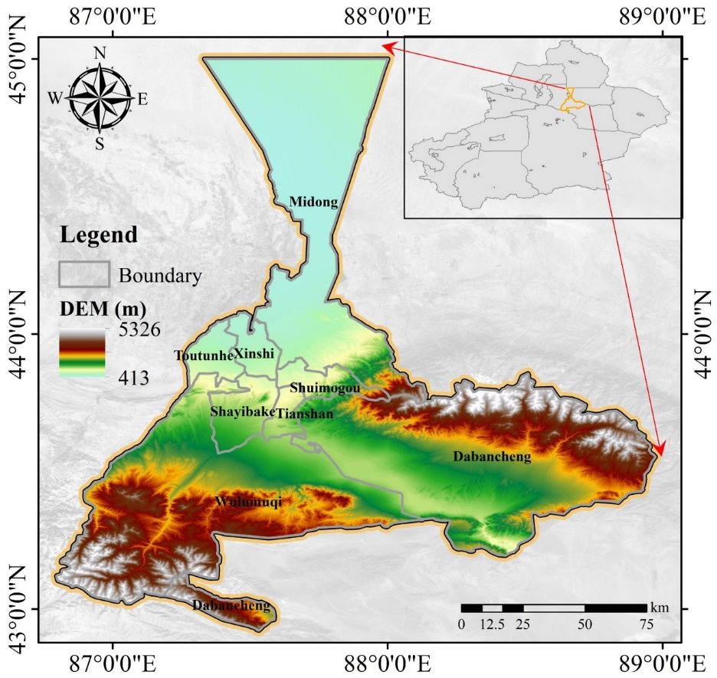
Fig. S1 Geographical Location Map of Urumqi.
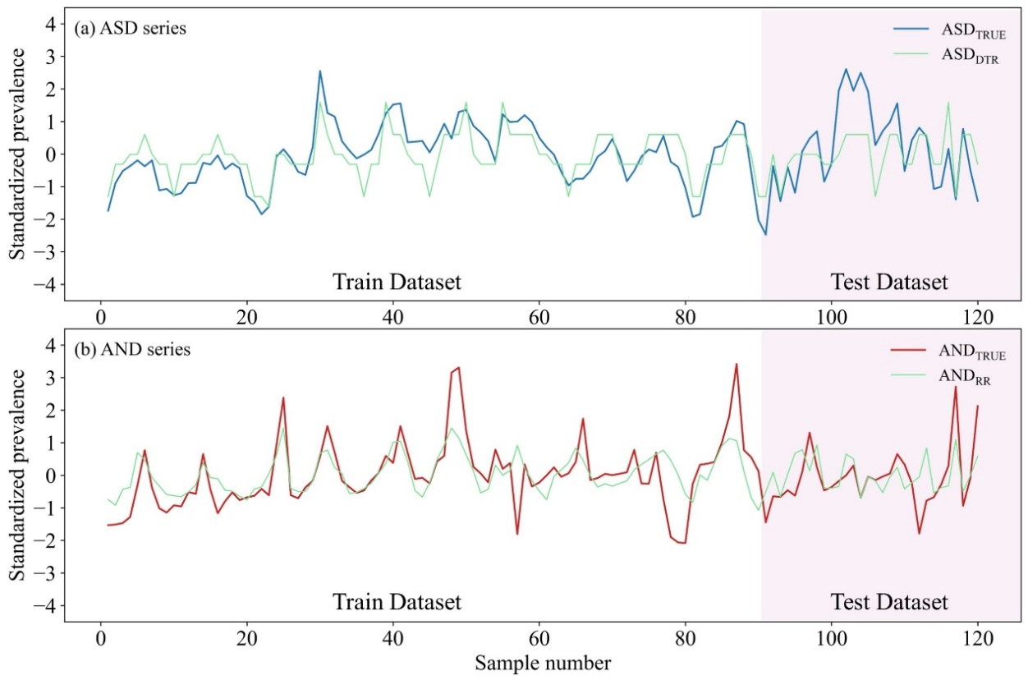
Fig. S2. Trend Changes of True and Best-Performing Machine Learning Model-Predicted ASD (a) and AND (b) Sequences on Training and Test Sets. Sample Number Represents the Randomly Selected Sample Number from the Train and Test Dataset.

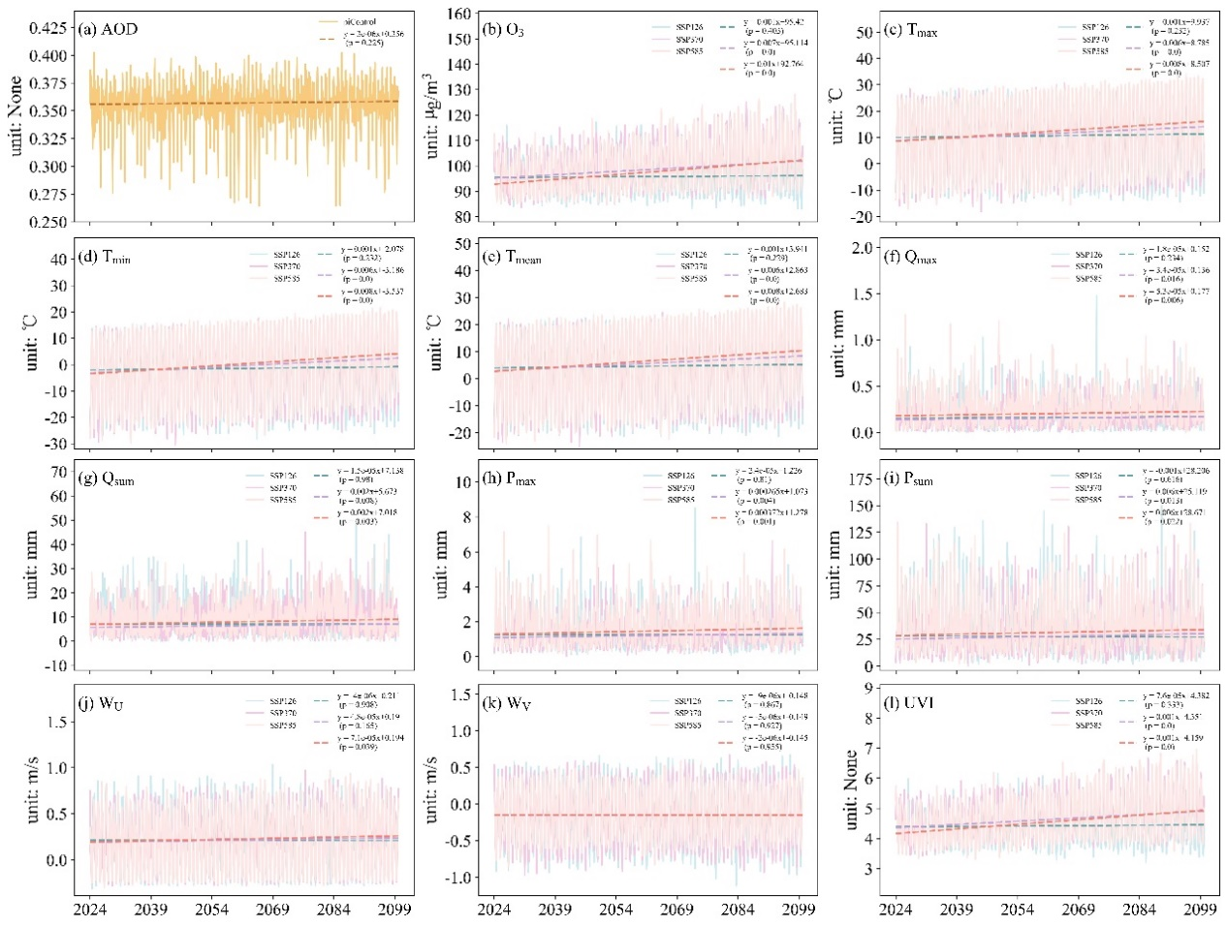
Fig. S3 Changing trends of 12 influencing factors of allergic diseases from 2024 to 2099 under different SSPs scenarios in the future.
Table. S1. The parameters of the generalized linear model for UVI estimation
Variables | Coefficients | Standard error | t-value | p-value
Model intercept | -4.39 | 0.53 | -8.25 | ***
AOD | -3.14 | 1.63 | 1.93 | *
O₃ | 0.08 | 0.01 | 15.62 | ***
Notes: ‘***’ indicates 0.001 significant level; ‘**’ indicates 0.01 significant level; ‘*’ indicates 0.05 significant level.
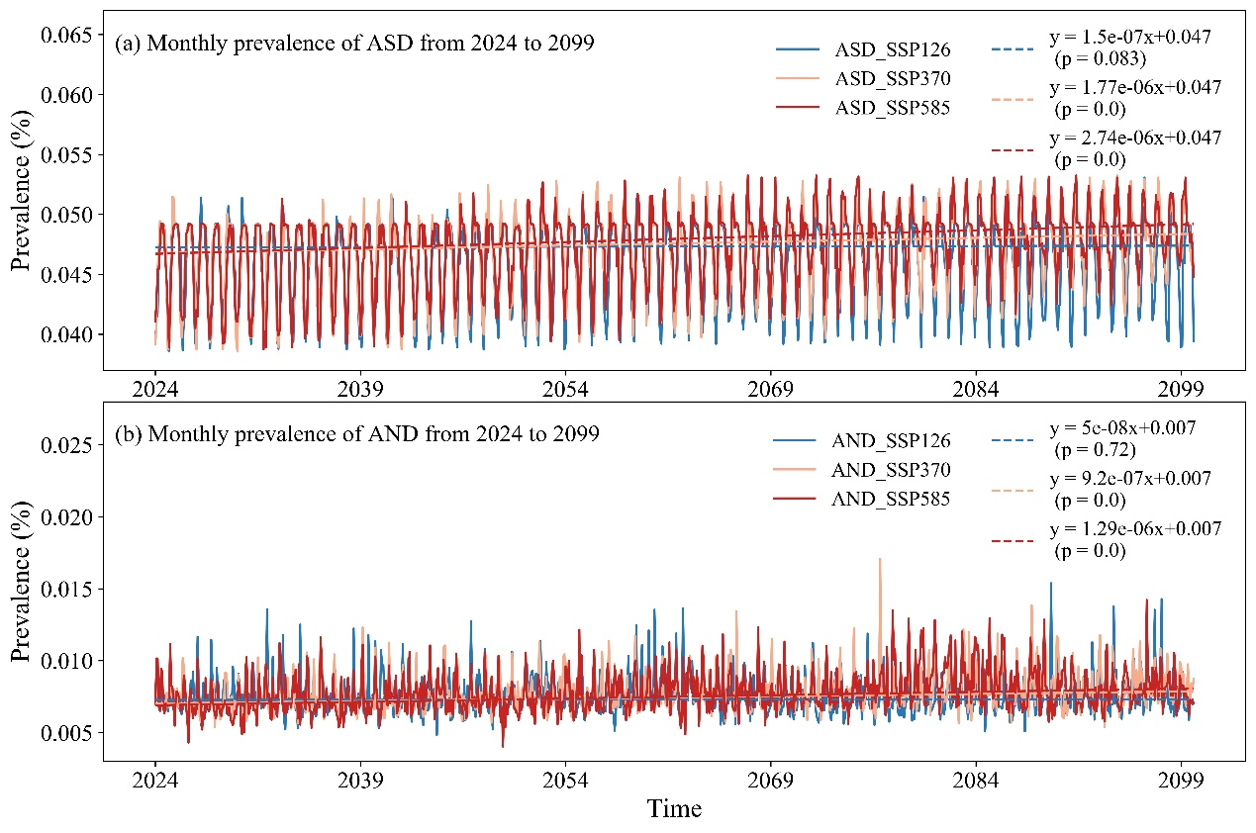
Fig. S4. The changing trends of the monthly prevalence of the ASD (a) and the AND (b) from 2024 to 2099 under different SSPs scenarios in the future.

# Fengxia Hu (hufengxia24813@163.com) and Yizhou Li (yzliyizhou@163.com) contributed equally to this work. ∗Correspondence to: Junqin Liang (drliangjq@163.com) and Jin Zhang (274953364@qq.com).

