Supporting Information for

Title:
Differential responses of soil organic and inorganic carbon to edaphic factors within, but not between, shelterbelts and croplands in China’s Drylands
Author names and affiliations:
Tengfei Yu, Tuo Han, Yidan Yin, Baofeng Li, Haiyang Xi, Wei Liu, Qi Feng

*Tengfei Yu
Email: yutf@lzb.ac.cn

This PDF file includes:
Tables S1
Figures S1-S5
Other supporting materials for this manuscript include the following:
Dataset S1

Table S1. Statistical characteristics (mean ± SE) of twenty edaphic factors with multivariate analysis of variance (MANOVA) results across depth intervals between shelterbelts (SF) and croplands (CF) at increasing distance gradients (CF_0.25H, CF_0.5H, CF_1H). MANOVA reports F-values with significance levels: ***P < 0.001, ** P < 0.01, *P < 0.0.
Depths  (cm) | Points | N | TN  (g kg⁻¹) | TP  (g kg⁻¹) | TK  (g kg⁻¹) | AP  (mg kg⁻¹) | AK  (mg kg⁻¹) | SMC  (%) | BD  (g cm⁻³) | Clay  (%) | Silt  (%) | Sand  (%) | pH | EC  (dS m⁻¹) | F⁻  (g L⁻¹) | Cl⁻  (g L⁻¹) | NO₃⁻  (g L⁻¹) | SO₄²⁻  (g L⁻¹) | Na⁺  (g L⁻¹) | K⁺  (g L⁻¹) | Mg²⁺  (g L⁻¹) | Ca²⁺  (g L⁻¹)
0-10 | SF | 30 | 1.13 ± 0.14a | 0.73 ± 0.03a | 19.80 ± 0.27a | 25.04 ± 5.82a | 420.62 ± 74.01a | 5.09 ± 0.89b | 1.46 ± 0.03b | 7.26 ± 0.53a | 45.15 ± 2.77a | 47.60 ± 3.21a | 8.07 ± 0.03a | 709.58 ± 147.96a | 0.24 ± 0.03a | 9.85 ± 1.45a | 10.26 ± 3.42a | 23.80 ± 4.68a | 2.63 ± 0.34a | 2.67 ± 0.25a | 2.55 ± 0.16a | 5.23 ± 0.28a
0-10 | CF_0.25H | 30 | 0.85 ± 0.09a | 0.80 ± 0.03a | 19.81 ± 0.23a | 26.27 ± 3.49a | 191.82 ± 19.86b | 9.83 ± 0.85a | 1.51 ± 0.02ab | 7.27 ± 0.71a | 41.67 ± 3.38a | 51.06 ± 4.01a | 8.06 ± 0.03a | 696.22 ± 123.82a | 0.24 ± 0.02a | 8.67 ± 1.25a | 13.43 ± 2.82a | 28.49 ± 6.14a | 2.27 ± 0.23a | 1.89 ± 0.30ab | 2.30 ± 0.13a | 5.66 ± 0.47a
0-10 | CF_0.5H | 30 | 0.84 ± 0.09a | 0.82 ± 0.03a | 20.22 ± 0.22a | 22.21 ± 2.56a | 166.3 ± 16.97b | 10.66 ± 0.77a | 1.56 ± 0.03a | 7.96 ± 0.65a | 44.75 ± 2.62a | 47.30 ± 3.15a | 8.04 ± 0.04a | 882.96 ± 204.72a | 0.27 ± 0.05a | 11.73 ± 1.65a | 17.37 ± 2.86a | 28.12 ± 4.51a | 2.70 ± 0.27a | 1.22 ± 0.16b | 2.26 ± 0.12a | 4.86 ± 0.30a
0-10 | CF_1H | 30 | 0.88 ± 0.09a | 0.8 ± 0.03a | 20.1 ± 0.23a | 22.04 ± 3.75a | 143.83 ± 15.10b | 13.03 ± 1.52a | 1.52 ± 0.02ab | 7.42 ± 0.64a | 44.65 ± 2.99a | 47.92 ± 3.53a | 8.04 ± 0.03a | 688.85 ± 123.5a | 0.24 ± 0.04a | 10.66 ± 0.99a | 10.38 ± 2.17a | 30.96 ± 5.61a | 2.85 ± 0.29a | 1.94 ± 0.31ab | 2.35 ± 0.14a | 5.22 ± 0.42a
10-30 | SF | 30 | 0.80 ± 0.08a | 0.67 ± 0.03a | 19.84 ± 0.29a | 8.66 ± 1.59a | 257.55 ± 45.63a | 6.54 ± 0.85b | 1.52 ± 0.03a | 8.53 ± 0.76a | 47.79 ± 3.21a | 43.68 ± 3.88a | 8.14 ± 0.02a | 406.56 ± 55.64a | 0.28 ± 0.03a | 7.19 ± 1.21a | 6.78 ± 2.12a | 21.07 ± 3.86a | 2.31 ± 0.27a | 1.91 ± 0.26a | 2.20 ± 0.17a | 4.55 ± 0.26a
10-30 | CF_0.25H | 30 | 0.71 ± 0.07a | 0.72 ± 0.03a | 19.68 ± 0.28a | 11.73 ± 2.11a | 152.50 ± 18.53b | 10.63 ± 0.79a | 1.57 ± 0.02a | 7.41 ± 0.57a | 45.21 ± 2.70a | 47.37 ± 3.15a | 8.10 ± 0.03a | 394.97 ± 69.97a | 0.36 ± 0.03a | 6.24 ± 0.63a | 5.24 ± 1.32a | 23.21 ± 5.54a | 2.06 ± 0.21a | 1.66 ± 0.24a | 2.07 ± 0.11a | 4.91 ± 0.37a
10-30 | CF_0.5H | 30 | 0.79 ± 0.07a | 0.75 ± 0.03a | 20.06 ± 0.25a | 12.33 ± 1.97a | 130.29 ± 11.97b | 11.82 ± 0.82a | 1.61 ± 0.03a | 7.94 ± 0.79a | 45.20 ± 2.87a | 46.86 ± 3.43a | 8.11 ± 0.03a | 506.76 ± 96.87a | 0.33 ± 0.03a | 9.62 ± 1.24a | 8.68 ± 1.40a | 28.39 ± 4.79a | 2.88 ± 0.31a | 1.67 ± 0.40a | 2.13 ± 0.11a | 4.98 ± 0.39a
10-30 | CF_1H | 30 | 0.76 ± 0.07a | 0.75 ± 0.03a | 20.15 ± 0.25a | 12.18 ± 1.63a | 116.1 ± 9.86b | 12.78 ± 0.74a | 1.57 ± 0.02a | 8.04 ± 0.66a | 45.15 ± 3.12a | 46.81 ± 3.69a | 8.13 ± 0.02a | 378.45 ± 60.30a | 0.35 ± 0.04a | 7.89 ± 0.80a | 5.53 ± 1.26a | 26.77 ± 4.26a | 2.54 ± 0.28a | 1.71 ± 0.30a | 2.20 ± 0.15a | 4.93 ± 0.36a
30-50 | SF | 30 | 0.56 ± 0.06a | 0.62 ± 0.02a | 19.66 ± 0.24a | 4.66 ± 0.91a | 159.48 ± 20.14a | 7.86 ± 0.96b | 1.54 ± 0.03a | 6.85 ± 0.51a | 44.71 ± 3.41a | 48.42 ± 3.87a | 8.15 ± 0.02a | 316.45 ± 25.32a | 0.33 ± 0.03a | 8.18 ± 1.01a | 5.74 ± 1.69a | 25.72 ± 4.55a | 3.04 ± 0.40a | 1.59 ± 0.20a | 2.14 ± 0.17a | 4.21 ± 0.31a
30-50 | CF_0.25H | 30 | 0.64 ± 0.06a | 0.62 ± 0.02a | 19.73 ± 0.28a | 4.92 ± 1.18a | 135.39 ± 15.71a | 11.64 ± 0.85a | 1.57 ± 0.02a | 7.67 ± 0.42a | 50.38 ± 2.76a | 41.95 ± 3.07a | 8.06 ± 0.03a | 426.42 ± 75.34a | 0.42 ± 0.04a | 5.63 ± 0.49a | 5.64 ± 1.20a | 26.52 ± 6.95a | 2.29 ± 0.26a | 1.42 ± 0.23a | 1.91 ± 0.10a | 4.58 ± 0.40a
30-50 | CF_0.5H | 30 | 0.67 ± 0.08a | 0.65 ± 0.03a | 20.03 ± 0.24a | 6.91 ± 1.59a | 131.50 ± 19.33a | 11.82 ± 0.79a | 1.59 ± 0.03a | 7.62 ± 0.64a | 45.56 ± 2.9a | 46.83 ± 3.32a | 8.07 ± 0.02a | 437.88 ± 90.76a | 0.35 ± 0.03a | 8.52 ± 1.03a | 8.49 ± 0.92a | 27.53 ± 4.72a | 2.68 ± 0.27a | 1.38 ± 0.32a | 1.96 ± 0.13a | 4.47 ± 0.36a
30-50 | CF_1H | 30 | 0.58 ± 0.05a | 0.63 ± 0.02a | 19.94 ± 0.23a | 4.89 ± 1.09a | 102.45 ± 9.01a | 13.14 ± 0.73a | 1.57 ± 0.02a | 7.55 ± 0.55a | 46.71 ± 3.05a | 45.75 ± 3.46a | 8.14 ± 0.03a | 369.5 ± 82.84a | 0.37 ± 0.04a | 7.52 ± 1.16a | 4.94 ± 1.23a | 25.92 ± 5.18a | 2.33 ± 0.24a | 1.67 ± 0.41a | 2.17 ± 0.17a | 4.86 ± 0.44a
50-100 | SF | 30 | 0.52 ± 0.06a | 0.60 ± 0.02a | 19.57 ± 0.27a | 3.40 ± 1.06a | 129.02 ± 13.83a | 9.52 ± 1.18b | 1.57 ± 0.03a | 7.29 ± 0.67a | 46.17 ± 3.94a | 46.53 ± 4.54a | 8.12 ± 0.03a | 454.98 ± 89.77a | 0.36 ± 0.04a | 8.23 ± 0.98a | 5.56 ± 1.59a | 36.87 ± 6.62a | 3.31 ± 0.53a | 1.30 ± 0.14a | 2.09 ± 0.16a | 4.26 ± 0.53a
50-100 | CF_0.25H | 30 | 0.46 ± 0.04a | 0.59 ± 0.02a | 19.69 ± 0.30a | 2.88 ± 0.42a | 106.54 ± 7.93a | 12.90 ± 1.12ab | 1.59 ± 0.02a | 7.71 ± 0.63a | 47.93 ± 3.74a | 44.37 ± 4.28a | 8.09 ± 0.03a | 424.29 ± 61.70a | 0.37 ± 0.04a | 6.73 ± 0.68a | 8.25 ± 1.97a | 34.92 ± 6.51a | 2.59 ± 0.32a | 1.02 ± 0.12a | 2.06 ± 0.15a | 4.50 ± 0.52a
50-100 | CF_0.5H | 30 | 0.47 ± 0.04a | 0.58 ± 0.02a | 19.81 ± 0.30a | 3.06 ± 0.43a | 106.78 ± 10.77a | 12.85 ± 0.91ab | 1.6 ± 0.03a | 7.58 ± 0.77a | 44.81 ± 3.72a | 47.59 ± 4.39a | 8.08 ± 0.03a | 458.67 ± 102.64a | 0.43 ± 0.04a | 8.05 ± 0.95a | 7.95 ± 1.08a | 33.76 ± 5.89a | 2.86 ± 0.32a | 1.18 ± 0.20a | 2.08 ± 0.15a | 4.69 ± 0.47a
50-100 | CF_1H | 30 | 0.47 ± 0.06a | 0.60 ± 0.02a | 19.88 ± 0.30a | 3.02 ± 0.81a | 96.44 ± 10.87a | 13.41 ± 0.61a | 1.59 ± 0.03a | 7.11 ± 0.57a | 44.92 ± 3.68a | 47.97 ± 4.19a | 8.14 ± 0.04a | 344.3 ± 80.01a | 0.39 ± 0.04a | 6.52 ± 0.71a | 3.63 ± 0.70a | 25.71 ± 5.63a | 2.26 ± 0.28a | 1.45 ± 0.25a | 1.96 ± 0.13a | 4.68 ± 0.51a
0-100 | SF | 120 | 0.75 ± 0.10a | 0.65 ± 0.03a | 19.72 ± 0.27a | 10.44 ± 3.44a | 241.67 ± 49.22a | 7.25 ± 1.01c | 1.53 ± 0.03b | 7.48 ± 0.63a | 45.95 ± 3.32a | 46.56 ± 3.87a | 8.12 ± 0.02a | 471.89 ± 94.48a | 0.30 ± 0.03a | 8.36 ± 1.18ab | 7.09 ± 2.32ab | 26.87 ± 5.09a | 2.82 ± 0.40a | 1.87 ± 0.24a | 2.24 ± 0.17a | 4.56 ± 0.37a
0-100 | CF_0.25H | 120 | 0.66 ± 0.07a | 0.68 ± 0.03a | 19.73 ± 0.27a | 11.45 ± 2.69a | 146.56 ± 16.95b | 11.25 ± 0.93b | 1.56 ± 0.02ab | 7.52 ± 0.58a | 46.30 ± 3.19a | 46.19 ± 3.67a | 8.08 ± 0.03a | 485.48 ± 87.99a | 0.35 ± 0.04a | 6.82 ± 0.83b | 8.14 ± 2.00ab | 28.29 ± 6.28a | 2.30 ± 0.26a | 1.50 ± 0.24ab | 2.09 ± 0.12a | 4.91 ± 0.45a
0-100 | CF_0.5H | 120 | 0.69 ± 0.08a | 0.70 ± 0.03a | 20.03 ± 0.25a | 11.13 ± 2.22a | 133.72 ± 15.48b | 11.79 ± 0.83ab | 1.59 ± 0.03a | 7.77 ± 0.71a | 45.08 ± 3.02a | 47.15 ± 3.56a | 8.07 ± 0.03a | 571.57 ± 134.84a | 0.35 ± 0.04a | 9.48 ± 1.26a | 10.62 ± 1.87a | 29.45 ± 4.97a | 2.78 ± 0.29a | 1.36 ± 0.28b | 2.11 ± 0.13a | 4.75 ± 0.38a
0-100 | CF_1H | 120 | 0.67 ± 0.07a | 0.70 ± 0.03a | 20.02 ± 0.25a | 10.53 ± 2.53a | 114.7 ± 11.79b | 13.09 ± 0.96a | 1.56 ± 0.02ab | 7.53 ± 0.60a | 45.36 ± 3.19a | 47.11 ± 3.69a | 8.11 ± 0.03a | 445.27 ± 92.22a | 0.34 ± 0.04a | 8.15 ± 0.96ab | 6.12 ± 1.50b | 27.34 ± 5.15a | 2.49 ± 0.27a | 1.69 ± 0.32ab | 2.17 ± 0.15a | 4.92 ± 0.43a
MANOVA | Points |  | 1.17 | 2.57 | 1.76 | 0.17 | 19.21*** | 29.77*** | 3.67* | 0.17 | 0.12 | 0.06 | 2.36 | 1.15 | 1.34 | 4.26** | 4.21** | 0.18 | 2.53 | 2.76* | 0.99 | 0.67
MANOVA | Depths |  | 26.04*** | 44.11*** | 0.67 | 63.03*** | 16.64*** | 5.34** | 5.36** | 0.73 | 0.53 | 0.42 | 4.19** | 10.90*** | 11.63*** | 6.59*** | 11.83*** | 1.62 | 0.67 | 4.96** | 4.46** | 2.75*
MANOVA | Points : Depths |  | 1.07 | 0.72 | 0.08 | 0.46 | 4.25*** | 0.64 | 0.28 | 0.39 | 0.37 | 0.37 | 0.56 | 0.19 | 0.59 | 0.41 | 0.54 | 0.45 | 0.90 | 1.02 | 0.34 | 0.30
Abbr. Total nitrogen, TN; Total phosphorus , TP; Total kalium, TK; Available phosphorus, AP; Available kalium, AK; Bulk density, BD; Soil moisture content, SMC; Percent of clay, Clay; Percent of silt, Silt; Percent of sand, Sand; Pondus hydrogenii, pH; Electrical conductivity, EC, F⁻, Cl⁻, NO₃⁻, SO₄²⁻, Na⁺, K⁺, Mg²⁺ and Ca²⁺ are concentration of ions.
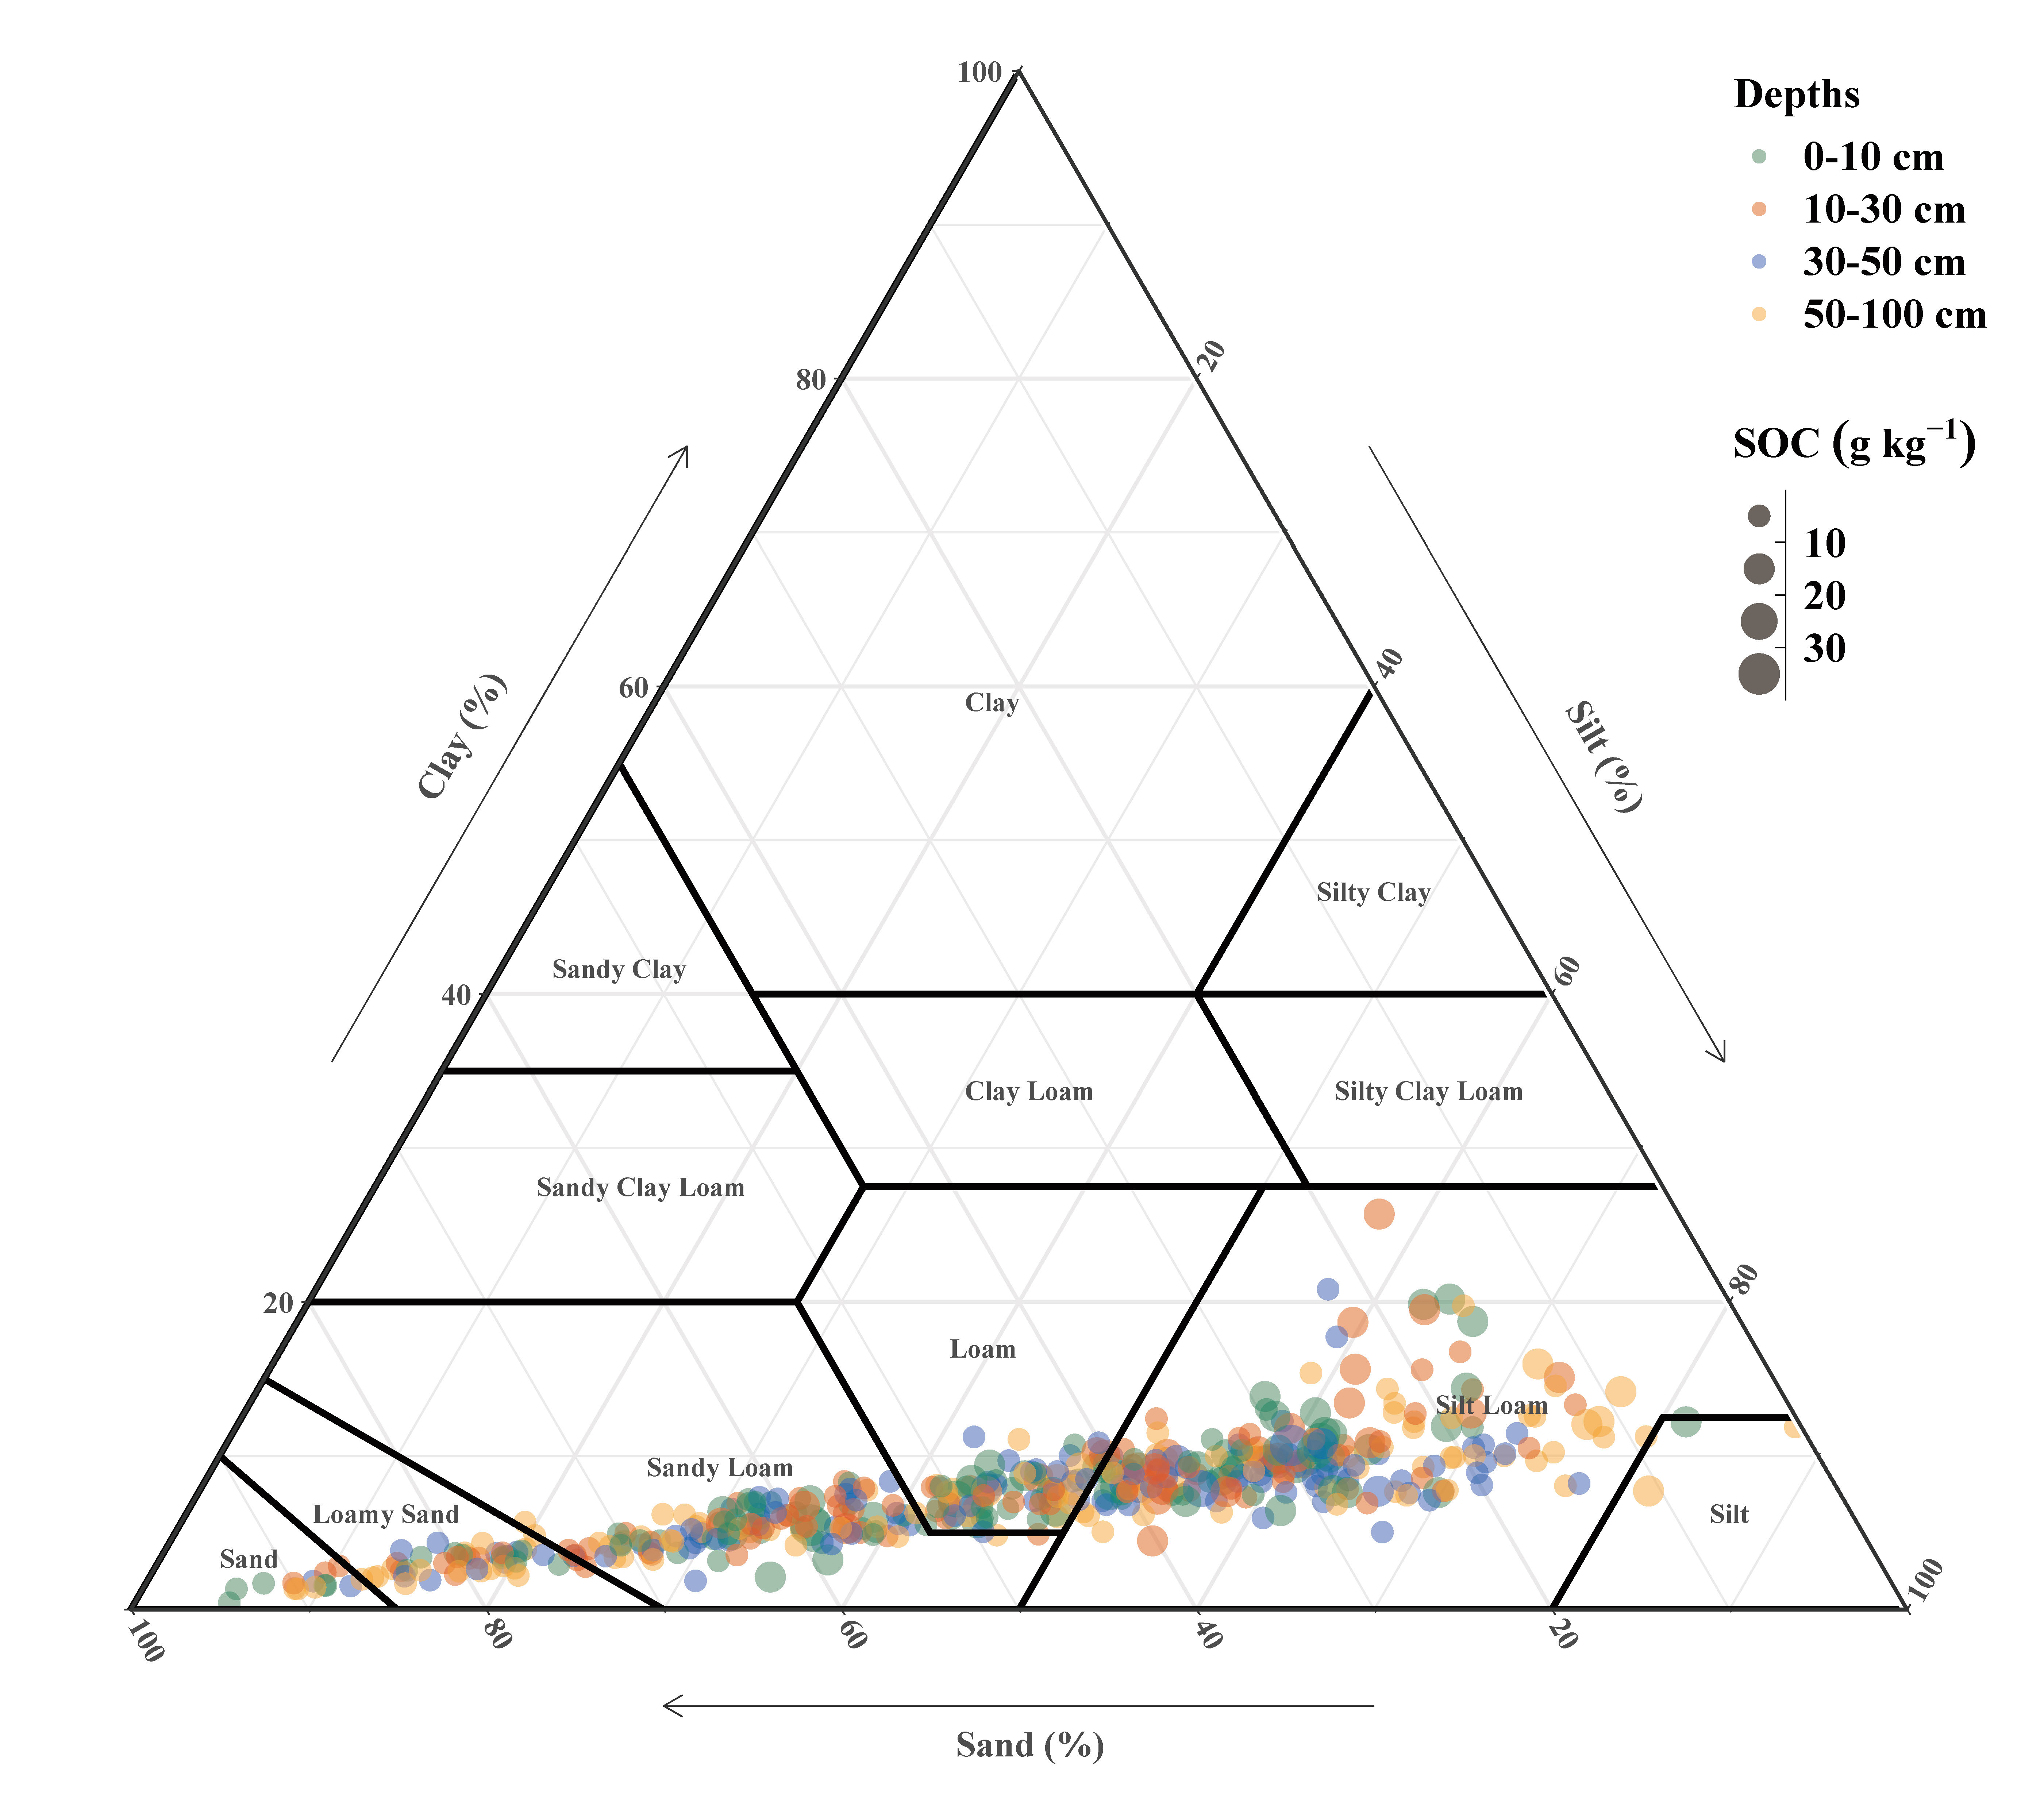
Fig. S1. Soil texture of sampling sites across depths within 100 cm profile segmented following soil organic carbon (SOC).
Fig. S2. Comparation of soil carbon fractions, (a) soil total carbon (STC), (b) soil organic carbon (SOC), (c) soil inorganic carbon (SIC), and (d) SIC:SOC ratio between shelterbelt forests (SF) and adjacent corn fields (CF) at increasing distance intervals from shelterbelts: CF_0.25H, CF_0.5H, and CF_1H.

Fig. S3. Comparation of edaphic factors for shelterbelt forests (SF) and adjacent corn fields (CF) at increasing distance intervals from shelterbelts: CF_0.25H, CF_0.5H, and CF_1H.

Fig. S4. Results of 10-fold cross-validation using LASSO regression of SOC (a-d) and SIC (e-h) for shelterbelt forests (SF) and adjacent corn fields (CF) at increasing distance intervals from shelterbelts: CF_0.25H, CF_0.5H, and CF_1H.
Fig. S5. Determining the primary edaphic factors of SOC (a) and SIC (b) using LASSO regression for shelterbelt forests (SF) and adjacent corn fields (CF) at increasing distance intervals from shelterbelts: CF_0.25H, CF_0.5H, and CF_1H.

