Supplementary materials
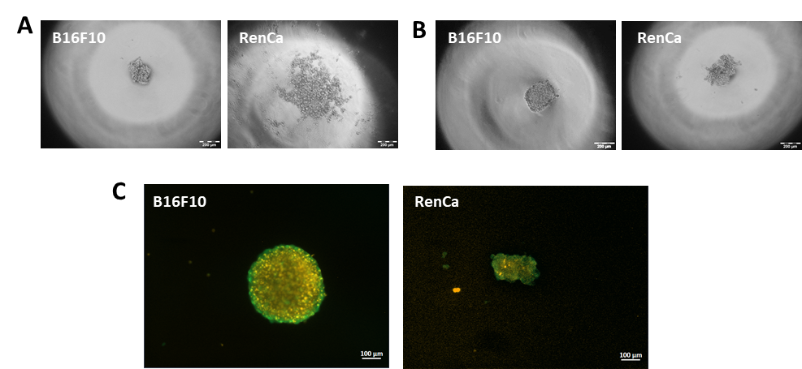
Supplementary Figure 1 Optimization of spheroid culture model. A- cell aggregates after 3 days of culture using standard hanging drop method without methylcellulose. B- cell aggregates after 3 days culture using standard hanging drop method with methylcellulose C- spheroids cultured in hypoxic condition stained by propidium iodide (orange - dead cells) and calcein (green - live cells), which show the positions of live and dead cells in the spheres.

