Table MT1: Inclusion and Exclusion criteria for selecting projects and MLOs
Inclusion | Exclusion
MLO is involved in interventions targeting SSPs in Ghana, Kenya, Malawi & South Africa | MLO is not involved in interventions targeting SSPs in Ghana, Kenya, Malawi & South Africa
MLO involved in CCA interventions (projects) targeting SSPs | MLO is not involved in CCA interventions targeting SSPs. This also includes government programs and strategies targeting CCA.
MLO projects which were initiated not earlier than 2015 or were ongoing in 2015 | MLO Projects/ related activities which ended before 2015
Macro-level (funders) organizations that play a dual role of funding and implementing of interventions targeting SSPs | Macro-level (funders) organizations which fund projects but do not implement interventions targeting SSPs

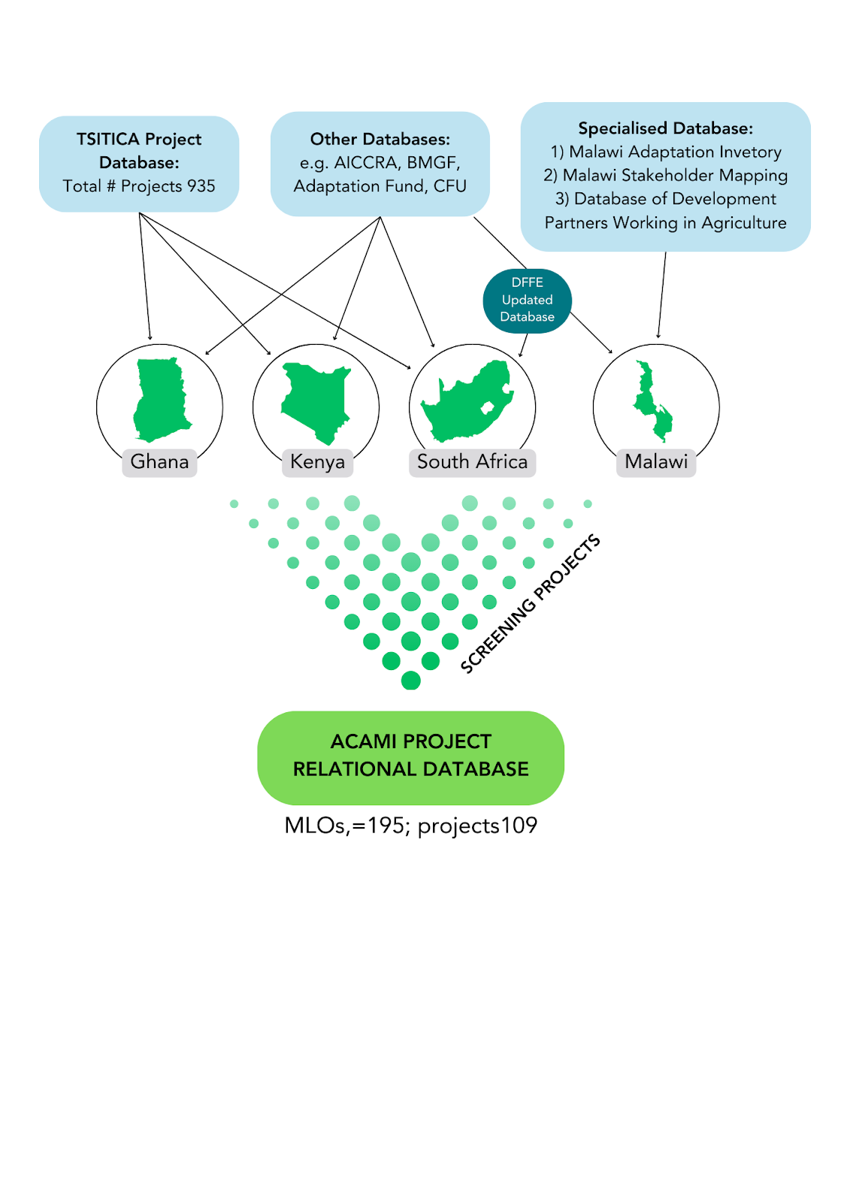
Figure M1: Identification and selection of MLOs, projects and contacts

