Supplementary information

Figure S1. Map of reference points used for spatial validation of fire events data across southern Europe.
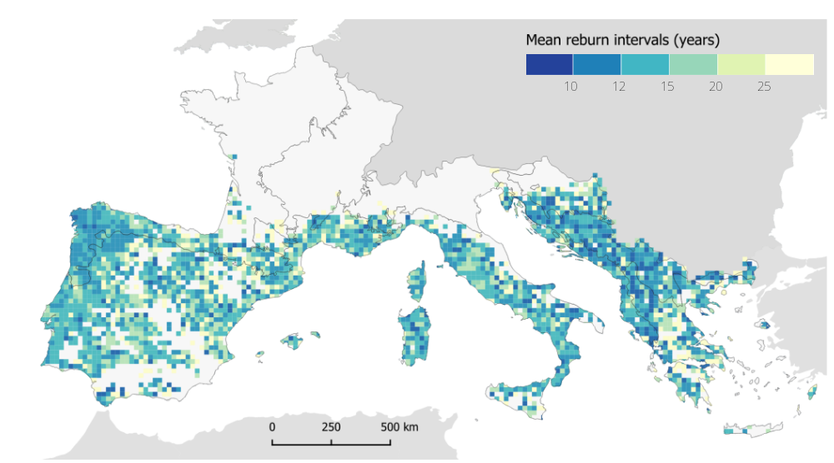
Figure S2. Mean reburn intervals per 20x20 km² grid.

Table S1. Percentage of reburns within each return interval
Percent of reburns within time intervals | West European Coastal | Balearic Sea and West Mediterranean | Adriatic Sea and Central Mediterranean | Aegean Sea and East Mediterranean | Dinaric Mountains and Balkan
0-5 | 2.98 | 2.50 | 2.13 | 2.19 | 1.60
6-10 | 21.82 | 14.27 | 18.52 | 26.05 | 31.38
11-15 | 77.75 | 64.61 | 72.79 | 62.28 | 81.21
16-20 | 95.55 | 89.87 | 94.92 | 80.24 | 94.33
21-25 | 98.09 | 96.82 | 98.03 | 90.12 | 99.11
26-30 | 99.15 | 98.94 | 98.85 | 95.81 | 99.47

Figure S3. Percentage of reburns per return interval and country. Black dot curve shows the overall distribution.
Figure S4. Percentage of total burned area attributed to annual reburns and new burns per country.

