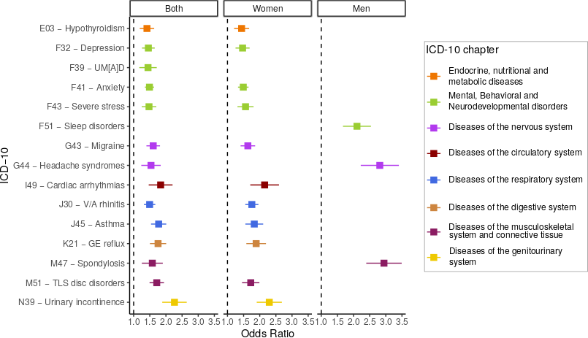 Sup Figure S1. Forest plot of the association between diagnoses and long COVID correcting by COVID-19 hospitalisation. In the y-axis, the ICD-10 code and description, and in the x-axis the odds ratio. Colours represent ICD-10 chapters.
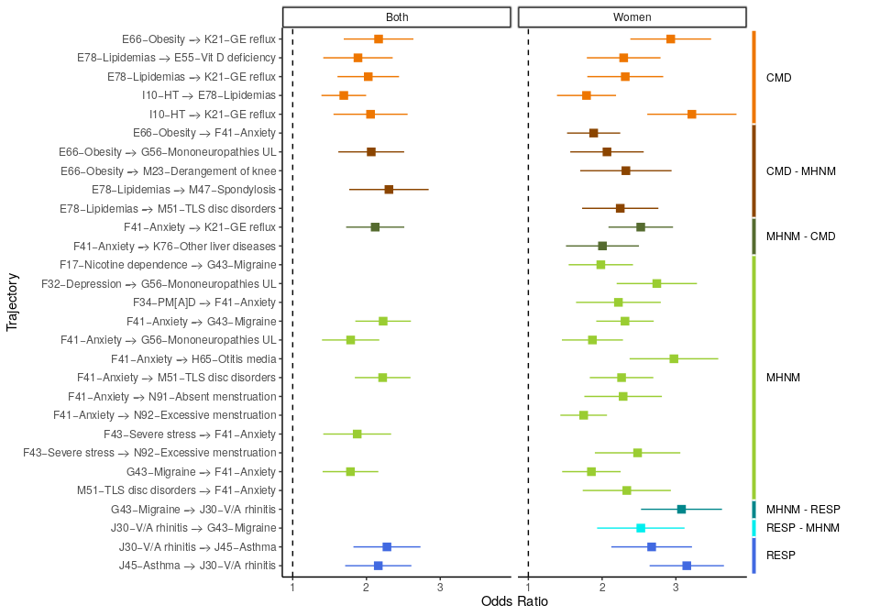
Sup Figure S2. Forest plot of the association between disease trajectories and long COVID correcting by COVID-19 severity. In the y-axis, the ICD-10 code and description of the trajectories, and in the x-axis the odds ratio. Colours represent trajectories clusters.

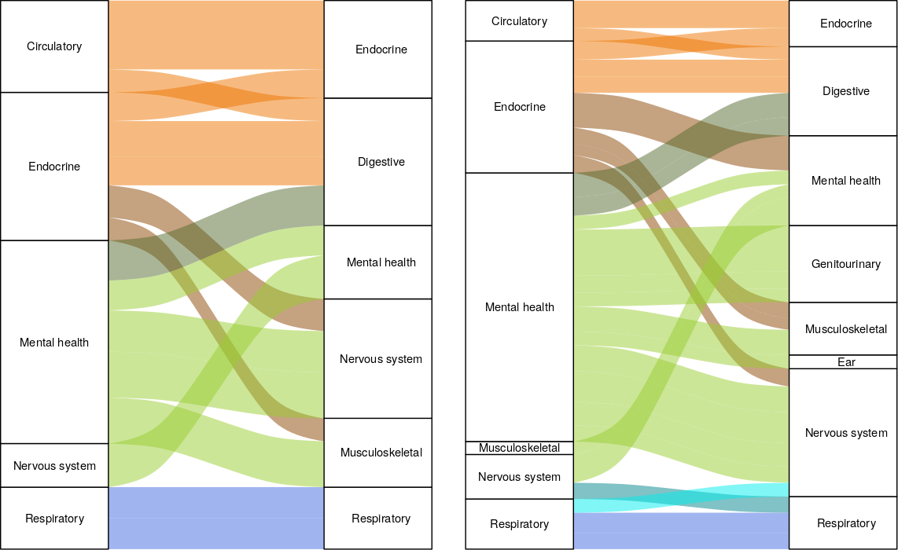
Sup Figure S3. Disease trajectories associated with long COVID corrected by COVID-19 severity, depicting the ICD-10 chapter of the first and second diagnosis for the aggregated analysis (left) and for women (right). The width of the lines represents the number of individuals with the trajectory and long COVID, and the colour the cluster of trajectories.

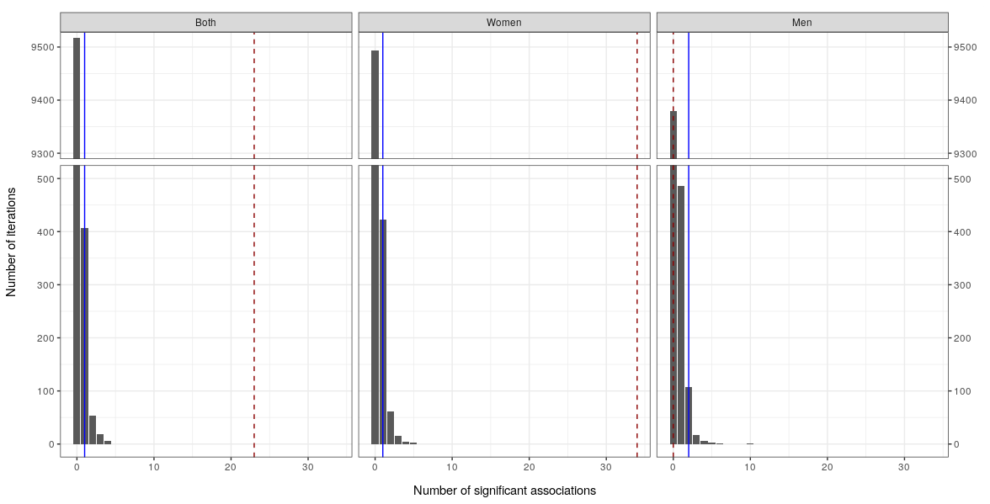 Sup Figure S4. Distribution of the number of significantly associated disease trajectories across 10,000 iterations of random long COVID case and controls distribution, in the aggregated and sex-specific analysis. The solid blue line indicates the 99th percentile. The red dashed line indicates the number of real associated disease trajectories for each analysis.
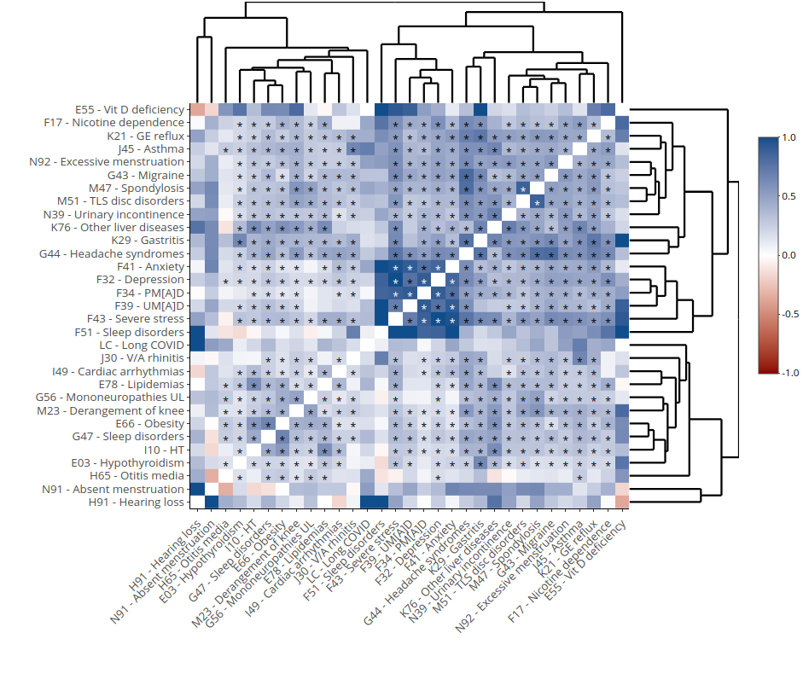 Sup Figure S5. Heatmap of the genetic correlation among the selected diseases and long COVID. Colour gradient indicates correlation, and asterisk indicates a p-value < 0.05.
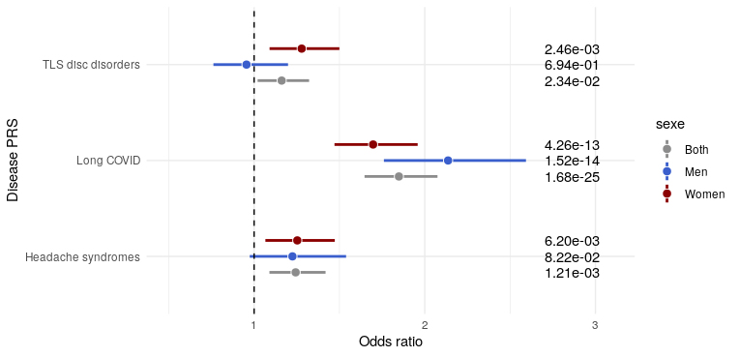
Sup Figure S6. Forest plot of the significant association (adjusted p-value < 0.05) between disease PRS and long COVID diagnosis. Aggregated and sex-stratified analysis.

