Supplementary Figures
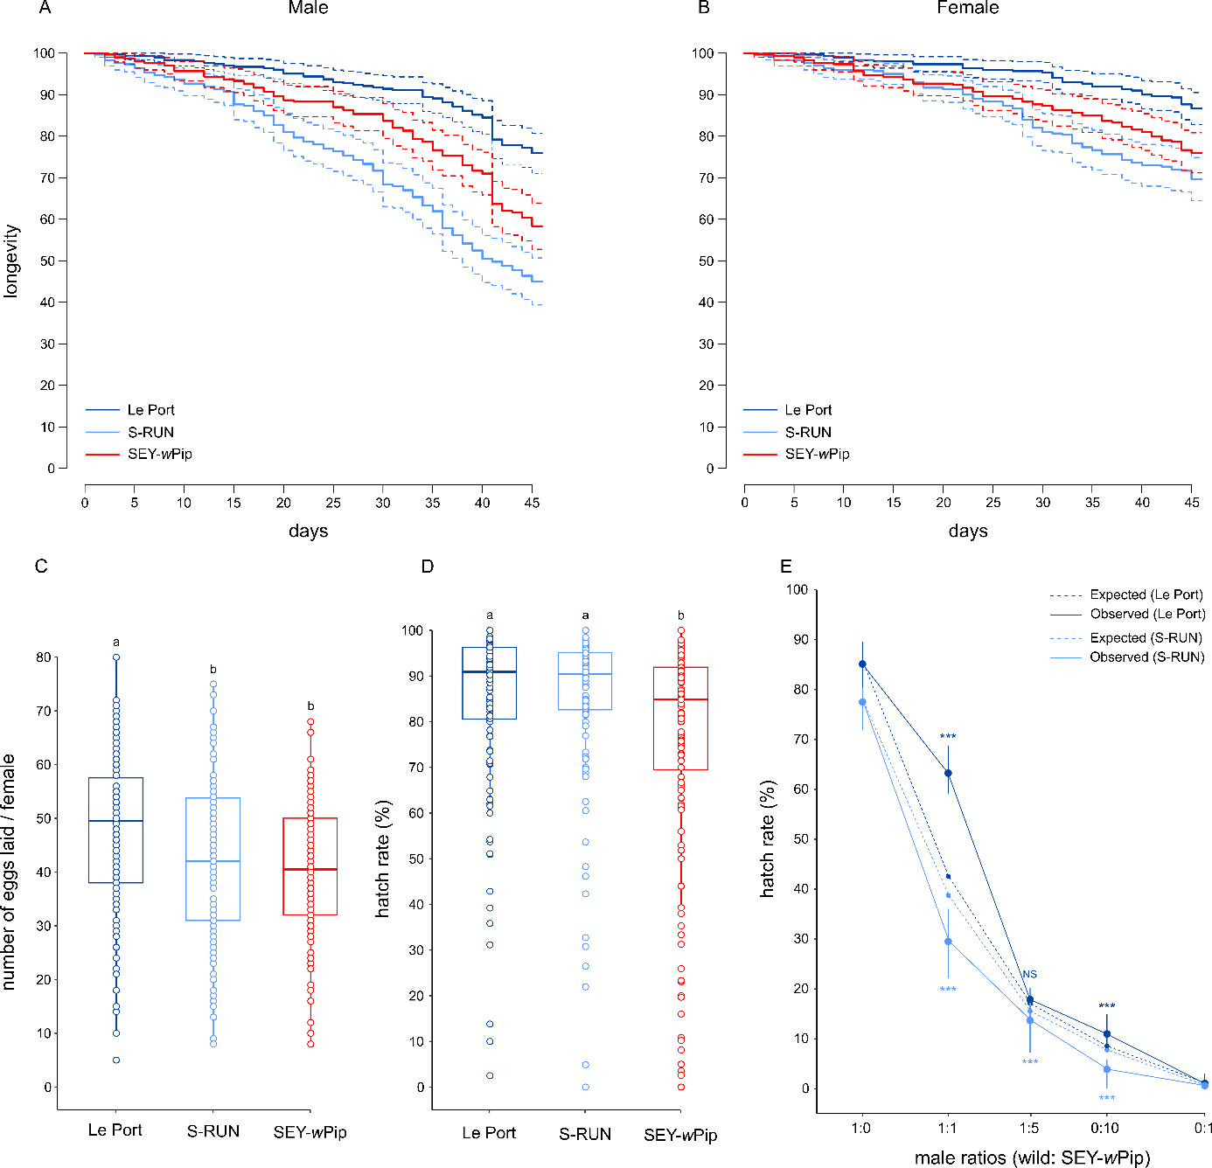

Supp. Fig 1: Life history traits and mating competitiveness of transinfected SEY-wPip line compared to the wild lines Le Port and S-RUN. A Male longevity. B Female longevity. C Number of eggs laid per female. D Eggs hatching rate (%). For panels A and B, the solid lines indicate the mean values and the dotted lines are the 95% CI. For panels C and D, horizontal bars the medians, and distinct letters significant variations between lines. For panel E, the point indicates the mean value and the vertical lines the min and max observed values.

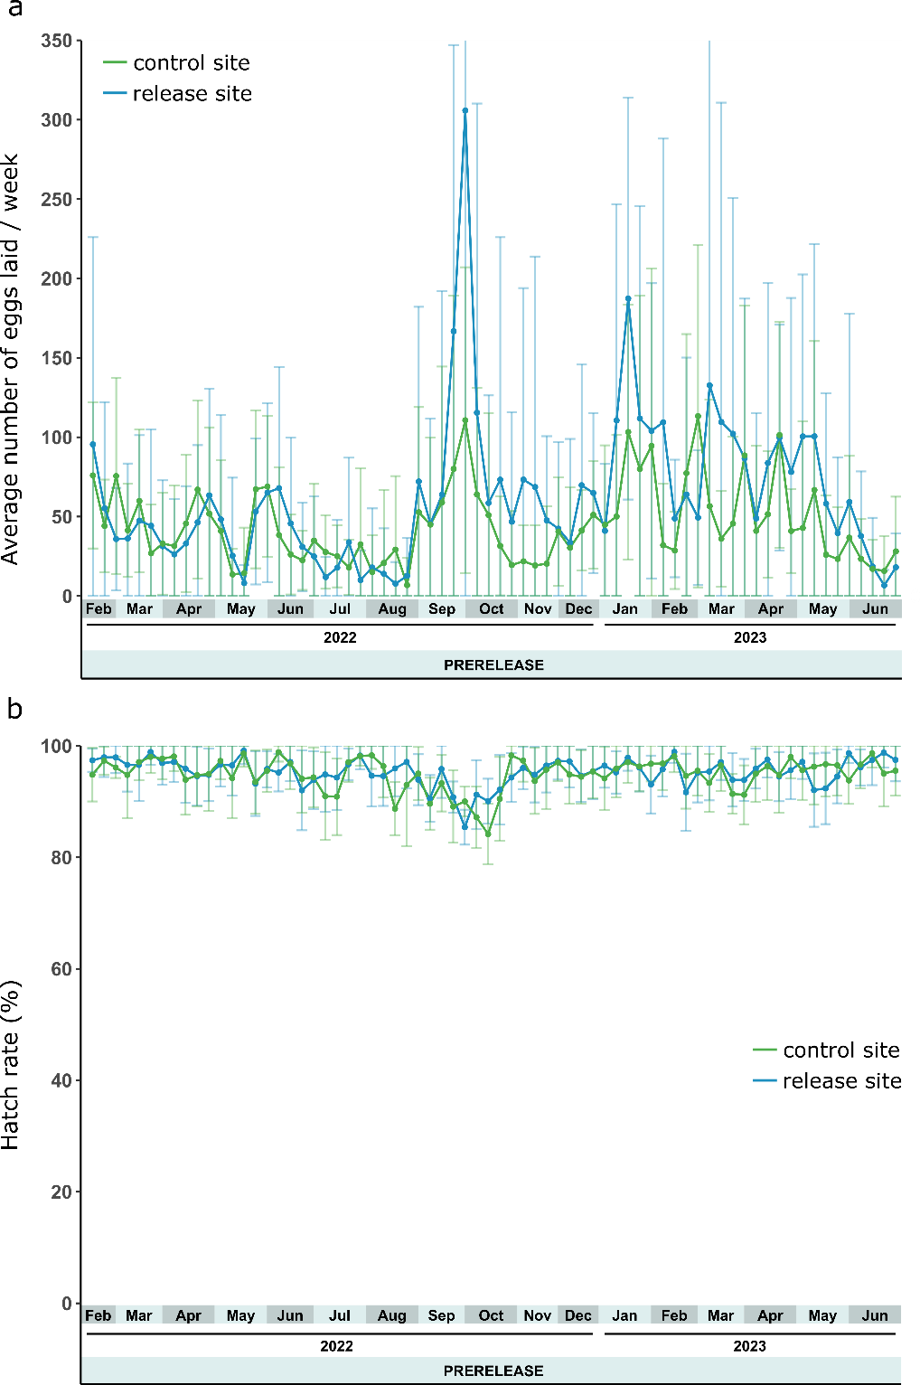

Supp. Fig 2: A The average number of hatched eggs per week during the prerelease phase in the control and release sites. B The hatch rate per week during the prerelease phase in the control and release sites.

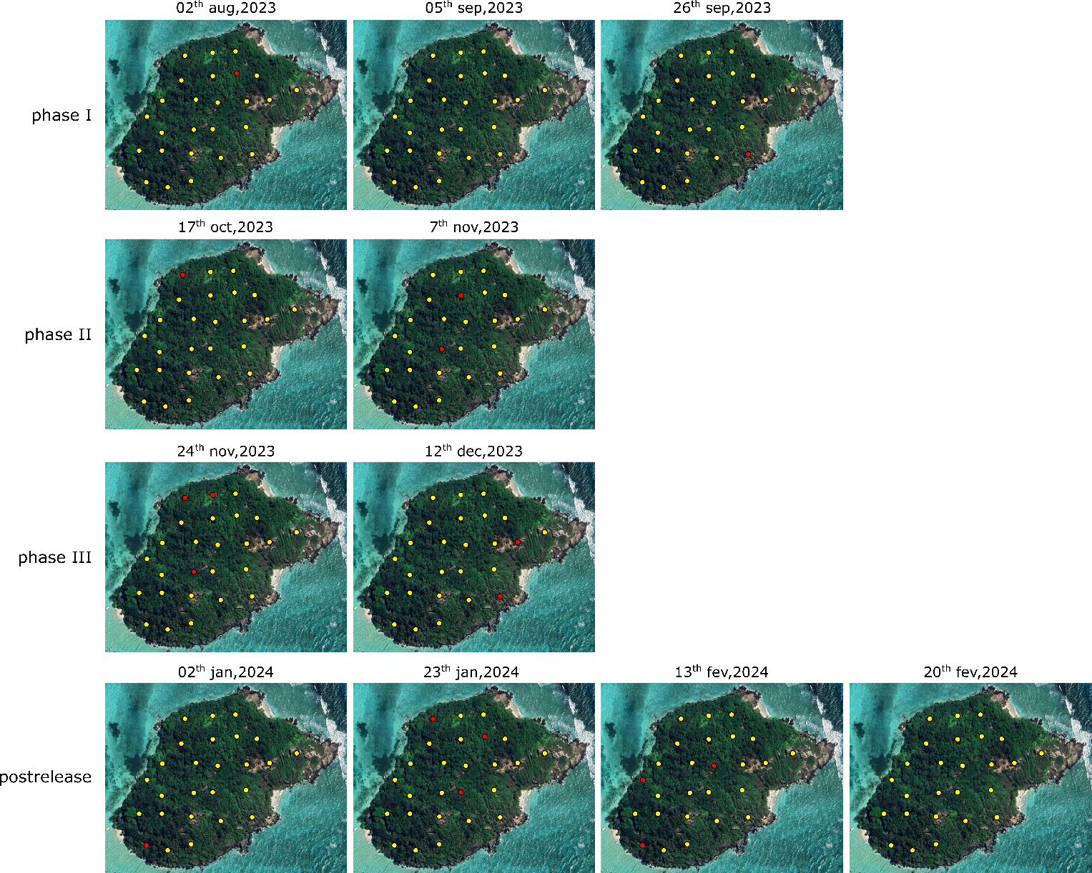

Supp. Fig 3: Spatial distribution of ovitraps in which wPip-positive individuals were detected at the release site. The red points correspond to the positive ovitraps in which at least one wPip-positive individual was detected and the yellow points correspond to the negative ovitraps.

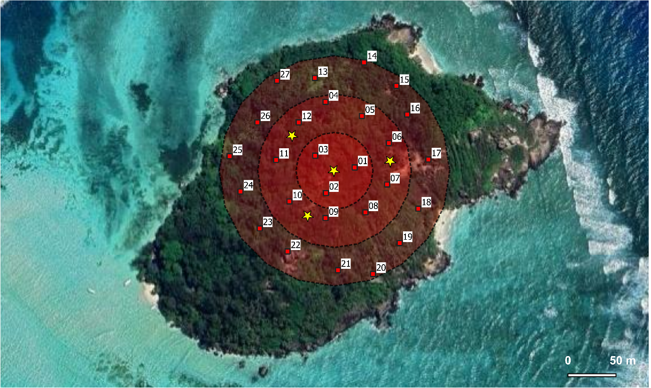

Supp. Fig 4: Position of BG traps for the Mark-Release-Recapture experiments. The red points represent the BG traps and the stars the position of release of marked males.
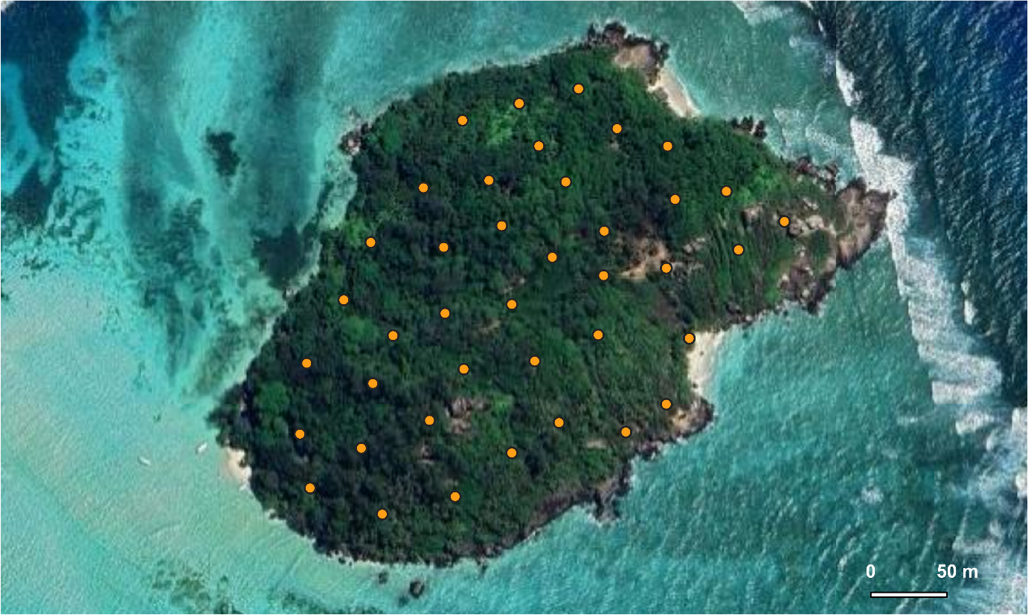

Supp. Fig 5: Localization of the forty release spots.

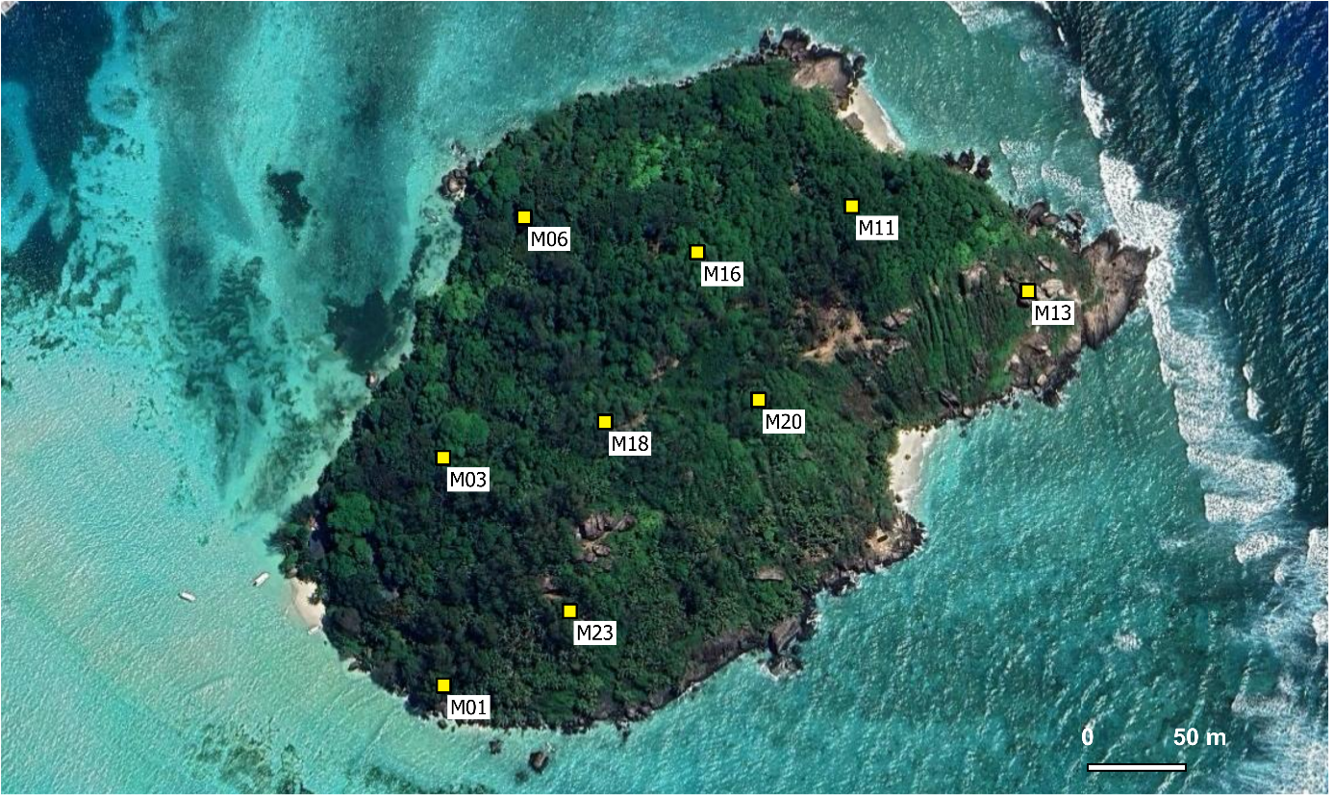

Supp. Fig 6: Position of BG traps used to estimate the incompatible male ratio in the release site.

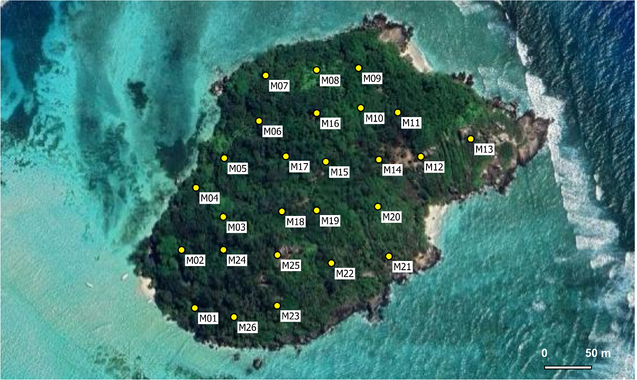
a

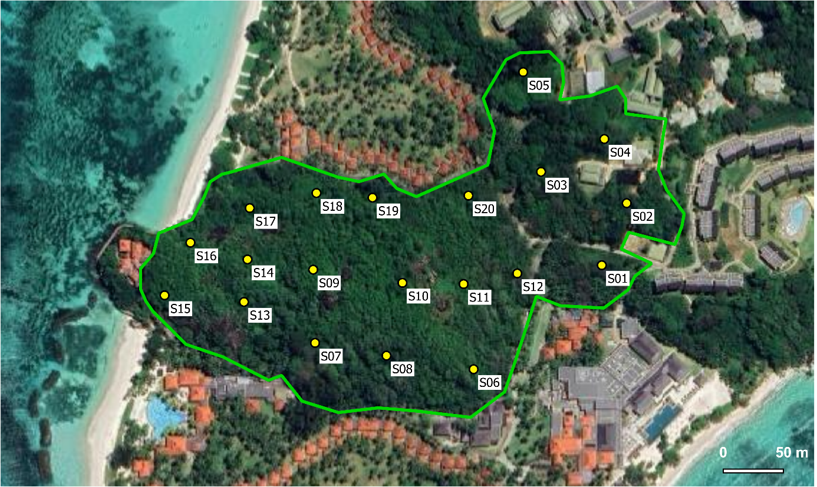
b

Supp. Fig 7: Position of ovitraps used for the monitoring of wild populations. A in the release site. B in the control site.

