Supplementary material

RAPID AND SPECIFIC NINHYDRIN-FREE CHROMOGENIC ASSAY FOR DETECTION OF METABOLICALLY ACTIVE HIPPURICASE-POSITIVE BACTERIA AND ITS VALIDATION IN RAW CHICKEN MEAT SAMPLES

Chunyan Yao¹, Alexandra Schmid¹, Greta Faccio*¹, Urs Spitz¹, Vesna Jovanović², Tamara Vasović², Tanja Ćirković Veličković^{2,3}

¹ Biosynth AG, Rietlistrasse 4, 9422 Staad, Switzerland.
² University of Belgrade- Faculty of Chemistry, Center of Excellence for Molecular Food Sciences and Department of Biochemistry, Studentski trg 16,11000 Belgrade, Serbia.
³ Serbian Academy of Sciences and Arts, Knez Mihajlova 35, Belgrade, Serbia.
*Corresponding author: Greta Faccio, PhD. Intellectual Property Manager, Biosynth AG, Rietlistrasse 4, 9422 Staad, Switzerland. E-mail: greta.faccio@biosynth.com.

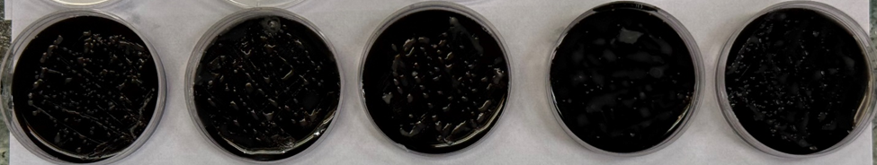
6 | 7 | 8 | 9 |  | 10
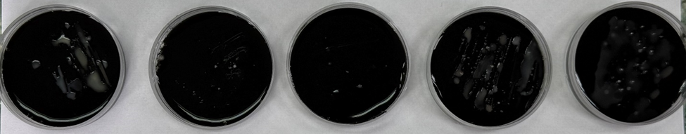
11 | 12 | 13 | 14 |  | 15
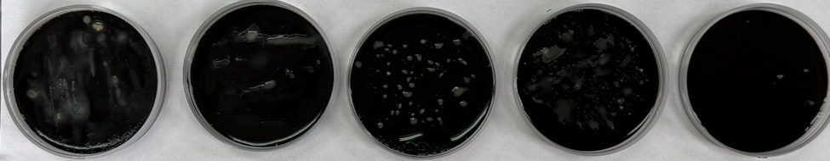
16 | 17 | 18 | 19 |  | 20
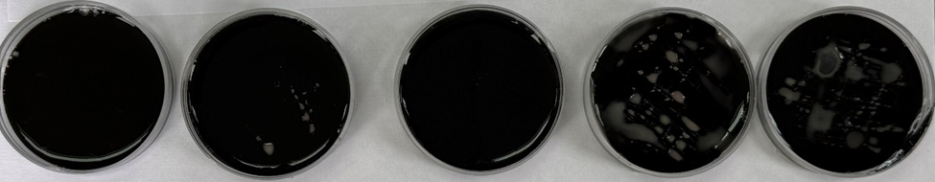
21 | 22 | 23 | 24 |  | 25
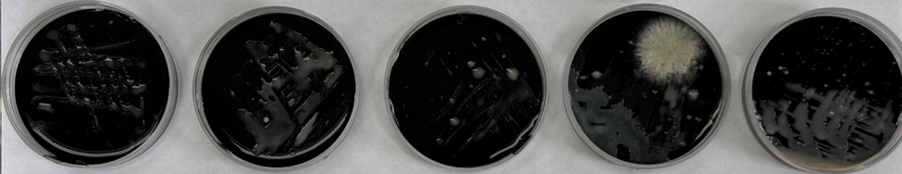
26 | 27 | 28 | 29 |  | 30
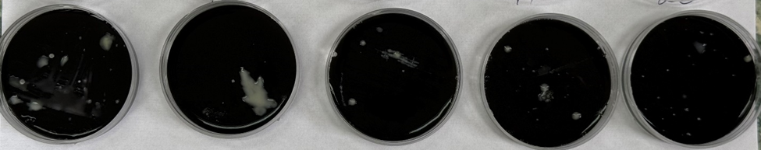
31 | 32 | 33 | 34 |  | 35
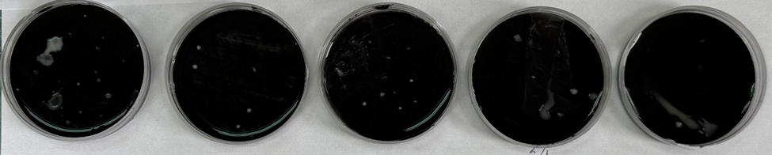
36 | 37 | 38 | 39 |  | 40
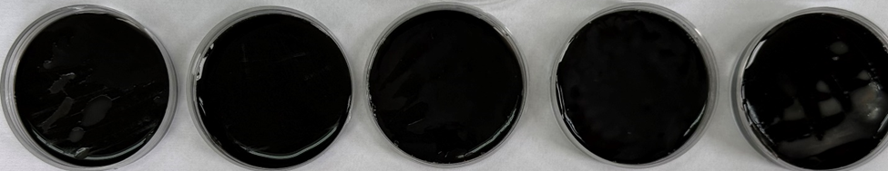
41 | 42 | 43 | 44 |  | 45
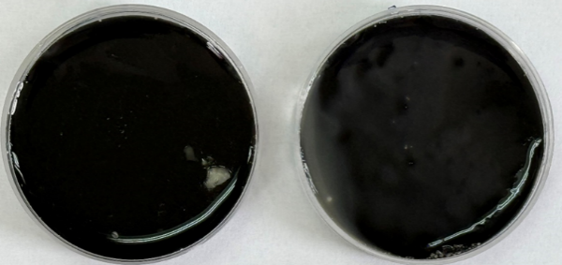 |  | 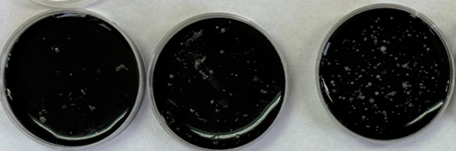
46 | 47 | 48 | 49 |  | 50
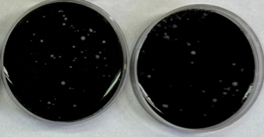 |  | 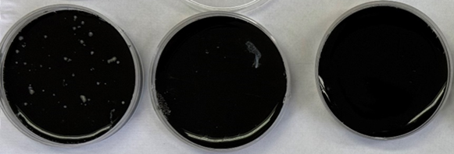
51 | 52 | 53 | 54 |  | 55
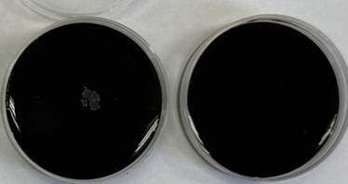 |  | 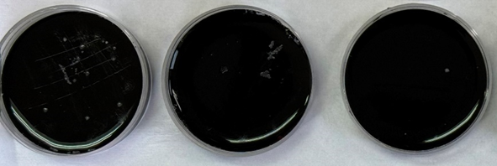
56 | 57 | 58 | 59 |  | 60
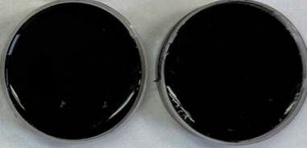 |  | 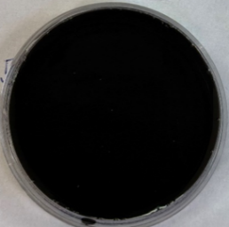 |  | 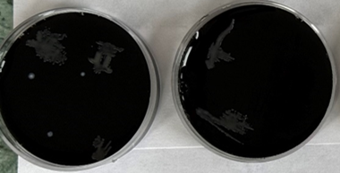
61 | 62 | 63 | 64 |  | 65
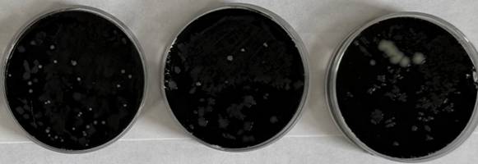 |  |  | 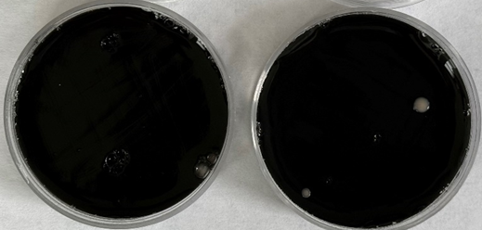

Figure 1S. Isolation of Campylobacter spp. from 65 chicken meat samples, after 48h incubation of plates with Campylobacter selective agar (mCCDA) at 37℃ under microaerophilic conditions. Samples marked with red were positive on hydrolysis of hippurate by hippuricase positive Campylobacter strains. Green marked samples have no bacterial colonies or only have a few of them.
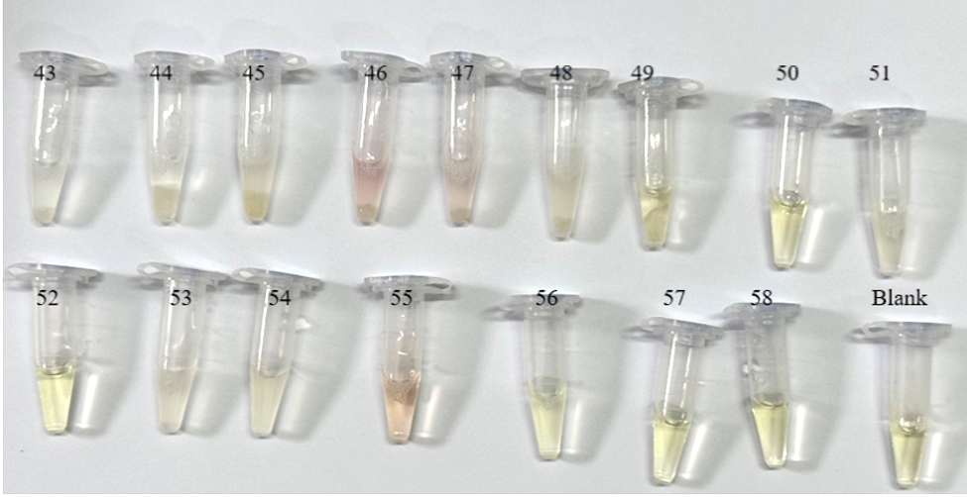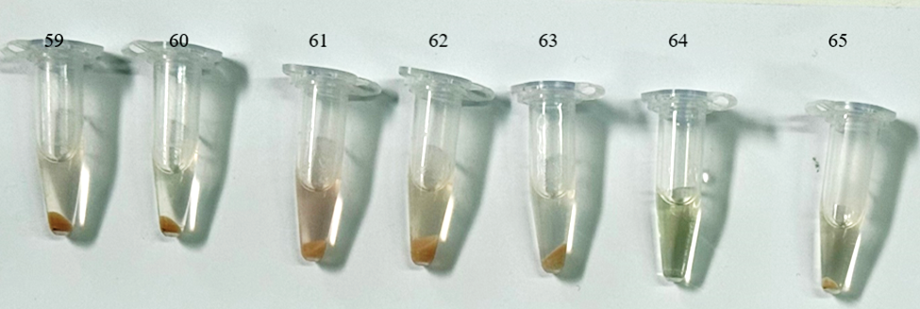
Figure 2S. Images complementing Figure 7 showcasing the colors developed during analysis of the 65 chicken meat samples using the rapid colorimetric assay.

Figure 3S - Colorations developed in the chromogenic assay using liquid culture samples of C. jejuni determined cell density, OD600 and used to visually estimate sample intensity.
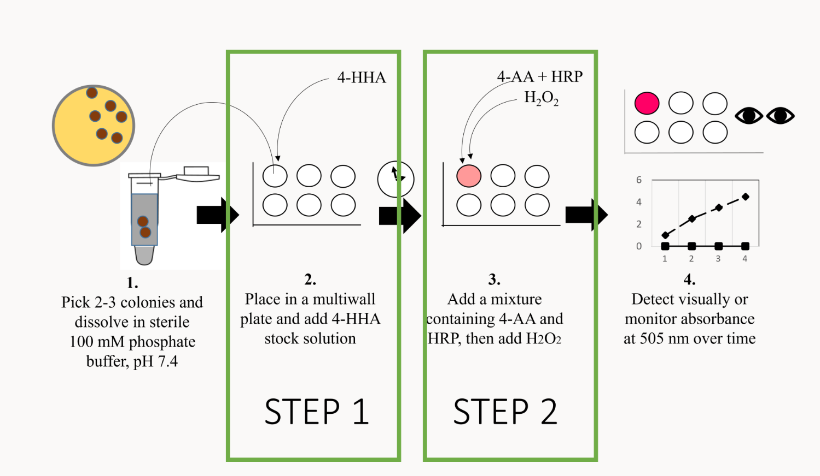
Figure 4S - Graphical representation of the two steps of the assay here presented for the detection of hippuricase-positive microorganisms. The output can be read visually or with a spectrophotometer to monitor signal development. The incubation time after addition of 4-HHA is for 1 h at 37°C.
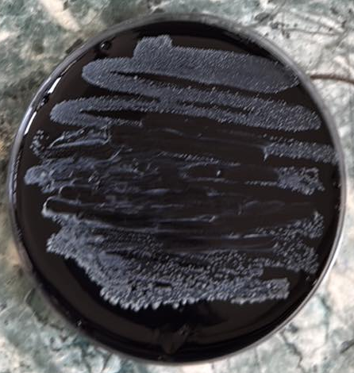
MIDDLE
START
END
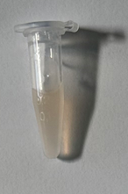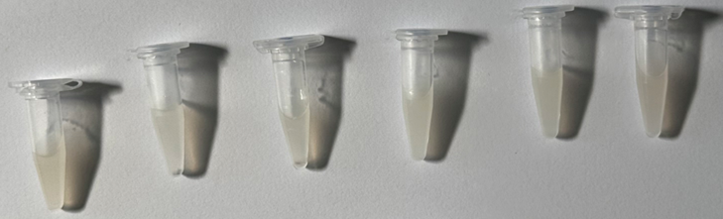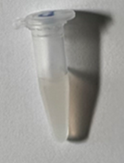
Start | Middle | End
Figure 5S – Sampling from different regions of the agar plate of sample 30 (shown at increased contrast for clarity) for the presence of C. jejuni for testing using the chromogenic biochemical assay. The photo was taken after the colonies were transferred from the different parts of plate into the test tube for assay and multiple sampling was done for the larger middle region to ensure representation.

