Supplementary Figure 1: Topography distribution of oral mucositis (grade ≤2 – NCI version 4.0)
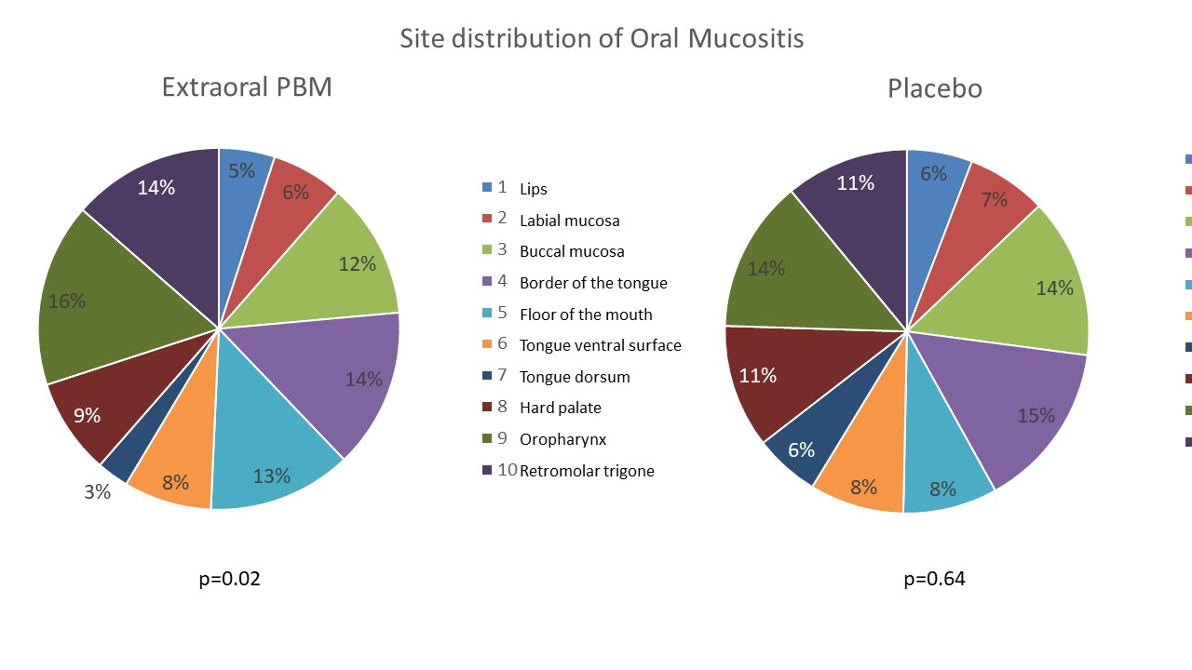
*Chi-square test for adherence - NCI- National Cancer Institute

