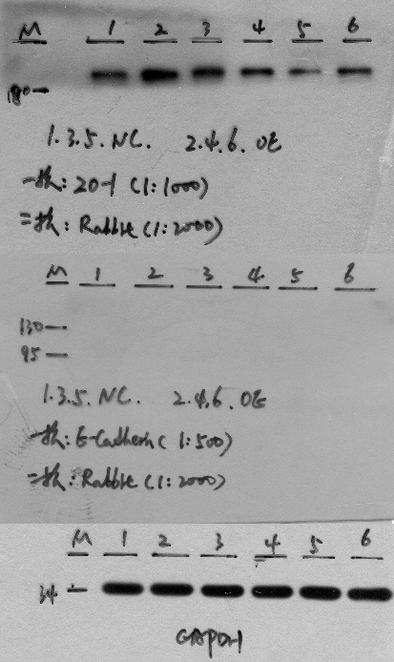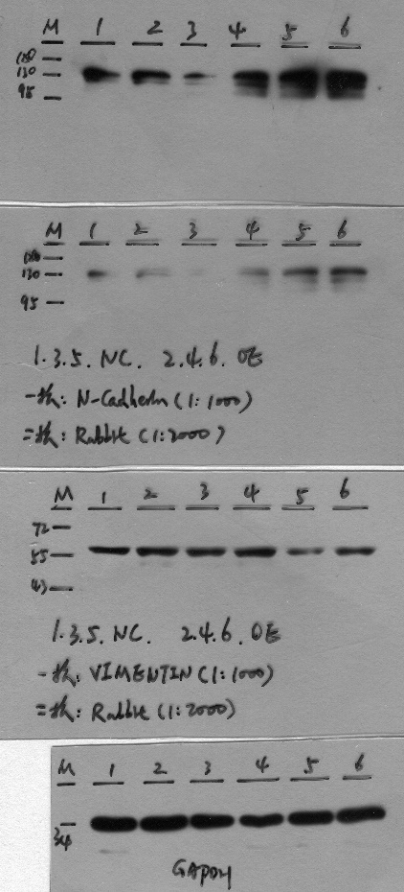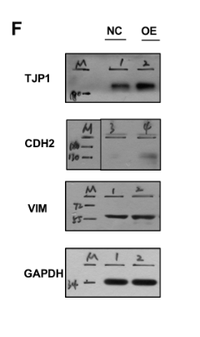
Figure Legend: Original, uncropped gels (left picture) are mached to the cropped versions in the manuscript as Figure 3F. TJP1 is the official symbol of ZO-1, we repeated the experiment three times and selected the lane 1 and lane 2 as representatives. CDH2 is the official symbol of N-cadherin, we repeated the experiment three times and selected the lane 3 and lane 4 as representatives. VIM is the official symbol of Vimentin, we repeated the experiment three times and selected the lane 1 and lane 2 as representatives.

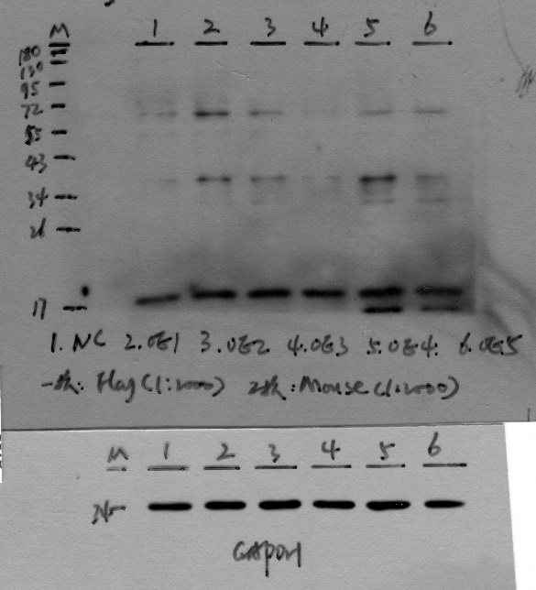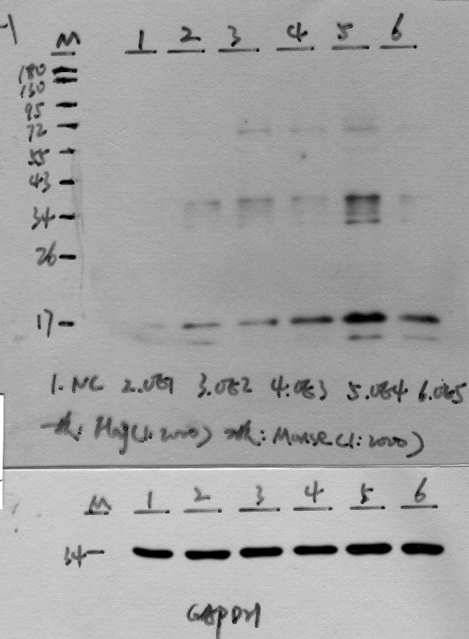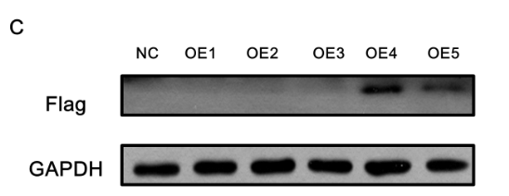
Figure Legend: Original, uncropped gels (left picture) are mached to the cropped versions in the manuscript as Figure 6C. NC: negetive control. OE1: The start codon was mutated from ATG to AAG to clarify the role of the start codon. OE2: IRES sequences (IRES1 and IRES2) in circEPS15 were truncated. OE3: IRES sequences (IRES2) in circEPS15 were truncated. OE4: IRES sequences (IRES1) in circEPS15 were truncated. OE5: A FLAG tag was divided to both sides (light and dark green). Circularization of this vector formed the same circular RNA as the endogenous circEPS15, except with a FLAG tag added behind the ORF. A FLAG tag antibody was used to detect circEPS15 expression in 293T cells transfected with the vectors described above.

