Supplementary Figure 1

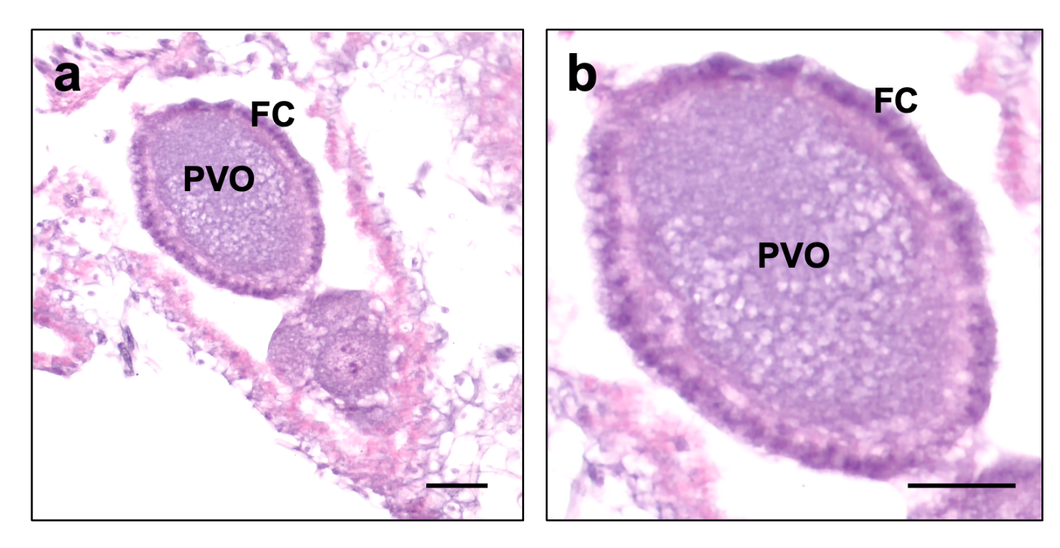

Fig. S1. Light micrograph of the previtellogenic oocyte of a Pogonomyrmex barbatus queen. No yolk granules were found. Intercellular spaces are not well delimited. (PVO) Previtellogenic oocyte, (FC) Follicular cells. Scale bars: 100µm.

