Supporting Information for
AMOC Weakening Dominates Global Warming Impacts on Precipitation Over Brazil
Isabelle Vilela ^{1*}, Paolo De Luca², Shunya Koseki³, Thiago Silva ⁴, Doris Veleda¹, Noel Keenlyside^{3*}
¹Department of Oceanography, Federal University of Pernambuco, Recife, Pernambuco, Brazil.

²Barcelona Supercomputing Center, Barcelona, Spain.

³Geophysical Institute, University of Bergen and Bjerknes Centre for Climate Research, Bergen, Norway

⁴Pernambuco Water and Climate Agency (APAC), Brazil
* Corresponding author: I. Vilela (Email: isabelle.vilelaoliveira@ufpe.br)
* Corresponding author: N. Keenlyside (Email: Noel.Keenlyside@uib.no)

Contents of this file
Text S1 calculation of the skill metrics.
Figures S1-S4.
Table S1-S2.

Introduction
his file provides supplementary table, figures and explanation for the additional information used in the main manuscript. These include a comprehensive explanation of the skill measures employed, along with additional figures and a table that describes all the models and simulations.

Text S1
We analyzed the annual total precipitation from extreme wet days PRCP when RR > 99th percentile (R99p) by definitions:
Annual total PRCP when RR > 99th percentile:
Let RR_{wj} be the daily precipitation amount on a wet day w (RR ≥ 1.0mm) in period i and let RR_{wn}99 be the 99th percentile of precipitation on wet days in the 1981-2010 period. If W represents the number of wet days in the period, then:
$$R99p=\sum_{w=1}^{w}{RRwj where RRwj >RRwn99}$$
We measure the association between CMIP6 ensemble variable changes using Spearman rank correlation. We avoid distributional assumptions with Spearman rank correlation. Definition of Spearman correlation coefficient:
$$r=\frac{6\sum_{i=1}^{n}{d_{i}^{2}}}{n(n^{2}-1)}$$
where i corresponds to each model (from 1 to n), and di is the difference between the ranks of x_{i} and o_{i} (variable x and y, respectively, for time step i).
Figure S1
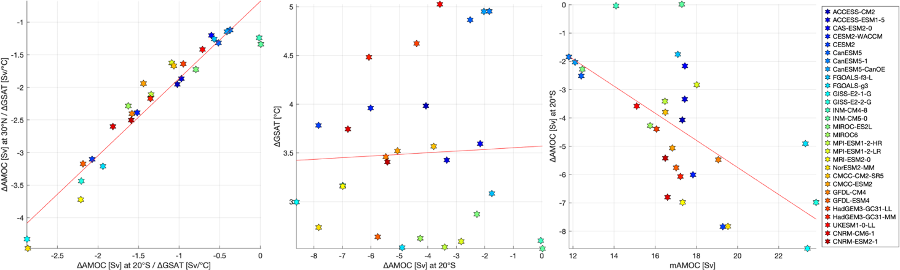
Figure S1. Scatter plots between a) ΔAMOC* at 20°S (Sv/°C) and ΔAMOC* at 30°N (Sv/°C) , b) ΔGSAT (°C) against ΔAMOC at 20°S (Sv) and c) ΔAMOC* and ΔPR*, the orange lines are the linear regressions: a (y = 1.18 x - 0.68 with R²: 0.92 ) , b (Y= 0.01x + 3.56 with R²:0), and c (Y = -0.47x -3.82 with R²:0.4). Asterisk indicates that all the variables are divided by ΔGSAT (°C) from each respective CMIP6 model (*).

Figure S2
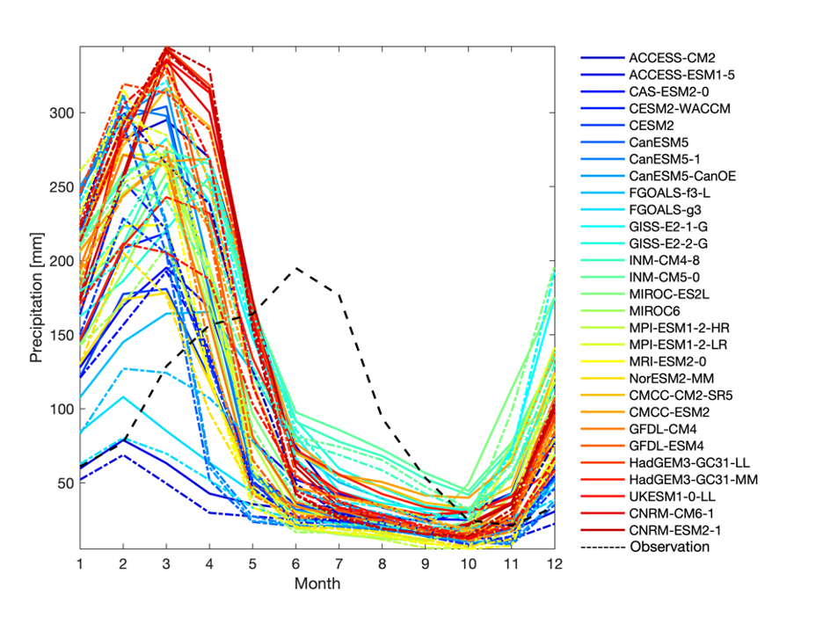
Figure S2. Climatology from monthly precipitation data of 29 CMIP6 models over ENEB. Filled lines represent the historical (1950-2000) period and dotted lines represent the SSP-585 scenario (2050-2100). The black dash line is the climatology from observation data of the Drought Monitor project from National Water Agency, and the period is 1959 to 2021.

Figure S3
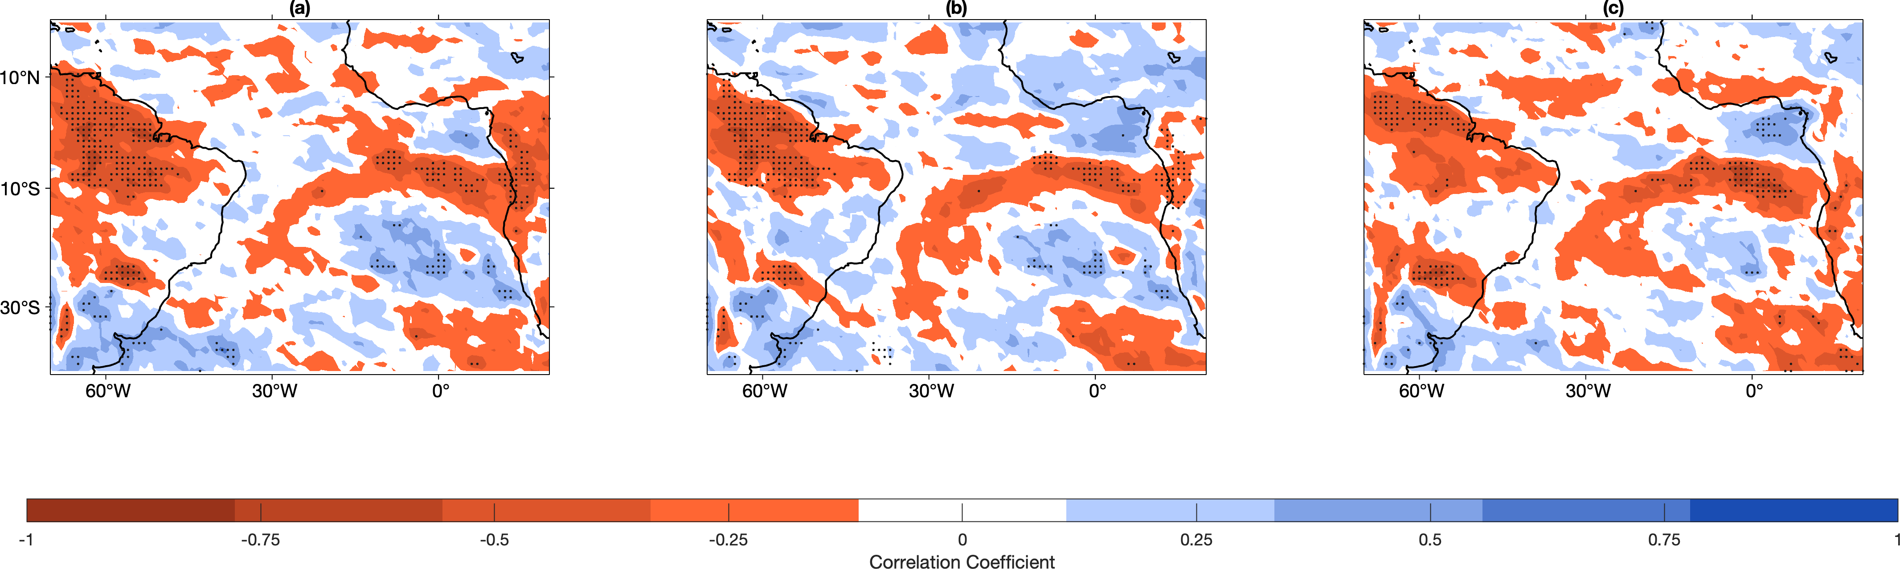
Figure S3. Correlation map between ΔAMOC at 20°S changes and a) ΔRx1day, b) ΔRx5day and c) ΔR99p. All the variables are divided by ΔGSAT from each respective CMIP6 model. Stipplings indicate grid cells where the skill measures are statistically significant (p ≤ 0.05).

Table S1
Table S1. Overview of all models and ensemble members used in this study for all the variables.
Institution | Models | Reference | AMOC, SST, PR, LHF Members | Rx5day, Rx1day, R99p, R95p  Members | DOI
CSIRO-ARCCSS | ACCESS-CM2 | Bi et al. (2020) | r1i1p1f1 | r1i1p1f1 | https://doi.org/10.1071/ES19040
CSIRO | ACCESS-ESM1-5 | Ziehn et al. (2020) | r1i1p1f1 | r1i1p1f1 | https://doi.org/10.1071/ES19035
CCCma | CanESM5-CanOE | Christian et al. (2022) | r1i1p2f1 | - | https://doi.org/10.5194/gmd-15-4393-2022
CCCma | CanESM5 | Swart et al. (2019) | r1i1p1f1 | r1i1p1f1 | https://doi.org/10.5194/gmd-12-4823-2019
CCCma | CanESM5-1 | Swart et al. (2019) | r1i1p1f1 | r1i1p1f1 | https://doi.org/10.5194/gmd-12-4823-2019
CAS | CAS-ESM2-0 | Guangqing et al. (2020) | r1i1p1f1 | - | https://doi.org/10.11871/jfdc.issn.2096-742X.2020.01.004
NCAR | CESM2 | Danabasoglu et al. (2020) | r4i1p1f1 | r4i1p1f1 | https://doi.org/10.1029/2019MS001916
NCAR | CESM2-WACCM | Gettelman et al. (2019) | r1i1p1f1 | r1i1p1f1 | https://doi.org/10.1029/2019JD030943
CMCC | CMCC-CM2-SR5 | Cherchi et al. (2019) | r1i1p1f1 | r1i1p1f1 | https://doi.org/10.1029/2018MS001369
CMCC | CMCC-ESM2 | Lovato et al. (2022) | r1i1p1f1 | r1i1p1f1 | https://doi.org/10.1029/2021MS002814
CNRM-CERFACS | CNRM-CM6-1 | Voldoire et al. (2019) | r1i1p1f2 | r1i1p1f2 | https://doi.org/10.1029/2019MS001683
CNRM-CERFACS | CNRM-ESM2-1 | Séférian et al. (2019) | r1i1p1f2 | r1i1p1f2 | https://doi.org/10.1029/2019MS001791
CAS | FGOALS-f3-L | He et al. (2020) | r1i1p1f1 | - | https://doi.org/10.1080/16742834.2020.1778419
CAS | FGOALS-g3 | Pu et al. (2020) | r1i1p1f1 | r1i1p1f1 | https://doi.org/10.1007/s00376-020-2032-0
NASA-GISS | GISS-E2-1-G | Kelley et al. (2020) | r1i1p1f2 | - | https://doi.org/10.1029/2019MS002025
NASA-GISS | GISS-E2-2-G | NASA/GISS (2019) | r1i1p3f2 | - | https://doi.org/10.22033/ESGF/CMIP6.6952
NOAA-GFDL | GFDL-CM4 | Ploshay et al. (2018) | r1i1p1f1 | r1i1p1f1 | https://doi.org/10.22033/ESGF/CMIP6.11330
NOAA-GFDL | GFDL-ESM2 | Krasting et al. (2018) | r1i1p1f1 | r1i1p1f1 | https://doi.org/10.22033/ESGF/CMIP6.8597
MOHC | HadGEM3-GC31-LL | Andrews et al. (2020) | r1i1p1f3 | r1i1p1f3 | https://doi.org/10.1029/2019MS001995
MOHC | HadGEM3-GC31-MM | Andrews et al. (2020) | r1i1p1f3 | - | https://doi.org/10.1029/2019MS001995
INM | INM-CM4-8 | Volodin et al. (2019) | r1i1p1f1 | r1i1p1f1 | https://doi.org/10.22033/ESGF/CMIP6.5069
INM | INM-CM5-0 | Volodin et al. (2019) | r1i1p1f1 | r1i1p1f1 | http://doi.org/10.22033/ESGF/CMIP6.5070
MIROC | MIROC6 | Tatebe et al. (2019) | r1i1p1f1 | r1i1p1f1 | https://doi.org/10.5194/gmd-12-2727-2019
MIROC | MIROC-ES2L | Hajima et al. (2020) | r1i1p1f2 | r1i1p1f2 | https://doi.org/10.5194/gmd-13-2197-2020
MPI-M | MPI-ESM1-2-HR | Jungclaus et al. (2019) | r1i1p1f1 | r1i1p1f1 | https://doi.org/10.22033/ESGF/CMIP6.6594
MPI-M | MPI-ESM1-2-LR | Mauritsen et al. (2019) | r1i1p1f1 | r1i1p1f1 | https://doi.org/10.1029/2018MS001400
MRI | MRI-ESM2-0 | Yukimoto et al. (2019) | r1i1p1f1 | r1i1p1f1 | https://doi.org/10.2151/jmsj.2019-051
NCC | NorESM2-MM | Seland et al. (2020) | r1i1p1f1 | r1i1p1f1 | https://doi.org/10.5194/gmd-13-6165-2020
NIMS-KMA | UKESM1-0-LL | Sellar et al. (2019) | r1i1p1f2 | r1i1p1f2 | https://doi.org/10.1029/2019MS001946
Table S2
Table S2. Models and measurement of AMOC index change.
Model | ΔAMOC [Sv] at 20°S | AMOC [Sv] mean strength (hist 50y at 20°S ) | ΔAMOC  [ % ] at 20°S | ΔAMOC [Sv] at 30°N | AMOC [Sv] mean strength (hist 50y at 30°N ) | ΔAMOC  [ % ] at 30°N | ΔGSAT [°C]
ACCESS-CM2 | -4 | 17 | -24 | -7 | 20 | -37 | 3,98
ACCESS-ESM1-5 | -3 | 17 | -19 | -6 | 20 | -30 | 3,43
CAS-ESM2-0 | -2 | 17 | -12 | -4 | 19 | -22 | 3,59
CESM2-WACCM | -6 | 17 | -34 | -9 | 19 | -48 | 3,96
CESM2 | -7 | 19 | -41 | -11 | 21 | -55 | 3,78
CanESM5 | -2 | 12 | -20 | -6 | 14 | -43 | 4,87
CanESM5-1 | -1 | 11 | -16 | -5 | 14 | -38 | 4,95
CanESM5-CanOE | -2 | 12 | -17 | -5 | 14 | -40 | 4,95
FGOALS-f3-L | -1 | 17 | -10 | -3 | 21 | -18 | 3,08
FGOALS-g3 | -4 | 23 | -21 | -8 | 29 | -27 | 2,53
GISS-E2-1-G | -8 | 23 | -37 | -12 | 25 | -50 | 2,99
GISS-E2-2-G | -6 | 23 | -29 | -10 | 26 | -41 | 3,17
INM-CM4-8 | 0 | 14 | 0 | -3 | 16 | -19 | 2,60
INM-CM5-0 | 0 | 17 | 0 | -3 | 18 | -18 | 2,52
MIROC-ES2L | -2 | 12 | -18 | -4 | 12 | -38 | 2,87
MIROC6 | -4 | 15 | -27 | -5 | 14 | -40 | 2,62
MPI-ESM1-2-HR | -3 | 16 | -21 | -5 | 18 | -29 | 2,53
MPI-ESM1-2-LR | -2 | 18 | -16 | -4 | 19 | -21 | 2,59
MRI-ESM2-0 | -6 | 17 | -40 | -11 | 19 | -60 | 3,16
NorESM2-MM | -7 | 19 | -40 | -12 | 23 | -52 | 2,73
CMCC-CM2-SR5 | -3 | 16 | -23 | -5 | 19 | -30 | 3,57
CMCC-ESM2 | -5 | 16 | -30 | -6 | 19 | -34 | 3,52
GFDL-CM4 | -5 | 19 | -29 | -8 | 20 | -41 | 3,46
GFDL-ESM4 | -5 | 17 | -34 | -8 | 21 | -38 | 2,64
HadGEM3-GC31-LL | -4 | 16 | -27 | -7 | 19 | -39 | 4,62
HadGEM3-GC31-MM | -6 | 17 | -35 | -9 | 17 | -56 | 4,48
UKESM1-0-LL | -3 | 15 | -24 | -7 | 18 | -39 | 5,02
CNRM-CM6-1 | -6 | 16 | -41 | -9 | 18 | -53 | 3,74
CNRM-ESM2-1 | -5 | 16 | -33 | -8 | 18 | -46 | 3,41
MME | -4 | 17 | -25 | -7 | 19 | -38 | 3,50

Table S3
Table S3. Models and CLIMPACT indices for ENEB, historical, changes and percentage of change (the H is historical, and the change is in mm).
Models | r95p_H | Δr95p | r95p_% | r99p_H | Δr99p | r99p_% | rx1  day_H | Δrx1  day | rx1  day_% | rx5  day_H | Δrx5  day | rx5day_%
ACCESS-CM2 | 376 | 114 | 30 | 113 | 116 | 103 | 70 | 20 | 29 | 167 | 33 | 20
ACCESS-ESM1-5 | 96 | -41 | -43 | 36 | -18 | -51 | 24 | -4 | -17 | 59 | -11 | -19
CESM2-WACCM | 234 | 97 | 42 | 70 | 79 | 112 | 44 | 13 | 29 | 119 | 29 | 24
CESM2 | 221 | 92 | 42 | 73 | 81 | 111 | 43 | 17 | 41 | 113 | 41 | 36
CanESM5 | 369 | -26 | -7 | 137 | 28 | 20 | 88 | 9 | 10 | 190 | -5 | -3
FGOALS-g3 | 170 | -82 | -48 | 64 | -34 | -53 | 45 | -11 | -24 | 80 | -20 | -25
INM-CM4-8 | 288 | 36 | 12 | 107 | -7 | -6 | 45 | 4 | 9 | 123 | -1 | -1
INM-CM5-0 | 445 | ### | -26 | 195 | -80 | -41 | 75 | -12 | -16 | 175 | -34 | -20
MIROC-ES2L | 281 | 56 | 20 | 81 | 28 | 35 | 37 | 3 | 8 | 121 | 8 | 7
MIROC6 | 247 | -20 | -8 | 73 | 16 | 22 | 53 | 5 | 10 | 140 | 2 | 1
MPI-ESM1-2-HR | 223 | 62 | 28 | 62 | 30 | 49 | 40 | 1 | 3 | 122 | 7 | 6
MPI-ESM1-2-LR | 237 | 89 | 37 | 61 | 26 | 42 | 37 | 1 | 2 | 125 | 3 | 2
MRI-ESM2-0 | 222 | 167 | 75 | 64 | 106 | 166 | 44 | 17 | 37 | 121 | 42 | 35
NorESM2-MM | 201 | 47 | 23 | 66 | 41 | 62 | 43 | 5 | 11 | 117 | 10 | 9
CMCC-CM2-SR5 | 362 | 33 | 9 | 117 | 58 | 49 | 52 | 16 | 31 | 130 | 23 | 18
CMCC-ESM2 | 313 | 25 | 8 | 91 | 50 | 55 | 46 | 12 | 26 | 115 | 18 | 16
GFDL-CM4 | 328 | 41 | 12 | 110 | 50 | 46 | 71 | 10 | 15 | 155 | 13 | 8
GFDL-ESM4 | 467 | 3 | 1 | 172 | 22 | 13 | 93 | 5 | 6 | 193 | 5 | 3
HadGEM3-GC31-LL | 395 | 165 | 42 | 120 | 132 | 110 | 73 | 22 | 30 | 173 | 33 | 19
UKESM1-0-LL | 373 | 151 | 41 | 113 | 141 | 125 | 69 | 26 | 37 | 164 | 43 | 26
CNRM-CM6-1 | 324 | 47 | 15 | 91 | 17 | 19 | 59 | 2 | 3 | 153 | 1 | 1
CNRM-ESM2-1 | 316 | 72 | 23 | 88 | 29 | 32 | 59 | 4 | 7 | 155 | 3 | 2

