Supplemental Figure 1: Directed Acyclic Graph (DAG) of persistent poverty, late-stage breast cancer, and included covariates.
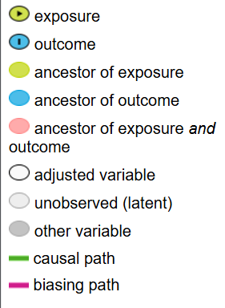
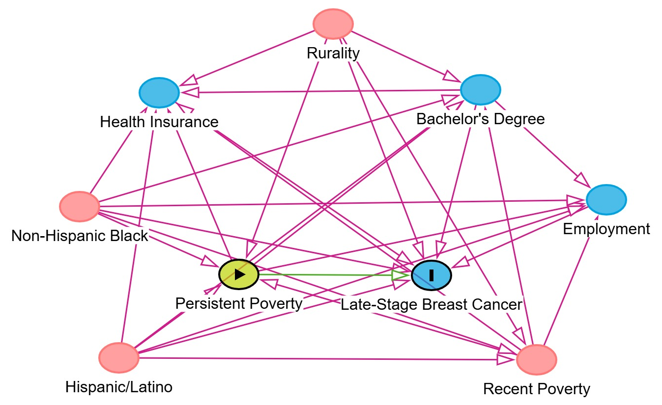

Supplemental Table 1: Mean late-stage BC incidence rates (per 100,000 person-years) from 2017-2021 (excluding 2020) within U.S. South Census Region counties (N = 592).
 | All Counties |  | Persistent Poverty |  | Non-Persistent Poverty
 | N | Mean Late-Stage Diagnosis Rate (SD) | n | Mean Late-Stage Diagnosis Rate (SD) | n | Mean Late-Stage Diagnosis Rate (SD) | p-value_{int}ª
Overall | 592 | 55.82 (21.6) | 138 | 59.72 (23.0) | 454 | 54.63 (20.7) | 0.03
Rural/Urban Status
Rural | 366 | 55.01 (24.3) | 116 | 59.09 (24.3) | 250 | 53.11 (24.0) | 0.03
Urban | 226 | 57.13 (16.4) | 22 | 63.10 (22.3) | 204 | 56.49 (15.6) | 0.19
Non-Hispanic Black
> 5% | 335 | 57.75 (19.3) | 81 | 61.74 (25.2) | 254 | 56.48 (16.9) | 0.03
< 5% | 257 | 53.30 (24.1) | 57 | 56.89 (22.1) | 200 | 52.28 (24.6) | 0.08
ª Multivariable model adjusted for recent poverty, rural-urban continuum code, % without health insurance, % unemployed, % Non-Hispanic Black, % Hispanic or Latino, and % with a bachelor’s degree or higher.
^{b} p-value for interaction based on multivariable model.

