Appendix

COVID-19 related restrictions in Québec
Table A1: Actions implemented in Québec from 2020–2022 to mitigate the impact of the COVID-19 pandemic (40)
Date  (month-year) | Event(s)
03-20 | Declaration of the sanitary crisis. Social distancing (1 meter). School closure (distance learning not offered by the majority of schools). First lockdown. Social distancing (2 meters).
05-20 | End of first lockdown.
07-20 | End of progressive deconfinement. Mandatory mask in public transport. Mandatory mask in closed public places.
08-20 | End of summer break - School reopening with mask mandatory for movement within the school. Social restrictions by region using a color code (green, yellow, orange, red).
10-20 | Partial lockdown by region.
12-20 | Closure of nonpriority businesses; most regions in lockdown.
01-21 | Second lockdown and curfew. Distance learning. High schools reopening with mask mandatory at all times. Partial closure of classrooms and schools. Every other day at school for secondary school students in years 3, 4, and 5 in orange zone.
02-21 | End of second lockdown.
03-21 | Vaccination initiated in the general population (by age groups). Secondary 3, 4 and 5 students return to class full-time.
04-21 | Special emergency measures in certain regions. Partial lockdown with online learning.  One-quarter of the population vaccinated.
05-21 | Half the population vaccinated. End of special emergency measures in certain regions. Flexible conditions begin across Québec.
07-21 | Social distancing (1 meter).
08-21 | Wearing a face covering no longer mandatory in outdoor public places. Back to school: return to class in-person with a mandatory intervention mask.
09-21 | Implementation of vaccination passport. 75% of entire Québec population adequately vaccinated.
12-21 | Rapid tests gradually distributed to the general population. No private gatherings allowed.  Curfew from 10 p.m. to 5 a.m. Back to school in-person postponed to January 17.
01-22 | End of curfew. Rapid screening tests available to students in all Québec high schools.  Indoor sports or leisure activities allowed for those under 18, limited to 25 people, for training only, and with mask.
02-22 | Booster dose available for 12- to 17-year-olds, at least three months after the last dose.
03-22 | Mask no longer required for students when sitting in class. Lifting of most sanitary measures.
05-22 | Mask no longer mandatory in several closed or partially closed public places. Still mandatory in public transport and health facilities.
06-22 | Lifting of mask requirement on public transport.

Interpretations of the FGT indices
Figure A1 illustrates the FGT-like indices. Suppose we are interested in the (hypothetical) responses of a population to a questionnaire on the presence of depressive symptoms (CESD-R-10). First, we order the respondents according to their mental health, starting with those who have the most significant depressive symptoms and ending with those who have the least significant depressive symptoms. In other words, respondents are ranked in ascending order on the basis of their reverse CESD-R-10 score, which ranges from 0–30. Second, the series is divided into 100 groups (percentiles), each containing an equivalent number of individuals. Thus, ten percent of respondents have a positive mental health score (reverse score) below the 10th percentile, 50% fall below the median, and so on.
Figure A1. Graphical representation of the prevalence, average gap and average inequality gap: Illustration of the use of the self-assessment score for depressive symptoms
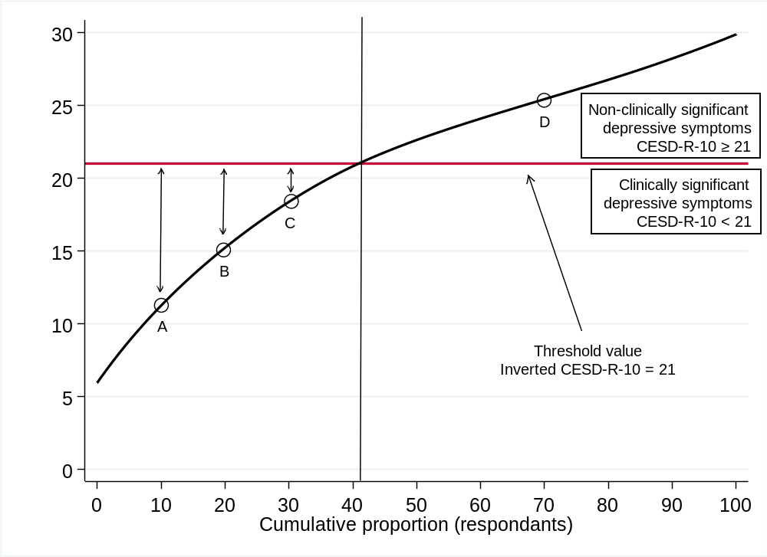
The curved black line represents the average score for each percentile of the population. Approximately 10% of the population has a positive mental health score below 11, half of the respondents have a score above 22, and the score exceeds 25 out of 30 in the last three deciles. All young people with an inverted score below 21 exhibit significant depressive symptoms (a CESD-R-10 score of 10 or higher indicated the presence of significant depressive symptoms). The red horizontal line, referred to as the health poverty line, separates the segment of the distribution including adolescents reporting significant depressive symptoms (curve below the health poverty line) from the segment including those without significant depressive symptoms. Respondents A, B, and C belong to the first group, whereas D belongs to the second.
Prevalence: The prevalence of significant depressive symptoms corresponds to the x-axis value at the intersection of the health poverty line and the curve representing the average score for each percentile. In this situation, the prevalence was 41%.
Average gap: Adolescents reporting significant depressive symptoms fall between the first and 41rd percentiles. As shown, the level of depressive symptoms among adolescents under the health poverty line varies significantly. The average score for individuals in group A is approximately 11, which is 10 points below the threshold value (-48%). The average score for respondents in group C is 17, which is 4 points below the threshold (-19%). The further the average score of adolescents reporting significant depressive symptoms is from the threshold, the more concerning their condition is, and vice versa. In other words, the larger the area between the Y axis and the prevalence line in Figure A1 is, the more severe the overall condition of the subsample of adolescents reporting significant depressive symptoms. An increase in this area from one year to the next signals a worsening of the average condition of adolescents reporting depressive symptoms.
Average inequality gap: This measure is similar to the average gap but assigns greater weight to adolescents who are further from the threshold value by squaring their deviation. A, B, and C represent three groups of adolescents from the same sample. Group A has a greater weight than B does, and B has a greater weight than C does. The average inequality score for individuals in Group A is approximately 10, which is 10 points below the threshold value (–(48%)²=−23%). The average score for respondents in group C is 17, which is 3 points below the threshold (–(19%)²=−4%).
These indices can be algebraically expressed as follows:
Prevalence = $\frac{H}{N}$ Average gap = $\sum_{i=1}^{H}{\frac{z-y_{i}}{z}}$ Average inequality gap =$\sum_{i=1}^{H}{{\left(\frac{z-y_{i}}{z}\right)}^{2}}$
where:
- N represents the total number of adolescents.
- H represents the number of adolescents reporting significant depressive symptoms.
- z represents the poverty line/threshold value (21)
- y represents the CESD-R-10 score of each adolescent reporting significant depressive symptoms
Figure A2. Distribution of reverse CESD-R-10 scores in 2018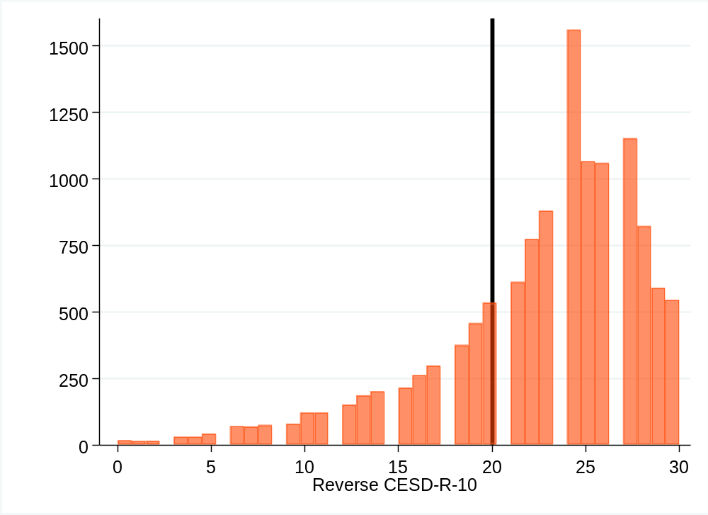
The black line represents the threshold value. Participants at or below this score are considered to have reported depressive symptoms.

Figure A3. Distribution of reverse GAD-7 scores in 2018
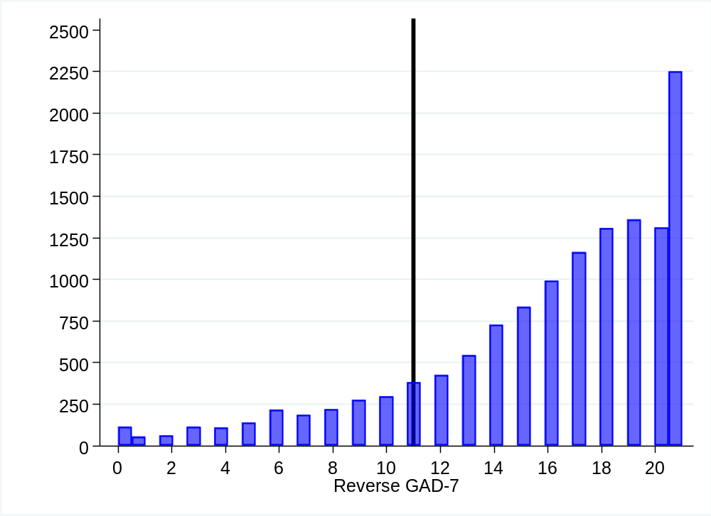
The black line represents the threshold value. Participants at or below this score are considered to have reported anxiety symptoms.

Figure A4. Distribution of reverse flourishing scores in 2018
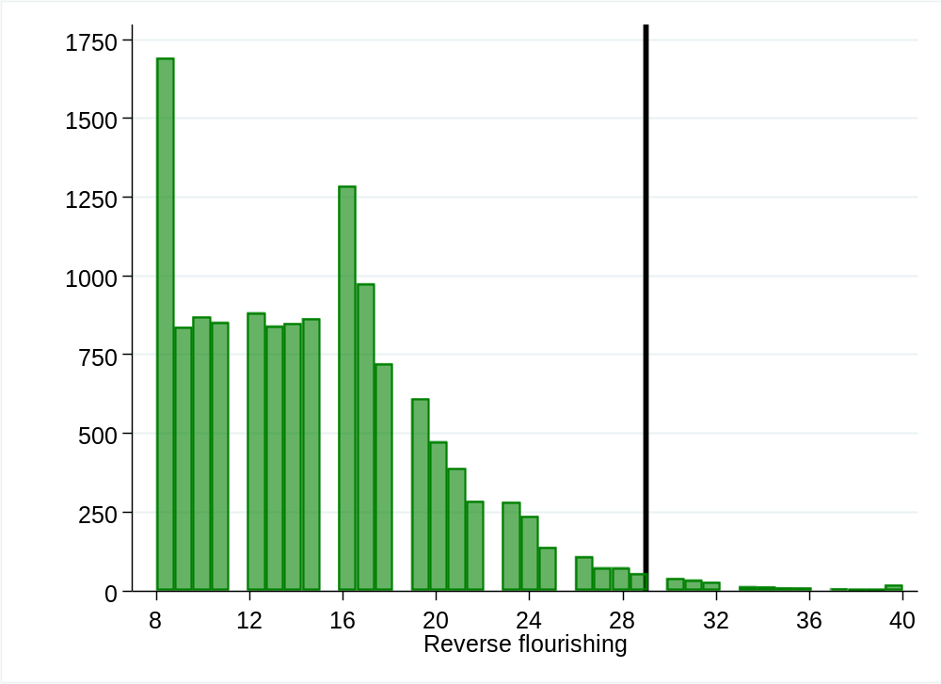
The black line represents the threshold value. Participants at or below this score are considered to have reported positive flourishing.

Missing data
Little’s MCAR test was statistically significant (p < 0.001), indicating that the data are not missing completely at random (MCAR). This suggests that missing data are likely dependent on observed variables, supporting the assumption of missing data at random (MAR). A preliminary analysis of the missing data revealed that 81% of our sample consisted of complete cases. Most patterns of missingness were concentrated on depressive symptoms, anxiety symptoms, flourishing scores, or a combination of these three variables (Table A2). Differences between participants with and without missing data on these outcomes were small in magnitude (Table A3). Although some differences reached statistical significance, this is likely attributable to the large sample size, which increases the likelihood of detecting small but practically negligible differences. Given that differences in participant characteristics between those with and without missing data were small in magnitude (Cohen’s d < 0.2, absolute differences < 0.16), we considered listwise deletion to be an appropriate method. This approach is valid under the assumption that missingness does not systematically bias results.
Table A2. Patterns of missing data
Percentage of complete cases | CESD-R-10 | GAD-7 | Flourishing Scale | Sex | Age | Family-level material deprivation
81%
6%
3%
3%
2%
2%
3% | 43 different other patterns, each accounting for less than 1%
The gray cases represent missing data.
Table A3. Missing data differences from indicators with and without missing data for sex, age and family level of material deprivation
 | Sex | Age | Family level of material deprivation
CESD-R-10
Mean without missing data | 1.46 | 14.51 | 0.30
Mean with missing data | 1.52 | 14.44 | 0.34
Difference | -0.06 (-0.07, -0.04) | 0.07 (0.04, 0.11) | -0.04 (-0.05, -0.04)
Cohen’s d | -0.11 | -0.09 | 0.05
GAD-7
Mean without missing data | 1.46 | 14.50 | 0.30
Mean with missing data | 1.51 | 14.47 | 0.36
Difference | -0.05 (-0.06, -0.04) | 0.03 (-0.01, 0.06) | -0.05 (-0.07, -0.04)
Cohen’s d | -0.10 | -0.12 | 0.02
Flourishing score
Mean without missing data | 1.46 | 14.52 | 0.29
Mean with missing data | 1.54 | 14.35 | 0.39
Difference | -0.08 (-0.09, -0.06) | 0.16 (0.12, 0.21) | -0.10 (-0.12, -0.09)
Cohen’s d | -0.15 | -0.21 | 0.10
95% confidence interval in parentheses.

Stratification by sex, age, and family-level material deprivation
Table A4. Estimations of single and double differences in mental health changes over time, stratified by sex
 |  |  | Difference (95% CIs)
 |  |  | Peri vs pre-pandemic  (2021-2019) | Post vs pre-pandemic  (2023-2019)
Prevalence | Depressive symptoms | Girls | 11.2  (8.2, 14.1) | 8.5  (6.2, 10.8)
Prevalence | Depressive symptoms | Boys | 4.7  (3.0, 6.4) | -0.4  (-2.7, 1.9)
Prevalence | Depressive symptoms | Difference girls―boys | 6.6  (3.8, 9.3) | 8.7  (5.4, 12.0)
Prevalence | Anxiety symptoms | Girls | 11.1  (8.7, 13.4) | 12.1  (10.2, 14.1)
Prevalence | Anxiety symptoms | Boys | 2.1  (0.7, 3.6) | 1.2  (-0.2, 2.6)
Prevalence | Anxiety symptoms | Difference girls―boys | 9.1  (7.1, 11.1) | 10.8  (8.7, 12.9)
Prevalence | Positive flourishing | Girls | -7.2  (-9.1, -5.4) | -13.8  (-15.9, -11.8)
Prevalence | Positive flourishing | Boys | -3.8  (-5.7, -1.9) | -6.3  (-9.1, -3.6)
Prevalence | Positive flourishing | Difference girls―boys | -3.4  (-1.0, -5.7) | -7.5  (-11.5, -3.5)
Average mental health gap | Depressive symptoms | Girls | 4.1  (3.0, 5.3) | 2.6  (1.3, 3.9)
Average mental health gap | Depressive symptoms | Boys | 0.9  (-0.7, 2.5) | -0.6  (-2.4, 1.1)
Average mental health gap | Depressive symptoms | Difference girls―boys | 3.2  (1.5, 4.9) | 3.2  (1.1, 5.3)
Average mental health gap | Anxiety symptoms | Girls | 2.3  (0.4, 4.2) | 3.4  (1.7, 5.0)
Average mental health gap | Anxiety symptoms | Boys | -0.7  (-2.9, 1.5) | -1.7  (-3.7, 0.3)
Average mental health gap | Anxiety symptoms | Difference girls―boys | 3.0  (0.4, 5.6) | 5.0  (2.0, 8.0)
Average mental health gap | Positive flourishing | Girls | -2.1  (-3.5, -0.8) | -3.9  (-5.4, -2.5)
Average mental health gap | Positive flourishing | Boys | 1.6  (0.0, 3.2) | -3.0  (-5.2, -0.9)
Average mental health gap | Positive flourishing | Difference girls―boys | -3.7  (-5.9, -1.6) | -0.9  (-3.3, 1.5)
Proportion adjusted for sex, age, and family-level material deprivation.
The results are presented as percentages.
Depressive symptoms: reverse CESD-R-10 ≤ 20; anxiety symptoms: reverse GAD-7 ≤ 11; or positive flourishing: reverse score ≤ 29.
The average gap represents the relative distance between the average mental health indicator score and the threshold value.

Figure 5. Trends in depressive symptoms, anxiety symptoms, and positive flourishing scores prevalence among adolescents (2018–2023), stratified by age.
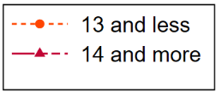
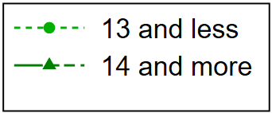
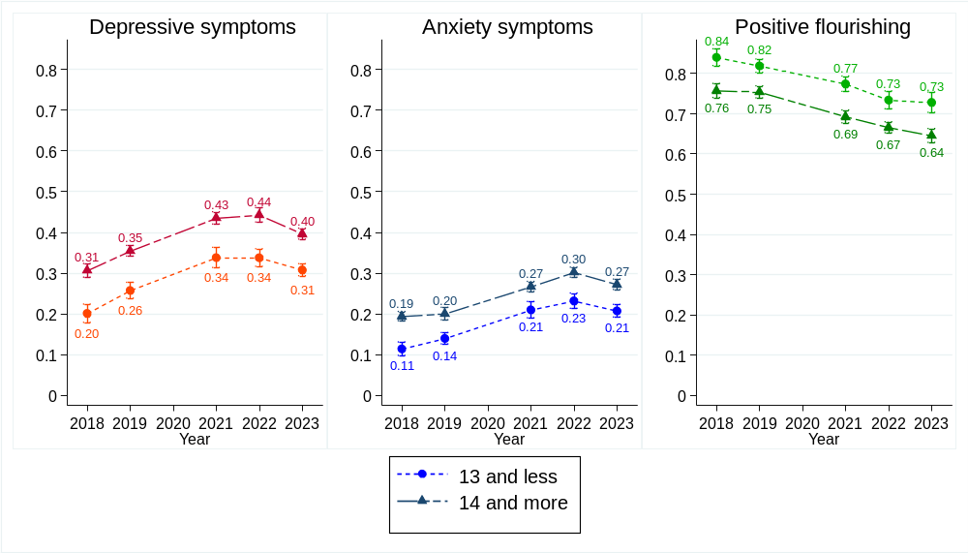
Proportion adjusted for sex, age, and family-level material deprivation.
Depressive symptoms: reverse CESD-R-10 ≤ 20; anxiety symptoms: reverse GAD-7 ≤ 11; or positive flourishing: reverse score ≤ 29.

Figure A6. Trends in the average gap from the threshold value across adolescents reporting depressive symptoms, anxiety symptoms or positive flourishing scores (2018–2023), stratified by age
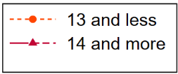
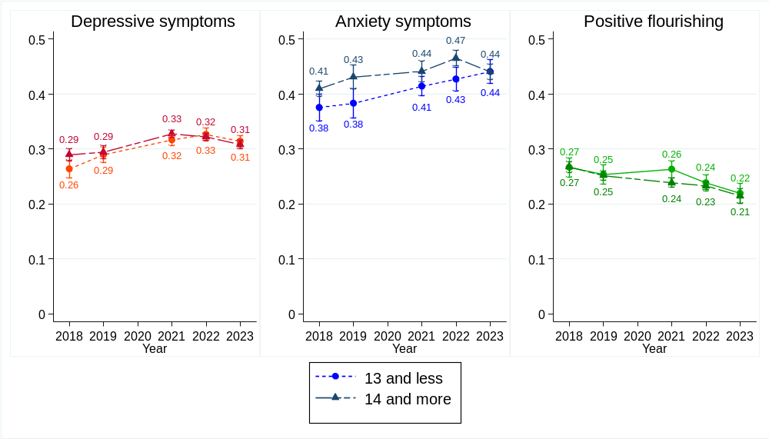
Proportion adjusted for sex, age, and family-level material deprivation.
Depressive symptoms: reverse CESD-R-10 ≤ 20; anxiety symptoms: reverse GAD-7 ≤ 11; or positive flourishing: reverse score ≤ 29.
The average gap represents the relative distance between the average mental health indicator score and the threshold value.

Table A5. Estimations of single and double differences in mental health changes over time, stratified by age
 |  |  | Difference (95% CIs)
 |  |  | Peri vs pre-pandemic  (2021-2019) | Post vs pre-pandemic  (2023-2019)
Prevalence | Depressive symptoms | 13 and less | 8.1  (4.9, 11.2) | 5.0  (2.9, 7.2)
Prevalence | Depressive symptoms | 14 and more | 8.1  (6.2, 10.0) | 4.2  (2.3, 6.1)
Prevalence | Depressive symptoms | Difference 13 and less―14 and more | 0.0  (-2.6, 2.6) | 0.8  (-1.6, 3.3)
Prevalence | Anxiety symptoms | 13 and less | 7.0  (4.7, 9.3) | 6.8  (5.1, 8.5)
Prevalence | Anxiety symptoms | 14 and more | 6.7  (4.8, 8.5) | 7.2  (5.4, 9.0)
Prevalence | Anxiety symptoms | Difference 13 and less―14 and more | 0.4  (-1.8, 2.6) | -0.4  (-2.8, 2.0)
Prevalence | Positive flourishing | 13 and less | -4.5  (-6.8, -2.2) | -9.1  (-11.5, -6.7)
Prevalence | Positive flourishing | 14 and more | -6.1  (-8.0, -4.2) | -10.8  (-12.5, -9.2)
Prevalence | Positive flourishing | Difference 13 and less―14 and more | 1.6  (-1.5, 4.7) | 1.8  (-1.1, 4.6)
Average mental health gap | Depressive symptoms | 13 and less | 2.7  (1.0, 4.4) | 2.5  (0.7, 4.2)
Average mental health gap | Depressive symptoms | 14 and more | 3.3  (1.9, 4.8) | 1.4  (-0.1, 2.8)
Average mental health gap | Depressive symptoms | Difference 13 and less―14 and more | -0.6  (-3.1, 1.8) | 1.1  (-1.4, 3.6)
Average mental health gap | Anxiety symptoms | 13 and less | 3.1  (0.5, 5.7) | 5.8  (3.3, 8.2)
Average mental health gap | Anxiety symptoms | 14 and more | 1.1  (-1.2, 3.3) | 1.0  (-0.5, 2.4)
Average mental health gap | Anxiety symptoms | Difference 13 and less―14 and more | 2.1  (-1.7, 5.8) | 4.8  (1.9, 7.7)
Average mental health gap | Positive flourishing | 13 and less | 0.1  (-1.3, 3.2) | -3.4  (-5.3, -1.6)
Average mental health gap | Positive flourishing | 14 and more | -1.3  (-2.3, -0.3) | -3.7  (-5.1, -2.3)
Average mental health gap | Positive flourishing | Difference 13 and less―14 and more | 2.2  (0.0, 4.5) | 0.2  (-1.8, 2.2)
Proportion adjusted for sex, age, and family-level material deprivation.
The results are presented as percentages.
Depressive symptoms: reverse CESD-R-10 ≤ 20; anxiety symptoms: reverse GAD-7 ≤ 11; or positive flourishing: reverse score ≤ 29.
The average gap represents the relative distance between the average mental health indicator score and the threshold value.
Figure A7. Trends in depressive symptoms, anxiety symptoms, and positive flourishing score prevalence among adolescents (2018–2023), stratified by family-level material deprivation
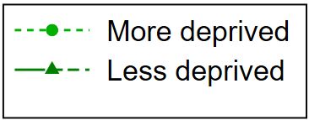
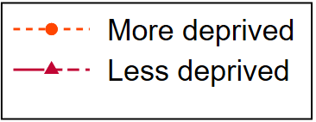
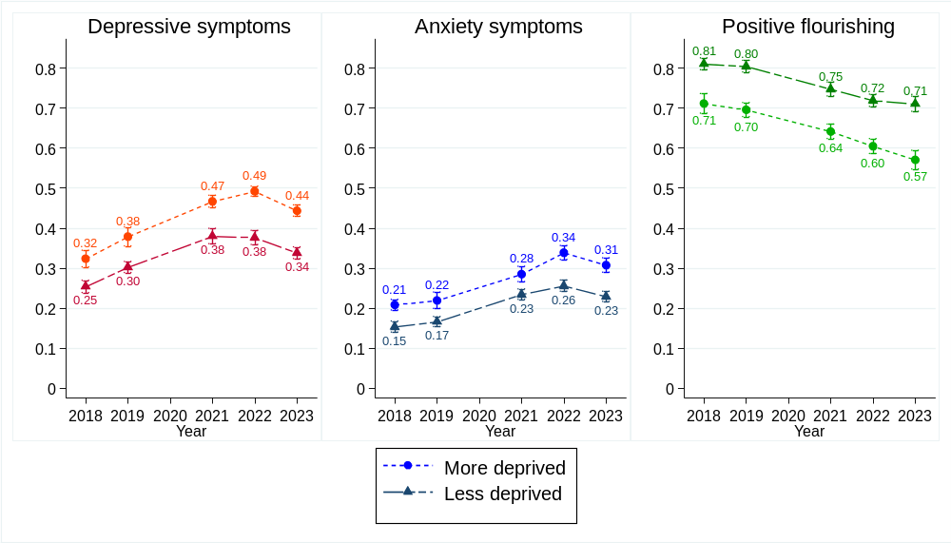
Proportion adjusted for sex, age, and family-level material deprivation.
Depressive symptoms: reverse CESD-R-10 ≤ 20; anxiety symptoms: reverse GAD-7 ≤ 11; or positive flourishing: reverse score ≤ 29.

Figure A8. Trends of the average gap from the threshold value over adolescents reporting depressive symptoms, anxiety symptoms or positive flourishing score (2018–2023), stratified by family-level material deprivation.
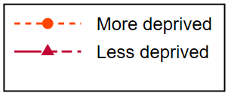
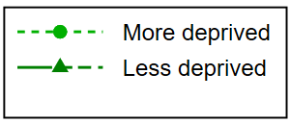
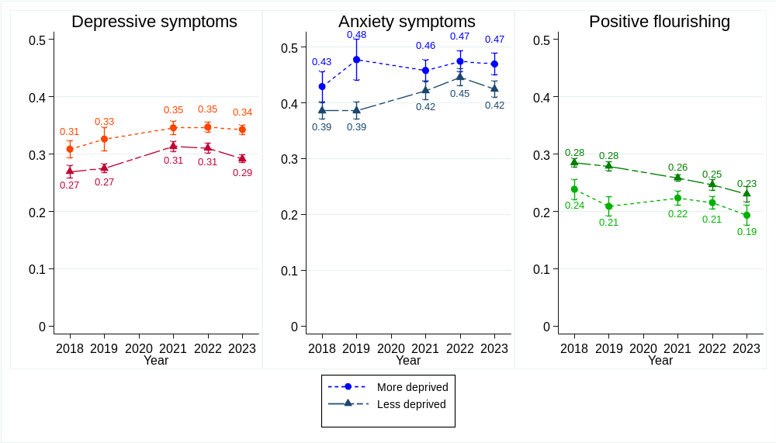
Proportion adjusted for sex, age, and family-level material deprivation.
Depressive symptoms: reverse CESD-R-10 ≤ 20; anxiety symptoms: reverse GAD-7 ≤ 11; or positive flourishing: reverse score ≤ 29.
The average gap represents the relative distance between the average mental health indicator score and the threshold value.

Table A6. Estimations of single and double differences in mental health changes over time, stratified by family-level material deprivation.
 |  |  | Difference (95% CIs)
 |  |  | Peri vs pre-pandemic  (2021-2019) | Post vs pre-pandemic  (2023-2019)
Prevalence | Depressive symptoms | More deprived | 8.8  (5.8, 11.8) | 6.5  (3.6, 9.3)
Prevalence | Depressive symptoms | Less deprived | 7.8  (5.6, 9.7) | 3.6  (1.8, 5.3)
Prevalence | Depressive symptoms | Difference more― less deprived | 1.1  (-1.2, 3.3) | 2.9  (-0.2, -6.0)
Prevalence | Anxiety symptoms | More deprived | 6.6  (4.4, 8.8) | 8.8  (6.5, 11.1)
Prevalence | Anxiety symptoms | Less deprived | 6.9  (5.0, 8.7) | 6.3  (4.8, 7.8)
Prevalence | Anxiety symptoms | Difference more― less deprived | -0.3  (-2.6, 2.0) | 2.5  (0.0, 5.0)
Prevalence | Positive flourishing | More deprived | -5.4  (-7.4, -3.5) | -12.5  (14.7, -10.4)
Prevalence | Positive flourishing | Less deprived | -5.7  (-7.4, -4.0) | -9.4  (-11.1, -7.7)
Prevalence | Positive flourishing | Difference more― less deprived | 0.3  (-1.9, 2.4) | -3.1  (-5.7, -0.5)
Average mental health gap | Depressive symptoms | More deprived | 2.0  (-0.3, 4.2) | 1.6  (-0.6, 3.9)
Average mental health gap | Depressive symptoms | Less deprived | 3.8  (2.9, 4.8) | 1.7  (0.8, 2.5)
Average mental health gap | Depressive symptoms | Difference more― less deprived | -1.9  (-4.2, 0.5) | 0.0  (-2.2, 2.2)
Average mental health gap | Anxiety symptoms | More deprived | -1.9  (-5.8, 1,9) | -0.8  (-3.4, 1.9)
Average mental health gap | Anxiety symptoms | Less deprived | 3.6  (2.2, 4.9) | 3.8  (2.3, 5.4)
Average mental health gap | Anxiety symptoms | Difference more― less deprived | -5.5  (-9.6, -1.4) | -4.6  (-8.0, -1.3)
Average mental health gap | Positive flourishing | More deprived | 1.5  (-0.4, 3.3) | -1.6  (-3.2, 0.1)
Average mental health gap | Positive flourishing | Less deprived | -2.0  (-3.1, -1.0) | -4.9  (-6.4, -3.3)
Average mental health gap | Positive flourishing | Difference more― less deprived | 3.5  (1.5, 5.5) | 3.3  (1.2, 5.4)
Proportion adjusted for sex, age, and family-level material deprivation.
The results are presented as percentages.
Depressive symptoms: reverse CESD-R-10 ≤ 20; anxiety symptoms: reverse GAD-7 ≤ 11; or positive flourishing: reverse score ≤ 29.
The average gap represents the relative distance between the average mental health indicator score and the threshold value.

Exclusion of 2020 data
Our decision to exclude the 2020 data from the main analysis is based on serious concerns regarding the representativeness and comparability of the findings over the years. However, we have added a detailed summary of the characteristics of the 2020 participants (see Table A5 below) and additional analyses (Figure A6) with the 2020 data.
To ensure consistency across years, we focused on a cohort of 31 high schools that participated annually. In 2020, however, only 23 of these schools participated in the COMPASS study, with a participation rate of just 37%. This low response rate likely reflects the circumstances of the first COVID-19 lockdown (March 13th to early May 2020), when schools were closed, and many adolescents viewed this period as a vacation. These conditions influenced both participation rates and the nature of the responses, making the 2020 data difficult to compare with those of other years.
As shown in Table A7, the characteristics of the participants in 2020 differed from those in other years, with fewer boys and adolescents from less deprived families participating. Mental health indicators (CESD-R-10, GAD-7, and the Flourishing Scale) also suggested better mental health during this period, likely reflecting the early pandemic context before broader challenges emerged. Moreover, the higher proportion of missing values limits the reliability of these findings and suggests that there was selection bias. For example, it is possible that adolescents who were living in difficult situations at home during the initial lockdowns were less likely to participate in a survey.
Our adjusted results (Figure A6) revealed that, in 2020, a lower proportion of adolescents reported depressive or anxiety symptoms, whereas a greater proportion reported a positive flourishing score compared with both the pre- and post-pandemic periods. Additionally, the average gap, representing the average mental health gap between the threshold score and the average CESD-R-10 score (≥ 10), GAD-7 score (≥ 10) or positive flourishing score (≥ 30), was smaller in 2020. These findings indicate that adolescents experienced fewer depressive and anxiety symptoms and flourished more than they did in other years.
These trends align with findings from a study by Gohari et al. (2024) (65), which analyzed a cohort of 5,319 adolescents from the COMPASS study and reported improvements in mental health indicators during 2020 compared with pre- and post-pandemic years. Compared with the excluded participants, the cohort included a greater proportion of females, white participants, and those with lower levels of depression and anxiety symptoms. The study compared two groups: 3,447 participants who responded just before the COVID-19 pandemic and 1,872 participants who responded during the first wave. A multilevel logistic regression with fixed effects was used to account for poor-quality data.
However, owing to the cross-sectional study design of our data, we were unable to statistically correct for these data quality issues. We opted to exclude 2020 data from the main analyses to maintain methodological consistency.

 |  |  | Pre-pandemic |  |  |  |  | Peri-pandemic |  |  |  |  |  | Post-pandemic
 |  |  | 2018  (N=14,320) |  | 2019  (N=14,796) |  |  | 2020  (N=4,183) |  |  | 2021  (N=11,937) |  |  | 2022  (N=13,926) |  |  | 2023  (N=17,042)
Sex
 | Boys |  | 6,829 (47.7%) |  | 7,035 (47.6%) |  |  | 1,603 (38.3%) |  |  | 5,315 (44.5%) |  |  | 6,387 (45.9%) |  |  | 8,102 (47.5%)
 | Missing |  | 67 (0.5%) |  | 118 (0.8%) |  |  | 61 (1.5%) |  |  | 183 (1.5%) |  |  | 250 (1.8%) |  |  | 198 (1.2%)
Age
 | Mean (SD) |  | 14.7 (1.6) |  | 14.6 (1.6) |  |  | 14.5 (1.6) |  |  | 14.5 (1.5) |  |  | 14.4 (1.5) |  |  | 14.5 (1.5)
 | Missing |  | 42 (0.3%) |  | 85 (0.6%) |  |  | 59 (1.4%) |  |  | 150 (1.3%) |  |  | 156 (1.1%) |  |  | 123 (0.7%)
Family level of material deprivation
 | More deprived |  | 3,396 (23.7%) |  | 3,396 (23.0%) |  |  | 794 (19.0%) |  |  | 3,923 (32.9%) |  |  | 5,141 (36.9%) |  |  | 6,157 (36.1%)
 | Missing |  | 0 |  | 39 (0.3%) |  |  | 619 (14.8%) |  |  | 218 (1.8%) |  |  | 196 (1.4%) |  |  | 153 (0.9%)
CESD-R-10
 | ≥ 10 |  | 3,365 (23.5%) |  | 4,058 (27.4%) |  |  | 1,041 (24.9%) |  |  | 4,238 (35.5%) |  |  | 5,087 (36.5%) |  |  | 5,769 (33.9%)
 | Mean (SD) |  | 7.4 (5.5) |  | 8.1 (5.8) |  |  | 7.8 (5.5) |  |  | 9.4 (6.5) |  |  | 9.5 (6.5) |  |  | 8.9 (6.2)
 | Missing |  | 1,890 (13.2%) |  | 2,061 (13.9%) |  |  | 711 (17.0%) |  |  | 1,676 (14.0%) |  |  | 1,735 (12.5%) |  |  | 1,577 (9.3%)
GAD-7
 | ≥ 10 |  | 2,171 (15.2%) |  | 2,372 (16.0%) |  |  | 566 (13.5%) |  |  | 2,709 (22.7%) |  |  | 3,600 (25.9%) |  |  | 4,034 (23.7%)
 | Mean (SD) |  | 5.0 (4.8) |  | 5.2 (4.9) |  |  | 5.0 (4.8) |  |  | 6.4 (5.4) |  |  | 6.9 (5.7) |  |  | 6.4 (5.6)
 | Missing |  | 1,231 (8.6%) |  | 1,385 (9.4%) |  |  | 607 (14.5%) |  |  | 1,346 (11.3%) |  |  | 1,327 (9.5%) |  |  | 1,241 (7.3%)
Flourishing scale
 | ≥ 30 |  | 10,677 (78.5%) |  |  | 10,852 (78.0%) |  |  | 2,892 (80.2%) |  |  | 7,712 (71.3%) |  |  | 8,675 (67.8%) |  |  | 4,902 (66.0%)*
 | Mean (SD) |  | 33.2 (5.3) |  | 33.1 (5.5) |  |  | 33.6 (5.2) |  |  | 32.3 (5.9) |  |  | 31.7 (6.1) |  |  | 31.4 (6.5)*
 | Missing |  | 721 (5.0%) |  | 874 (5.9%) |  |  | 577 (13.8%) |  |  | 1,117 (9.4%) |  |  | 1,131 (8.1%) |  |  | 818 (9.9%)*
Table A7. Characteristics of Quebec adolescents who participated in the COMPASS study (2018–2023)
* The questionnaire on flourishing was completed by a total of 8,241 adolescents in 2023.

Figure A9. Trends in adolescents’ mental health: prevalence and average gap from the threshold value (2018–2023)
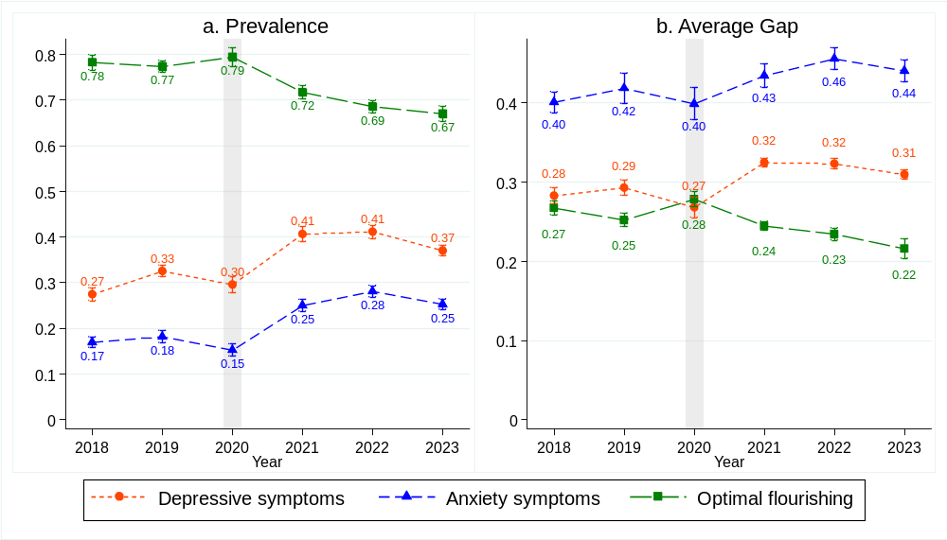
a. Prevalence adjusted for sex, age, and family-level material deprivation.
b. The average gap represents the relative distance between the average mental health indicator score and the threshold value.
Depressive symptoms: reverse CESD-R-10 ≤ 20; anxiety symptoms: reverse GAD-7 ≤ 11; or positive flourishing: reverse score ≤ 29.

