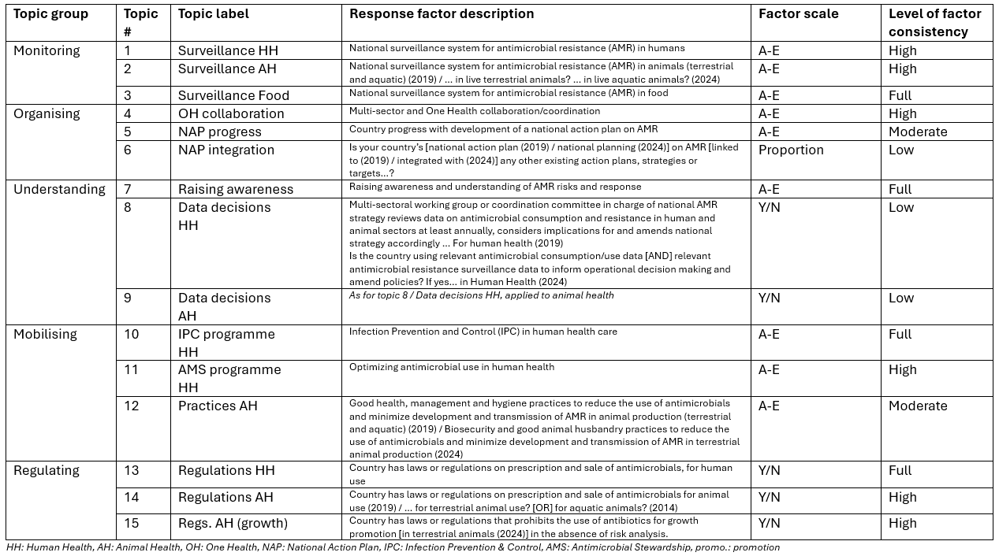Table 1: Study topics

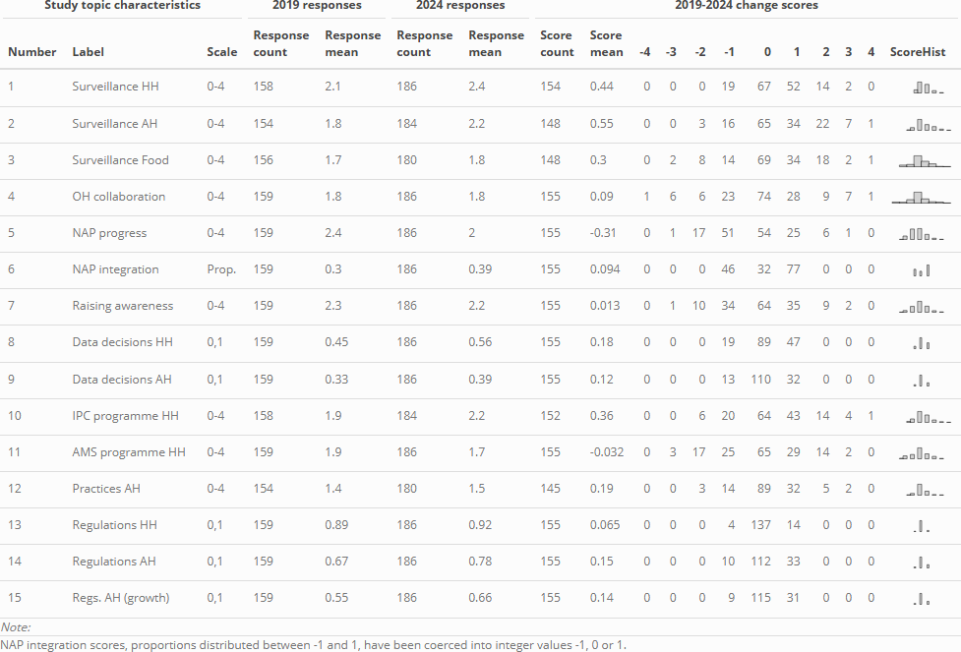
Note that h3c scores, proportions distributed between -1 and 1, have been coerced into integer values -1, 0 or 1.
Table 2: Global change scores
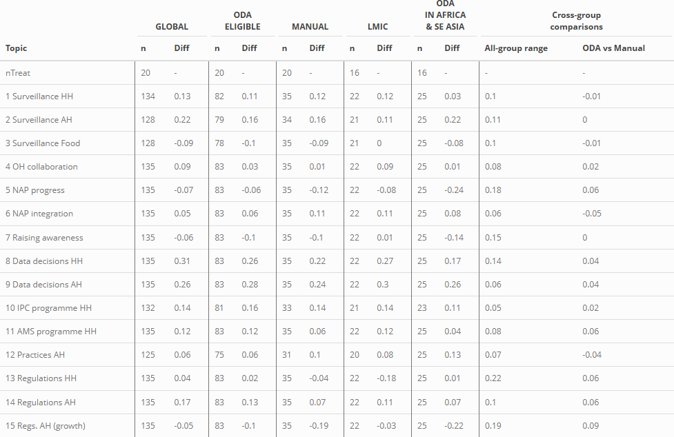
Table 3: Differences in change scores between FF-supported countries and main control groups
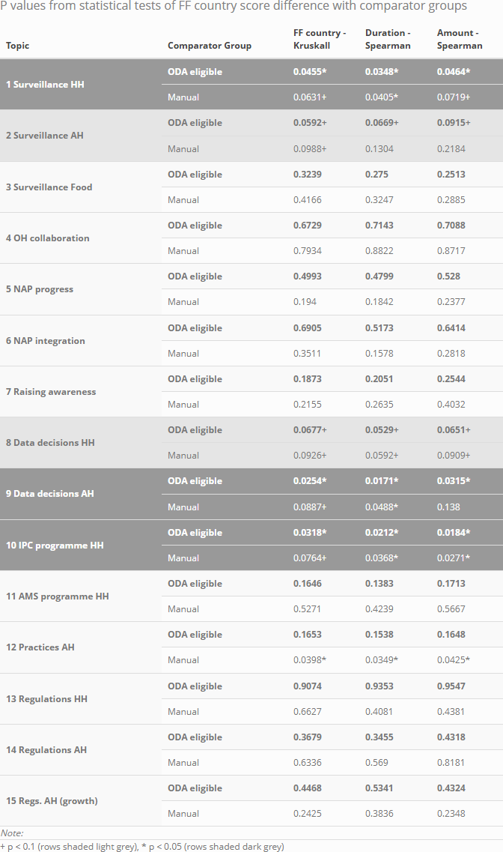
Table 4: Statistical tests of differences in change scores
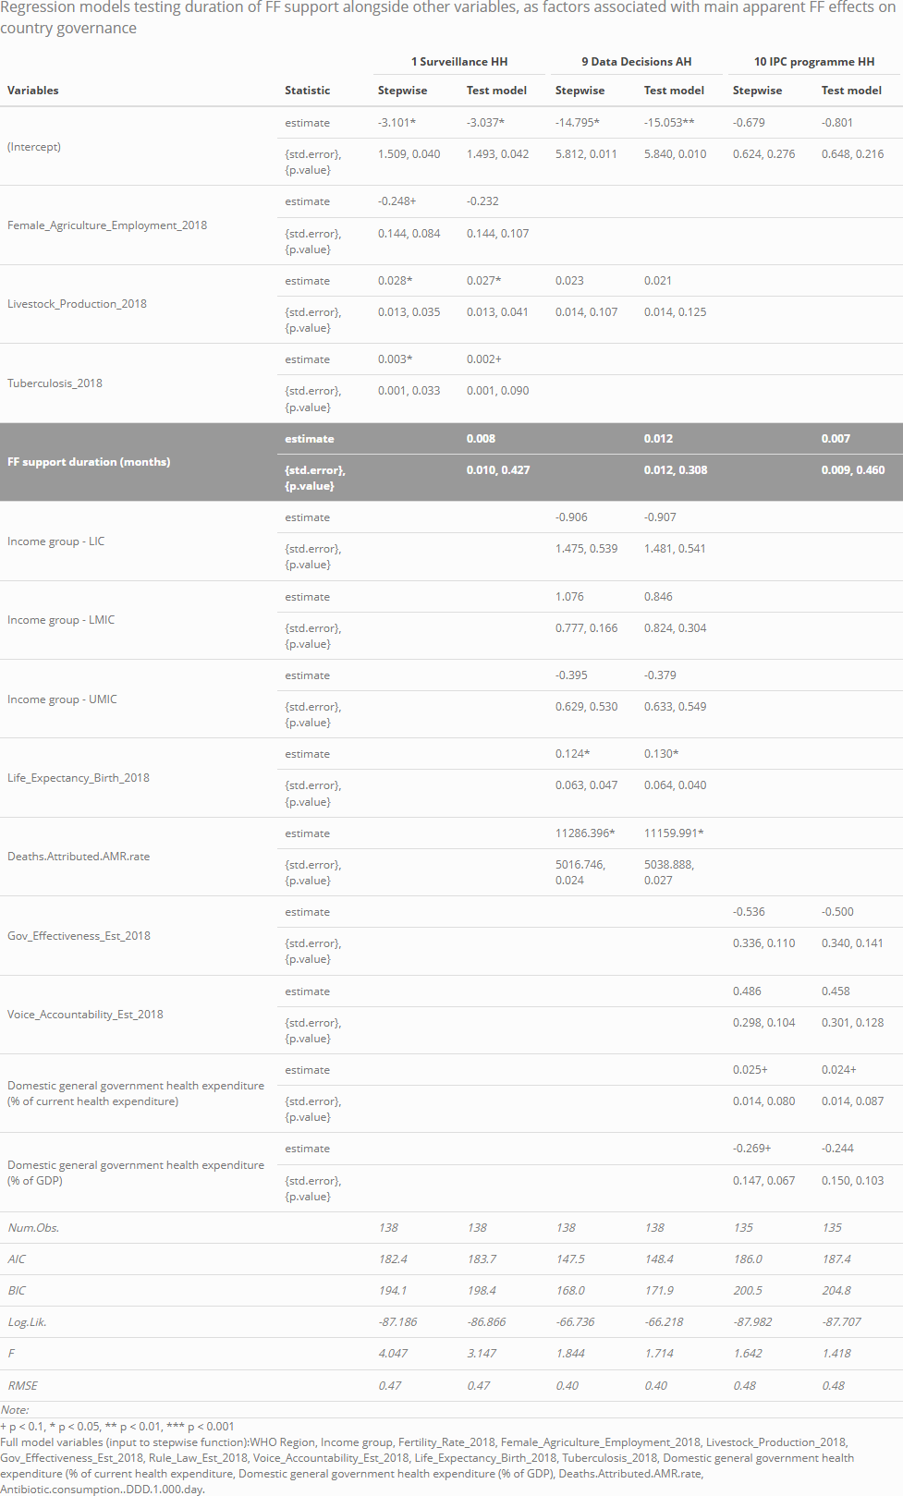
Table 5: Regression modelling outputs

