Supplementary
Supplementary table 1
Participant opinions of individual Reframe IT-UK elements
Reframe IT-UK Element | Disliked | Neither Liked or Disliked | Liked | N/A (Did Not Use) or Missing
Video diaries | 1 | 5 | 0 | 4
CBT activities | 2 | 1 | 3 | 4
Overall look and feel | 0 | 3 | 3 | 4
Message board | 0 | 2 | 3 | 6
Topics covered | 1 | 2 | 3 | 4
Host character | 1 | 2 | 2 | 5
Female character | 1 | 2 | 2 | 5
Male character | 1 | 2 | 2 | 5
 | Unhelpful | Neither helpful or unhelpful | Helpful | N/A (Did Not Use) or Missing
Recognising my emotions | 2 | 2 | 3 | 3
Identifying my 'problem situations' | 1 | 2 | 4 | 3
Identifying my 'tipping point' | 1 | 3 | 3 | 3
Recognising my 'unhelpful thoughts' | 1 | 1 | 5 | 3
Learning who I can go to for help | 1 | 3 | 3 | 3
Scheduling activities I enjoy | 2 | 3 | 2 | 3
Problem solving | 1 | 3 | 2 | 4
Replacing unhelpful thoughts with helpful thoughts | 2 | 3 | 1 | 3

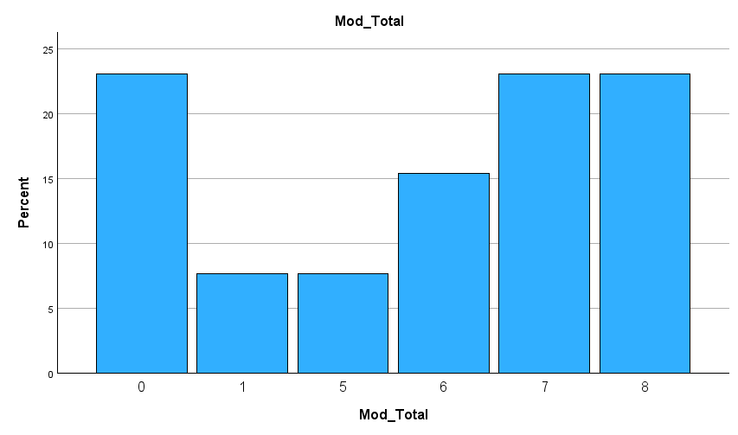
Supplementary Figure 1. Bar chart of the percentage of modules completed.
Number of Modules
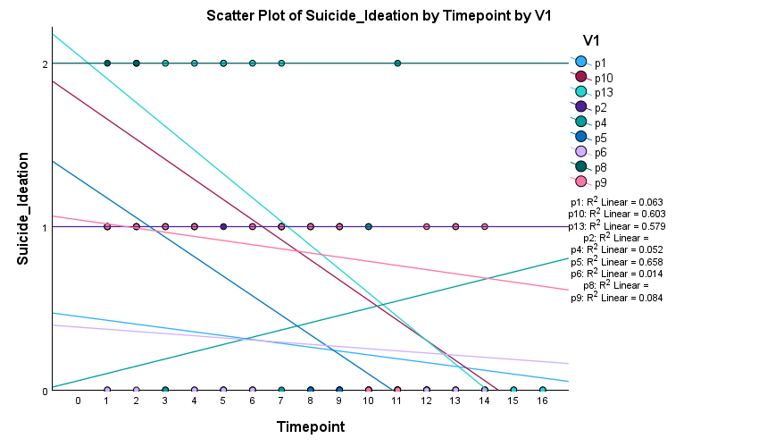
Figure 2. Scatterplot of suicide ideation by timepoint for each participant.
Participant

