Supplemental Materials for:

Larger natural emotion vocabularies track with
better mental health in psychotherapeutic conversations

Sahi, Hull, Vine, & Nook

Supplemental Figures

Supplemental Figure 1. Visual Inspection of Internalizing Symptoms and Emotion Vocabularies Over Time Across Exploratory and Validation Datasets
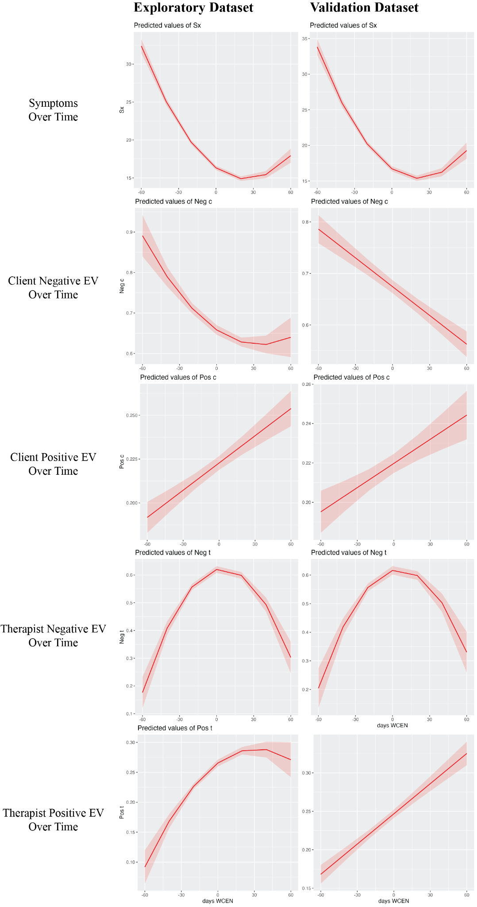
Note. For each mixed-effect model including time as the primary predictor variable, we checked for non-linearity using a polynomial regression approach. Model comparison provided evidence of non-linear associations for several of these models. However, visual inspection of these relationships, as pictured above, suggested that they were essentially monotonic, with the exception of therapist negative emotion vocabulary which increased until the midway point of therapy and then decreased for the remainder of therapy. For ease of interpretation and in line with the principle of parsimony, in the main manuscript we report the results of linear models for all associations except for time and therapist negative emotion vocabulary.

Supplemental Tables

Supplemental Table 1. Links between client and therapist emotion vocabularies and internalizing symptoms, controlling for emotional tone, general vocabulary, and time in therapy.
 | Client |  | Therapist
Negative Emotion Vocabulary | β_{e} | β_{v} | β_{e} | β_{v}
Negative EV (W) | 0 | -0.01 | -0.05*** | -0.05**
Negative EV (B) | -0.08** | -0.06* | 0.05 | 0.01
Negative Tone (W) | 0.07*** | 0.07*** | 0.03* | 0
Negative Tone (B) | 0.36*** | 0.36*** | 0.18*** | 0.19***
General Vocab (W) | 0.04*** | 0.04*** | 0.06*** | 0.05***
General Vocab (B) | -0.02 | -0.09*** | -0.02 | -0.05*
Time (W) | -0.36*** | -0.37*** | -0.45*** | -0.44***
Time (B) | -0.06*** | -0.09*** | -0.08*** | -0.12***
EarlyLate (Categorical) | NA | NA | 0.07*** | 0.06**
EarlyLate*Negative EV (W) | NA | NA | 0.04* | 0.04*
EarlyLate*Negative EV (B) | NA | NA | -0.03* | 0
Positive Emotion Vocabulary | β_{e} | β_{v} | β_{e} | β_{v}
Positive EV (W) | -0.01 | -0.02 | -0.04*** | -0.01
Positive EV (B) | -0.13*** | -0.10*** | -0.10*** | -0.08***
Positive Tone (W) | -0.08*** | -0.06*** | -0.05*** | -0.08***
Positive Tone (B) | -0.17*** | -0.15*** | -0.10*** | -0.06*
General Vocab (W) | 0.06*** | 0.05*** | 0.06*** | 0.05***
General Vocab (B) | 0 | -0.06* | -0.03 | -0.06**
Time (W) | -0.36*** | -0.37*** | -0.36*** | -0.37***
Time (B) | -0.06** | -0.10*** | -0.06** | -0.09***
Note. This table summarizes results from eight separate models looking at associations between emotion vocabularies and internalizing symptoms. Standardized betas and associated p-values are provided for models looking at client and therapist emotion vocabularies in the exploratory and validation datasets (subscripts “e” and “v” respectively). The categorical variable for "early" vs. "late" therapy and associated interaction terms were only included in the therapist's negative emotion vocabulary models. The rows focused on our primary predictors of interest (i.e., emotion vocabularies) are highlighted in blue. EV = emotion vocabulary; W = within-person centered; B = between-person centered; *** = p < .001, ** = p < .01, * = p < .05

Supplemental Table 2. Links between client and therapist emotion vocabularies and internalizing symptoms, controlling for emotional tone, general vocabulary, time in therapy, and word count.
 | Client |  | Therapist
Negative Emotion Vocabulary | β_{e} | β_{v} | β_{e} | β_{v}
Negative EV (W) | 0 | -0.01 | -0.05*** | -0.05**
Negative EV (B) | -0.08*** | -0.06 | 0.05 | 0.01
Negative Tone (W) | 0.07*** | 0.07*** | 0.03* | 0
Negative Tone (B) | 0.36*** | 0.36*** | 0.18*** | 0.19***
General Vocab (W) | 0.03** | 0.04** | 0.05*** | 0.04**
General Vocab (B) | -0.04 | -0.09*** | -0.03 | -0.06*
Time (W) | -0.36*** | -0.37*** | -0.45*** | -0.43***
Time (B) | -0.06*** | -0.09*** | -0.08*** | -0.12***
Word Count | -0.03 | 0 | -0.01 | -0.02
EarlyLate (Categorical) | NA | NA | 0.07*** | 0.06**
EarlyLate*Negative EV (W) | NA | NA | 0.04 | 0.04*
EarlyLate*Negative EV (B) | NA | NA | -0.03* | 0
Positive Emotion Vocabulary | β_{e} | β_{v} | β_{e} | β_{v}
Positive EV (W) | -0.01 | -0.02 | -0.04*** | -0.01
Positive EV (B) | -0.13*** | -0.10*** | -0.10*** | -0.08**
Positive Tone (W) | -0.08*** | -0.06*** | -0.06*** | -0.08***
Positive Tone (B) | -0.18*** | -0.15*** | -0.11*** | -0.06*
General Vocab (W) | 0.04*** | 0.05*** | 0.05*** | 0.04**
General Vocab (B) | -0.01 | -0.06* | -0.05* | -0.08**
Time (W) | -0.36*** | -0.37*** | -0.36*** | -0.37***
Time (B) | -0.06** | -0.10*** | -0.06** | -0.09***
Word Count | -0.04 | 0 | -0.03 | -0.03
Note. This table is the same as Supplemental Table 1, except that we re-ran these models to additionally control for speaker word count in case this variable was a confound. Results were consistent across these two sets of analyses. Analyses reported in this table were not pre-registered. EV = emotion vocabulary; W = within-person centered; B = between-person centered; *** = p < .001, ** = p < .01, * = p < .05

Supplemental Table 3. Model building summary.
 | Exploratory |  | Validation
Model | Evidence of nonlinearity? | Improves with random slope? | Evidence of nonlinearity? | Improves with random slope?
Internalizing symptoms over time | Quadratic | Yes | Quadratic | Yes
Client negative EV over time | Quadratic | Yes | No | Yes
Client positive EV over time | No | Yes | No | Yes
Therapist negative EV over time | Quadratic | Yes | Quadratic | Yes
Therapist positive EV over time | Quadratic | Yes | No | Yes
Client negative EV and symptoms | NA | No | NA | No
Client positive EV and symptoms | NA | No | NA | No
Therapist negative EV and symptoms | NA | No | NA | No
Therapist positive EV and symptoms | NA | No | NA | No
Note. For each mixed effects model including time as the primary predictor variable, we used model comparisons to check for non-linearity and test whether adding a random slope improved model fit. This table summarizes the results from these analyses. We found evidence of non-linearity for several models, but plots indicated that several of these relationships were essentially monotonic (see Supplemental Figure 1). In terms of random slopes, for models where time was the only predictor, adding a random slope improved model fit, but for models testing associations between emotion vocabulary and internalizing symptoms which included several control variables, adding a random slope did not improve fit. Findings did not substantially change depending on the inclusion of a random slope. All results in the main manuscript report statistics from the best models.

