Supplementary Information for
Quantifying Environmental and Energy Assets for the Geopolitics of Climate Change Mitigation
Contents
Supplementary Figures 2
Supplementary Tables 6
Supplementary Text 11
S1. Panel efficiency calculation 11
S2. CF calculation method 12
References 12

Supplementary Figures
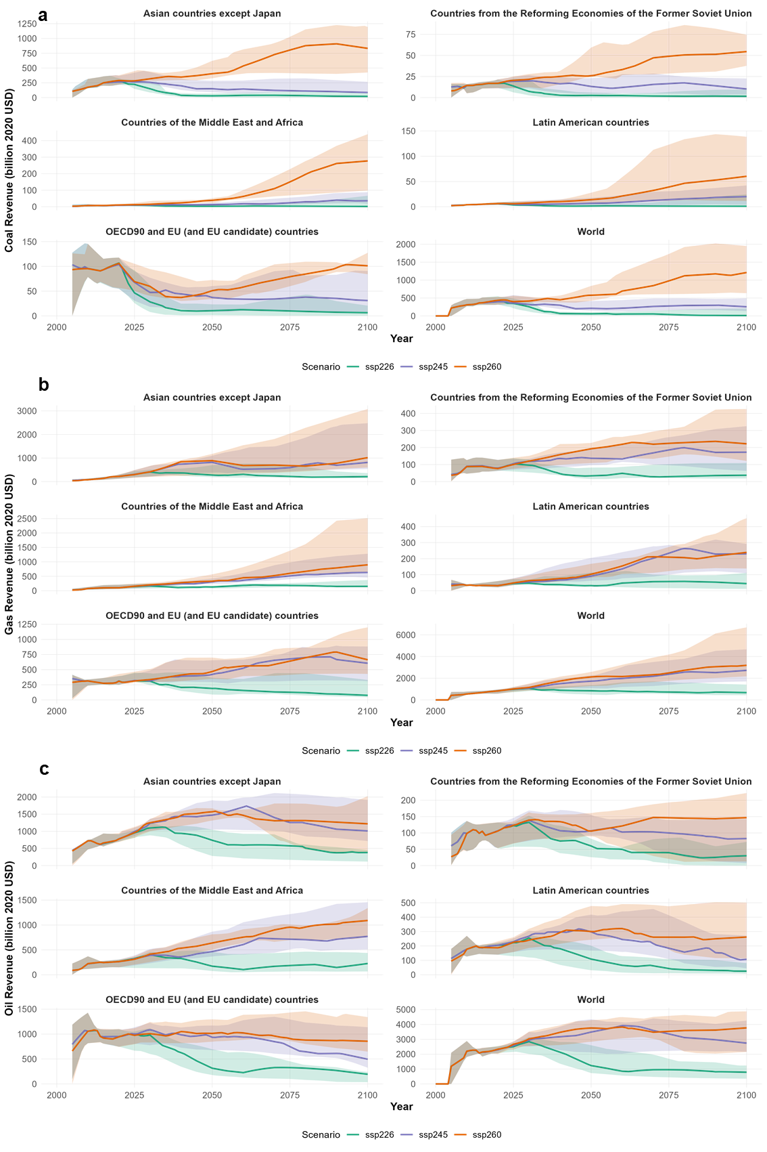
Supplementary Fig. 1 Fossil fuel revenues in AR6 R5 regions under two mitigation scenarios and the baseline. (a) Coal, (b) Gas, and (c) Oil revenues. Lines represent the multi-model median, and shaded areas indicate the 66.7% confidence interval across models.

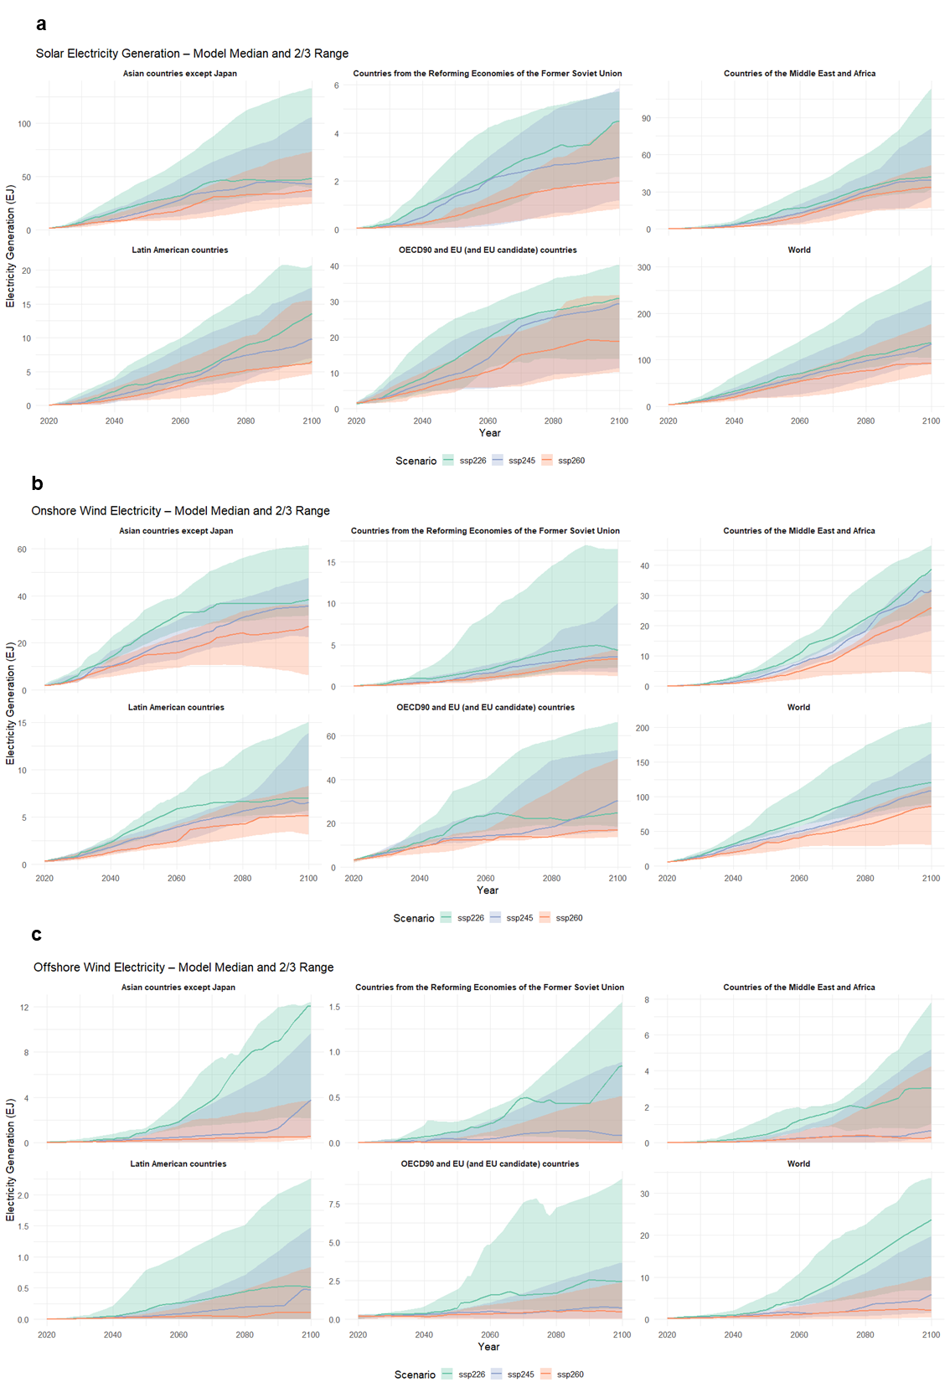
Supplementary Fig. 2 Renewable electricity generation in AR6 R5 regions under two mitigation scenarios and the baseline. (a) Solar, (b) Onshore wind, and (c) Offshore wind generation. Lines represent the multi-model median, and shaded areas indicate the 66.7% confidence interval across models.
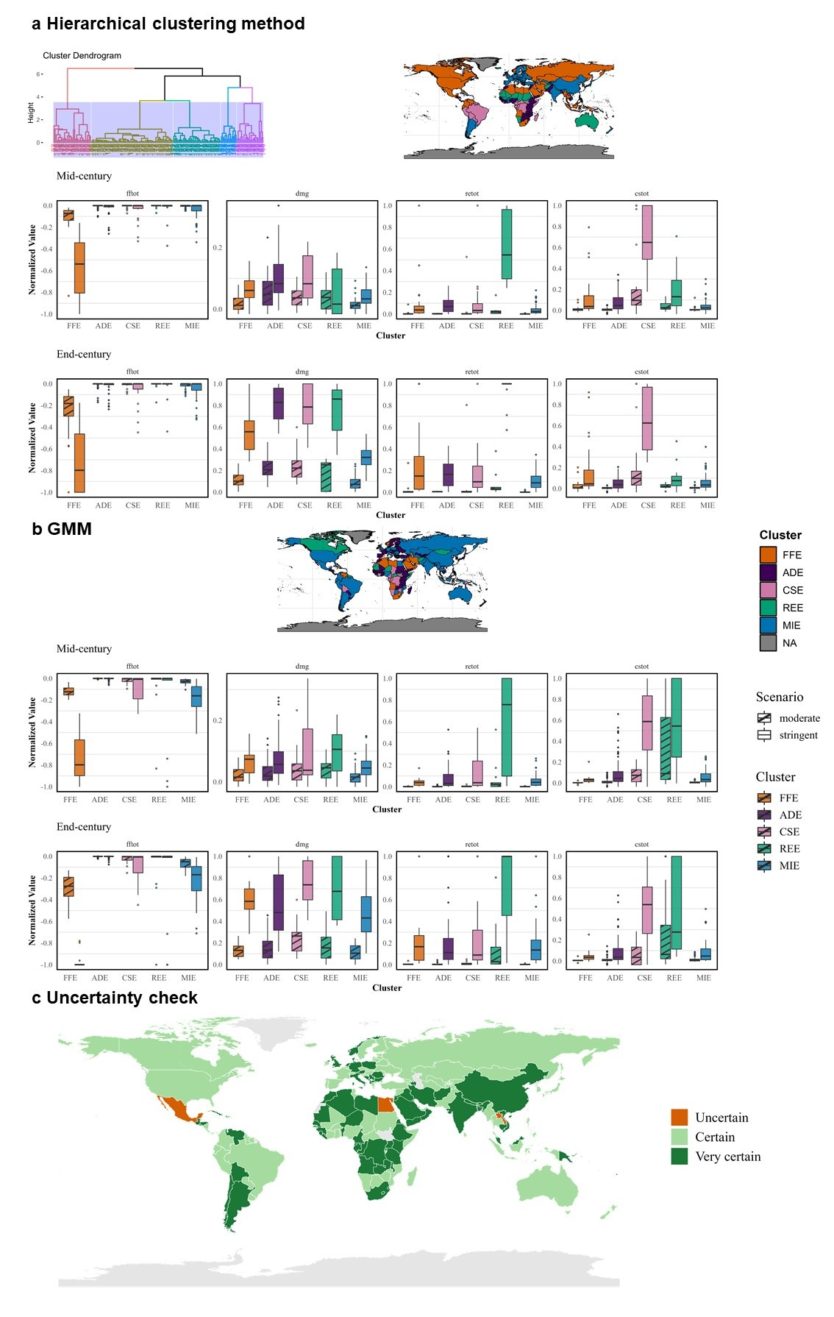
Supplementary Fig. 3 Clustering results from alternative methods. (a) Hierarchical clustering, (b) Gaussian Mixture Model (GMM), and (c) Uncertainty check. In panel (c), clustering uncertainty is categorized as follows: Uncertain—all three methods assign different clusters; Certain—two methods agree, one differs; Very certain—all three methods agree. Among 172 countries, 4 are identified as uncertain (Egypt, Laos, Mexico, and Samoa), 79 as very certain, and 89 as certain.
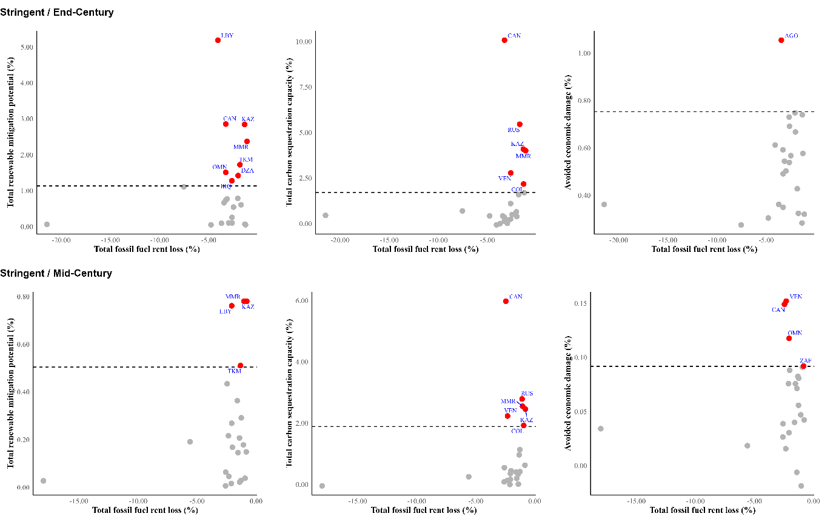
Supplementary Fig. 4 Scatter plots compare total fossil fuel rent losses (x-axis) with three key mitigation assets (y-axis): total renewable energy mitigation potential, total carbon sequestration capacity, and avoided economic damage, all expressed as percentages of each country's discounted cumulative GDP. The top row presents results for the stringent mitigation scenario by end-century, and the bottom row shows mid-century projections under the same scenario. The dashed horizontal lines represent the upper quartile (75th percentile) of the global distribution for each asset with all clusters included. Countries exceeding this threshold are highlighted in red, indicating stronger mitigation opportunities relative to fossil fuel losses within the FFE cluster.
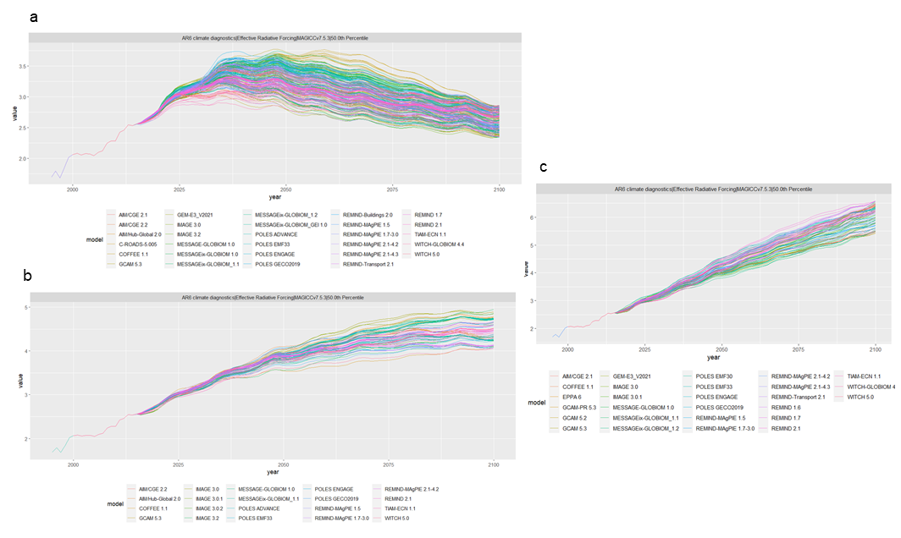
Supplementary Fig. 5 Selection of SSP2 scenarios from the AR6 database. Scenarios are filtered based on global median forcing values that fall within ±10% of target forcing levels: (a) 2.6, (b) 4.5, and (c) 6.0 W/m², respectively. The figure presents all IAMs that meet the criteria for each scenario; however, only IAMs common across all three scenarios are retained for the subsequent analysis.
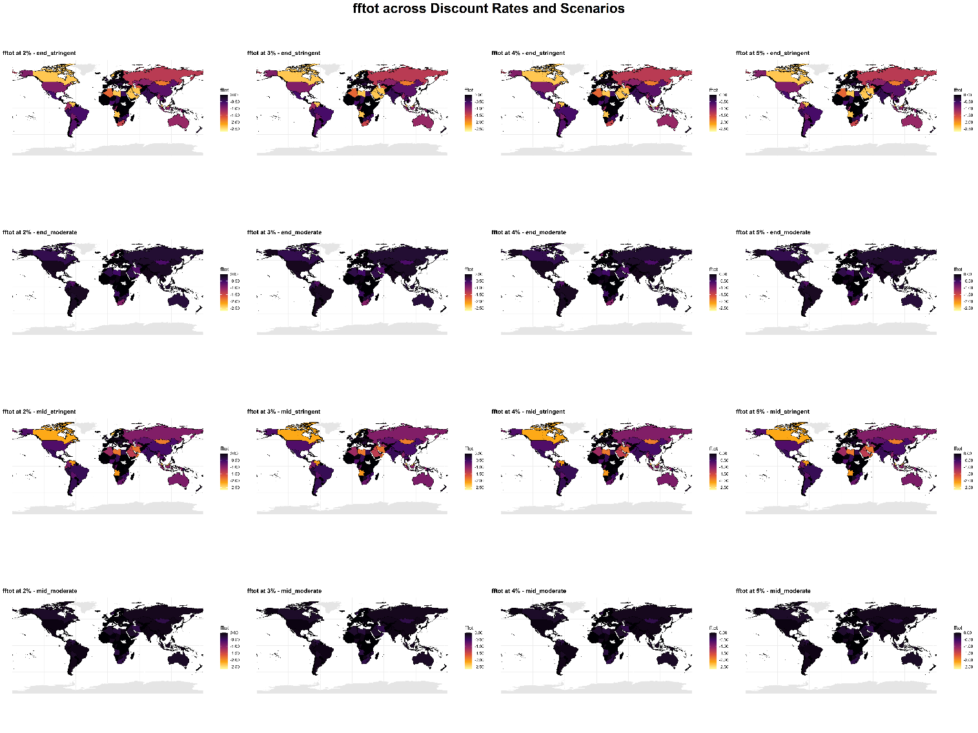
Supplementary Fig. 6.1 Sensitivity analysis for total fossil fuel rent loss (fftot) across discount rates. This figure displays total fossil fuel rent loss (fftot, unit: % of cumulative GDP) at discount rates of 2%, 3%, 4%, and 5%, under two mitigation scenarios (stringent and moderate) and two time periods (mid- and end-century).
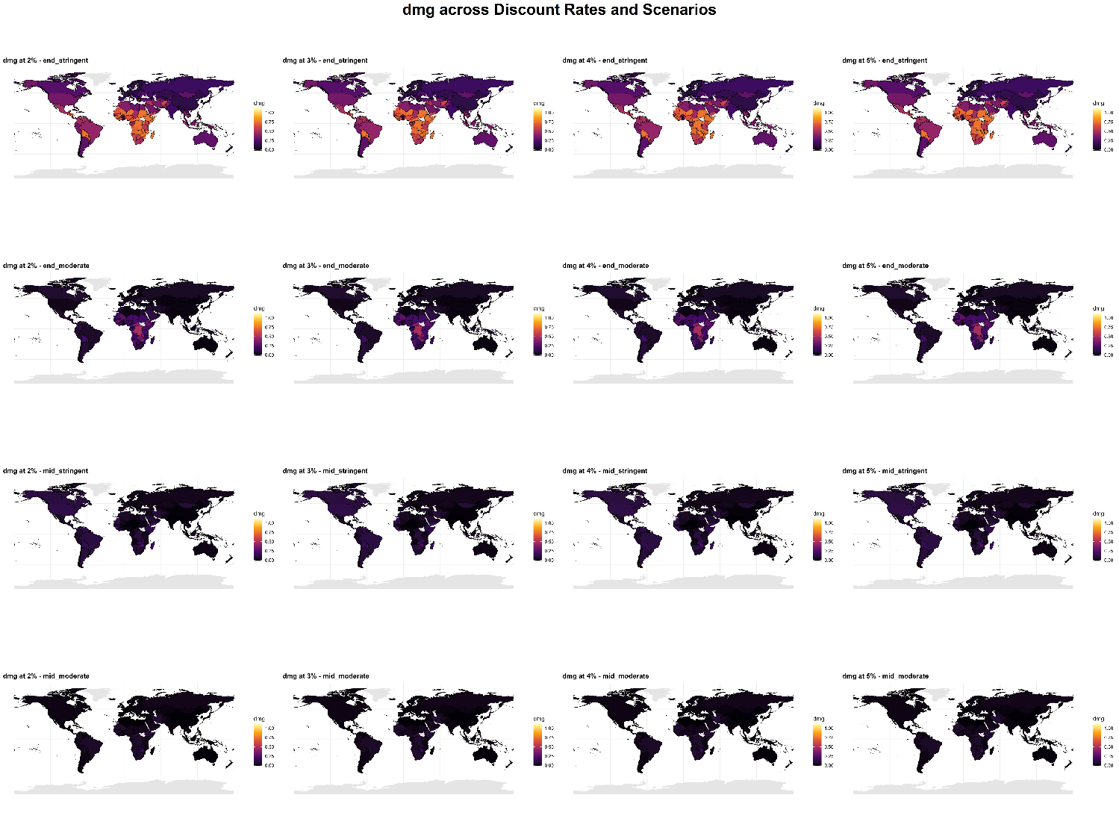
Supplementary Fig. 6.2 Sensitivity analysis for avoided economic damage (dmg) across discount rates. This figure displays avoided economic damage (dmg, unit: % of cumulative GDP) at discount rates of 2%, 3%, 4%, and 5%, under two mitigation scenarios (stringent and moderate) and two time periods (mid- and end-century).
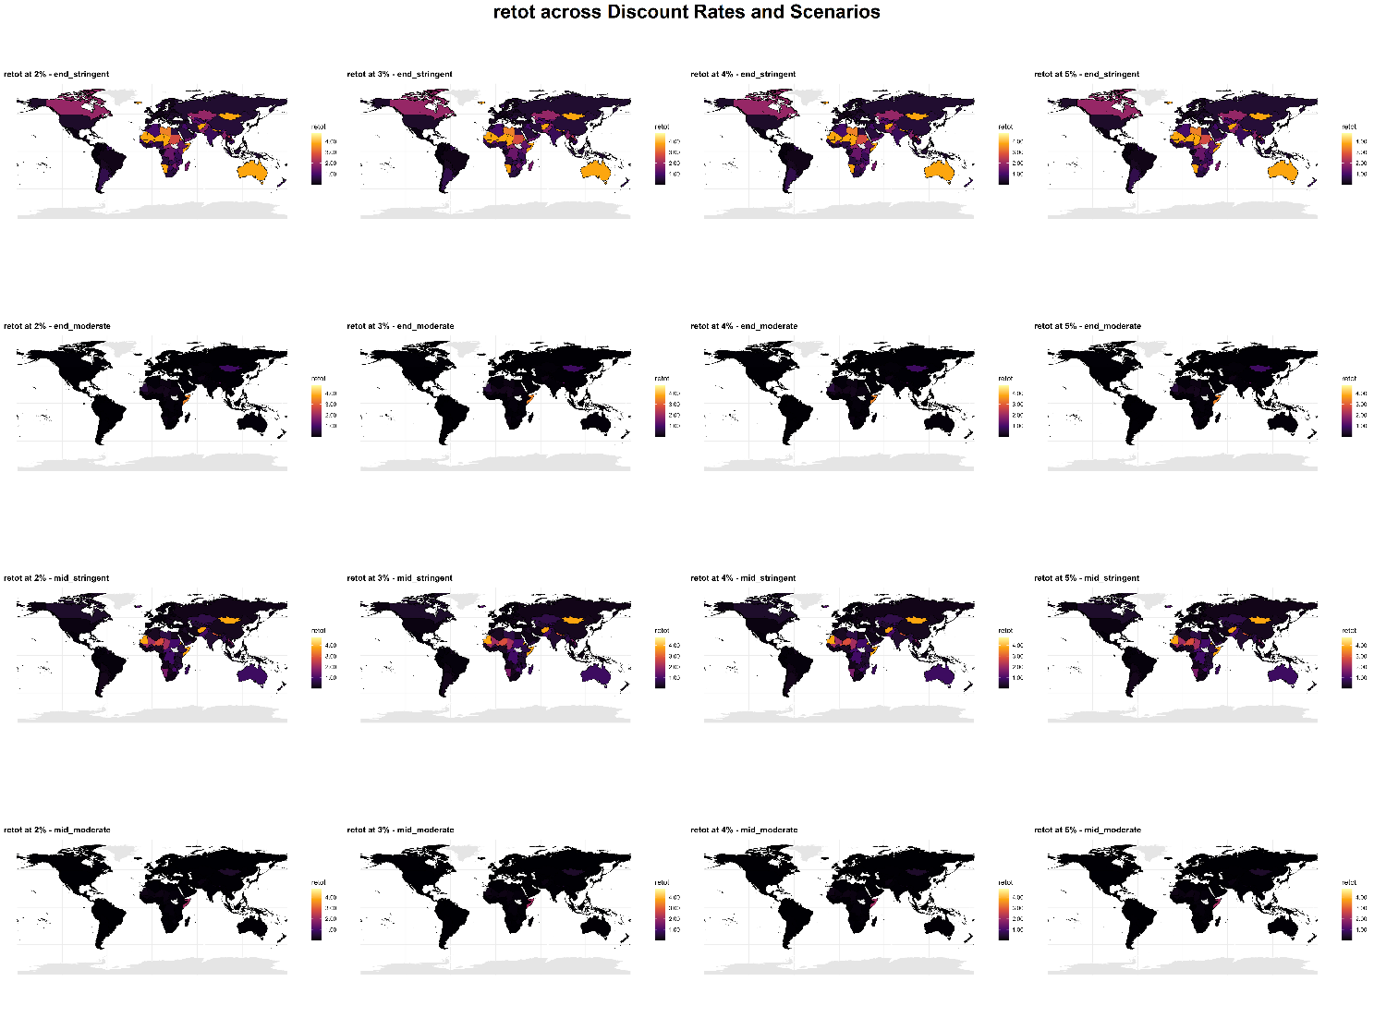
Supplementary Fig. 6.3 Sensitivity analysis for total renewable mitigation potential (retot) across discount rates. This figure displays total renewable mitigation potential (retot, unit: % of cumulative GDP) at discount rates of 2%, 3%, 4%, and 5%, under two mitigation scenarios (stringent and moderate) and two time periods (mid- and end-century).
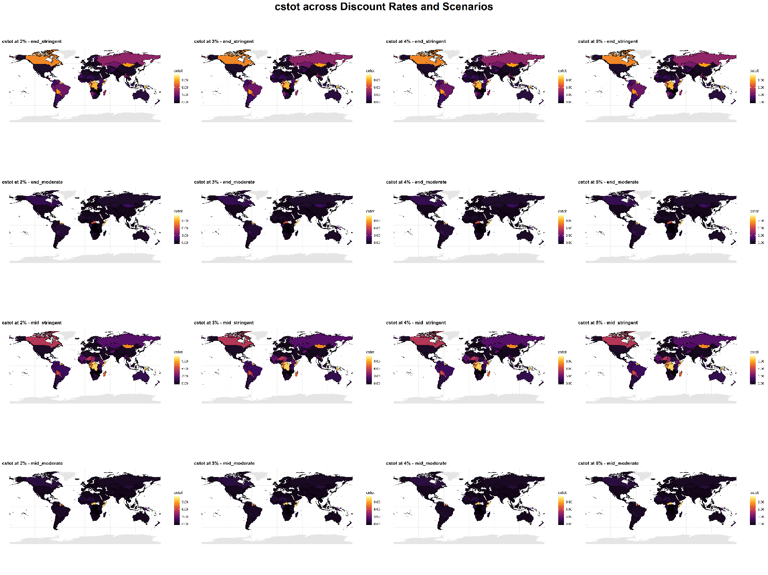
Supplementary Fig. 6.4 Sensitivity analysis for total carbon sequestration capacity (cstot) across discount rates. This figure displays total carbon sequestration capacity (cstot, unit: % of cumulative GDP) at discount rates of 2%, 3%, 4%, and 5%, under two mitigation scenarios (stringent and moderate) and two time periods (mid- and end-century).

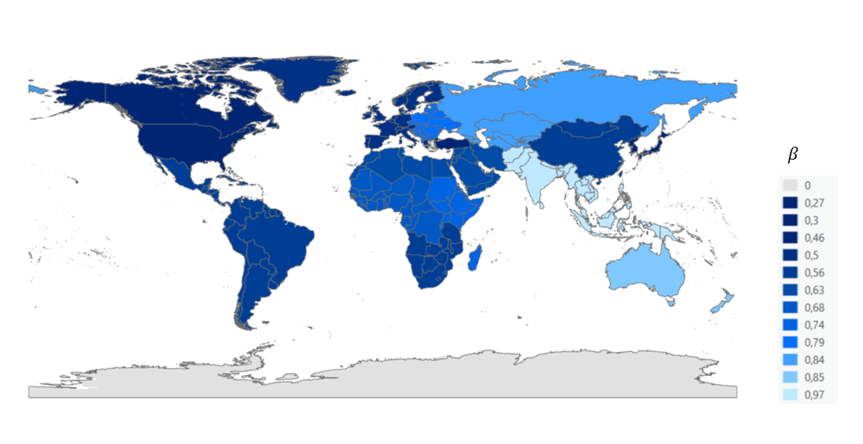
Supplementary Fig. 7 Region-specific coefficient β_r for converting floor area to roof area.

Supplementary Tables
Supplementary Table 1 Five most similar countries for each country based on distance-based similarity analysis. Similarity coefficient is calculated based on detailed sub-dimensional factors, including fossil fuel rent losses (coal, gas, oil), avoided economic damage, mitigation potential from solar and wind energy generation, and natural and managed carbon sequestration capacities.
ISO3 | Top1 | Top2 | Top3 | Top4 | Top5
AFG | NER (0.58) | ERI (0.55) | MLI (0.52) | MRT (0.5) | TCD (0.49)
AGO | IRQ (0.44) | SAU (0.44) | ECU (0.43) | KWT (0.42) | COG (0.41)
ALB | HRV (0.82) | ITA (0.8) | HUN (0.8) | SVK (0.79) | SVN (0.79)
ARE | THA (0.75) | ALB (0.7) | MEX (0.7) | USA (0.69) | DNK (0.67)
ARG | USA (0.65) | NZL (0.63) | EGY (0.62) | ISR (0.62) | PER (0.61)
ARM | EST (0.74) | LTU (0.73) | SVK (0.73) | BLR (0.73) | FIN (0.73)
AUS | KAZ (0.48) | CHN (0.46) | BWA (0.46) | IDN (0.46) | ZAF (0.46)
AUT | ITA (0.91) | CHE (0.9) | ESP (0.89) | BEL (0.89) | FRA (0.87)
AZE | IRN (0.7) | DZA (0.67) | OMN (0.6) | QAT (0.54) | TKM (0.53)
BDI | RWA (0.59) | BEN (0.56) | SWZ (0.55) | YEM (0.52) | NPL (0.52)
BEL | LUX (0.92) | CHE (0.91) | ESP (0.91) | FRA (0.9) | SVK (0.9)
BEN | RWA (0.74) | TZA (0.72) | KEN (0.72) | SWZ (0.71) | MWI (0.7)
BFA | TJK (0.75) | TGO (0.71) | KEN (0.69) | KGZ (0.68) | YEM (0.65)
BGD | TGO (0.64) | PAK (0.63) | TJK (0.63) | MDA (0.62) | UZB (0.62)
BGR | MKD (0.77) | BIH (0.74) | MNE (0.71) | IND (0.69) | CHN (0.67)
BHS | URY (0.72) | CUB (0.66) | WSM (0.66) | MUS (0.65) | IRL (0.64)
BIH | BGR (0.74) | CHN (0.71) | MNE (0.68) | MKD (0.66) | SRB (0.65)
BLR | CHL (0.87) | SVK (0.87) | CHE (0.87) | ESP (0.86) | FRA (0.85)
BLZ | PRY (0.66) | CMR (0.65) | NIC (0.57) | HND (0.56) | KHM (0.55)
BOL | PER (0.48) | PRY (0.48) | BLZ (0.45) | BRA (0.44) | GAB (0.44)
BRA | PER (0.7) | THA (0.65) | MEX (0.65) | PAN (0.63) | USA (0.63)
BRN | TTO (0.47) | NOR (0.44) | IRN (0.4) | OMN (0.4) | QAT (0.39)
BTN | NPL (0.48) | KGZ (0.44) | TJK (0.44) | SWZ (0.42) | BFA (0.42)
BWA | COL (0.54) | CHN (0.51) | BIH (0.51) | BGR (0.51) | ZAF (0.51)
CAF | COD (0.37) | MDG (0.36) | BLZ (0.34) | GAB (0.34) | CMR (0.34)
CAN | LBY (0.48) | MYS (0.43) | VEN (0.43) | NOR (0.42) | SAU (0.41)
CHE | ESP (0.93) | FRA (0.91) | BEL (0.91) | AUT (0.9) | SVK (0.9)
CHL | HKG (0.87) | BLR (0.87) | SWE (0.87) | KOR (0.86) | FIN (0.86)
CHN | BIH (0.71) | BGR (0.67) | IDN (0.63) | IND (0.6) | MKD (0.58)
CIV | SYR (0.82) | GTM (0.79) | JOR (0.79) | GMB (0.77) | MAR (0.77)
CMR | BLZ (0.65) | LBR (0.61) | BEN (0.59) | TZA (0.57) | CIV (0.56)
COD | MDG (0.42) | ETH (0.38) | BLZ (0.38) | CMR (0.37) | CAF (0.37)
COG | GAB (0.52) | NIC (0.51) | PRY (0.51) | BLZ (0.5) | BRA (0.46)
COL | CHN (0.58) | IDN (0.57) | BWA (0.54) | BIH (0.53) | BGR (0.53)
COM | SLV (0.87) | GTM (0.79) | CRI (0.79) | HTI (0.78) | PSE (0.76)
CPV | PRI (0.9) | CYP (0.89) | PRT (0.89) | JPN (0.89) | PYF (0.87)
CRI | PAN (0.87) | HTI (0.86) | LKA (0.84) | DOM (0.82) | JAM (0.81)
CUB | WSM (0.73) | SWE (0.72) | URY (0.72) | CPV (0.71) | CRI (0.7)
CYP | JPN (0.93) | PRT (0.93) | PRI (0.9) | CPV (0.89) | PYF (0.88)
CZE | POL (0.88) | DEU (0.84) | SVN (0.8) | UKR (0.8) | GRC (0.79)
DEU | CHE (0.86) | ESP (0.86) | FRA (0.85) | SVN (0.85) | SVK (0.85)
DJI | SEN (0.77) | UZB (0.73) | YEM (0.72) | MDA (0.71) | TUN (0.69)
DNK | IRL (0.82) | MUS (0.81) | KOR (0.81) | GBR (0.79) | CHL (0.79)
DOM | LBN (0.91) | LKA (0.9) | JAM (0.89) | PRT (0.87) | CYP (0.87)
DZA | AZE (0.67) | IRN (0.62) | OMN (0.61) | TKM (0.54) | USA (0.54)
ECU | KWT (0.67) | SAU (0.65) | ARE (0.65) | THA (0.64) | USA (0.6)
EGY | ISR (0.74) | MEX (0.73) | NGA (0.72) | TUN (0.7) | USA (0.7)
ERI | NER (0.65) | AFG (0.55) | MLI (0.53) | TCD (0.46) | MRT (0.45)
ESP | CHE (0.93) | SVK (0.92) | FRA (0.91) | BEL (0.91) | ITA (0.9)
EST | LTU (0.88) | AUT (0.85) | ESP (0.85) | ITA (0.84) | BLR (0.84)
ETH | UGA (0.68) | MDG (0.67) | SLE (0.65) | MWI (0.62) | KEN (0.6)
FIN | SWE (0.91) | CHL (0.86) | BLR (0.85) | CPV (0.84) | PRI (0.83)
FJI | VUT (0.73) | GEO (0.58) | LVA (0.58) | BRA (0.57) | EST (0.57)
FRA | CHE (0.91) | ESP (0.91) | BEL (0.9) | LUX (0.89) | AUT (0.87)
GAB | PRY (0.61) | NIC (0.58) | BLZ (0.53) | COG (0.52) | PNG (0.51)
GBR | FRA (0.79) | DNK (0.79) | NLD (0.79) | CHE (0.78) | IRL (0.78)
GEO | LVA (0.81) | EST (0.76) | LTU (0.74) | AUT (0.73) | ARM (0.72)
GHA | LTU (0.79) | LUX (0.78) | SVK (0.77) | HRV (0.77) | FRA (0.75)
GIN | CIV (0.75) | GTM (0.74) | SLE (0.71) | SYR (0.71) | COM (0.69)
GMB | SYR (0.83) | JOR (0.83) | MAR (0.83) | PSE (0.82) | SLV (0.79)
GNB | SDN (0.58) | DJI (0.54) | MRT (0.53) | NAM (0.52) | TLS (0.52)
GNQ | CRI (0.8) | HTI (0.78) | PAN (0.76) | MAR (0.75) | LKA (0.74)
GRC | TUR (0.86) | CYP (0.84) | PRT (0.84) | JPN (0.83) | LBN (0.82)
GTM | SLV (0.8) | CIV (0.79) | COM (0.79) | SYR (0.77) | GMB (0.75)
GUY | SUR (0.7) | PNG (0.44) | FJI (0.39) | GAB (0.39) | VUT (0.38)
HKG | PYF (0.93) | NLD (0.88) | PRI (0.88) | CHE (0.87) | JPN (0.87)
HND | CIV (0.76) | GTM (0.72) | GNQ (0.7) | SLV (0.7) | COM (0.7)
HRV | SVK (0.89) | ESP (0.88) | BEL (0.87) | SVN (0.87) | ITA (0.85)
HTI | CRI (0.86) | PAN (0.85) | LKA (0.83) | JAM (0.82) | PSE (0.82)
HUN | SVN (0.86) | HRV (0.85) | UKR (0.82) | BEL (0.81) | ALB (0.8)
IDN | CHN (0.63) | COL (0.57) | BIH (0.56) | BGR (0.56) | IND (0.51)
IND | MKD (0.76) | MNE (0.74) | BGR (0.69) | POL (0.68) | ROU (0.67)
IRL | CHL (0.86) | KOR (0.85) | ESP (0.83) | DNK (0.82) | FRA (0.82)
IRN | AZE (0.7) | OMN (0.69) | DZA (0.62) | QAT (0.61) | TTO (0.59)
IRQ | SAU (0.65) | KWT (0.59) | ECU (0.55) | MYS (0.53) | VEN (0.53)
ISL | TLS (0.52) | MUS (0.5) | DNK (0.49) | TUN (0.49) | NZL (0.49)
ISR | MEX (0.75) | PHL (0.75) | LBN (0.74) | HTI (0.74) | EGY (0.74)
ITA | JPN (0.91) | AUT (0.91) | CHE (0.9) | BEL (0.9) | ESP (0.9)
JAM | DOM (0.89) | PAN (0.87) | LKA (0.87) | LBN (0.85) | CPV (0.85)
JOR | SYR (0.9) | GMB (0.83) | MAR (0.81) | CIV (0.79) | TUN (0.74)
JPN | CYP (0.93) | PYF (0.93) | PRI (0.92) | PRT (0.91) | ITA (0.91)
KAZ | AUS (0.48) | CHN (0.46) | VNM (0.43) | BIH (0.43) | BWA (0.43)
KEN | TZA (0.75) | MWI (0.73) | SWZ (0.72) | YEM (0.72) | BEN (0.72)
KGZ | BFA (0.68) | TJK (0.67) | TGO (0.63) | NPL (0.61) | YEM (0.6)
KHM | TZA (0.71) | SEN (0.69) | KEN (0.69) | SLE (0.67) | DJI (0.67)
KOR | PYF (0.89) | PRI (0.88) | JPN (0.88) | PRT (0.88) | HKG (0.87)
KWT | SAU (0.8) | ECU (0.67) | MYS (0.6) | VEN (0.6) | IRQ (0.59)
LAO | SRB (0.41) | MNE (0.39) | BIH (0.38) | ZWE (0.37) | IND (0.37)
LBN | DOM (0.91) | LKA (0.9) | PRT (0.89) | CYP (0.88) | JPN (0.86)
LBR | CMR (0.61) | BEN (0.55) | GIN (0.52) | CIV (0.52) | RWA (0.51)
LBY | SAU (0.51) | MYS (0.49) | CAN (0.48) | KWT (0.47) | IRQ (0.46)
LKA | LBN (0.9) | DOM (0.9) | JAM (0.87) | PAN (0.85) | PRT (0.85)
LSO | SLE (0.61) | TZA (0.59) | UGA (0.58) | ETH (0.57) | GIN (0.55)
LTU | ESP (0.89) | SVK (0.88) | EST (0.88) | CHE (0.87) | LUX (0.86)
LUX | BEL (0.92) | SVK (0.9) | FRA (0.89) | CHE (0.89) | ESP (0.88)
LVA | GEO (0.81) | EST (0.8) | LTU (0.78) | AUT (0.76) | ESP (0.73)
MAR | LKA (0.85) | GMB (0.83) | TUN (0.82) | SYR (0.81) | JOR (0.81)
MDA | UZB (0.79) | HUN (0.78) | HRV (0.76) | SEN (0.75) | GHA (0.73)
MDG | ETH (0.67) | SLE (0.54) | LSO (0.54) | UGA (0.53) | KEN (0.51)
MEX | THA (0.78) | ISR (0.75) | PHL (0.74) | USA (0.74) | EGY (0.73)
MKD | MNE (0.78) | BGR (0.77) | IND (0.76) | ROU (0.69) | POL (0.68)
MLI | NER (0.63) | TCD (0.58) | ERI (0.53) | AFG (0.52) | MRT (0.5)
MMR | TKM (0.6) | PAK (0.48) | DZA (0.48) | AZE (0.48) | BGD (0.46)
MNE | MKD (0.78) | IND (0.74) | BGR (0.71) | BIH (0.68) | ROU (0.62)
MNG | AUS (0.36) | MOZ (0.34) | ZAF (0.33) | KAZ (0.33) | BWA (0.32)
MOZ | ZAF (0.48) | ZWE (0.45) | BWA (0.44) | SRB (0.44) | BIH (0.4)
MRT | NAM (0.61) | GNB (0.53) | SDN (0.51) | TCD (0.51) | AFG (0.5)
MUS | KOR (0.85) | CYP (0.83) | PRT (0.82) | JPN (0.82) | IRL (0.81)
MWI | RWA (0.75) | KEN (0.73) | TZA (0.73) | SLE (0.72) | SWZ (0.7)
MYS | KWT (0.6) | VEN (0.6) | SAU (0.6) | ECU (0.54) | IRQ (0.53)
NAM | MRT (0.61) | SDN (0.53) | GNB (0.52) | DJI (0.48) | BHS (0.47)
NCL | SLB (0.45) | URY (0.45) | CUB (0.44) | BHS (0.42) | WSM (0.42)
NER | ERI (0.65) | MLI (0.63) | AFG (0.58) | TCD (0.52) | MRT (0.46)
NGA | EGY (0.72) | SYR (0.69) | JOR (0.68) | CIV (0.67) | MEX (0.66)
NIC | PRY (0.66) | GAB (0.58) | BLZ (0.57) | CMR (0.54) | HND (0.53)
NLD | HKG (0.88) | PYF (0.88) | ITA (0.88) | CHE (0.87) | JPN (0.87)
NOR | TTO (0.61) | OMN (0.55) | IRN (0.5) | DZA (0.47) | AZE (0.47)
NPL | KGZ (0.61) | TJK (0.6) | SWZ (0.58) | YEM (0.55) | BFA (0.54)
NZL | SWE (0.71) | IRL (0.7) | DNK (0.7) | FIN (0.7) | CHL (0.69)
OMN | IRN (0.69) | DZA (0.61) | AZE (0.6) | TTO (0.59) | NOR (0.55)
PAK | BGD (0.63) | YEM (0.61) | EGY (0.6) | DJI (0.59) | SEN (0.59)
PAN | JAM (0.87) | CRI (0.87) | LKA (0.85) | HTI (0.85) | DOM (0.84)
PER | BRA (0.7) | ISR (0.64) | PAN (0.63) | MEX (0.63) | JAM (0.62)
PHL | TUR (0.81) | MAR (0.78) | LKA (0.78) | LBN (0.77) | HTI (0.77)
PNG | FJI (0.54) | BLZ (0.53) | PRY (0.52) | GAB (0.51) | VUT (0.5)
POL | CZE (0.88) | DEU (0.78) | UKR (0.77) | SVN (0.75) | GRC (0.73)
PRI | JPN (0.92) | PYF (0.91) | CPV (0.9) | CYP (0.9) | PRT (0.88)
PRT | CYP (0.93) | JPN (0.91) | LBN (0.89) | CPV (0.89) | PRI (0.88)
PRY | BLZ (0.66) | NIC (0.66) | GAB (0.61) | HND (0.56) | CMR (0.55)
PSE | GMB (0.82) | HTI (0.82) | SLV (0.81) | TUN (0.81) | MAR (0.8)
PYF | HKG (0.93) | JPN (0.93) | PRI (0.91) | ITA (0.9) | KOR (0.89)
QAT | IRN (0.61) | AZE (0.54) | OMN (0.54) | TTO (0.52) | TKM (0.51)
ROU | UKR (0.77) | HUN (0.76) | SVN (0.74) | POL (0.73) | CZE (0.73)
RUS | AZE (0.48) | DZA (0.48) | USA (0.46) | ARG (0.46) | PER (0.46)
RWA | MWI (0.75) | BEN (0.74) | TZA (0.69) | SWZ (0.69) | KEN (0.69)
SAU | KWT (0.8) | ECU (0.65) | IRQ (0.65) | MYS (0.6) | VEN (0.59)
SDN | DJI (0.58) | GNB (0.58) | KEN (0.56) | YEM (0.55) | PAK (0.54)
SEN | DJI (0.77) | MDA (0.75) | YEM (0.74) | UZB (0.73) | JOR (0.72)
SLB | NCL (0.45) | ZMB (0.41) | URY (0.37) | CUB (0.37) | WSM (0.36)
SLE | TZA (0.74) | MWI (0.72) | GIN (0.71) | KEN (0.68) | UGA (0.68)
SLV | COM (0.87) | HTI (0.81) | PSE (0.81) | GTM (0.8) | MAR (0.79)
SOM | CAF (0.31) | ERI (0.3) | COD (0.3) | NER (0.28) | MDG (0.28)
SRB | BIH (0.65) | CHN (0.56) | MNE (0.55) | BGR (0.54) | MKD (0.51)
SUR | GUY (0.7) | PNG (0.45) | GAB (0.44) | PRY (0.4) | FJI (0.4)
SVK | ESP (0.92) | CHE (0.9) | BEL (0.9) | LUX (0.9) | HRV (0.89)
SVN | BEL (0.88) | HRV (0.87) | SVK (0.86) | ESP (0.86) | ITA (0.86)
SWE | FIN (0.91) | CHL (0.87) | BLR (0.84) | CPV (0.82) | PRI (0.82)
SWZ | KEN (0.72) | BEN (0.71) | MWI (0.7) | RWA (0.69) | YEM (0.67)
SYR | JOR (0.9) | GMB (0.83) | CIV (0.82) | MAR (0.81) | SLV (0.78)
TCD | MLI (0.58) | NER (0.52) | MRT (0.51) | GNB (0.5) | AFG (0.49)
TGO | MDA (0.73) | GHA (0.73) | BFA (0.71) | UZB (0.7) | TJK (0.7)
THA | MEX (0.78) | USA (0.77) | ARE (0.75) | ALB (0.72) | VNM (0.69)
TJK | BFA (0.75) | TGO (0.7) | YEM (0.68) | KGZ (0.67) | KEN (0.67)
TKM | MMR (0.6) | DZA (0.54) | AZE (0.53) | IRN (0.52) | QAT (0.51)
TLS | TUN (0.6) | PSE (0.57) | BHS (0.57) | DJI (0.56) | MUS (0.56)
TTO | NOR (0.61) | IRN (0.59) | OMN (0.59) | AZE (0.53) | QAT (0.52)
TUN | MAR (0.82) | PSE (0.81) | GMB (0.78) | LKA (0.78) | LBN (0.75)
TUR | GRC (0.86) | DOM (0.84) | LBN (0.84) | LKA (0.84) | PRT (0.82)
TZA | KEN (0.75) | SLE (0.74) | MWI (0.73) | BEN (0.72) | KHM (0.71)
UGA | MWI (0.7) | ETH (0.68) | SLE (0.68) | KEN (0.66) | TZA (0.65)
UKR | SVN (0.84) | GRC (0.82) | HUN (0.82) | TUR (0.81) | CZE (0.8)
URY | WSM (0.76) | BHS (0.72) | CUB (0.72) | SWE (0.68) | NZL (0.67)
USA | THA (0.77) | MEX (0.74) | EGY (0.7) | ARE (0.69) | ISR (0.66)
UZB | MDA (0.79) | HRV (0.74) | SEN (0.73) | HUN (0.73) | UKR (0.73)
VEN | MYS (0.6) | KWT (0.6) | SAU (0.59) | ECU (0.56) | IRQ (0.53)
VNM | THA (0.69) | USA (0.65) | IND (0.63) | ROU (0.63) | ALB (0.62)
VUT | FJI (0.73) | GEO (0.6) | EST (0.59) | LVA (0.59) | JAM (0.58)
WSM | URY (0.76) | SWE (0.73) | CUB (0.73) | JAM (0.71) | PAN (0.71)
YEM | SEN (0.74) | DJI (0.72) | KEN (0.72) | MDA (0.69) | TJK (0.68)
ZAF | BWA (0.51) | SRB (0.51) | MOZ (0.48) | BIH (0.46) | AUS (0.46)
ZMB | UGA (0.5) | TZA (0.47) | LSO (0.47) | SLE (0.47) | ETH (0.46)
ZWE | MOZ (0.45) | SRB (0.43) | ZAF (0.42) | BWA (0.4) | BIH (0.38)

Supplementary Table 2 CMIP6 General Circulation Models (GCMs) employed in this study.
GCM | RCP26 (SSP126) | RCP45 (SSP245) | RCP60 (SSP460)
CanESM5 | × | × | ×
CanESM5-1 | × | × | ×
FGOALS-g3 | × | × | ×
IPSL-CM6A-LR | × | × | ×
MIROC6 | × | × | ×
MRI-ESM2-0 | × | × | ×

Supplementary Table 3 The land suitability factors of different land or sea pixel types, based on Gernaat et al.’s study¹.
Land/Sea pixel type | LSF  (Utility PV, %) | LSF  (Onshore Wind, %) | LSF  (Offshore wind, %)
Forest | 0 | 10 | -
Tropical forest | 0 | 0
Barren land | 5 | 100 | -
Shrubland | 1 | 50 | -
Tropical shrubland | 0 | 0
Extensive grassland | 5 | 80 | -
grassland | 1 | 80 | -
Cropland | 1 | 70 | -
Biofuel land | 0 | 70
Urban area | 0 | 0 | -
Pixel with urban fraction > 90% | 0 | 0 | -
Average elevation > 2km | 0 | 0 | -
Average slope > 5 degree | 0 | 0 | -
Environmental protected area | 0 | 0 | -
Marine protected area | - | - | 0
Shipping lanes | - | - | 85
Exclusive economic zone (EEZ) | - | - | 100
Sea area outside the EEZ | - | - | 0
Sea area covered with permanent ice and snow | - | - | 0
See depth > 1km | - | - | 0

Supplementary Text

S1. Panel efficiency calculation
The photovoltaic (PV) panel efficiency at a given grid cell i and year t is calculated as:
$$η_{PV,i,t}=17\%×(1+γ\left[T_{i,t}-T_{STC}\right])$$
Where $T_{i,t}$ is the PV cell temperature, $T_{STC}=25$°C represents the standard condition, and $γ$ is the temperature coefficient of efficiency, reflecting the rate at which efficiency decreases with increasing temperature, which is -0.005 °C⁻¹².
Then, The PV cell temperature $T_{i,t}$ is estimated as a function of ambient environmental conditions using the following empirical equation:
$$T_{i,t}=c_{1}+c_{2}∙{tas}_{i,t}+c_{3}∙{rsds}_{i,t}+c_{4}∙{vws}_{i,t}$$
Where ${tas}_{i,t}$, ${rsds}_{i,t}$, ${vws}_{i,t}$ are ambient temperature, solar irradiation, wind speed (10m height), respectively, which can be derived from climate model datasets. The coefficients used in the temperature model are: $c_{1}$=4.3°C, $c_{2}$=0.943, $c_{3}$=0.028°C m² W⁻¹ and $c_{4}$=-1.528°C sm^{−11,3}.

S2. CF calculation method
To calculate the capacity factor (CF), a Weibull distribution function is employed to estimate the wind speed distribution over the course of a year. The probability of wind turbine operation within a specific wind speed range is determined using the cumulative Weibull distribution function:
$$P(v_{c}<v<v_{f})=exp [-{(v_{c}/c)}^{k}]-exp [-{(v_{f}/c)}^{k}]$$
$$c=v×{\text{(0.568+0.433}\text{/k}\text{) }}^{-\frac{1}{k}}$$
where $P\left(v_{c}<v<v_{f}\right)$ denotes the operation probability of a turbine; $v_{c}$ is the cut in speed; $v_{f}$ is the cut out speed; c and k are the Weibull scale parameter and shape parameter, respectively; In this study, the hub height is set as 100m and the wind speed at 100m height can be estimated according to the surface wind speed data from CMIP 6:
$$v\text{=}v_{ref}×{(H/H_{ref}) }^{α}$$
Subsequently, CF is derived from the probability distribution functions of wind turbine operation⁴,
$$CF=\frac{\exp\left(-{\left(\frac{v_{c}}{c}\right)}^{k}\right)-\exp\left(-{\left(\frac{v_{r}}{c}\right)}^{k}\right)}{{\left(\frac{v_{r}}{c}\right)}^{k}{-\left(\frac{v_{c}}{c}\right)}^{k}}-\exp\left(-{\left(\frac{v_{f}}{c}\right)}^{k}\right)$$
where $v_{c}$​, $v_{r}$​, and $v_{f}$ denote the cut-in wind speed (4 m/s), rated wind speed (13 m/s), and cut-out wind speed (25 m/s), respectively. The parameter k is the shape factor of the Weibull distribution, set to k=2¹, while c is the scale factor, calculated from the mean wind speed v and the shape parameter k. Together, these parameters characterize the wind speed distribution, which forms the basis for estimating the capacity factor. This formulation integrates the probabilistic characteristics of wind speed distributions with turbine operating parameters, enabling the estimation of capacity factor (CF) as a measure of expected energy generation under varying wind conditions.

References
1 Gernaat, D. E. H. J. et al. Climate change impacts on renewable energy supply. Nature Climate Change 11, 119-125 (2021). https://doi.org:10.1038/s41558-020-00949-9
2 Tonui, J. K. & Tripanagnostopoulos, Y. Performance improvement of PV/T solar collectors with natural air flow operation. Solar Energy 82, 1-12 (2008). https://doi.org:https://doi.org/10.1016/j.solener.2007.06.004
3 Chenni, R., Makhlouf, M., Kerbache, T. & Bouzid, A. A detailed modeling method for photovoltaic cells. Energy 32, 1724-1730 (2007). https://doi.org:https://doi.org/10.1016/j.energy.2006.12.006
4 Sasi, K. K. & Basu, S. On the Prediction of Capacity Factor and Selection of Size of Wind Electric Generators — a Study based on Indian Sites. Wind Engineering 21, 73-88 (1997).

