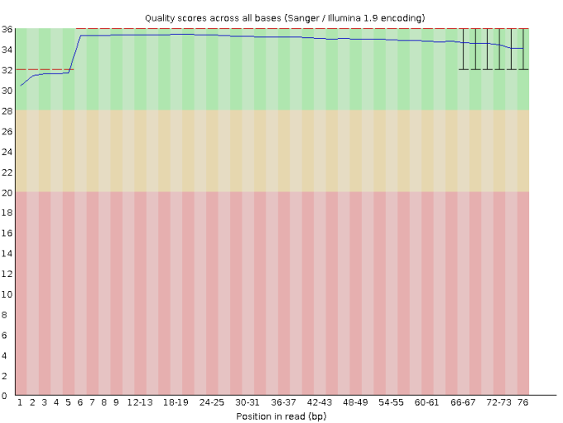Fig:S1 Per base sequence quality | 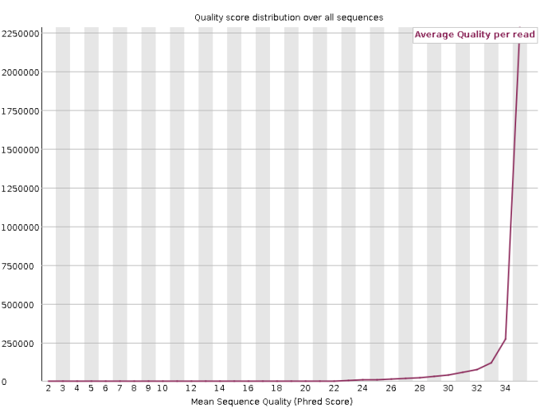Fig:S2 Per sequence quality scores
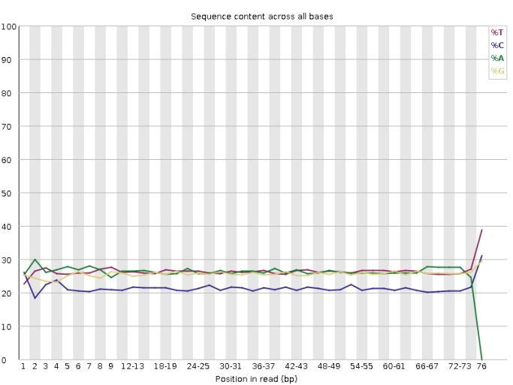Fig:S3 Per base sequence content | 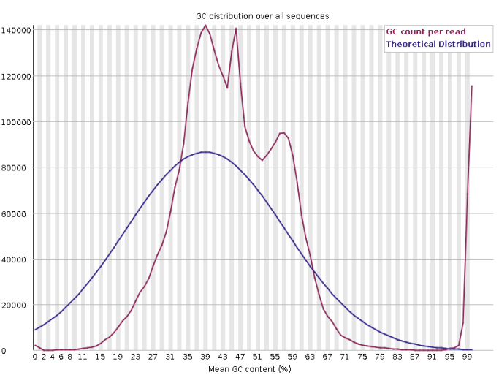Fig:S4 Per sequence GC content
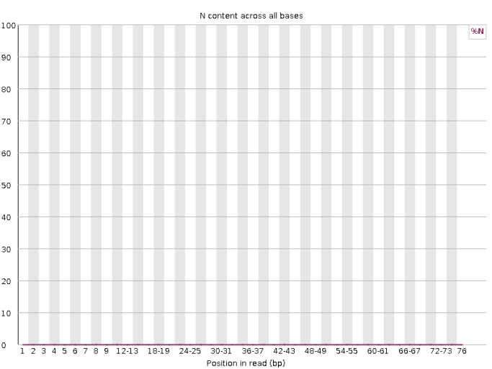Fig:S5 Per base N content | 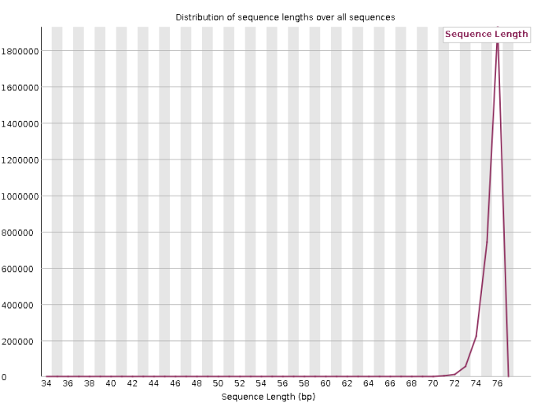Fig:S6 Sequence Length Distribution
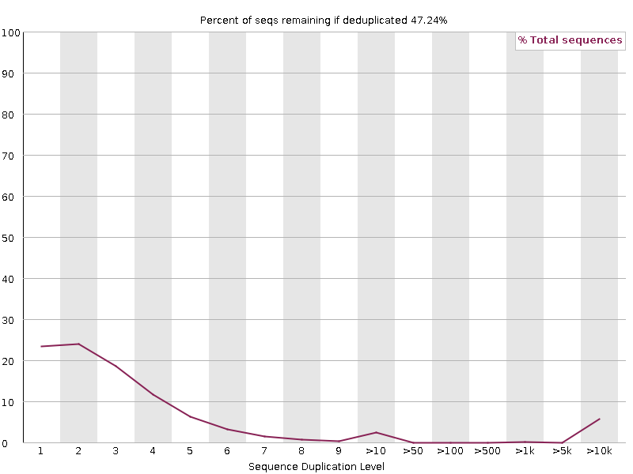Fig:S7 Sequence Duplication Levels | 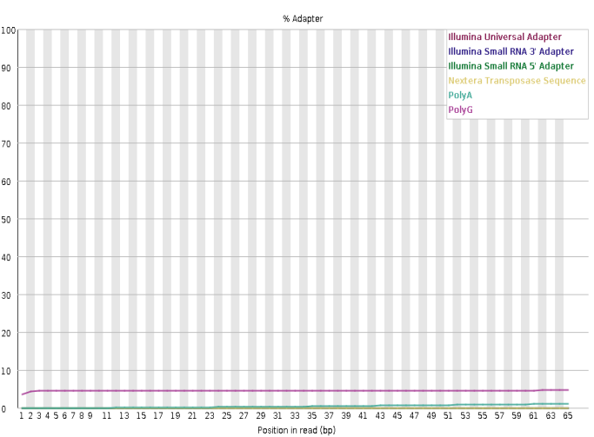Fig:S8 Adapter Content

Table S1 Basic Statistics of the FASTQ Results
Measure | Value
Filename | SRR15606980_1.gz
File type | Conventional base calls
Encoding | Sanger/Illumina 1.9
Total Sequences | 2986747
Total Bases | 225.1 Mbp
Sequences flagged as poor quality | 0
Sequence length | 35-76
%GC | 47

Table S2 Overrepresented sequences of SCLC cell lines
Sequence | Count | Percentage | Possible Source
GGGGGGGGGGGGGGGGGGGGGGGGGGGGGGGGGGGGGGGGGGGGGGGGGG | 114591 | 3.836649036560512 | No Hit
GATCGGAAGAGCACACGTCTGAACTCCAGTCACAGCTAAGCATCTCGTAT | 43546 | 1.4579741772570625 | TruSeq Adapter, Index 11 (97% over 38 bp)
TGGGGGGGGGGGGGGGGGGGGGGGGGGGGGGGGGGGGGGGGGGGGGGGGG | 16935 | 0.5670048383743249 | No Hit
AGGGGGGGGGGGGGGGGGGGGGGGGGGGGGGGGGGGGGGGGGGGGGGGGG | 4263 | 0.14273053593089738 | No Hit

