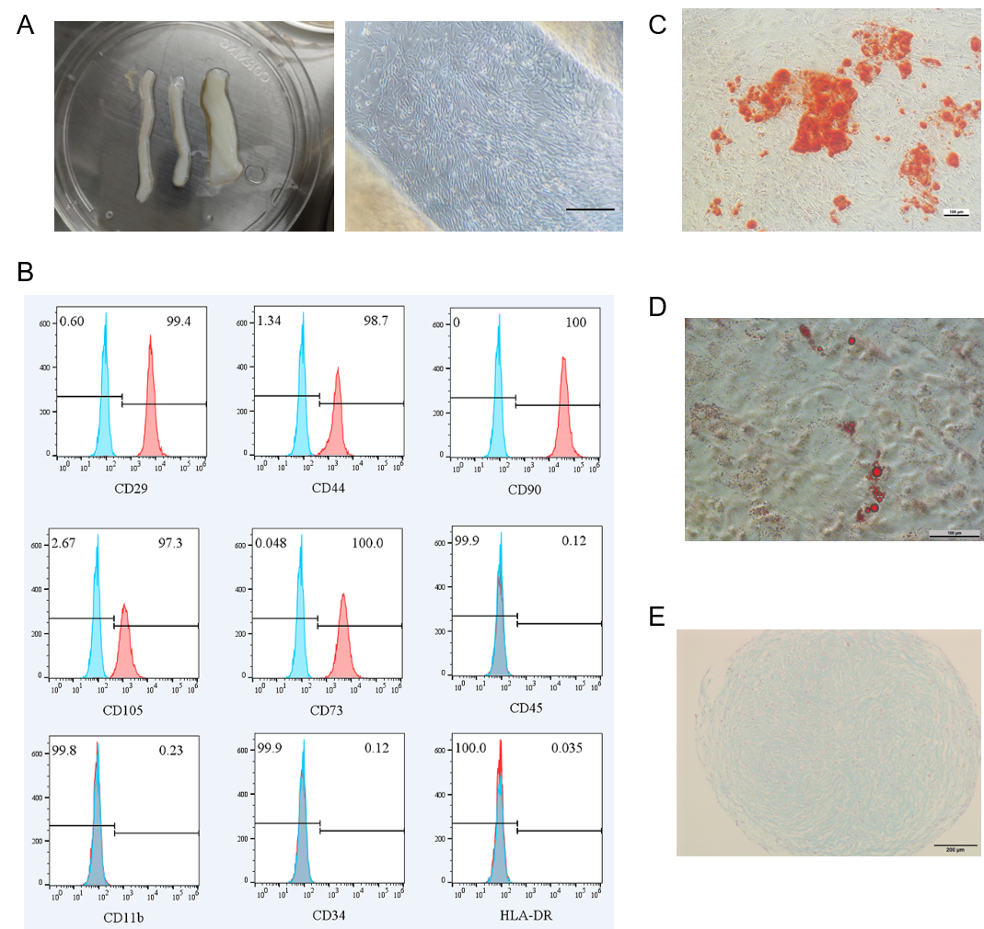
Figure S1. Isolation, culture, and characterization of MSCs. (A) Primary MSCs migrating from explanted Wharton's jelly of human umbilical cord tissue under adherent culture conditions, Scale bar shows 100 μm. (B) Flow cytometric analysis of surface markers in passage 3 (P3) MSCs. Positive markers: CD29 (99.4%), CD44 (98.7%), CD90 (100%), CD105 (97.3%), CD73 (100%); Negative markers: CD45 (0.12%), CD11b (0.23%), CD34 (0.12%), HLA-DR (0.035%). (C) Alizarin Red S staining demonstrating calcium deposition after osteogenic differentiation of P3 MSCs, scale bar show100 μm. (D) Lipid droplet formation visualized by Oil Red O staining following adipogenic induction in P3 MSCs, scale bar shows 100 μm. (E) Alcian Blue staining showing glycosaminoglycan synthesis during chondrogenic differentiation of P3 MSCs, scale bar shows 200 μm.

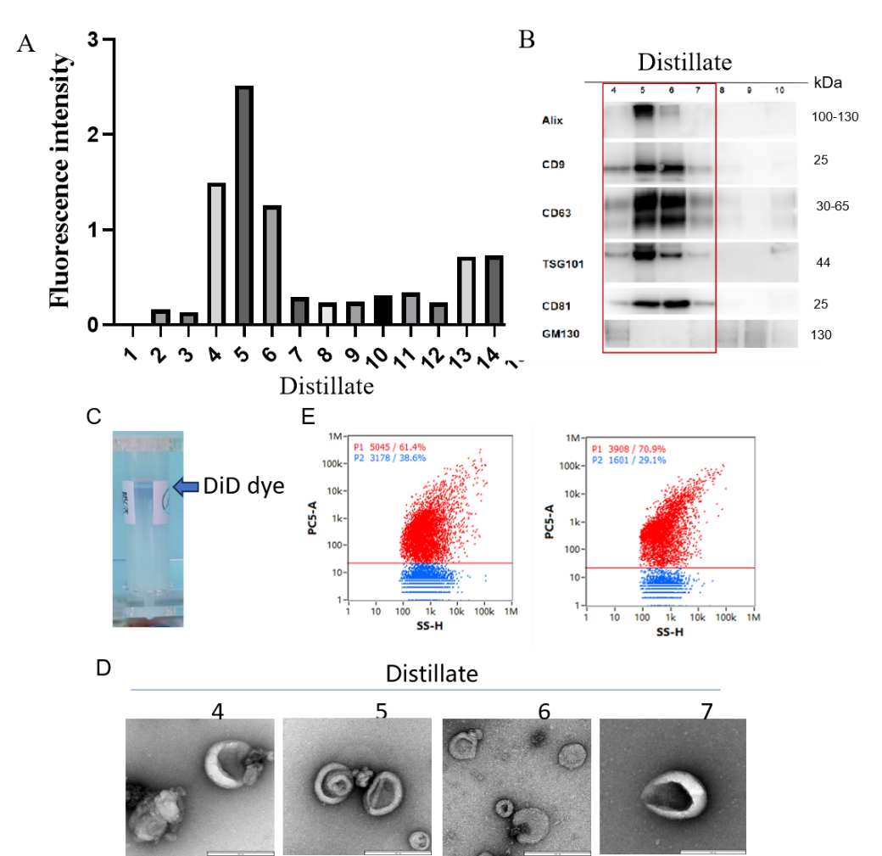
Figure S2. DID labelling of MSC-EVs and removal of free dye by SEC.(A) Fluorescence intensity of each fraction was detected by SEC after DID labelling of hucMSC-EVs. (B) Western blot identification of EV markers: Alix, CD9, CD63, TSG101,CD81, and golgi matrix marker: GM130. (C) Residual free dye in the upper layer is visible after SEC separation of DID-labelled MSC-EVs(blue arrow pointing). (D) TEM images of different fractions. scale bars show 200 nm.

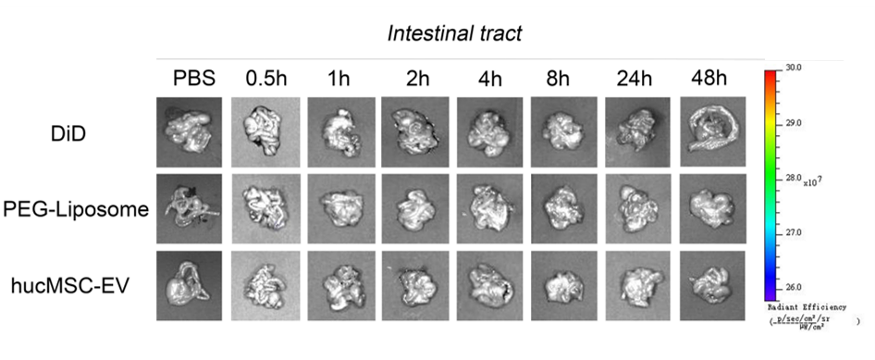
Figure S3. Post-injection gastrointestinal tract distribution. Fluorescence distribution imaging of the gastrointestinal tract organ in the DiD-Labeled PEG-Liposomes group and DiD-Labeled hucMSC-EVs group.

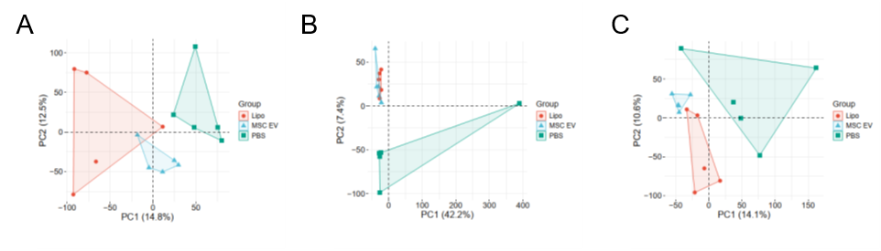
Figure S4. PCA plot performed on each groups. The PCA plot shows the distribution of liver(A), lung(B), and kidney(C) samples in a reduced-dimensional space, where each data point represents an observation in the data set. The X and Y axes of the plot represent the first two principal components, which capture the maximum variability in the data. The blue, red, and green colors respectively represent PEG-Liposomes, hucMSC-EVs, and PBS.

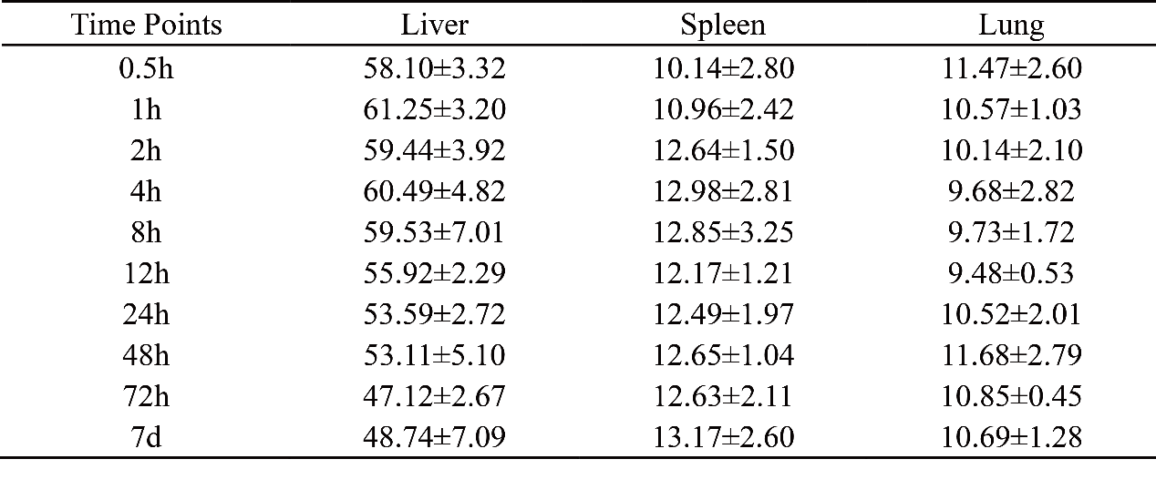
Table S1. Percentage of fluorescence of liver, spleen and lung as a percentage of fluorescence of all organs at different time points after injection of DiD-labelled hucMSC-EVs. Data are presented as mean ± standard deviation. n=5.

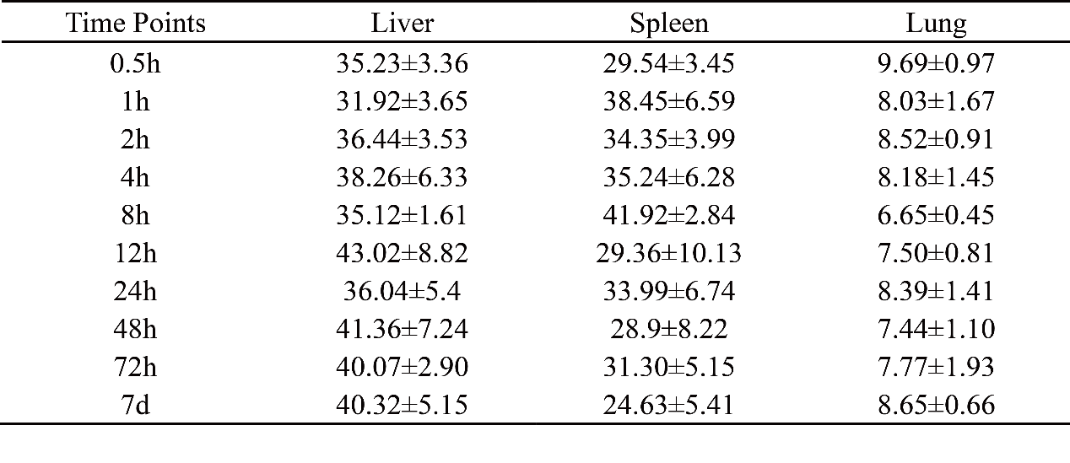 Table S2. Percentage of fluorescence of liver, spleen and lung as a percentage of fluorescence of all organs at different time points after injection of DiD-labelled PEG-Liposomes. Data are presented as mean ± standard deviation. n=5.

