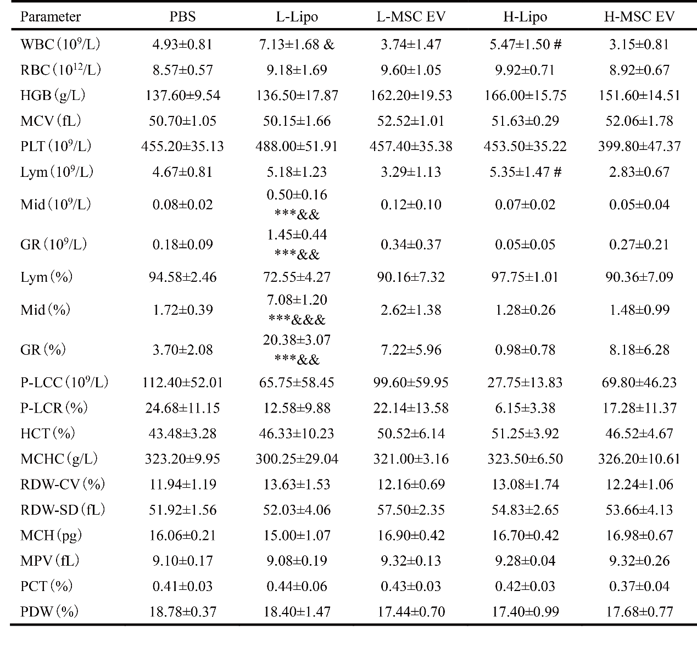
Table 1. Blood routine analysis after 5 injections. Data are presented as mean ± standard deviation. n=4. *** p< 0.001 vs PBS control group. & p<0.05, && p<0.01, &&& p<0.001 L-EV group vs L-Lipo group. # p<0.05, ## p<0.01, ### p<0.001 H-EV group vs H-Lipo group. WBC: white blood cell count; RBC: red blood cell count; HGB: hemoglobin; MCV: mean corpuscular volume; PLT: platelet count; Lym: lymphocyte count; Mid: mid-cell count; GR: granulocyte count; P-LCC: large platelet count; P-LCR: large platelet ratio; HCT: hematocrit; MCHC: mean corpuscular hemoglobin concentration; RDW-CV: red cell distribution width-coefficient of variation; RDW-SD: red cell distribution width-standard deviation; MCH: mean corpuscular hemoglobin; MPV: mean platelet volume; PCT: plateletcrit; PDW: platelet distribution width.

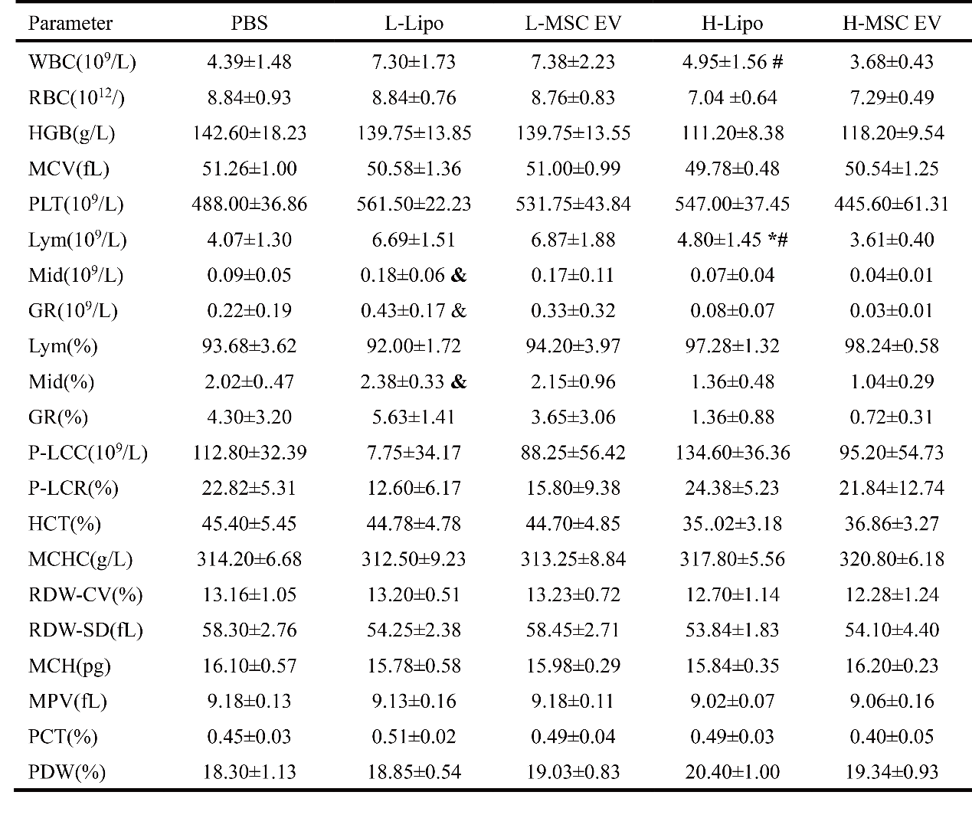
Table 2. Blood routine analysis after 10 injections. Data are presented as mean ± standard deviation. n=4. * p< 0.05 vs PBS control group. & p<0.05 L-EV group vs L-Lipo group. # p<0.05, H-EV group vs H-Lipo group. WBC: white blood cell count; RBC: red blood cell count; HGB: hemoglobin; MCV: mean corpuscular volume; PLT: platelet count; Lym: lymphocyte count; Mid: mid-cell count; GR: granulocyte count; P-LCC: large platelet count; P-LCR: large platelet ratio; HCT: hematocrit; MCHC: mean corpuscular hemoglobin concentration; RDW-CV: red cell distribution width-coefficient of variation; RDW-SD: red cell distribution width-standard deviation; MCH: mean corpuscular hemoglobin; MPV: mean platelet volume; PCT: plateletcrit; PDW: platelet distribution width.

