Appendix

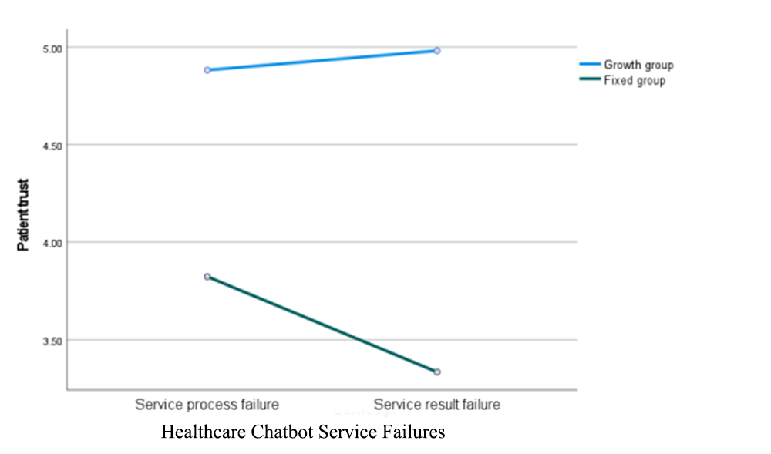

Fig.1 Experiment 2: Result graph of interaction effects

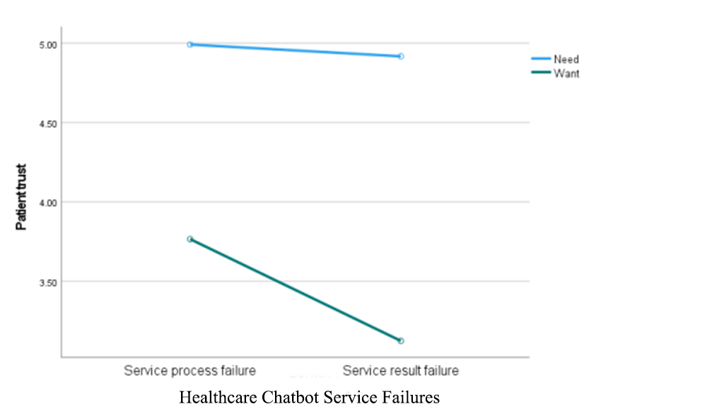
Fig.2 Experiment 3: Result graph of interaction effects

