Clinical evaluation
Supplementary Table 1 Clinical parameters and tests used to determine the type of hearing loss
Clinical evaluation | Tests | Confirmation
Evaluation at the time of pregnancy | Infections during pregnancy (STORCH&HIV tests) | To rule out congenital non-genetic causes
Evaluation at the time of pregnancy | Use of ototoxic medication | To rule out congenital non-genetic causes
Newborn health parameters | Birth asphyxia | To rule out birth-related complications
Newborn health parameters | Birth weight <1.5kg | To rule out birth-related complications
Newborn health parameters | Neonatal APGAR scores <0–4 at one minute or <0–6 at five minutes | To rule out birth-related complications
Newborn health parameters | The need for neonatal mechanical ventilation | To rule out birth-related complications
Newborn health parameters | Hyperbilirubinaemia requiring transfusion | To rule out birth-related complications
Audiometric assessment | Pure Tone Audiometry (PTA) | To confirm hearing loss
Audiometric assessment | Otoacoustic Emission (OAE) | To confirm hearing loss
Audiometric assessment | Bone conduction | To rule out conductive hearing loss
Audiometric assessment | Tympanometry | To rule out conductive hearing loss
Audiometric assessment | Brainstem Evoked Response Audiometry (BERA) | To confirm sensorineural hearing loss
Biochemical analysis | Hemoglobin level | To confirm syndromic hearing loss
Biochemical analysis | Thyroid stimulating hormone | To confirm syndromic hearing loss
Biochemical analysis | Serum creatinine | To confirm syndromic hearing loss
Biochemical analysis | Fasting blood glucose | To confirm syndromic hearing loss
Radiological imaging | Computer Tomography (CT) Scan | To rule out ear malformations
Radiological imaging | Magnetic Resonance Interference (MRI) | To rule out ear malformations
STORCH syphilis toxoplasmosis other infections (varicella zoster virus, parvovirus B19) rubella cytomegalovirus and herpes simplex virus, HIV human immunodeficiency virus
Family pedigree
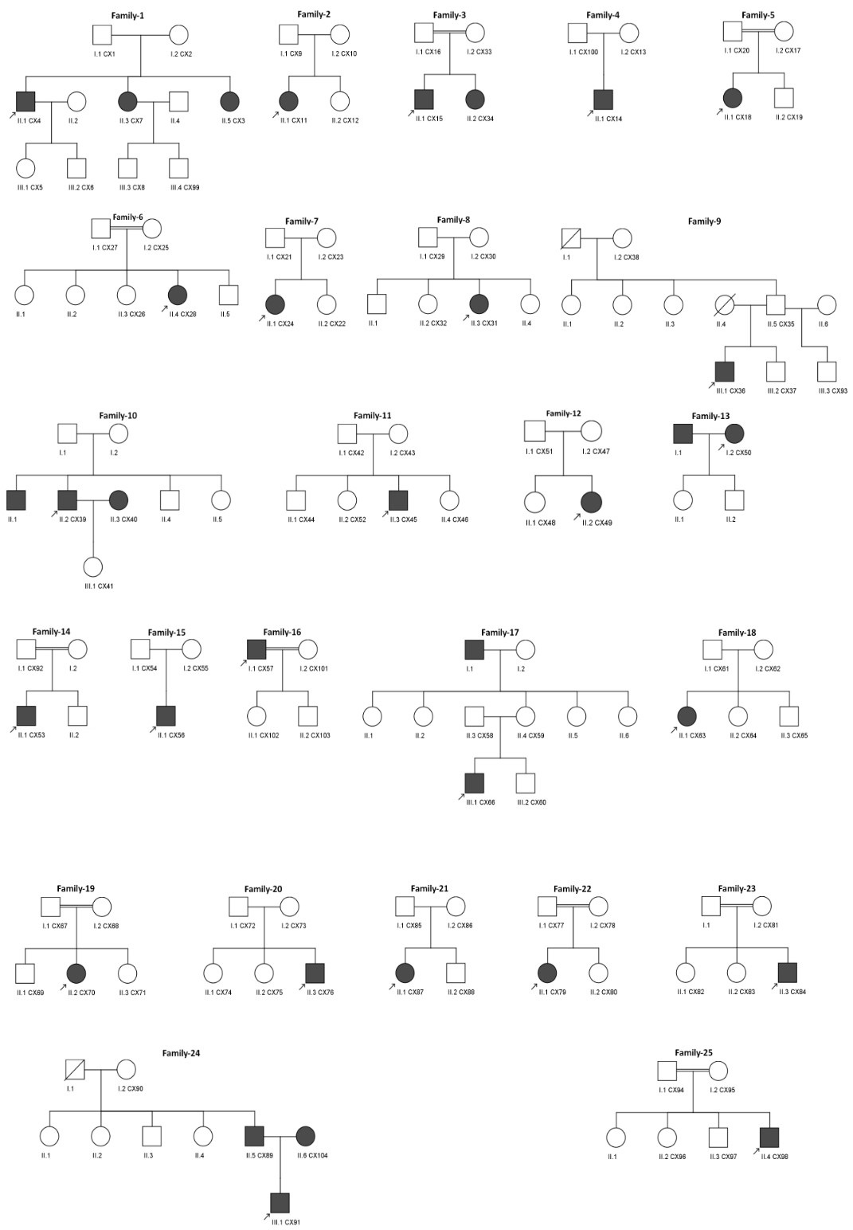
Supplementary Fig. 1 Family pedigree was drawn for all 25 families studied using CeGaT Pedigree Chart Designer software. Among them, nine families exhibited consanguinity (double line between the parents). Within the pedigrees, individuals with CX identities were available for this study.
WES data analysis process
Fastq raw data quality was analyzed using FastQC Tool. Sequencing adapters, low quality bases from 3` and 5` ends and low-quality reads were removed using Fastp Tool. Processed fastq reads were aligned against GRCh38 reference using BWA-MEM Tool. GATK 4.2.6.1, which includes Picard V2.27.1, was used for germline SNP and indel calling. After alignment, PCR and optical read duplicates were removed using GATK-MarkDuplicates. Base quality scores were calibrated using GATK-BaseRecalibrator and GATK-ApplyBQSR. Germline SNPs and indels were identified using GATK-HaplotypeCaller and joint genotyping was performed on one or more (family/cohort) using GATK-GenotypeGVCFs. Variants artefacts from the call set were filtered out using GATK-VariantRecalibrator and GATK-ApplyVQSR. Identified variants were annotated using Ensembl Variant Effect Predictor (VEP). VEP V108 GRCh38 reference-based data was used to functionally annotate the variants. VEP annotated variants were filtered using Microsoft Excel (Supplementary Fig. 2). Various parameters such as inheritance modes and zygosity between proband, parents and siblings, allele frequency information from Global and IndiGenome databases, HL phenotype terms, exonic and protein coding variants were used as filters to further prioritize the variants.
WES data analysis results
Quality Control and Pre-processing
FastQ data was generated using HiSeq X platform (Illumina) with paired end reads (2x150 bp). An average of 13 Gb FastQ data with 85 million reads were generated for each sample. Average read base quality was about Q38 with 94% of data above Q30 quality score. Average GC content was 49% across the samples. Approximately 6 million low quality reads were removed during FastQ pre-processing using Fastp tool. Low quality bases were also removed from both 3` and 5` ends of the reads, generating an average of 145 bp read length.
Alignment and Coverage Metrics
The overall alignment and passed alignment percentage across the samples was ~99.9% and 99%, respectively. Of these, 9% of reads were marked as duplicates. Further, 99.8% panel was covered with an average of 94X read depth while 80.5% reads were covered within the given intervals (on-target) region.
Variant calling, annotation, filtration, prioritization, and interpretation
An average of 69592 pass on-target variants were identified, which included 61265 SNPs and 8327 indels. About 61.8% of the variants were homozygous, while the rest were heterozygous with the Ti/Tv ratio of 2.44. VEP V108 GRCh38 data was used to functionally annotate the variants. Most of the variants were identified in the exonic region (73.26%) (Supplementary Fig. 3a). Of the exonic region variants, almost half of the variants (46%) were seen in 3`-UTR. Missense and silent variants were 19% each, 9% variants were non-coding. 6% variants were identified in 5`-UTR region and the rest of the variants constituted 1% (Supplementary Fig. 3b). Using stringent filtering criteria,
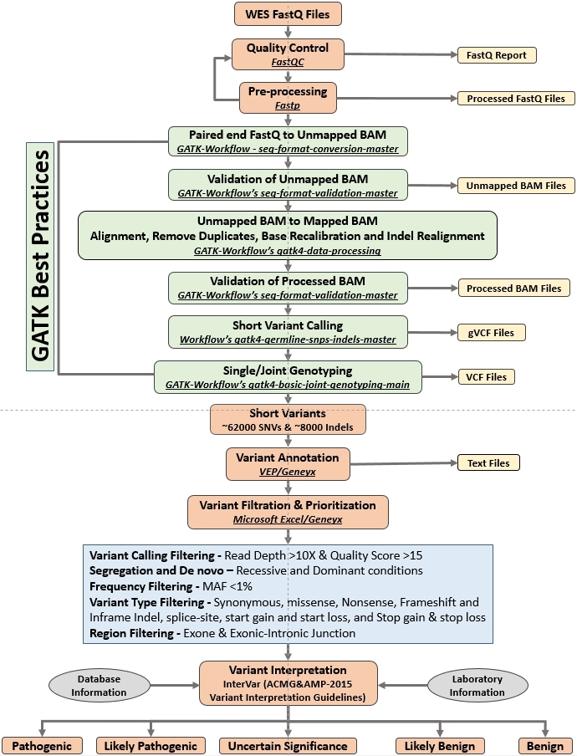
Supplementary Fig. 2 Whole exome sequencing data analysis overview. FastQC, Fastp, BWA-MEM, GATK, VEP, Microsoft Excel/Geneyx, and InterVar were used for quality control, preprocessing, read alignment, variant annotation, variant filtration, and variant classification, respectively. InterVar was used to classify the variants based on the ACMG and AMP 2015 guidelines.
variants from all 31 affected individuals were prioritized for different mode of inheritance (homozygous recessive, compound heterozygous, de novo dominant and autosomal dominant) and clinical significance (pathogenic, likely pathogenic, variants of uncertain significance, likely benign or benign). Seven specific pathogenic variants, five known and two novel, were prioritized in 12 affected individuals. Five VUS associated with HL genes were prioritized with high confidence in 6 individuals. Causative variants specific for HL could not be prioritized in rest of the affected individuals. We identified two novel variants which have not been previously documented in any database. These variants have been reported in the ClinVar database (SCV002818294 and SCV002818294).
Supplementary Fig. 3 Summary of pass on-target annotated variants. (a) Distribution of all pass on-target annotated variants. (b) Distribution of pass on-target annotated exonic variants.

