Supplementary Figure 1: ROC-curve to determine a relevant cutoff for PSM length
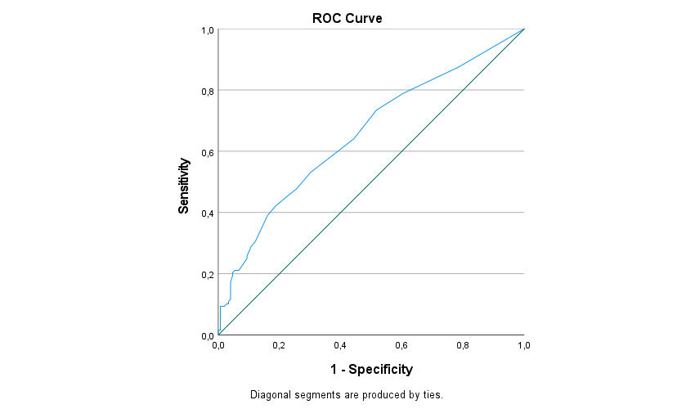

Area under the curve: 0.653

