Supplementary Materials

Table S1 Multiple regression of age predicting impulsivity traits (Full sample, N=653)

 | Positive Urgency |  |  | Negative Urgency |  |  | Lack of Perseverance |  |  | Lack of Premeditation |  |  | Sensation Seeking |  |  | Total Impulsivity
 | B | SE | p | B | SE | p | B | SE | p | B | SE | p | B | SE | p | B | SE | p
Age | −0.08 | 0.03 | .02 | −0.03 | 0.04 | .50 | −0.004 | 0.04 | .92 | −0.05 | 0.03 | .15 | −0.07 | 0.04 | .09 | −0.23 | 0.11 | .05
Age² | 0.0005 | 0.0004 | .11 | 0.0002 | 0.0004 | .67 | −0.0002 | 0.0004 | .58 | 0.0004 | 0.0003 | .17 | 0.0004 | 0.0004 | .31 | 0.001 | 0.001 | .26
Sex | 0.24 | 0.23 | .30 | −0.15 | 0.27 | .58 | 0.25 | 0.24 | .31 | −0.29 | 0.22 | .19 | 1.17 | 0.30 | <.001 | 1.23 | 0.79 | .12
Education | −0.22 | 0.08 | .004 | −0.22 | 0.09 | .01 | −0.26 | 0.08 | .001 | −0.10 | 0.07 | .18 | −0.20 | 0.10 | .04 | −0.99 | 0.26 | <.001
Medical conditions | 0.08 | 0.33 | .81 | −0.10 | 0.38 | .80 | 0.44 | 0.34 | .19 | −0.01 | 0.31 | .98 | −0.42 | 0.41 | .31 | −0.003 | 1.10 | .998
R² | 0.09 | – | – | 0.021 | – | – | 0.05 | – | – | 0.01 | – | – | 0.07 | – | – | 0.09 | – | –
Adjusted R² | 0.09 | – | – | 0.01 | – | – | 0.05 | – | – | 0.01 | – | – | 0.06 | – | – | 0.09 | – | –
F | 13.51 | – | <.001 | 2.75 | – | .02 | 7.44 | – | <.001 | 1.69 | – | .14 | 9.84 | – | <.001 | 13.53 | – | <.001
Note. Sex: 1=female, 2=male; Medical conditions: 1=yes, 2=no.

Table S2 Multiple regression of impulsivity predicting health protective behaviors (Full sample, N=653)
 | Positive Urgency |  |  | Negative Urgency |  |  | Lack of Perseverance |  |  | Lack of Premeditation |  |  | Sensation Seeking |  |  | Total Impulsivity
 | B | SE | p | B | SE | p | B | SE | p | B | SE | p | B | SE | p | B | SE | p
Intercept | 41.50 | 2.39 | <.001 | 41.22 | 1.983 | <.001 | 41.36 | 2.06 | <.001 | 38.13 | 1.99 | <.001 | 39.49 | 2.23 | <.001 | 38.56 | 4.14 | <.001
Impulsivity | –0.06 | 0.48 | .90 | –0.30 | 0.417 | .48 | –0.20 | 0.48 | .68 | 0.73 | 0.49 | .14 | 0.26 | 0.42 | .54 | 0.23 | 0.19 | .23
Impulsivity² | –0.02 | 0.03 | .57 | 0.01 | 0.024 | .83 | –0.01 | 0.03 | .81 | –0.08 | 0.03 | .02 | –0.02 | 0.02 | .23 | –0.005 | 0.002 | .05
Age | 0.03 | 0.01 | .04 | 0.04 | 0.013 | .005 | 0.03 | 0.01 | .02 | 0.04 | 0.01 | .005 | 0.03 | 0.01 | .01 | 0.02 | 0.01 | .06
Sex | –1.08 | 0.56 | .06 | –1.19 | 0.567 | .04 | –1.08 | 0.56 | .06 | –1.27 | 0.56 | .02 | –0.87 | 0.57 | .13 | –1.03 | 0.56 | .06
Education | 0.3 | 0.08 | .004 | 0.27 | 0.177 | .13 | 0.24 | 0.18 | .18 | 0.27 | 0.17 | .13 | 0.26 | 0.18 | .14 | 0.15 | 0.18 | .40
Medical conditions | 2.38 | 0.78 | .002 | 2.33 | 0.786 | .003 | 2.48 | 0.78 | .002 | 2.41 | 0.78 | .002 | 2.23 | 0.78 | .005 | 2.43 | 0.77 | .002
R² | 0.06 | – | – | 0.05 | – | – | 0.06 | – | – | 0.07 | – | – | 0.06 | – | – | 0.09 | – | –
Adjusted R² | 0.05 | – | – | 0.04 | – | – | 0.05 | – | – | 0.06 | – | – | 0.05 | – | – | 0.08 | – | –
F | 7.07 | – | <.001 | 5.94 | – | <.001 | 6.86 | – | <.001 | 8.40 | – | <.001 | 6.88 | – | <.001 | 10.5 | – | <.001
Note. Sex: 1=female, 2=male; Medical conditions: 1=yes, 2=no.
Table S3 Interaction between sensation seeking and four-dimension impulsivity predicting protective behaviors (Full sample, N=653)
 | B (SE) | t | p
Intercept | 40.18 (3.31) | 12.13 | < .001
Sensation Seeking | 0.53(0.31) | 1.75 | .08
Four-dimension impulsivity | 0.11 (0.10) | 1.02 | .31
Sex | -0.99 (0.56) | -1.77 | .08
Education | 0.15 (0.17) | 0.86 | .39
Medical conditions | 2.41 (0.77) | 3.13 | .002
Age | 0.02 (0.01) | 1.71 | .09
Sensation Seeking × Four-dimension impulsivity | -0.02 (0.01) | -2.47 | .01
Note. Four-dimension impulsivity = the total score of the positive and negative urgency, lack of premeditation, and lack of perseverance facets of impulsivity.

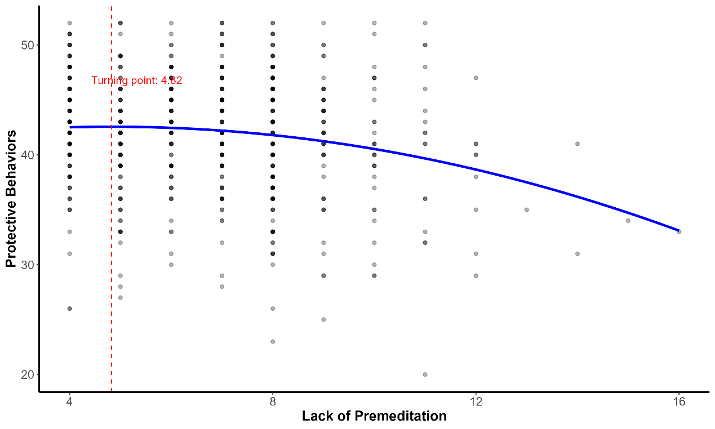

Fig. S1 Quadratic association between lack of premeditation and health protective behaviors

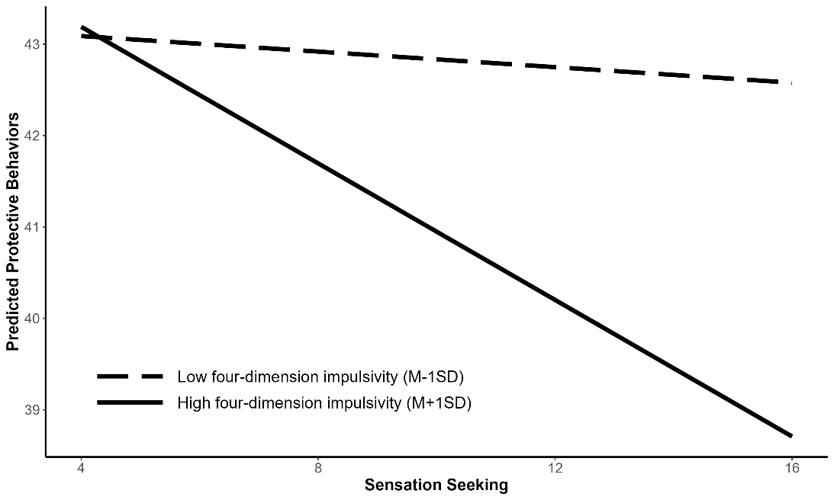

Fig. S2 Interaction between sensation seeking and four-dimension impulsivity predicting protective behaviors. Note. Four-dimension impulsivity = the total score of the positive and negative urgency, lack of premeditation, and lack of perseverance facets of impulsivity.

