Dual Electrochemical Sensing of Spiked virus and SARS-CoV-2 Using Natural Bed-receptor (MV-gal1)
E. Ghazizadeh ^{a,b}*, Ali Neshastehrizd,^{b} Ali Dehghani Firoozabadi^{c}, E.Saievar-Iranizad^{d}
aDepartment of Medical Biotechnology, School of Medicine, Mashhad University of Medical Sciences, Mashhad, Iran
bRadiation Biology Research Center, Iran University of Medical Sciences (IUMS), Tehran, Iran
c Yazd Cardiovascular Research Center, Shahid Sadoughi University of Medical Sciences,Yazd, Iran
d Department of Physics, Faculty of Science, University of Tarbiat Modarres, Tehran, Iran

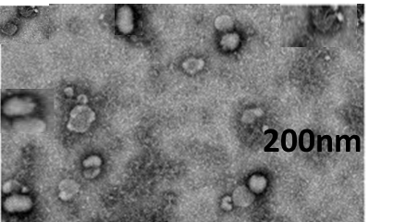

Fig S1. The images of TEM about characterization of MV-extracted from bone marrow-derived mesenchymal stem cells

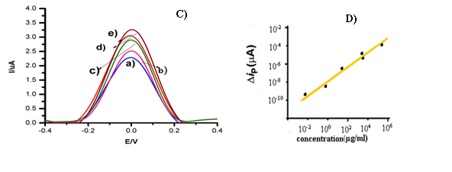
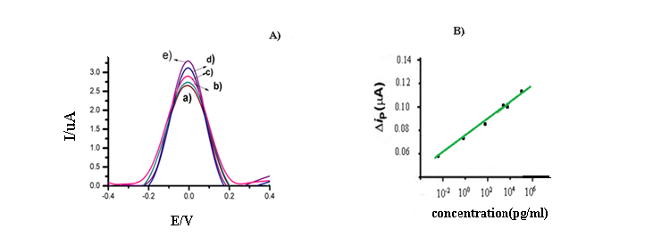

Fig S2. The performance of the sensor for screening and specific detection of SARS-CoV-2 in0.01× UTM(A) Screening of SARS-CoV-2 Antigen based on DPV images using the 500 ng/mL(e) to 1 µ/mL(a) on the MV-gal1/SCPE-GNP. (B) A calibration plot of the current density vs log concentration of SARS-CoV-2 Antigen. (C) Specific detection of SARS-CoV-2 Antigen based on DPV images using the 1 µg/mL (e) to 250 500fg/mL. (D) A calibration plot of the current density vs log concentration of SARS-CoV-2 Antigen.

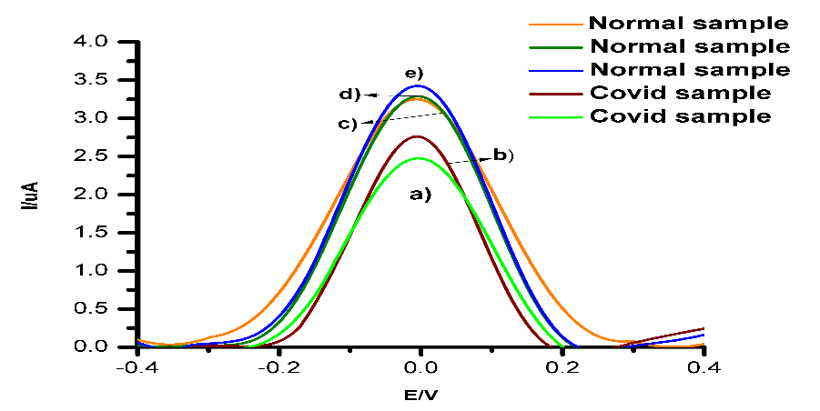

Fig S3. Normalize the sensor between the covid-19 samples and normal samples.

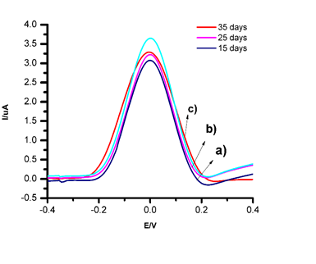
A)
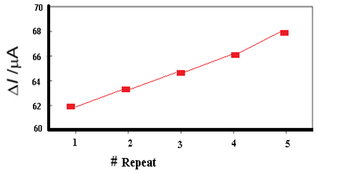
B)

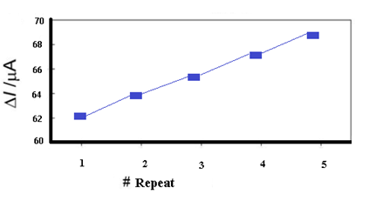
C)

Fig S4. (A) DPV behaviors of stability of MV-gal1@ SARS-CoV-2 Antigen@ Au/Anti-SARS-CoV-2 spike sensors in different days. (B, C) Reproducibility behaviors of MV-gal1@ SARS-CoV-2 Antigen@ Au/Anti-SARS-CoV-2 spike sensors while adding the SARS-CoV-2 Antigen and Au/Anti-SARS-CoV-2 spike.

Table S1. Clinical characteristics of laboratory confirmed patients with COVID-19
patient#1 patient#2 patient#3 |  | patient#4
Age (years)/Sex 25/M 48/M 55/F  Fever + + +  Chills - - -  Cough + + +  Dyspnea - -  Diarrhea - - +  Viral load 3.12 × 10⁶ 2.23 × 10⁶ 3.14 × 10⁵ |  | 32/M  +  -  +  +  +  3.67× 10⁴

Table S2. Calibration results for MV-gal1@ SARS-CoV-2 Antigen@ Au/Anti-SARS-CoV-2 spike sensors
Variable | Range tested | Selected Value
Number of repetitions | 1-10 | 1-10
Incubation time of SARS-CoV-2 Antigen and MV-gal1 (hour) | 18-24 | 24
Incubation time of SARS-CoV-2 Antigen and MV-gal1 (temparture) | 25-37° | 26°
Anti-SARS-CoV-2 spike , uM | 25-37° | 34°
Dropping Anti-SARS-CoV-2 spike (temparture) | 4° | 4°
Dropping of SARS-CoV-2 Antigen (time) | 2-4 | 4

Table S3. Validation of MV-gal1@Au/Anti-SARS-CoV-2 Biosensor using clinical samples validated by Real-time PCR
Real time PCR

MV-gal1@Au/Anti-SARS-CoV-2 Positive Negative Total
Biosensor

Positive 4 1 5
Negative 2 10 12
Total 6 11 17
PPA 96.38 % (93% CI 93.64%–95.96%)
NPA 98.46 % (98 % CI 93.84%–99.00%)

