Supplemental materials

List of the Supplemental figures and tables:
Supplemental Figure S1. Sequencing identification of the pGL3-sgRNA expression vector.
Supplemental Figure S2. Genotyping of the sgM2 locus in MSTN-edited F1 generation Hu sheep.
Supplemental table S1. Oligo sequences of sgRNAs.
Supplemental table S2. Primers of in vitro transcription (IVT) templates.
Supplemental table S3. Primers for Editing detection.
Supplemental table S4. Individual level off target detection primers.

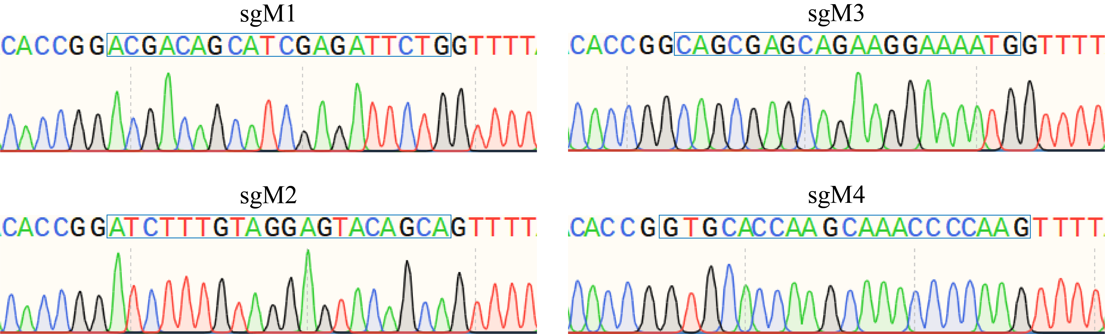
A
B

Supplemental Figure S1. Sequencing identification of the pGL3-sgRNA expression vector.
(A) Sequencing identification of the pGL3-sgM1 expression vector; (B) Sequencing identification of the pGL3-sgM2 expression vector.

Supplemental Figure S2. Genotyping of the sgM2 locus in MSTN-edited F1 generation Hu sheep. (A) Amplification of the sgM2 locus region in MSTN-edited F1 generation Hu sheep. (B) Sequencing identification of the sgM2 locus region in MSTN-edited F1 generation Hu sheep.

Supplemental table1. Oligo sequences of sgRNAs

Primers | Sequence (5’→3’)
sgRNA-M1(sgM1) | CAGCGAGCAGAAGGAAAATGTGG
sgRNA-M2(sgM2) | GTGCACCAAGCAAACCCCAAAGG
sgM1-F | caccgGCAGCGAGCAGAAGGAAAATG
sgM1-R | aaacCATTTTCCTTCTGCTCGCTGC
sgM2-F | caccgGTGCACCAAGCAAACCCCAA
sgM2-R | aaacTTGGGGTTTGCTTGGTGCAC

Supplemental table2. Primers of in vitro transcription (IVT) templates

IVT templates | IVT-Primers | Sequences（5’→3’）
IVT-BE3 | IVT-BE3-F | taatacgactcactatagggGATCC
IVT-BE3 | IVT-BE3-R | TCGAGGCTGATCAGGGGGTTTTTA
IVT-MSTN-sgM1 | IVT-MSTN-sgM1-F | ttaatacgactcactataggCAGCGAGCAGAAGGAAAATG
IVT-MSTN-sgM1 | IVT-MSTN-sgM1-R | AAAAGCACCGACTCGGTGCC
IVT-MSTN-sgM2 | IVT-MSTN-sgM2-F | ttaatacgactcactatagGTGCACCAAGCAAACCCCAA
IVT-MSTN-sgM2 | IVT-MSTN-sgM2-R | AAAAGCACCGACTCGGTGCC

Supplemental table3. Primers for Editing detection

Primers | Primer sequence (5’→3’) | Product size | Tm
sgM1-JC-F | AGCCAATCACAGATCCCGAC | 707 | 60
sgM1-JC-R | TCTTTGCCCTCCTCCTTACG | 707 | 60
sgM2-JC-F | GCAGGAAGACATAAGCTAGGC | 660 | 59
sgM2-JC-R | TTGTAGGAGTACAGCAAGGGC | 660 | 59

Supplemental table4. Individual level off target detection primers

Primer name | Primer sequence (5’→3’) | Product size | Tm
sgM2-OT1 | F:CTGCCTGCCAAAAACAAATTCT | 401 | 59
 | R:CTCTGTCTGCTTTTGGTGGC | 401 | 59
sgM2-OT2 | F:CACACCCACTGATGATGCCTA | 401 | 60
 | R:ACTTCAGTTCCCCTTGTGCTT | 401 | 60
sgM2-OT3 | F:CATCACAGACTGAAAACGGAA | 410 | 58
 | R:GTGTAATACTGTAGCCCCGTC | 410 | 58
sgM2-OT4 | F:CCACCACATGCCAGTTGCT | 471 | 60
 | R:CTTGGGACAGGCTTTCACTC | 471 | 60
sgM2-OT5 | F:AGGAACCTGGAAGGGAATC | 546 | 60
 | R:CTCTGTTGCTGCGTGCTG | 546 | 60

