Additional file 1: Online Supplement
Predictive risk factors at admission and a "burning point" during hospitalization serve as sequential alerts for critical illness in COVID-19 patients
Mei Zhou MD^{1†}, Juanjuan Xu PhD^{1†}, Kai Wang MD^{2†}, Zhengrong Yin MS^{1†}, Xingjie Hao PhD^{2†}, Xueyun Tan MD¹, Yafei Huang PhD³, Hui Li MS¹, Fen Wang MS¹, Chengguqiu Dai MS², Guanzhou Ma PhD¹, Zhihui Wang MS⁴, Limin Duan MD¹, Yang Jin PhD¹*

- Abbreviations
- Supplementary methods
Details of data processing and model construction
Model validation and comparison
- Supplementary notes
Definition of various organ injuries
Dynamic changes of 47 indicators in critical and non-critical COVID-19 patients
- Table S1. Outlier rate and missing rate for each variable and the missing rate of variables in each participant
- Table S2. The proportion of variance for the first 10 principal components in PCA analysis
- Table S3. Variables selected in Random Forest prediction model
- Table S4. Variables selected in LASSO prediction model
- Table S5. Comparison of the AUC values (C-statistics) among different models
- Table S6. The observed and predicted events of critical illness by nomogram model for each quantile in the testing set
- Table S7. Dynamic changes of SOFA score and laboratory findings before the critical illness onset (CIO)
- Figure S1. Principle component analysis
- Figure S2. LASSO Regression analysis
- Figure S3. Hosmer-Lemeshow test of three prediction models in the testing set
- Figure S4. Online prediction tool developed based on the nomogram to predict, at admission, the risk of developmet to critical illness in COVID-19 patients
- Figure S5. Change pattern of hemotologic and coagulation indicators
- Figure S6. Change pattern of inflammatory, energy&metabolism and Cardiac function indicators
- Figure S7. Change pattern of Liver and Renal function indicators
Abbreviations
Q2±3IQR, median ± 3*interquartile range; AUC, area under the receiver operating characteristic curve; COPD, chronic obstructive pulmonary disease; ARDS, acute respiratory distress syndrome; CT, computed tomography; SOFA, Sequential Organ Failure Assessment; WBC, white blood cell; RBC, red blood cell; PLT, platelet; NLR, neutrophil to lymphocyte ratio; TBIL, total bilirubin; DBIL, direct bilirubin; ALT, Alanine aminotransferase; AST, Aspartate aminotransferase; ALP, Alkaline phosphatase; GGT, γ-glutamyl transpeptidase; TP, total protein; A/G, Albumin/globin; TBA, total bile acid; Tch, total cholesterol; TG, triglyceride; HDL-C, high density lipoprotein cholesterol; LDL-C, low density lipoprotein cholesterol; BUN, blood urea nitrogen; UA, uric acid; Cys-C, cystatin C; CK, creatine kinase; LDH, lactate dehydrogenase; CRP, C-reactive protein; PCT, procalcitonin; PT, prothrombin time; INR, international normalised ratio; APTT, activated partial thromboplastin time; FIB, fibrinogen; TT, thrombin time; BNP, brain natriuretic peptide; CK-MB, creatine kinase muscle-brain isoform; hsTNΙ, hypersensitive cardiac troponin Ι

Supplementary methods
Details of data processing and model construction
In our study cohort, 1150 adult COVID-19 patients and 87 variables for each participant were collected to construct baseline prediction models. Three physicians and four trained medical students checked the collected data for accuracy. For continuous variables, any observation that lied outside the range of median ± 3 * interquartile ranges (IQR) was considered to be an outlier and recorded as a missing value. The outlier rate and missing rate for each variable and participants were shown in Table S1, respectively. To ensure the data integrity and avoid potential selection bias, variables or participants with missing rate of less than 40% were all included, thus six variables (i.e. PCT, Ferritin, BNP, myoglobin, CK-MB, hsTNI) and 32 patients were excluded. Subsequently, 81 variables including 2 demographic variables, 12 comorbidity variables, 14 symptom variables, 42 laboratory finding variables, 10 imaging features variables, and the variable of time from illness onset to admission were analyzed and 1118 patients remained (Table S1). We used the random forest machine learning method to impute the remaining missing values. This method use the proximity matrix computed with the completed observations to impute the missing values¹. For continuous variables, the imputed value was the weighted average of the completed observations, where the weights were the proximities. For categorical variables, the imputed value was the category with the largest average proximity. Given the imputed dataset, we conducted principal component analysis (PCA) to explore the distribution of participants and evaluated the important variables related to the critical illness with the R package “factoextra”². The singular value decomposition method was utilized to examine the covariance matrix computed by normalized variables and the first 10 principal components (PCs) were extracted (Table S2). The first four PCs were plotted for participants to explore the distribution of sample and were plotted for variables to access the potential variables related to critical illness outcome. Participants were labelled as outlier and excluded subsequently if their first two PCs were out the corresponding range of median ± 3*IQR and no cases exceeded this range and were excluded in this process (Figure S1 A-D). PCA showed that the first principal component (PC1) was mainly composed of laboratory indicators, including CRP, SOFA score, NLR, LDH etc. (Figure S1 E), rather than comorbidities, and performed better in distinguishing the condition (critical or non-critical) of participants (Figure S1 B).
To construct the prediction model for critical illness outcome, we randomly divided the remaining participants (N=1118) into a training set (70% of participants, N=783 [non-critical/critical: 587/196]) and a testing set (30%, N=335 [non-critical/critical: 241/94]). Firstly, machine learning based Random forest model and Least Absolute Shrinkage and Selection Operator (LASSO) logistic regression were applied to develop the prediction models on training dataset.
We trained the random forest model with all the 81 variables by using the R package “randomForest” and then extracted the importance of each variable, measured by the Mean Decrease Gini index³. We then chose the top 20 important features (variables) to construct the final random forest prediction model (Table S3). LASSO regression penalizes the absolute size of the coefficients of a regression model by the λ parameter (ranging from 0 to 1) to improve the prediction accuracy and interpretability. With larger penalties (λ), the coefficients of weaker predictors will be shrunk to zero, so that only the strongest prediction variables remained in the model. We conducted a 10-fold cross-validation to train model and optimal λ was selected based on the area under the receiver operating characteristic curve (AUC) with the R package “glmnet”⁴ (Figure S2). We then constructed the final LASSO prediction model with the variables (n=19) having the strongest prediction power determined by the optimal λ (Table S4).
Finally, we chose the variables, appearing in both the random forest prediction model and LASSO prediction model, as candidate predictors to construct multivariable logistic prediction model. We performed univariable logistic analysis for each of these candidate predictors, and computed the corresponding odds ratio (OR) with 95% confidence interval (CI) and AUC. To avoid the co-linearity problem, we chose one of the two predictors with the maximum AUC, if the spearmen rank correlation coefficient between predictors was ≥0.60. We then performed multivariable logistic regression analysis with the remaining predictors. To enhance the clinical application of the logistic prediction model, we established a nomogram with the results from the multivariable logistic regression by using the package “rms”⁵, which was then used to construct a web-based risk calculator
(https://hust-covid19.shinyapps.io/Critical-illness-Predictive-Tool/) (Figure S4).
Model validation and comparison
The distinguishing power of these three models was assessed by the C-statistics (also AUC [area under curve]) on both training and testing datasets. For internal validation, we estimated the C-statistics with 95% confidence interval (CI) by using 10,000 bootstrap resamples to reduce overfitting bias. The difference in C-statistics between these models was analyzed by non-parametric bootstrap method with 10,000 resamples (Table S5). The Hosmer-Lemeshow (H-L) test (Table S6, Figure S3) and calibration plot comparing the predictive and actual probabilities of critical illness were utilized to validate the predictive performance of these models. Besides, we performed decision curve analysis (DCA), which quantifies the net benefits and cost benefit ratio, to evaluate the clinical benefits of these models with the R package “Decision Curve”⁶. Sensitivity analysis was finally conducted to assess the influence of the incomplete observations appearing in the predictors in nomogram model by leaving the incomplete cases out.

Supplementary notes
Definition of various organ injuries
The diagnostic criteria for acute kidney injury were based on the KDIGO clinical practice guidelines⁷. Cardiac injury was confirmed if the serum level of hypersensitive cardiac troponin I (hsTNI) was above the upper limit of the reference range (>28 pg/mL)⁸. Liver injury was diagnosed according to the elevated bilirubin and aminotransferase⁹.
Dynamic changes of 47 indicators in critical and non-critical COVID-19 patients
As shown in Figure 3, Figure S5-7, we discovered that critical patients, not non-critical patients, had a consistently high level of SOFA score, indicating that severe sepsis persisted in critical patients^{10,11}. Compared with non-critical patients, critical patients had a persistently higher level of abnormal inflammatory indices, such as neutrophils, CRP, and PCT, suggesting that critical patients were in a lasting state of inflammation activation. At the early stage of the disease, lymphopenia and decreased eosinophils could be found in both two groups but the lymphocyte level was much lower in critical patients. Afterwards, they gradually returned to be normal in non-critical patients, but remained abnormal in critical patients. These findings implied that lymphocytes were continuously depleted and immune response was impaired in critical patients, this was consistent with a previous study which showed that restored lymphocytes, eosinophils could serve as the predictors for the recovery of COVID-19 patients¹². As for the coagulation index, D-dimer of critical patients was dramatically elevated and the level of PLT was decreased while this was not the case in non-critical patients, indicating the presence of severe and long-term coagulation disorder in the critical patients. Moreover, we found that critical patients had cardiac dysfunction (higher LDH, hsTNI, BNP, and myoglobin), hepatic dysfunction (elevated DBIL, TBIL, AST, GGT, ALT and decreased TP, albumin, prealbumin, A/G) and renal dysfunction (increased BUN, Cys-C) during the whole hospital-stay period. However, non-critical patients only had mild liver dysfunction. A recent study¹³ suggested that persistent inflammation and coagulation disorders might be closely related to myocardial damage. The RBC and hemoglobin in most critically ill patients were initially within the normal range, but then gradually dropped to abnormal level. In contrast, the majority of non-critical patients had RBC and hemoglobin within the normal range throughout the hospital stay. Decreased levels of TP, albumin, prealbumin, HDL-C, RBC and hemoglobin suggested excessive body consumption and malnutrition in critical patients. Therefore, nutritional support for critical patients should be strengthened. Besides, only 31.1% of critical patients had diabetes, suggesting that lasting high fasting blood glucose levels in critical patients might be a result of stress responses to acute SARS-CoV-2 infection. It was reported that both acute and chronic hyperglycemia could aggravate COVID-19 patients’ condition by up-regulating the expression of ACE2¹⁴.

Tables
Table S1. Outlier rate and missing rate for each variable and the missing rate of variables in each participant
Missing variables |  | Outlier, n/N (%)  Q2±3*IQR |  | Number of cases, n (%)  (N=1150)
Demographics
Age |  | - |  | 0 (0)
Sex |  | - |  | 0 (0)
Clinical characteristics
Time from illness onset to admission |  | - |  | 0 (0)
Initial symptoms
Fever |  | - |  | 30 (2.6)
Highest temperature |  | - |  | 84 (7.3)
Sore throat |  | - |  | 59 (5.1)
Fatigue |  | - |  | 46 (4.0)
Myalgia |  | - |  | 54 (4.7)
Cough |  | - |  | 37 (3.2)
Sputum production |  | - |  | 46 (4.0)
Chest tightness |  | - |  | 46 (4.0)
Dyspnea |  | - |  | 51 (4.4)
Running nose |  | - |  | 55 (4.8)
Vomiting |  | - |  | 50 (4.3)
Nausea |  | - |  | 50 (4.3)
Diarrhea |  | - |  | 47 (4.1)
Headache |  | - |  | 52 (4.5)
Asymptomatic |  | - |  | 30 (2.6)
Comorbidities
Hypertension |  | - |  | 17 (1.5)
Diabetes |  | - |  | 17 (1.5)
Coronary heart disease |  | - |  | 17 (1.5)
Cerebrovascular disease |  | - |  | 17 (1.5)
Malignancy |  | - |  | 17 (1.5)
Chronic bronchitis |  | - |  | 17 (1.5)
Asthma |  | - |  | 17 (1.5)
COPD |  | - |  | 17 (1.5)
Kidney disease |  | - |  | 17 (1.5)
Liver disease |  | - |  | 17 (1.5)
Others |  | - |  | 17 (1.5)
Number of comorbidities |  | - |  | 17 (1.5)
Complications
Sepsis |  | - |  | 1 (0.1)
ARDS |  | - |  | 0 (0)
Acute liver injury |  | - |  | 1 (0.1)
Acute cardiac injury |  | - |  | 1 (0.1)
Acute kidney injury |  | - |  | 1 (0.1)
Baseline CT features
Pneumonia area (lesion ratio to lung) |  | - |  | 41 (3.6)
Uni-/Bilateral pneumonia |  | - |  | 41 (3.6)
Central/Peripheral (lesion location) |  | - |  | 41 (3.6)
Consolidation |  | - |  | 41 (3.6)
Patchy exudation |  | - |  | 41 (3.6)
Ground-glass opacity |  | - |  | 41 (3.6)
White lung |  | - |  | 41 (3.6)
Pleural effusion |  | - |  | 41 (3.6)
Lymph node enlargement |  | - |  | 41 (3.6)
SOFA score at admission |  | 14/1137 (1.2) |  | 30 (2.6)
Baseline Laboratory findings
WBC |  | 23/1116 (2.1) |  | 57 (5)
RBC |  | 2/1114 (0.2) |  | 38 (3.3)
Hemoglobin |  | 5/1114 (0.4) |  | 41 (3.6)
PLT |  | 3/1114 (0.3) |  | 39 (3.4)
Neutrophil count |  | 28/1115 (2.5) |  | 63 (5.5)
Lymphocyte count |  | 3/1116 (0.3) |  | 37 (3.2)
NLR |  | 64/1115 (5.7) |  | 99 (8.6)
Monocyte count |  | 12/1114 (1.1) |  | 48 (4.2)
Eosinophil count |  | 27/1114 (2.4) |  | 63 (5.5)
Basophil count |  | 22/1114 (2) |  | 58 (5)
TBIL |  | 30/1103 (2.7) |  | 77 (6.7)
DBIL |  | 40/1103 (3.6) |  | 87 (7.6)
ALT |  | 41/1104 (3.7) |  | 87 (7.6)
AST |  | 40/1106 (3.6) |  | 84 (7.3)
ALP |  | 29/1065 (2.7) |  | 114 (9.9)
GGT |  | 85/1094 (7.8) |  | 141 (12.3)
TP |  | 5/1104 (0.5) |  | 51 (4.4)
Albumin |  | 0/1104 (0) |  | 46 (4)
Globin |  | 8/1104 (0.7) |  | 54 (4.7)
Albumin/globin |  | 1/1104 (0.1) |  | 47 (4.1)
Prealbumin |  | 0/1051 (0) |  | 99 (8.6)
TBA |  | 55/1056 (5.2) |  | 149 (13)
Tch |  | 3/719 (0.4) |  | 434 (37.7)
TG |  | 22/719 (3.1) |  | 453 (39.4)
HDL-C |  | 4/719 (0.6) |  | 435 (37.8)
LDL-C |  | 1/719 (0.1) |  | 432 (37.6)
Creatinine |  | 48/1101 (4.4) |  | 97 (8.4)
BUN |  | 53/1098 (4.8) |  | 105 (9.1)
UA |  | 20/1101 (1.8) |  | 69 (6)
Cys-C |  | 55/1006 (5.5) |  | 199 (17.3)
Glucose |  | 69/1083 (6.4) |  | 136 (11.8)
CK |  | 64/925 (6.9) |  | 289 (25.1)
LDH |  | 28/1098 (2.6) |  | 80 (7)
CO₂ |  | 1/1006 (0.1) |  | 145 (12.6)
CRP |  | 0/1077 (0) |  | 73 (6.3)
PCT |  | 62/734 (8.4) |  | 478 (41.6)
Ferritin |  | 0/195 (0) |  | 955 (83)
D-dimer |  | 127/882 (14.4) |  | 395 (34.3)
PT |  | 21/1007 (2.1) |  | 164 (14.3)
INR |  | 21/1008 (2.1) |  | 163 (14.2)
APTT |  | 9/1008 (0.9) |  | 151 (13.1)
FIB |  | 0/1006 (0) |  | 144 (12.5)
TT |  | 28/1008 (2.8) |  | 170 (14.8)
BNP |  | 20/301 (6.6) |  | 869 (75.6)
Myoglobin |  | 37/349 (10.6) |  | 838 (72.9)
CK-MB |  | 36/352 (10.2) |  | 834 (72.5)
hsTNΙ |  | 41/386 (10.6) |  | 805 (70)
Missing rate of variables in each participant
0% | - |  | 262 (22.8)
0-1% | - |  | 0 (0)
1-5% | - |  | 280 (24.3)
5-10% | - |  | 345 (30)
10-20% | - |  | 143 (12.4)
20-30% | - |  | 52 (4.5)
30-40% | - |  | 36 (3.1)
>40% | - |  | 32 (2.8)
Note: The result of Missing value includes the sample data judged as outlier plus the missing value existing in original data

Table S2. The proportion of variance explained by each of the first 10 principal components in PCA analysis
Item | Principal Components (PC)
Item | PC1 | PC2 | PC3 | PC4 | PC5 | PC6 | PC7 | PC8 | PC9 | PC10
Proportion of Variance (%) | 10.8 | 5.3 | 4.3 | 3.7 | 3.3 | 2.9 | 2.6 | 2.5 | 2.3 | 2.1
Cumulative Proportion (%) | 10.8 | 16.2 | 20.4 | 24.1 | 27.4 | 30.3 | 32.8 | 35.3 | 37.6 | 39.7

Table S3. Variables selected in Random Forest prediction model
Variables | Mean Decrease of Gini index
SOFA score | 65.413
NLR | 27.131
D-dimer | 26.216
LDH | 24.480
CRP | 17.974
Neutrophil count | 13.641
Lymphocyte count | 12.093
PLT | 9.777
WBC | 9.375
Prealbumin | 9.260
BUN | 8.857
Age | 8.793
CK | 8.689
HDL-C | 7.984
Glucose | 7.849
INR | 7.674
Pneumonia area (lesion ratio to lung) | 7.327
Tch | 7.317
LDL-C | 7.012
DBIL | 6.590

Table S4. Variables selected in LASSO prediction model
Variable | Beta
Age | 0.008
Coronary heart disease | 0.396
Cerebrovascular disease | 1.559
Other underlying diseases | 0.199
SOFA score | 1.236
Neutrophil count | 0.103
NLR (neutrophil to lymphocyte ratio) | 0.022
ALP (Alkaline phosphatase) | 0.001
Creatinine | -0.011
LDH (lactate dehydrogenase) | 0.002
CRP (C-reactive protein) | 0.010
D-dimer | 0.305
INR (international normalised ratio) | 1.553
Highest temperature | -0.089
Dyspnea | 0.108
Pneumonia area (lesion ratio to lung): small vs. medium | 0.820
Pneumonia area (lesion ratio to lung): small vs. large | 1.216
Ground glass | 0.136
White lung | 1.182

Table S5. Comparison of the AUC values (c-statistics) among different models
 | Random forest & LASSO | Random forest & Nomogram | LASSO & Nomogram | Nomogram & sensitivity analysis
Training set,  P value | <.001 | <.001 | <.001 | .43
Testing set,  P value | .63 | .73 | .55 | .26
Note: 10,000 non-parametric bootstrap test was used for the comparison of AUC values

Table S6. The observed and predicted events of critical illness for each quantile in testing set
 | Quantile |  |  |  |  |  |  |  |  |  | P value
 | 0-10th | 10-20th | 20-30th | 30-40th | 40-50th | 50-60th | 60-70th | 70-80th | 80-90th | 90-100th | P value
Random forest prediction model
Sample size | 35 | 32 | 35 | 32 | 34 | 33 | 33 | 34 | 33 | 34 | .445
Observed events | 0 | 0 | 1 | 1 | 2 | 1 | 5 | 17 | 31 | 33 | .445
Predicted events | 0.063 | 0.224 | 0.745 | 1.349 | 3.045 | 5.345 | 9.047 | 17.545 | 24.771 | 30.960 | .445
LASSO prediction model
Sample size | 34 | 33 | 34 | 33 | 34 | 33 | 33 | 34 | 33 | 34 | .744
Observed events | 0 | 0 | 0 | 2 | 0 | 3 | 6 | 18 | 30 | 32 | .744
Predicted events | 0.187 | 0.380 | 0.632 | 1.110 | 2.061 | 3.921 | 7.997 | 16.649 | 27.238 | 33.240 | .744
Nomogram
Sample size | 34 | 33 | 34 | 33 | 34 | 33 | 33 | 34 | 33 | 34 | .863
Observed events | 0 | 0 | 1 | 0 | 1 | 2 | 8 | 20 | 26 | 33 | .863
Predicted events | 0.059 | 0.147 | 0.309 | 0.698 | 1.581 | 3.604 | 9.099 | 19.449 | 29.400 | 33.657 | .863
Note: P value was calculated by Hosmer-Lemeshow test.

Table S7. Dynamic changes of SOFA score and laboratory findings after the critical illness onset (CIO).
Variables | Day 0  Critical illness onset | Day 1 | Day 3 | Day 5 | Estimate | Std. Error | Pr (>|t|)
Representative variables
SOFA score | 4.00 (3.00-6.00) | 5.00 (3.00-7.00) | 4.00 (3.00-7.00) | 3.00 (2.00-5.00) | 0.109 | 0.045 | 0.015
NLR | 18.29 (9.59-30.55) | 16.02 (9.79-30.83) | 17.78 (9.53-33.26) | 11.16 (5.61-20.79) | -0.594 | 0.238 | 0.013
CRP, mg/L | 78.00 (37.36-128.24) | 77.66 (36.30-131.28) | 81.45 (21.15-120.77) | 45.34 (15.06-83.65) | -3.417 | 1.011 | 0.0008
Glucose, mmol/L | 8.50 (6.62-12.12) | 8.30 (6.89-10.59) | 8.58 (6.57-11.76) | 9.06 (6.68-11.53) | 0.037 | 0.077 | 0.628
D-dimer, μg/mL | 8.00 (2.60-8.50) | 8.50 (3.40-8.50) | 8.00 (3.97-8.50) | 5.47 (2.57-8.50) | -0.102 | 0.043 | 0.019
LDH, U/L | 467.50 (339.00-625.50) | 430.50 (336.00-623.00) | 392.00 (283.00-547.00) | 291.00 (226.00-434.00) | -19.029 | 3.383 | <0.0001
BUN, mmol/L | 8.25 (6.20-13.52) | 9.37 (7.25-14.92) | 8.21 (6.17-12.56) | 7.30 (5.06-10.93) | 0.026 | 0.090 | 0.768
Hematology
WBC, ×10⁹/L | 11.12 (7.71-16.48) | 11.82 (8.64-16.23) | 10.86 (7.02-14.85) | 8.30 (6.39-10.95) | -0.439 | 0.090 | <0.0001
Neutrophil count, ×10⁹/L | 9.96 (6.69-15.20) | 10.79 (7.38-14.84) | 9.59 (6.56-13.31) | 6.95 (5.82-9.30) | -0.404 | 0.085 | <0.0001
Lymphocyte count, ×10⁹/L | 0.55 (0.36-0.81) | 0.56 (0.30-0.91) | 0.49 (0.35-0.82) | 0.52 (0.35-0.89) | 0.002 | 0.006 | 0.748
Hemoglobin, g/L | 118.50 (103.00-133.25) | 113.00 (96.00-124.00) | 108.00 (97.25-118.75) | 107.50 (82.00-119.00) | -2.504 | 0.274 | <0.0001
RBC, ×10¹²/L | 3.93 (3.33-4.39) | 3.63 (3.10-4.07) | 3.52 (3.01-3.86) | 3.49 (2.64-3.89) | -0.077 | 0.009 | <0.0001
Monocyte count, ×10⁹/L | 0.37 (0.22-0.54) | 0.31 (0.20-0.52) | 0.36 (0.23-0.57) | 0.36 (0.21-0.51) | -0.008 | 0.005 | 0.101
Eosinophil count, ×10⁹/L | 0.01 (0-0.03) | 0.01 (0-0.05) | 0.01 (0-0.05) | 0.01 (0-0.04) | 0.00004 | 0.0009 | 0.964
Coagulation function
PLT, ×10⁹/L | 141.50 (85.00-221.00) | 114.00 (66.00-218.00) | 128.50 (64.00-215.50) | 145.50 (74.50-212.75) | -3.392 | 1.058 | 0.001
PT, s | 14.50 (13.40-15.60) | 14.90 (13.90-15.83) | 14.50 (13.60-15.45) | 14.30 (13.35-15.60) | -0.024 | 0.039 | 0.536
INR | 1.16 (1.05-1.25) | 1.19 (1.10-1.29) | 1.15 (1.06-1.26) | 1.14 (1.04-1.26) | -0.001 | 0.004 | 0.754
TT, s | 15.60 (14.60-16.60) | 15.20 (14.60-16.30) | 15.30 (14.28-16.83) | 15.35 (14.65-15.88) | 0.0009 | 0.043 | 0.984
FIB, g/l | 3.95 (2.80-5.01) | 3.75 (2.49-4.79) | 3.78 (2.67-4.76) | 3.78 (2.71-5.03) | -0.021 | 0.028 | 0.458
APTT, s | 37.05 (32.12-41.70) | 37.00 (31.80-43.50) | 36.80 (33.35-41.95) | 36.10 (30.72-42.58) | 0.204 | 0.153 | 0.183
Inflammation
PCT, ng/mL | 0.31 (0.13-0.62) | 0.55 (0.26-1.04) | 0.29 (0.10-0.73) | 0.18 (0.07-0.59) | -0.006 | 0.012 | 0.640
Ferritin, ng/ml | 1086.0 (540.1-2000.5) | 1542.7 (356.0-2000.5) | 1317.5 (733.01-1738.2) | 1433.4 (1327.7-2000.5) | -40.222 | 40.072 | 0.320
Energy and metabolism
LDL-C, mmol/L | 2.03 (1.45-2.77) | 1.82 (1.15-2.62) | 1.91 (1.11-2.27) | 1.98 (1.56-2.56) | 0.005 | 0.017 | 0.770
Tch, mmol/L | 3.56 (3.05-4.53) | 3.46 (2.80-4.20) | 3.29 (2.99-4.05) | 3.31 (2.88-4.36) | -0.024 | 0.021 | 0.254
HDL-C, mmol/L | 0.77 (0.64-0.93) | 0.79 (0.65-0.89) | 0.84 (0.72-1.02) | 0.77 (0.57-0.96) | -0.006 | 0.006 | 0.333
TG, mmol/L | 1.35 (1.1-1.89) | 1.56 (1.07-1.92) | 1.58 (1.06-2.08) | 1.25 (0.99-1.66) | 0.011 | 0.017 | 0.540
CO₂, mmol/L | 27.30 (23.10-30.10) | 28.20 (24.50-31.37) | 29.70 (26.50-32.10) | 28.70 (26.52-32.65) | 0.601 | 0.108 | < 0.0001
Cardiac function
CK, U/L | 111.50 (57.00-281.00) | 182.00 (65.00-359.75) | 59.50 (38.25-167.00) | 43.00 (29.00-67.00) | -7.063 | 3.609 | 0.052
BNP, pg/ml | 95.00 (38.90-230.45) | 84.40 (49.90-197.60) | 157.75 (61.85-274.65) | 128.20 (54.70-262.90) | 7.562 | 5.624 | 0.180
CK-MB, ng/ml | 1.70 (0.90-3.10) | 2.10 (1.20-3.90) | 1.20 (0.80-2.10) | 0.80 (0.70-1.40) | -0.231 | 0.061 | 0.0002
Myoglobin, ng/ml | 84.30 (55.88-175.22) | 105.10 (61.80-319.80) | 121.90 (55.40-230.90) | 81.95 (46.15-136.47) | -1.023 | 5.567 | 0.854
hsTNΙ, ng/L | 16.65 (6.88-53.85) | 26.10 (7.60-55.50) | 26.85 (7.77-104.47) | 21.30 (9.30-68.70) | -1.811 | 2.548 | 0.478
Liver function
TBIL, μmol/L | 15.20 (10.55-23.25) | 15.80 (10.85-22.40) | 13.00 (8.50-19.20) | 14.55 (8.48-21.17) | -0.054 | 0.176 | 0.759
DBIL, μmol/L | 5.50 (3.60-8.30) | 6.95 (4.40-10.62) | 5.50 (3.60-9.10) | 5.30 (3.10-10.40) | 0.034 | 0.084 | 0.685
ALP, U/L | 79.00 (59.00-101.00) | 74.50 (61.75-99.50) | 77.00 (64.50-96.75) | 75.00 (54.00-100.00) | -0.278 | 0.449 | 0.536
TP, g/L | 59.40 (55.75-65.68) | 59.40 (54.10-63.20) | 60.90 (55.78-65.60) | 61.10 (56.57-65.25) | -0.037 | 0.126 | 0.766
Albumin, g/L | 27.70 (23.90-30.10) | 27.00 (23.60-30.00) | 27.40 (24.60-31.40) | 30.30 (26.50-32.90) | 0.330 | 0.081 | < 0.0001
Prealbumin, mg/L | 98.05 (70.00-135.82) | 97.60 (69.50-144.40) | 114.90 (82.55-149.45) | 138.55 (98.92-166.55) | 3.794 | 0.856 | < 0.0001
AST, U/L | 34.00 (25.00-52.00) | 29.30 (23.00-54.00) | 30.00 (21.00-44.50) | 26.00 (20.00-43.00) | 0.102 | 0.467 | 0.827
Globin, g/L | 32.15 (29.00-37.45) | 31.20 (27.40-34.30) | 33.25 (27.78-36.98) | 31.60 (25.83-35.12) | -0.390 | 0.091 | < 0.0001
A/G | 0.80 (0.70-1.00) | 0.80 (0.70-1.00) | 0.80 (0.70-1.00) | 0.90 (0.80-1.20) | 0.022 | 0.004 | < 0.0001
TBA, μmol/L | 3.10 (1.80-5.00) | 2.85 (1.50-5.57) | 3.30 (1.80-6.00) | 3.60 (2.30-5.60) | 0.235 | 0.061 | 0.0001
GGT, U/L | 42.50 (28.00-64.00) | 43.00 (27.50-70.00) | 46.00 (31.00-61.50) | 45.00 (31.00-77.00) | -0.285 | 0.545 | 0.601
ALT, U/L | 37.00 (24.00-55.50) | 40.00 (25.50-53.00) | 31.00 (22.50-54.00) | 30.00 (18.00-54.00) | -0.190 | 0.489 | 0.698
Renal function
Cys-C, mg/L | 0.97 (0.80-1.33) | 1.03 (0.83-1.49) | 0.94 (0.78-1.49) | 0.96 (0.83-1.48) | 0.014 | 0.008 | 0.069
Creatinine, μmol/L | 68.00 (55.50-90.05) | 71.40 (56.70-85.62) | 58.85 (48.15-80.15) | 61.00 (51.50-73.20) | -0.022 | 0.520 | 0.966
UA, μmol/L | 213.15 (146.90-311.10) | 195.80 (138.12-275.15) | 165.70 (89.30-238.70) | 140.60 (118.90-209.05) | -5.176 | 1.732 | 0.003
Note: The linear mixed model has been adjusted for age, sex and comorbidities.
Abbreviations: SOFA, Sequential Organ Failure Assessment; PLT, platelet; NLR, neutrophil to lymphocyte ratio; BUN, blood urea nitrogen; LDH, lactate dehydrogenase; RBC, red blood cell; WBC, white blood cell; PT, prothrombin time; INR, international normalised ratio; TT, thrombin time; FIB, fibrinogen; APTT, activated partial thromboplastin time; CRP, C-reactive protein; PCT, procalcitonin; LDL-C, low density lipoprotein cholesterol; Tch, total cholesterol; HDL-C, high density lipoprotein cholesterol; TG, triglyceride; CK, creatine kinase; BNP, brain natriuretic peptide; CK-MB, creatine kinase muscle-brain isoform; hsTNΙ, hypersensitive cardiac troponin I; TBIL, total bilirubin; DBIL, direct bilirubin; ALP, Alkaline phosphatase; TP, total protein; AST, Aspartate aminotransferase; A/G, Albumin/globin; TBA, total bile acid; GGT, γ-glutamyl transpeptidase; ALT, Alanine aminotransferase; Cys-C, cystatin C; UA, uric acid.

Figures
Figure S1. Principle component analysis
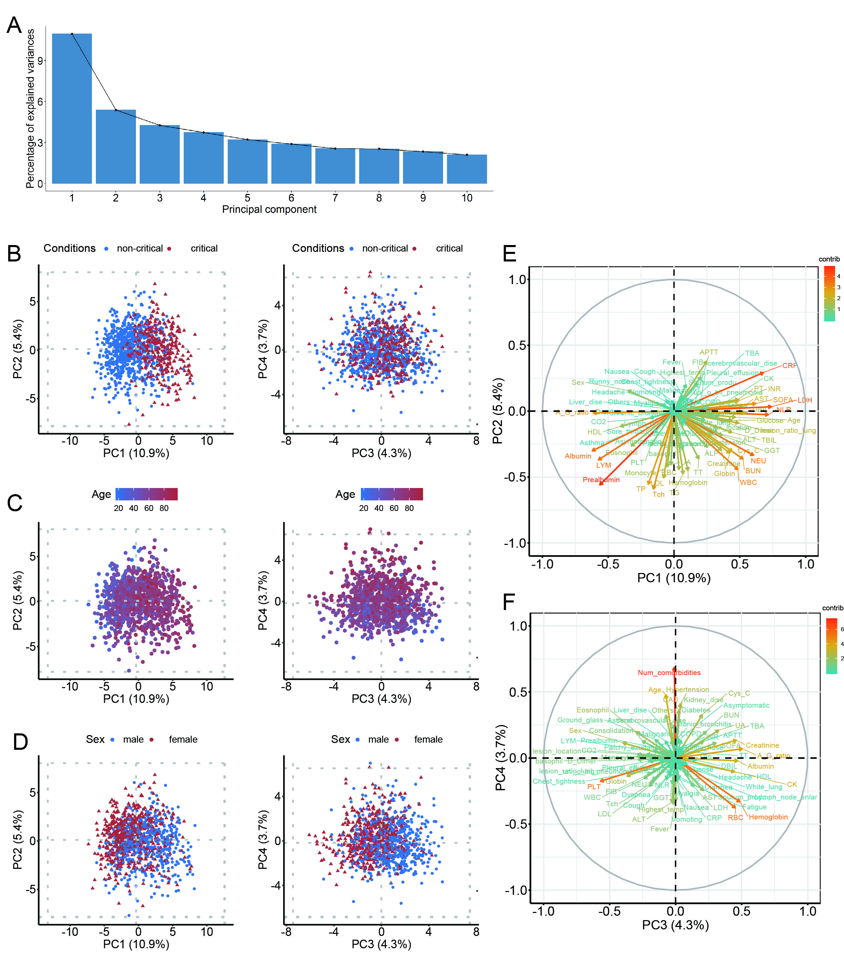
(A) Scree plot of principal component analysis (PCA). The percentage of variances explained by each of the selected 10 principal component were shown. PCA plots of the first four principle component (PC) for samples grouped by conditions (B), age (C), and sex (D) of participants; the grey dotted line represented median - 3*interquartile range, median, and median + 3*interquartile range respectively in both horizontal and vertical axis. PCA plots for Variables between PC1 and PC2 (E), PC3 and PC4 (F); positive correlated variables point to the same side of the plot, negative correlated variables was on the contrary; different colour for each variable indicated the contribution of a variable to a given principal component (in percentage).

Figure S2. LASSO Regression analysis

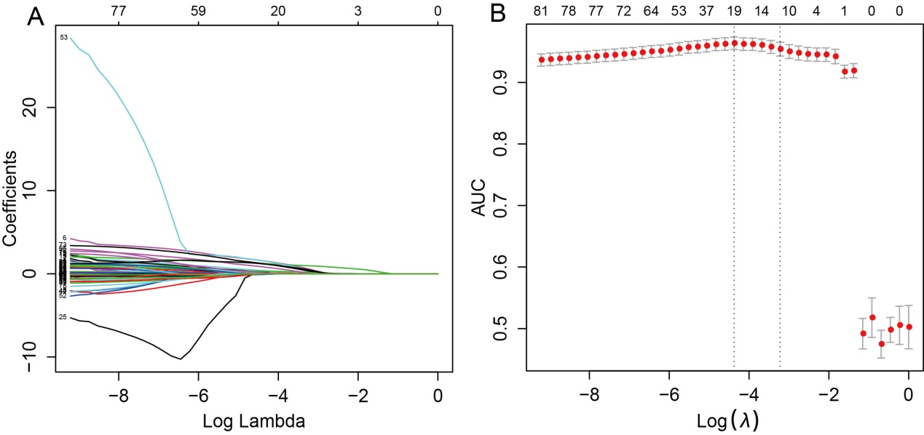
(A) Lasso coefficient profiles (y-axis) of the 81 variables. The lower x-axis indicated the Log Lambda (λ). The top x-axis indicated the average numbers of predictors. (B) Identification of the optimal λ in the Lasso regression with 10-fold cross-validation based on maximum area under the receiver operating characteristic (AUC). The vertical axis indicated AUC and horizontal axis indicated Log λ. Red dot with vertical bar represented average AUC and 95% CI for each model with a given λ.

Figure S3. Hosmer-Lemeshow test of three prediction models in the testing set

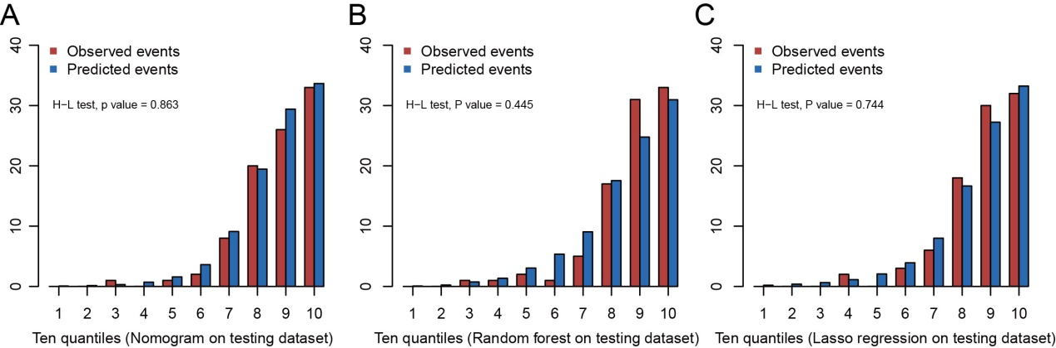
Bar plots of the observed events (red bar) and predicted events (blue bar) in each of the ten quantiles with the nomogram prediction model (A), random forest prediction model (B) and Lasso regression prediction model (C) on testing set. H-L test refers to Hosmer-Lemeshow χ² test.

Figure S4: Online prediction tool developed based on the nomogram to predict, at admission, the risk of developmet to critical illness in COVID-19 patients

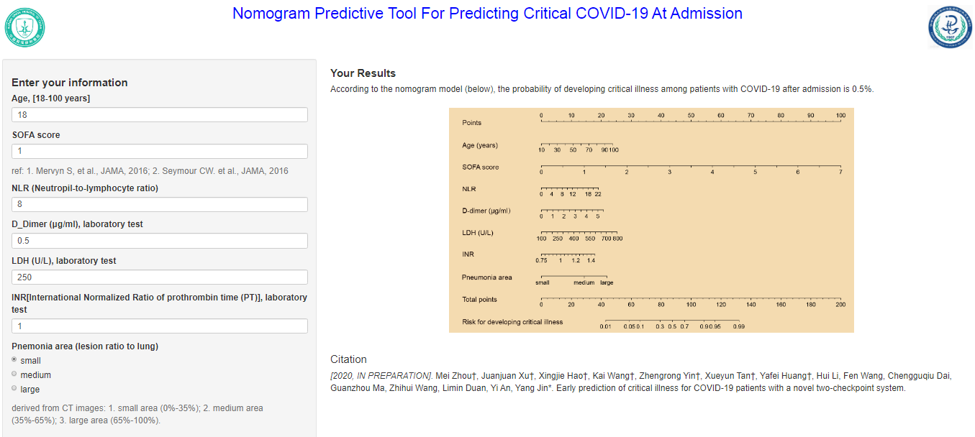

Figure S5. Change pattern of hemotologic and coagulation indicators

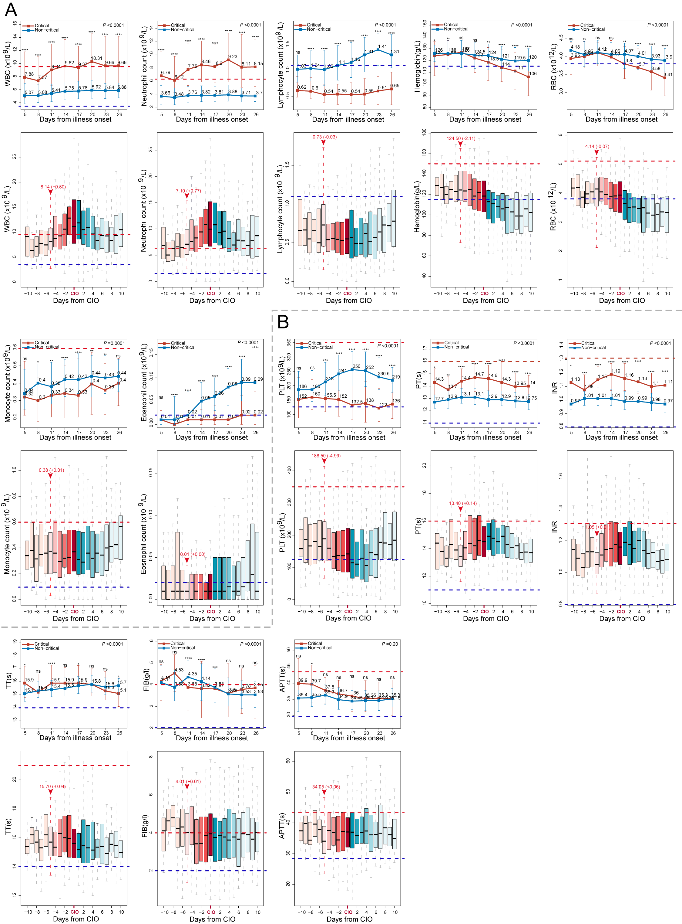
(A) The dynamic changes of hemotologic indicators starting from illness onset between critical and non-critical patients (line chart), and those starting from critical illness onset (CIO) in critical patients (boxplot). (B) The dynamic changes of coagulation indicators. The horizontal red dotted line and the horizontal blue dotted line represent the upper and lower limits of the reference value range of each indicator, respectively. In line chart, the results are reported as median (IQR). In the boxplot, the day of “burning point” is highlighted by vertical red dotted line and red arrow, above which are indicator's median value at the “burning point” and its average daily increment/decrement from “burning point” to CIO estimated by linear mixed model, they are expressed in the form of median (+increment) or median (-decrement).

Figure S6. Change pattern of inflammatory, energy&metabolism and cardiac function indicators

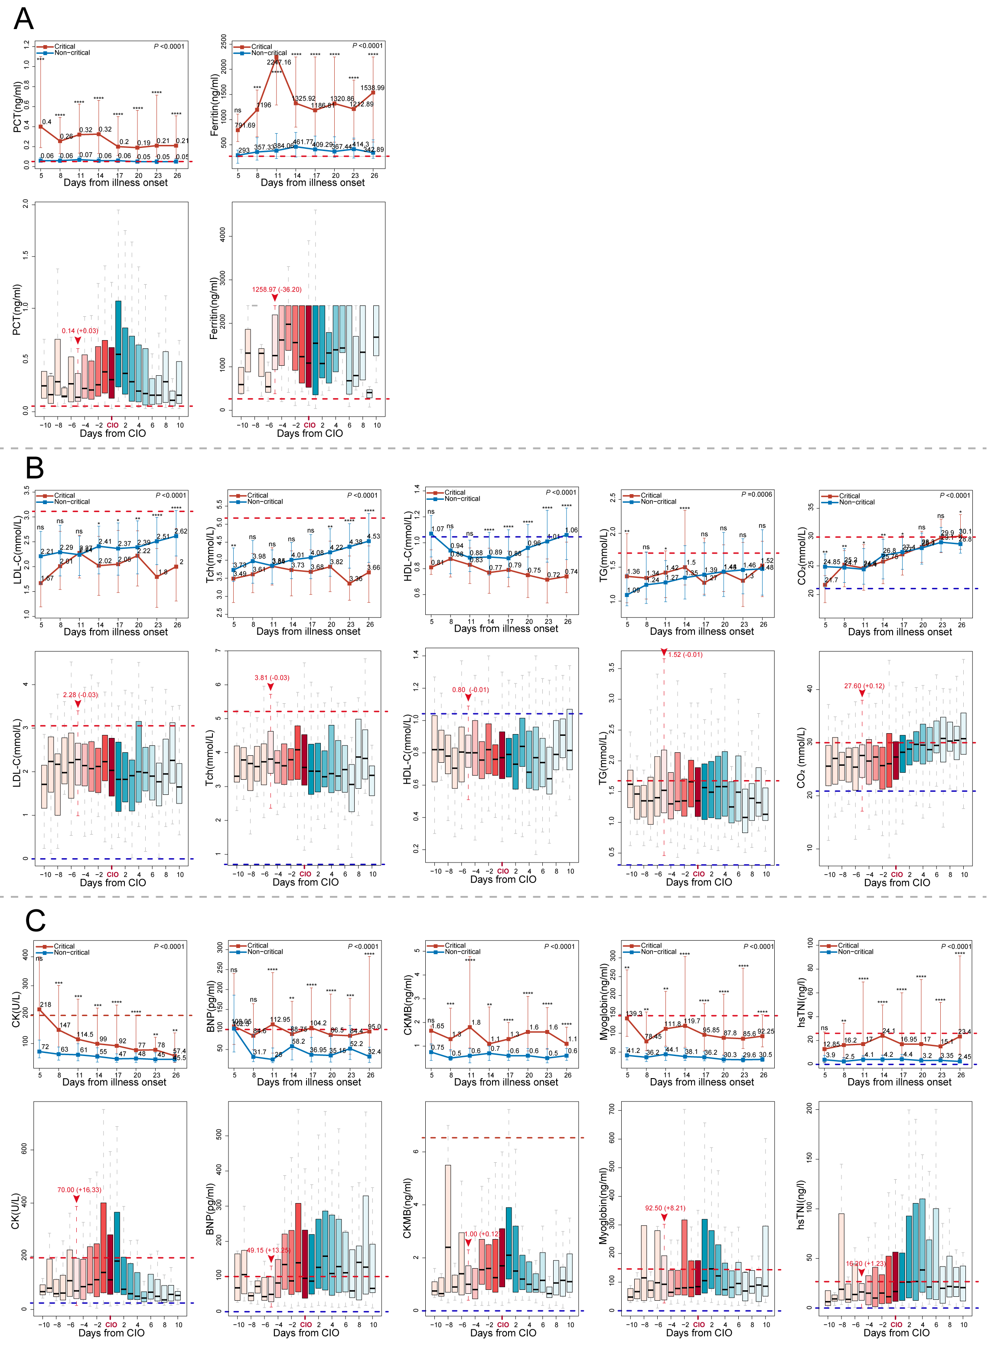
(A) The dynamic changes of inflammatory factors starting from illness onset between critical and non-critical patients (line chart), and those starting from CIO in critical patients (boxplot). The dynamic changes of energy&metabolism indicators (B), and cardiac function indicators (C).

Figure S7. Change pattern of liver and renal function indicators
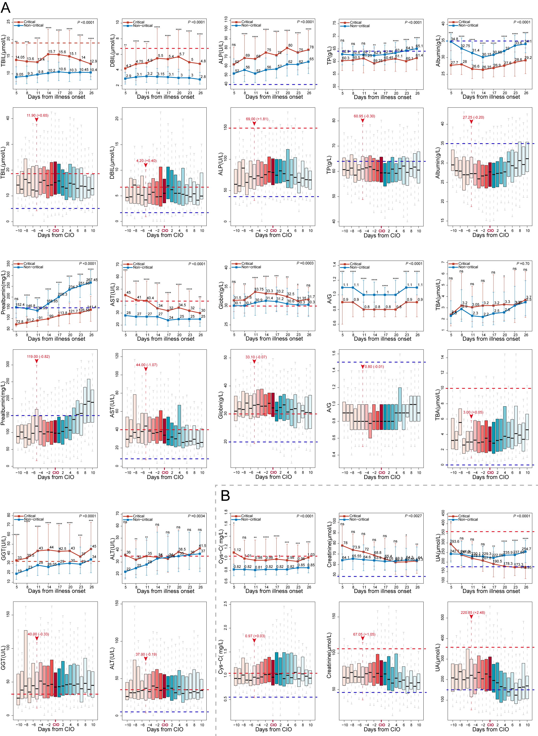
(A) The dynamic changes of Liver function indicators starting from illness onset between critical and non-critical patients (line chart), and those starting from CIO in critical patients (boxplot). (B) The dynamic changes of renal function indicators.
References
S1. L. B. Manual for Setting Up, Using, and Understanding Random Forest V4.0. [cited 2020 March 10]. Available from: https://www.stat.berkeley.edu/~breiman/Using_random_forests_v4.0.pdf.
S2. Kassambara A MF. Factoextra: extract and visualize the results of multivariate data analyses. [cited 2020 March 10]. Available from: https://CRAN.R-project.org/package=factoextra.
S3. Hong H, Xiaoling G, Hua Y. Variable selection using Mean Decrease Accuracy and Mean Decrease Gini based on Random Forest. Paper presented at: 2016 7th IEEE International Conference on Software Engineering and Service Science (ICSESS); 26-28 Aug. 2016, 2016.
S4. Friedman J, Hastie T, Tibshirani R. Regularization Paths for Generalized Linear Models via Coordinate Descent. Journal of statistical software 2010; 33: 1-22.
S5. Harrell FE, Jr., Lee KL, Califf RM, Pryor DB, Rosati RA. Regression modelling strategies for improved prognostic prediction. Stat Med 1984; 3: 143-152.
S6. Kerr KF, Brown MD, Zhu K, Janes H. Assessing the Clinical Impact of Risk Prediction Models With Decision Curves: Guidance for Correct Interpretation and Appropriate Use. J Clin Oncol 2016; 34: 2534-2540.
S7. Khwaja A. KDIGO clinical practice guidelines for acute kidney injury. Nephron Clin Pract 2012; 120: c179-184.
S8. Yang X, Yu Y, Xu J, Shu H, Xia J, Liu H, Wu Y, Zhang L, Yu Z, Fang M, Yu T, Wang Y, Pan S, Zou X, Yuan S, Shang Y. Clinical course and outcomes of critically ill patients with SARS-CoV-2 pneumonia in Wuhan, China: a single-centered, retrospective, observational study. The Lancet Respiratory Medicine 2020; 8: 475-481.
S9. Chen T, Wu D, Chen H, Yan W, Yang D, Chen G, Ma K, Xu D, Yu H, Wang H, Wang T, Guo W, Chen J, Ding C, Zhang X, Huang J, Han M, Li S, Luo X, Zhao J, Ning Q. Clinical characteristics of 113 deceased patients with coronavirus disease 2019: retrospective study. BMJ 2020; 368: m1091.
S10. Zhou F, Yu T, Du R, Fan G, Liu Y, Liu Z, Xiang J, Wang Y, Song B, Gu X, Guan L, Wei Y, Li H, Wu X, Xu J, Tu S, Zhang Y, Chen H, Cao B. Clinical course and risk factors for mortality of adult inpatients with COVID-19 in Wuhan, China: a retrospective cohort study. Lancet 2020; 395: 1054-1062.
S11. Lambden S, Laterre PF, Levy MM, Francois B. The SOFA score-development, utility and challenges of accurate assessment in clinical trials. Crit Care 2019; 23: 374.
S12. Chen R, Sang L, Jiang M, Yang Z, Jia N, Fu W, Xie J, Guan W, Liang W, Ni Z, Hu Y, Liu L, Shan H, Lei C, Peng Y, Wei L, Liu Y, Hu Y, Peng P, Wang J, Liu J, Chen Z, Li G, Zheng Z, Qiu S, Luo J, Ye C, Zhu S, Zheng J, Zhang N, Li Y, He J, Li J, Li S, Zhong N. Longitudinal hematologic and immunologic variations associated with the progression of COVID-19 patients in China. J Allergy Clin Immunol 2020.
S13. Shi S, Qin M, Cai Y, Liu T, Shen B, Yang F, Cao S, Liu X, Xiang Y, Zhao Q, Huang H, Yang B, Huang C. Characteristics and clinical significance of myocardial injury in patients with severe coronavirus disease 2019. Eur Heart J 2020.
S14. Bornstein SR, Rubino F, Khunti K, Mingrone G, Hopkins D, Birkenfeld AL, Boehm B, Amiel S, Holt RI, Skyler JS, DeVries JH, Renard E, Eckel RH, Zimmet P, Alberti KG, Vidal J, Geloneze B, Chan JC, Ji L, Ludwig B. Practical recommendations for the management of diabetes in patients with COVID-19. The lancet Diabetes & endocrinology 2020.

