Supplementary Materials

- Figure S1. Accuracy of edge weights
- Figure S2. Bootstrapped difference test for edge weights
- Figure S3. Stability of node expected influences
- Figure S4. Bootstrapped difference test for node expected influences
- Figure S5. The bridge expected influence indices among Chinese college students.

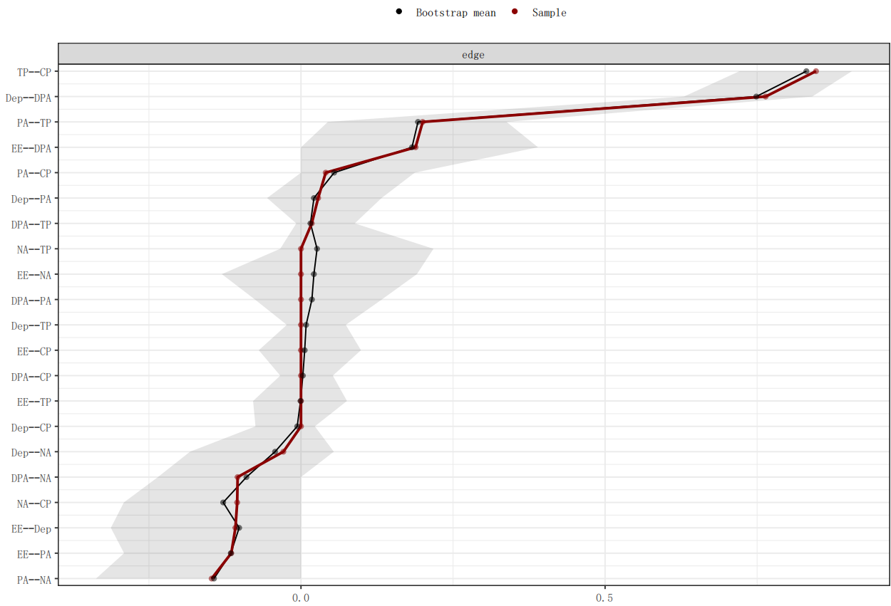
Figure S1. Accuracy of edge weights
Note: The red line depicts the sample edge weights and the gray bar depicts the bootstrapped confidence interval.

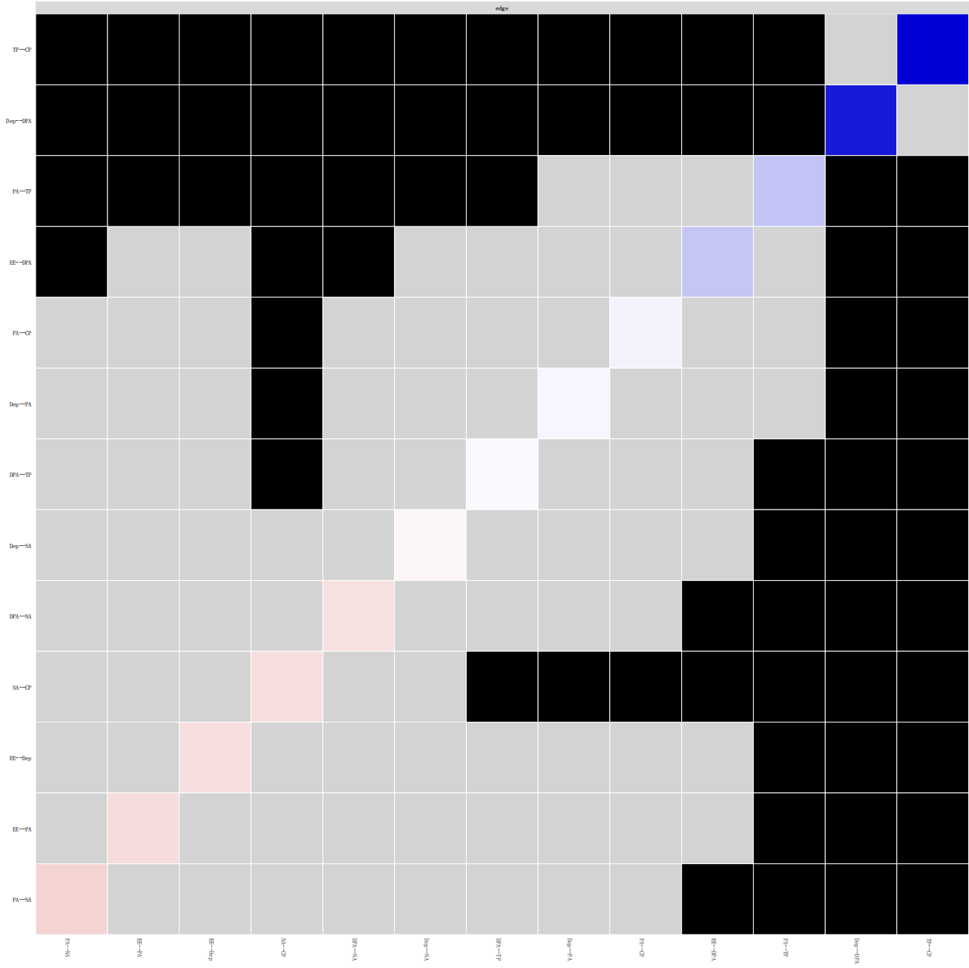
Figure S2. Bootstrapped difference test for edge weights
Note: Gray boxes indicate edge weights that do not differ significantly from one another, while black boxes indicate edge weights that do differ significantly. Blue and red boxes on the diagonal correspond to edge weights with positive and negative correlations, respectively.

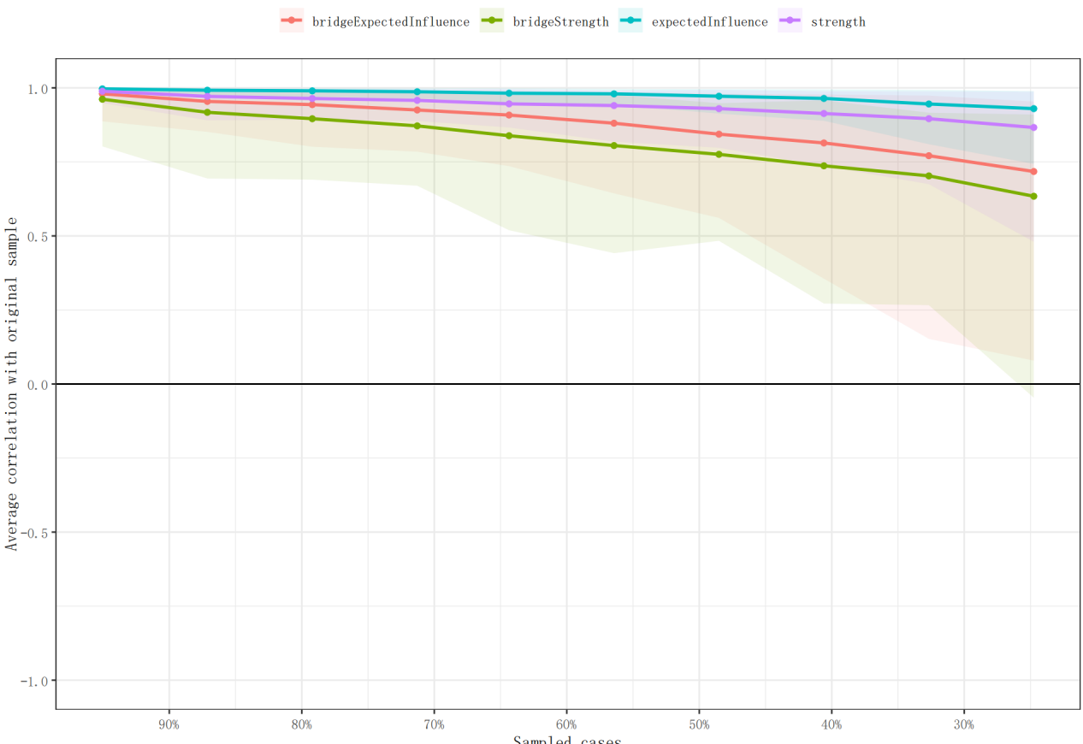
Figure S3. Stability of node expected influences
Note: The red bar represents the average correlation between node expected influences in the full sample and subsample with the red area depicting the 2.5th quantile to the 97.5th quantile.

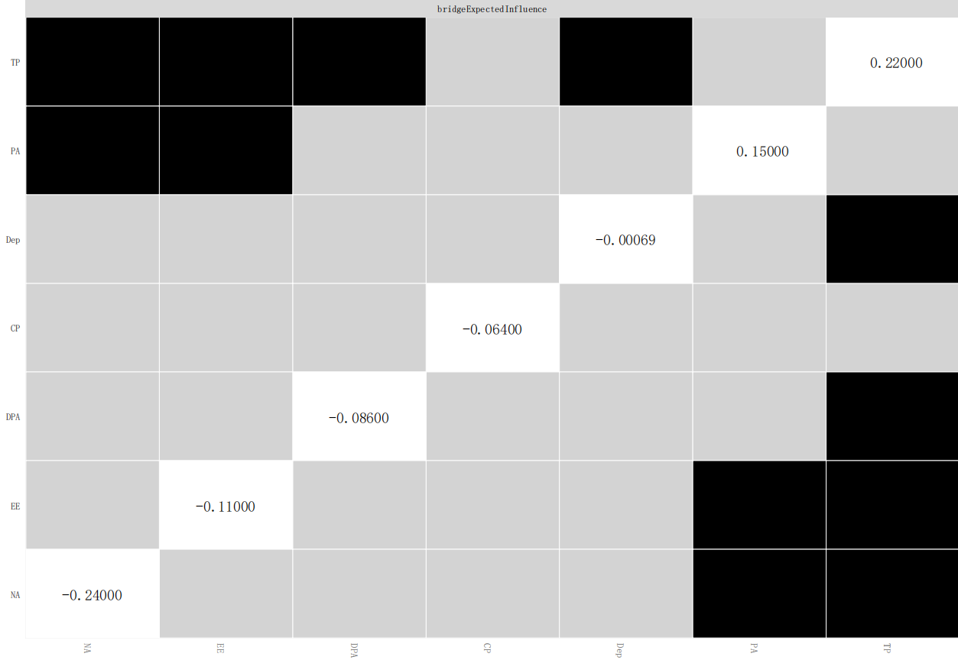
Figure S4. Bootstrapped difference test for node expected influences
Note: Gray boxes indicate node expected influences that do not differ significantly from one another, while black boxes indicate node expected influences that do differ significantly. The number in the white boxes (i.e., diagonal line) represent the value of node expected influences.

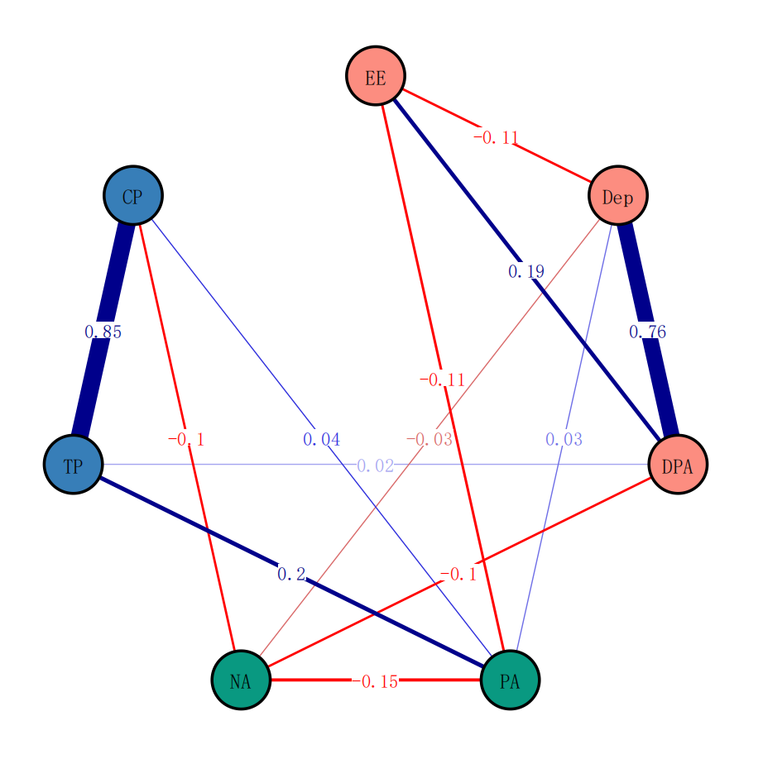
Figure 5. The MBI-GS-JPS- PANAS network model and the bridge expected influence indices among Chinese college students.

