Biobank Participants’ Perspectives on Receiving Genetic Risk Information from a Biobank – The case of Haemochromatosis

SUPPLEMENTARY INFORMATION

Jonna Clancy^{1*}, Janina Forstén², Elina Koskinen², Mikko Arvas³, Fredrik Åberg⁴, Kimmo Pitkänen^{1#}, Johanna Castrén^{2#}

¹ Finnish Red Cross Blood Service Biobank, Härkälenkki 13, 01730 Vantaa, Finland
² Finnish Red Cross Blood Service, Härkälenkki 13, 01730 Vantaa, Finland
³ Finnish Red Cross Blood Service R&D, Biomedicum 1, Haartmaninkatu 8, 00290 Helsinki, Finland
⁴ Transplantation and Liver Surgery, Helsinki University Hospital and University of Helsinki, Helsinki, Finland
# Equal contribution

*Corresponding author:
Jonna Clancy, PhD
Finnish Red Cross Blood Service
Biobank/Research & Development
Härkälenkki 13
01730 Vantaa
Finland
+358 50 553 2373
jonna.clancy@bloodservice.fi
Contents
Survey 2
Reference intervals 8
Survey results 9

Survey

SURVEY FOR DONORS WHO HAVE RECEIVED GENETIC RISK INFORMATION – EVALUATION OF THE EXPERIENCE

Research code:________________________

Background information
1. Age
years
2. Sex
- Male
- Female
- Non-binary
- I wish not to answer

3. How many times have you donated blood?
In this context, donation refers to the donation of whole blood, not the mechanical donation of plasma or platelets (plasmapheresis or thrombapheresis).
- I have never donated blood
- 1-10
- 11-20
- 21-30
- 31-40
- 51-60
- 61-70
- 71-80
- 81-90
- 91-100
- More than 100

4. What year did you donate for the first time?
Please write the year, e.g 2010

5. How are you planning to continue blood donation after receiving the information about iron accumulation tendency?
- More often than nowadays
- Like nowadays
- More seldom than nowadays
- I am going to stop blood donation because of the information I’ve received
- I am going to stop blood donation for some other reason, eg. my age
- I can’t tell

6. The received genetic information was easy to understand
- Yes
- No
- I don’t know

7. Did you understand when you gave the biobank consent that it could lead to receiving information relevant to health?
- Yes
- No

8. Would you like to receive similar information in the future, should it appear?
- Yes
- No
If you wish, you can complete your answer

Evaluate the following statements below based on your experience
9. It was useful to receive genetic information
- Fully agree
- Partly agree
- I don’t disagree or agree
- Party disagree
- Fully disagree

10. Receiving genetic information did not worry me
- Fully agree
- Partly agree
- I don’t disagree or agree
- Party disagree
- Fully disagree

11. The genome data in biobanks should be used more widely to promote health
- Fully agree
- Partly agree
- I don’t disagree or agree
- Party disagree
- Fully disagree

12. How has receiving genetic information affected your trust in The Blood Service?
- Has strengthened
- Has partly strengthened
- Has had no effect
- Has partly weakened
- Has weakened
If you wish you can complete your answer

13. How has receiving genetic information affected to your willingness to belong to the Blood Service Biobank?
- Has strengthened
- Has partly strengthened
- Has had no effect
- Has partly weakened
- Has weakened

14. After receiving the information, did you apply for health care?
- Yes
- No

If you answered “No” to question 14, you can continue from question 23.

15. To which health care facility did you apply?
- Student health care
- Occupational health
- Specialized medical care
- Public health care
- Private health care
- Other, which____________
Evaluate the statements below according to your experience
16. My situation was taken care of fluently in healthcare
- Fully agree
- Partly agree
- I don’t disagree or agree
- Party disagree
- Fully disagree

17. I got enough support from health care
- Fully agree
- Partly agree
- I don’t disagree or agree
- Party disagree
- Fully disagree

18. My questions were answered in health care
- Fully agree
- Partly agree
- I don’t disagree or agree
- Party disagree
- Fully disagree

19. In health care services, the attitude towards the returned information from Biobank was…
- Positive
- Partly positive
- Neutral
- Partly negative
- Negative

20. Were you subjected to the following laboratory tests in healthcare and what were their results?
The test was taken Result
Yes No
Confirmation of HFE C282Y +/+
Ferritin µ/l
Transferrin saturation %
Basic blood count, hemoglobin g/l
Basic blood count, MCV fl
Alanine aminotransferase U/l

Note: these laboratory tests were referred here in the same manner as they were originally referred in the letter where the participants were guided to apply health care and have these laboratory tests done.

21. Did you undergo any other tests? If yes, what tests and what were the results?

22. Did you get a clinical diagnosis for hemochromatosis (ICD10: E83.1)?
- Yes
- No
- I don’t know

23. Have you had the following symptoms or diagnosed diseases?
Tiredness Yes No
Joint symptoms Yes No
Type 2 diabetes Yes No
Some other symptoms, what?

Evaluate the statements below
24. I believe that I can influence my risk of hemochromatosis with my lifestyle
- Fully agree
- Partly agree
- I don’t disagree or agree
- Party disagree
- Fully disagree

25. Receiving risk information motivates me to take better care of my health
- Fully agree
- Partly agree
- I don’t disagree or agree
- Party disagree
- Fully disagree

26. I have discussed about my tendency to haemochromatosis with my close relatives
Close relative means biological parents, siblings and children
- Yes
- No
If yes, with how many?

If you wish, you can tell how the information was received among the relatives or what kind of thoughts may have been brought up

We appreciate your time regarding the research

Reference intervals

The reference intervals are reported in accordance with Helsinki University Hospital reference: https://diagnostiikka.hus.fi/hakusivu?search=&tabs=ebs
Laboratory measurement | Female | Male
P -Ferrit µg/l | 15 - 125 | 20 - 195
fP-Trfesat % | 17 - 52 | 17 - 52
Basic blood count, haemoglobin g/L | 117 - 155 | 134 - 167
Basic blood count, MCV fl | 82 - 98 | 82 - 98
Alanine transaminase U/l | < 35 | < 50

Survey results

Background information

1. Age
2. Sex
3. How many times have you donated blood?
4. What year did you donate for the first time?
Results for the questions 1-4 are shown in the article Table 1

5. How are you planning to continue blood donation after receiving the information about iron accumulation tendency?
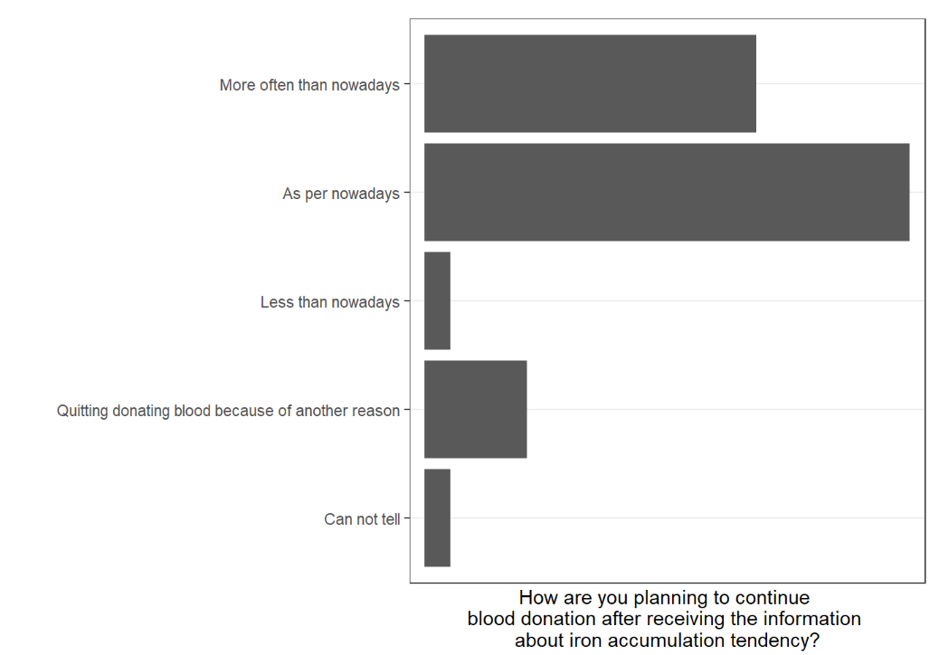

6. The received genetic information was easy to understand
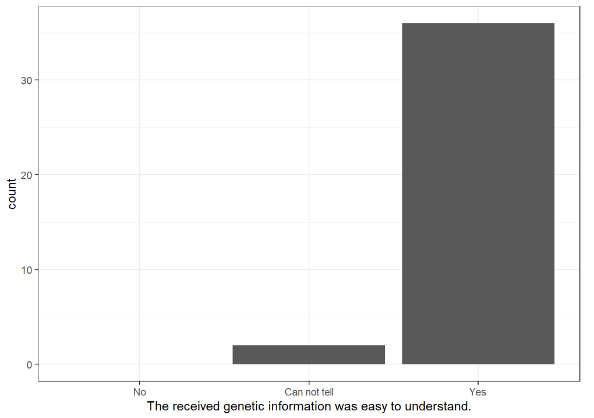

7. When you gave your consent for biobank, did you understand it could lead to receiving information relevant to your health?
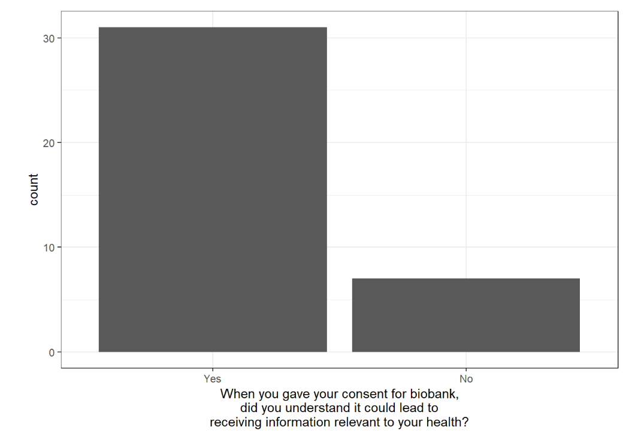

8. Would you like to receive similar information in the future, should it appear?
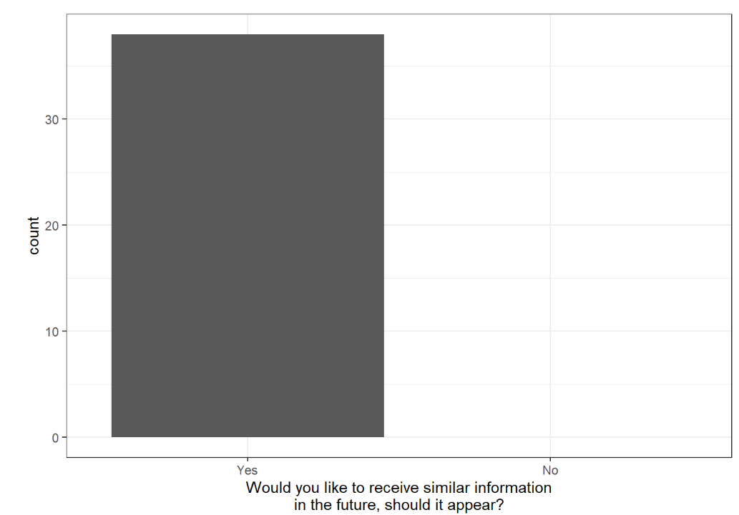

9. It was useful to receive genetic information
10. Receiving genetic information did not worry me
11. The genome data in biobanks should be used more widely to promote health
Results for the questions 9-11 are shown in the article Figure 1D

12. How has receiving genetic information affected your trust in The Blood Service?
13. How has receiving genetic information affected to your willingness to belong to the Blood Service Biobank?
Results for the questions 12-13 are shown in the article Figure 1C

14. After receiving the information, did you apply for health care?
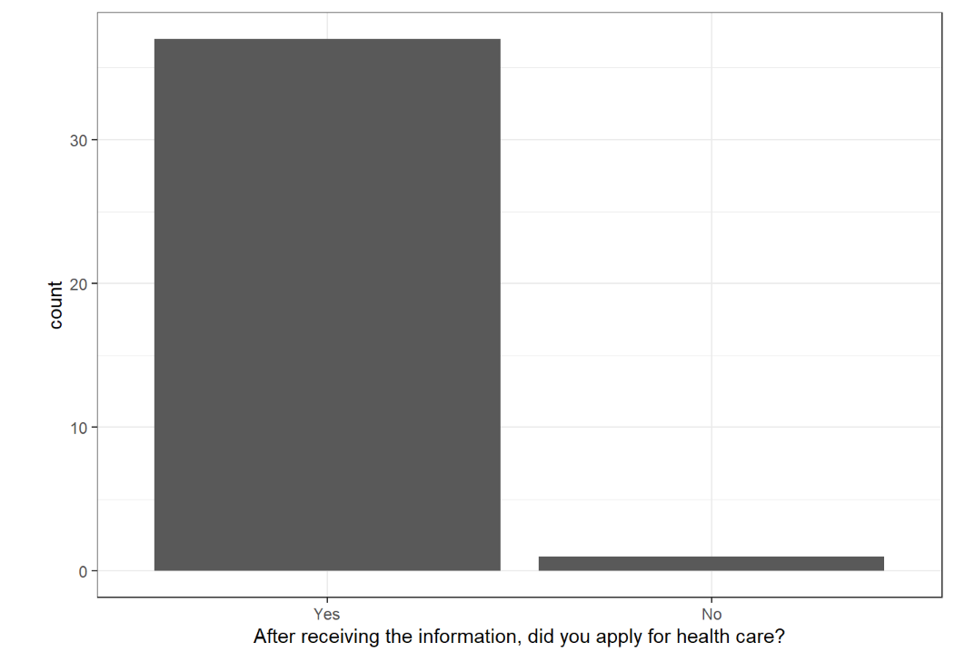

15. To which health care facility did you apply?
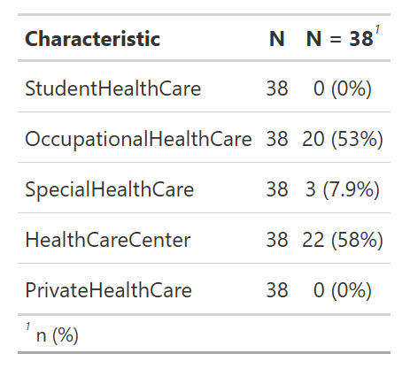

16. I got enough support from health care
17. My situation was taken care of fluently in healthcare
18. My questions were answered in health care
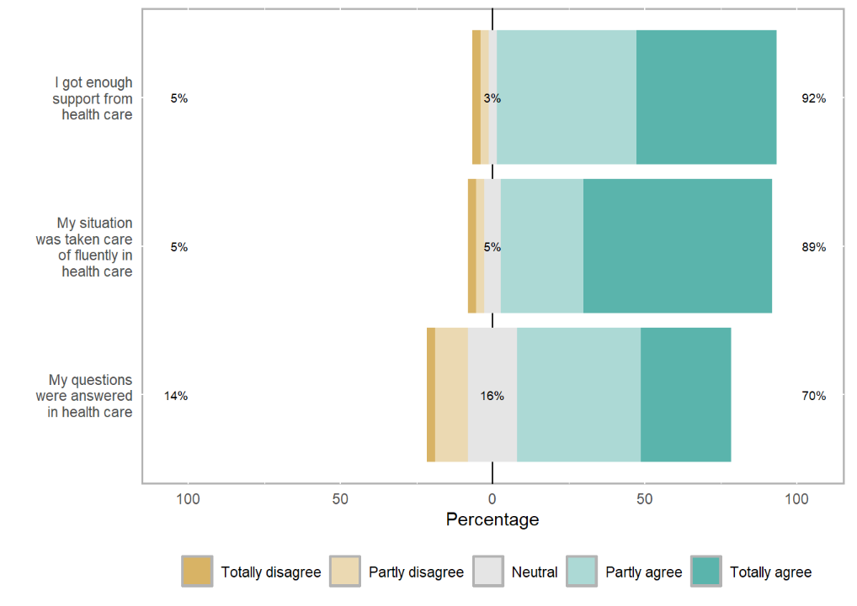

19. In health care services, the attitude towards the returned information from Biobank was…
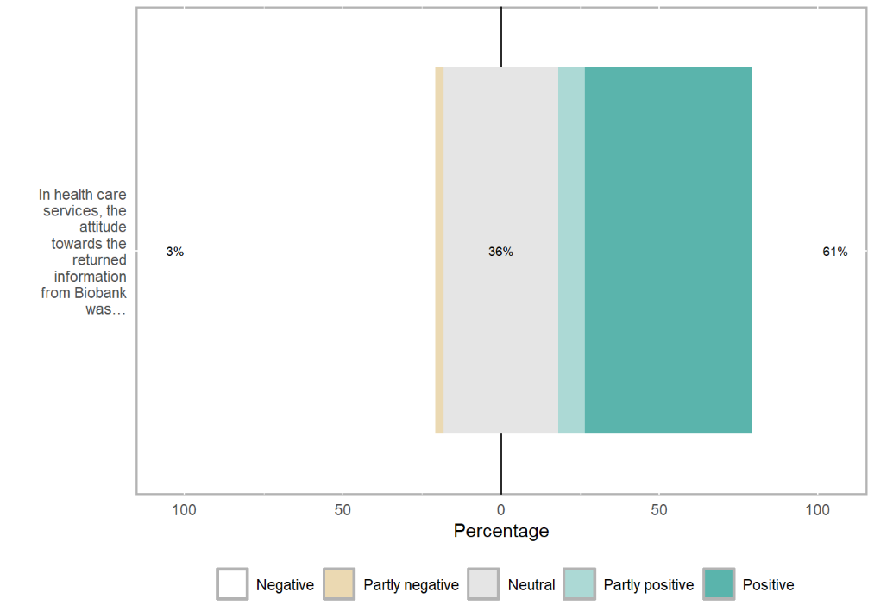

20. Were you subjected to the following laboratory tests in healthcare and what were their results?
Results for the question 20 are shown in the article Table 2

21. Did you undergo any other tests? If yes, what tests and what were the results?
Open field answers are not shown

22. Did you get a clinical diagnosis for hemochromatosis (ICD10: E83.1)?
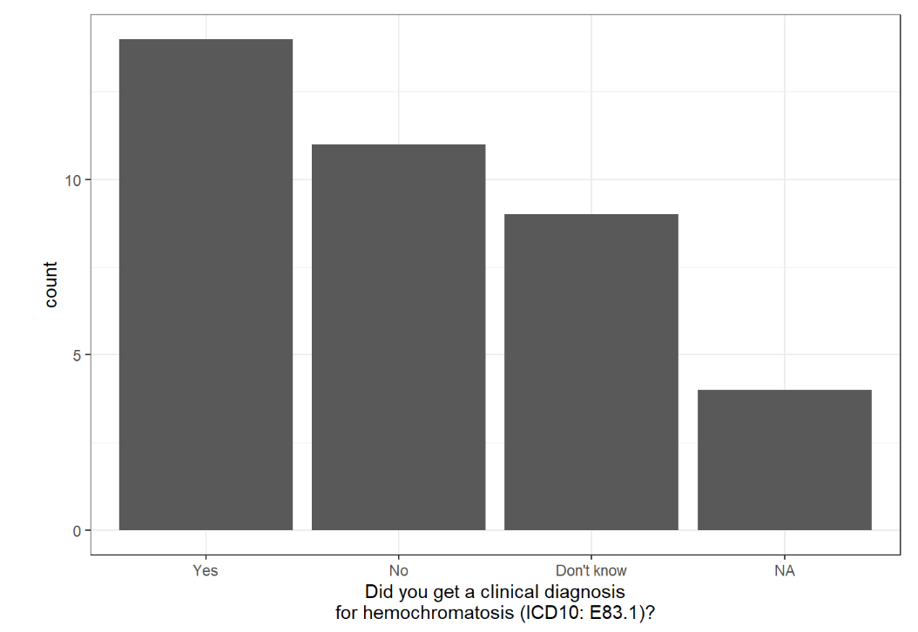

23. Have you had the following symptoms or diagnosed diseases?
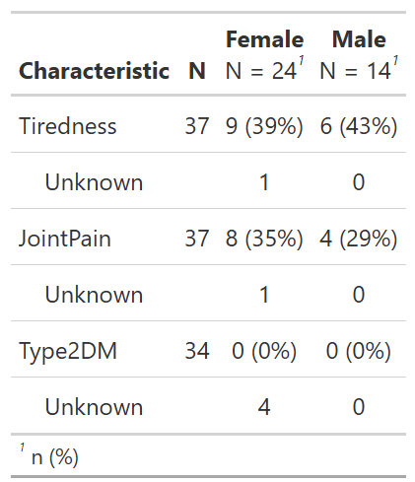
< 5

24. I believe I can make an impact to my predisposition to haemochromatosis with my lifestyle
25. Receiving genetic risk information motivates me to take care of my health better
Results for the questions 24-25 are shown in the article Figure 1D

26. I have discussed about my tendency to hemochromatosis with my close relatives
If yes, with how many?
