Supplementary Data
for
A Framework for Evaluating the Integration of Green Infrastructure into Stormwater System Design
Velocity and Cover Constraints
The minimum flow velocity in a drain flowing full is 0.6 m/sec to prevent sedimentation, and the maximum does not exceed 3.66 m/sec to prevent pipe erosion (SASO, 2020). Storm drains will be designed to avoid surcharge under peak flow conditions. When the topography is favorable, the bed slope of the drain is kept parallel to the ground slope. However, the minimum gradient for a section of the drain is generally considered the gradient necessary to satisfy the minimum velocity requirements according to KSA code (Table S4) (SASO, 2020). In cases where the drain runs through steep ground, the drain bed slope is governed by the maximum permissible velocity. The minimum size of pipes used for the storm drainage system is 300 mm (SASO, 2020). Drains are routed to minimize excavation depth, following the natural ground slopes where appropriate. A pipe cover of 0.9 m should be ensured to prevent pipe breaking due to truck and car loads.
Catch basins are placed in the sag points of the roads to work properly (Figure S4), and they are placed between sags at a suitable spacing to prevent flooding. Manholes are provided at the top of every storm drain, at the end of each line, at all changes in diameter, gradient, or alignment, and at all intersections of drains. Multiple-entry manholes are acceptable. According to the KSA code, a maximum spacing between manholes based on pipe diameter is required for future maintenance (Table S5).

Figures
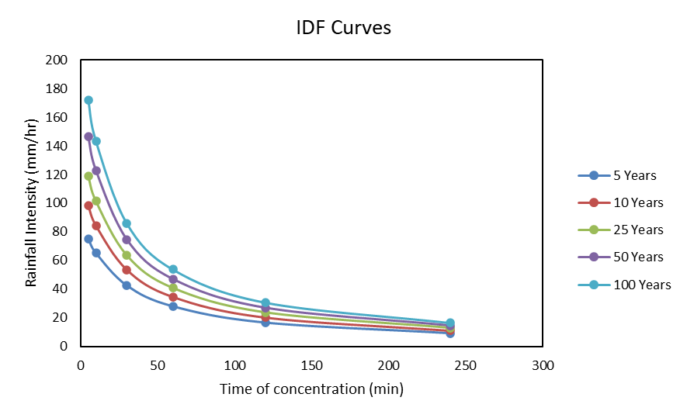
Fig. S1. IDF curves for the area of interest.
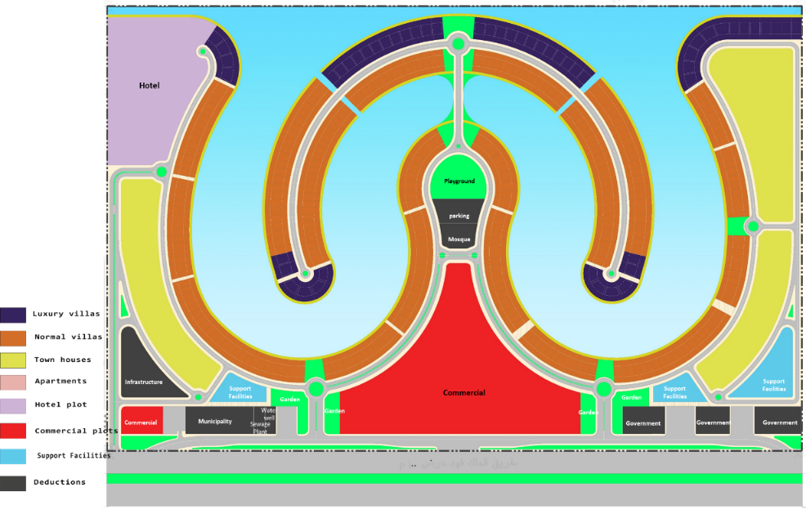
Fig. S2. The land use map in the area of study.
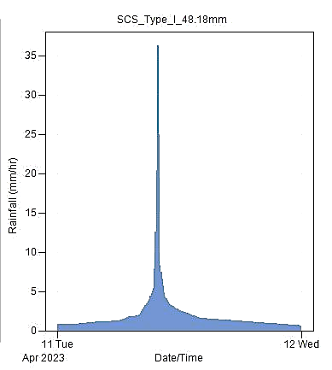
Fig. S3. SCS CN Rainfall Distribution Type (II).

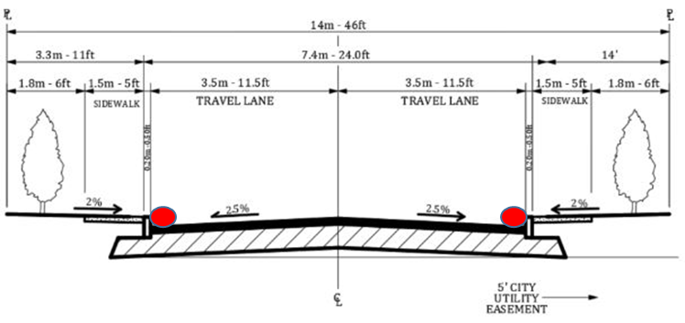
Fig. S4. Typical Road Cross Section Shows the Location of Catch basin, red circles represent catch basins.

Tables
Table S1. Rainfall intensity for different storm duration and return periods.
 | Duration (min)
Return Period | 5 | 10 | 30 | 60 | 120 | 240 | 480 | 960 | 1440
5 Years | 75.17 | 65.15 | 42.49 | 27.92 | 16.56 | 9.13 | 4.81 | 2.47 | 1.66
10 Years | 98.36 | 84.27 | 53.57 | 34.64 | 20.30 | 11.10 | 5.82 | 2.99 | 2.01
25 Years | 119.16 | 101.48 | 63.69 | 40.86 | 23.80 | 12.97 | 6.79 | 3.48 | 2.34
50 Years | 146.54 | 122.90 | 74.71 | 47.04 | 27.02 | 14.60 | 7.60 | 3.88 | 2.61
100 Years | 172.00 | 143.33 | 86.00 | 53.75 | 30.71 | 16.54 | 8.60 | 4.39 | 2.95

Table S2. Runoff coefficient for urban areas (Source: KSA code).
Land cover type | Runoff Coefficients
Asphalt roads and parking | 0.90
Buildings (including green parts) | 0.60
Green areas | 0.20

Landuse | Soil Group (A) Cover Type | CN
Roads | Streets and Roads | 98
Buildings | Town Houses | 77
Parking | Paved parkings | 98
Green Areas | Open Space (grass >75%) | 39
Commercial | Commercial and businesses | 80
Table S3. SCS CN values for different land use from NRCS.

Table S4. Allowed Minimum and Maximum Slopes for Different Pipe Diameters
Diameter (mm) | Min. Slope (%) | Max. Slope (%)
300 | 0.2 | 7.15
400 | 0.14 | 4.87
500 | 0.1 | 3.73
600 | 0.08 | 3.84
700 | 0.06 | 2.31
800 | 0.05 | 1.93
900 | 0.05 | 1.65
1000 | 0.04 | 1.44
>1000 | 0.03 | 1.13

Table S5. Allowed Maximum Spacing for Different Pipe Diameters.
Pipe Diameter | Spacing (meter)
< 800 mm | 70 - 100
> 800 mm | 100 - 120

Table S6. Low impact development (LID) parameters- for design.
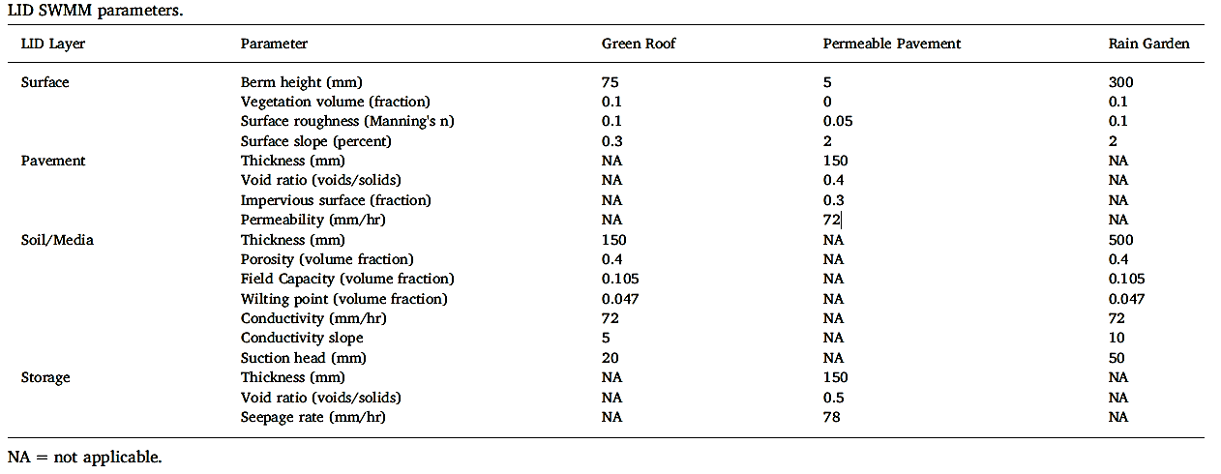

Table S7. Economic Assessment Metrics.
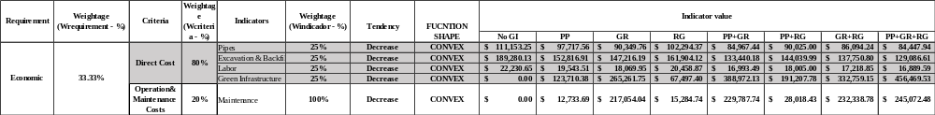

Table S8. Environmental Assessment Metrics.
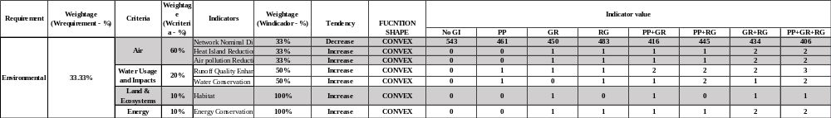

Table S9. Resiliency Assessment Metrics.

