Age-related nigral downregulation of the Parkinson’s risk factor FAM49B primes human microglia for inflammaging

Jacqueline Martin^{1,2,*}, Guan-Ju Lai^{1,2,3,*}, Christopher Y. Park^{4,*}, Colista West^{1,2}, Trevor Van Brunt^{1,2,5}, Samarah Ahmed^{1,2}, Saheed Lawal^{1,2}, Maya Dickson^{1,2}, Taylor Russo^{1,2}, Wendy Akmentin^{1,2}, Molly Weiner⁶, Benjamin Kolisnyk⁷, Olga G. Troyanskaya^{8,9,10} and Markus Riessland^{1,2}

*equal contribution

Affiliations:
¹Department of Neurobiology and Behavior; Stony Brook University, Stony Brook, NY 11794, USA
²Center for Nervous System Disorders; Stony Brook University, Stony Brook, NY 11794, USA
³Molecular and Cell Biology Program, Department of Biochemistry and Cell Biology, Stony Brook University, NY 11794, USA
⁴Flatiron Institute, Simons Foundation, New York, NY, USA.
⁵Medical Scientist Training Program, Stony Brook University Renaissance School of Medicine, Stony Brook University, Stony Brook, NY 11794, USA
⁶Perelman School of Medicine at the University of Pennsylvania, Philadelphia, PA 19104, USA
⁷Laboratory of Molecular and Cellular Neuroscience, The Rockefeller University, New York, NY 10065, USA
⁸Lewis–Sigler Institute for Integrative Genomics, Princeton University, Princeton, NJ, USA.
⁹Flatiron Institute, Simons Foundation, New York, NY, USA.
¹⁰Department of Computer Science, Princeton University, Princeton, NJ, USA
Correspondence:
Markus Riessland
markus.riessland@stonybrook.edu

SUPPLEMENTARY FIGURES

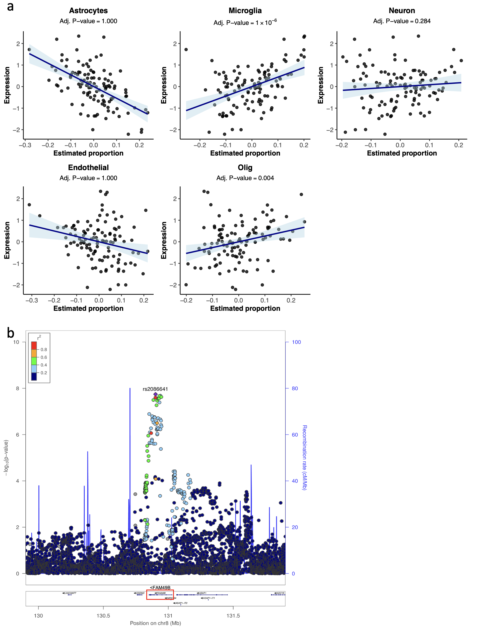
Figure S1. Correlation of FAM49B expression with inferred proportions of major brain cell types in the human SNpc. a) Scatter plots showing the correlation between FAM49B normalized expression and estimated relative proportions of five major brain cell types—microglia, astrocytes, neurons, oligodendrocytes, and endothelial cells—across 114 GTEx SNpc bulk RNA-seq samples. Cell-type proportions were inferred based on cell-type-specific marker genes from Zhang et al. (see Methods). FAM49B expression shows the strongest positive correlation with microglia abundance compared to associations observed for other cell types, supporting microglia as the primary cell type expressing FAM49B in the SNpc. b) Manhattan plot shows the SNP rs2086641 which is significantly associated with PD (based on Nalls et al., 2019 and derived from https://pdgenetics.shinyapps.io/GWASBrowser/). The red box shows the genomic location of FAM49B.

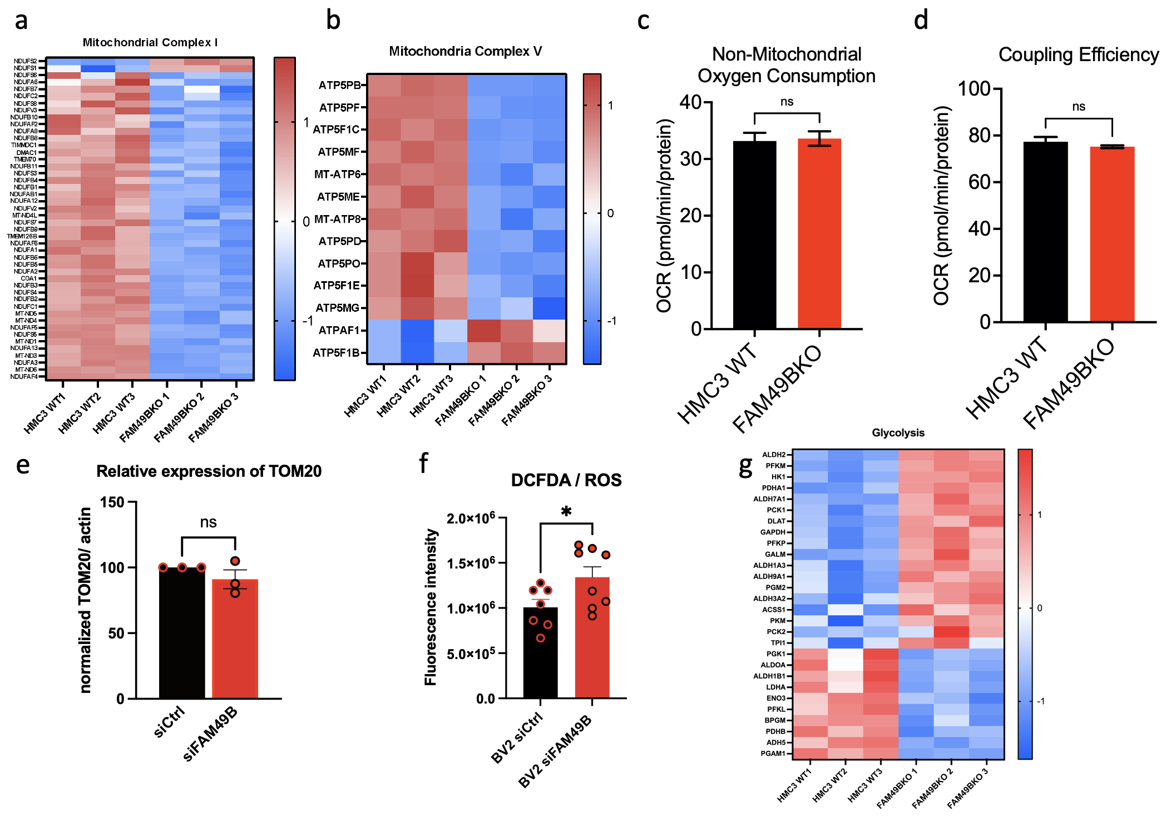
Figure S2. Reduced expression of FAM49B in microglia causes metabolic changes. Heatmaps of oxidative mitochondrial complex I (a) and V (b) show significantly altered genes in FAM49B-KO cells. Bar graphs show no significant change in coupling efficiency (c) and non-mitochondrial oxygen consumption (d) (n=18 for each condition, Student’s t-test). e) Quantification of TOM20 expression based on confocal imaging. No significant differences between siRNA control and siFam49b in BV2 cells was observed, indicating that there is no change in overall mitochondria numbers. Reactive oxygen species was upregulated in BV2 Fam49b knockdown cells as determined by a DCFDA assay (f).(N=7,8, Welch’s t test, *p = 0.0404). Heatmap of glycolysis-related genes show significantly altered genes in FAM49B-KO cells.

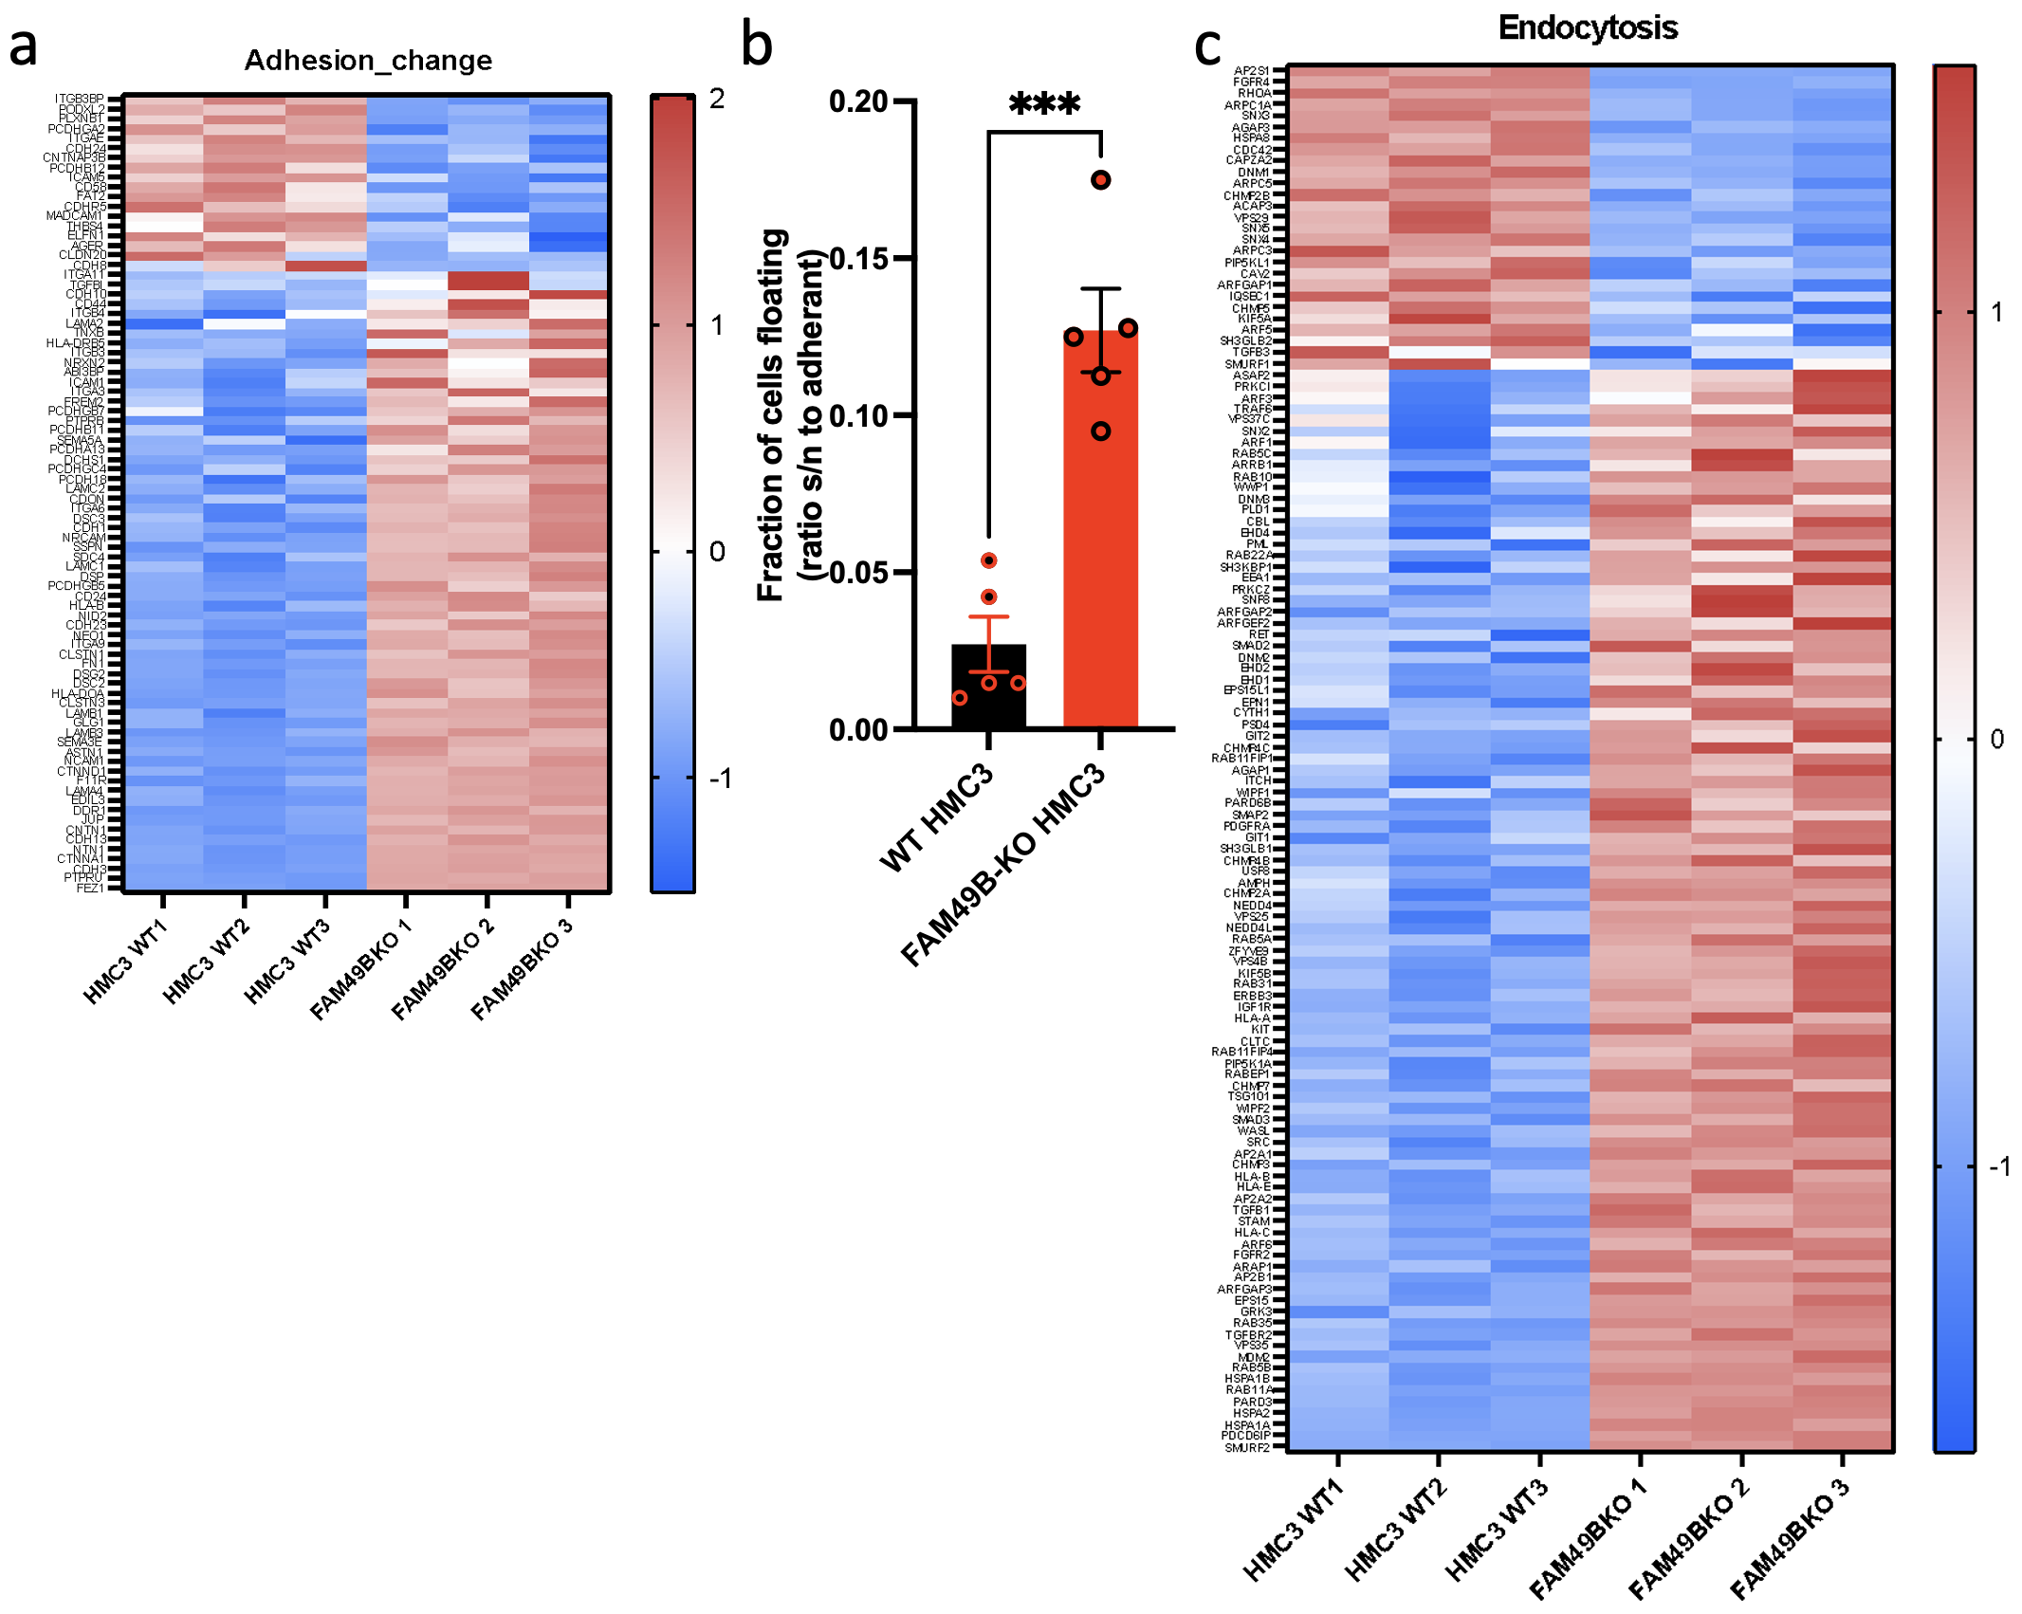
Figure S3. FAM49B reduction causes cytoskeletal rearrangements.
Heatmaps of adhesion (a) and endocytosis (c) genes that were significantly altered in FAM49B-KO cells. b) Bar graph shows a significant reduction in cell attachment overnight. N=3, n=5(WT)/5(KO), *** p<0.001, Student’s unpaired t-test

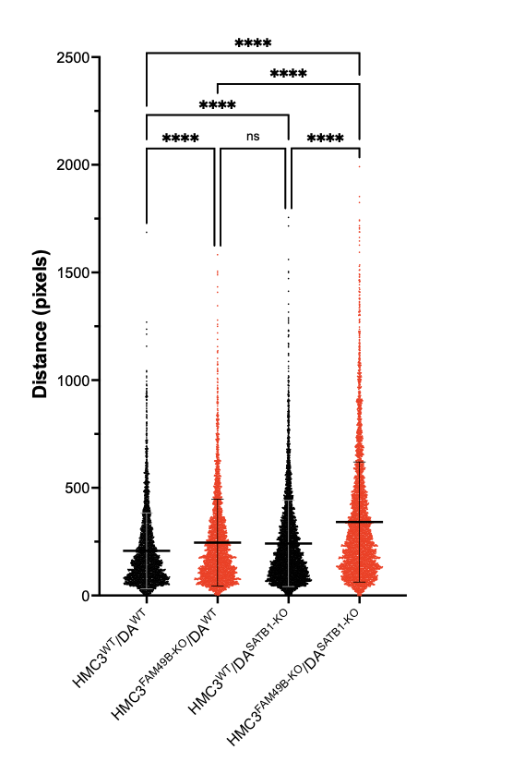
Figure S4. Exposure of FAM49B-KO microglia induced migration response in midbrain cultures. Scatterplot of distance traveled of global cell movement induced by plating WT and FAM49B-KO microglia (HMC3) on WT and SATB1-KO dopamine neuron cultures (DA) (HMC3^{WT}/DA^{WT}; HMC3^{WT}/DA^{SATB1-KO}; HMC3^{FAM49B-KO}/DA^{SATB1-KO}). Mean ± SD is shown (n>4.200, N=3, 3 per condition), data was analyzed using One-way ANOVA. ** p<0.01 **** p<0.001.

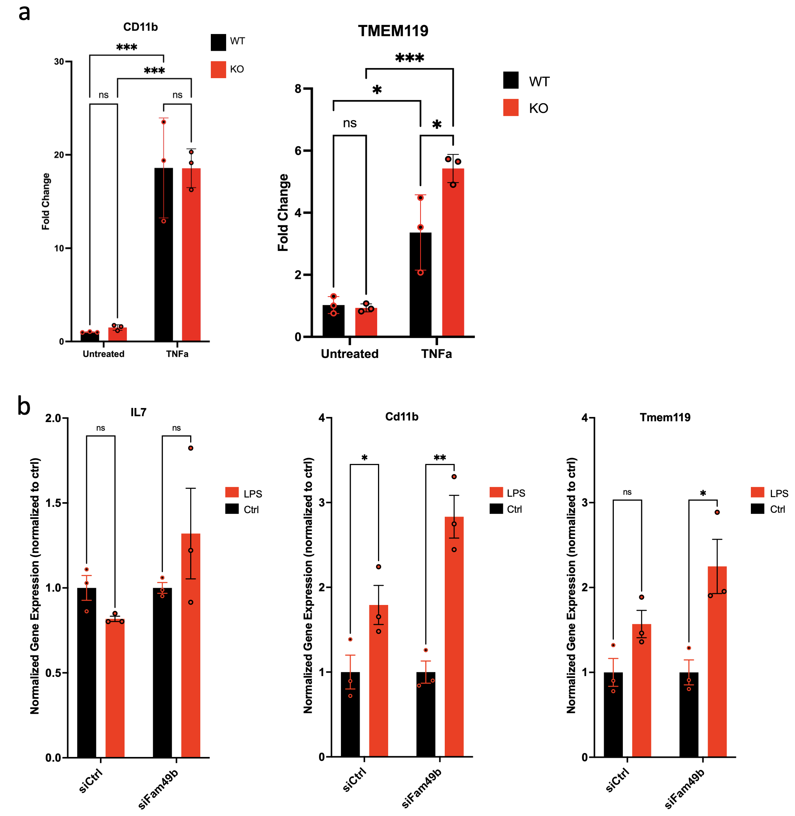
Figure S5. Inflammatory gene expression in FAM49B-reduced cells.
Bar graphs show qPCR-based gene expression data of CD11b and TMEM119 in HMC3 cells (a) and IL7, Cd11b and Tmem119 in BV2 cells (b). Immune reaction was triggered with TNFα (HMC3) or LPS treatment (BV2). Note that cells lacking FAM49B showed a stronger response. (Data are presented as mean ± SEM and were analyzed using an unpaired Mann-Whitney t-test. * p< 0.05, ** p< 0.01, *** p< 0.001).

