Supplementary Materials for

Cell Line-Specific Estrogen Responses Uncover Functional Sex Differences in Murine Macrophages

Alison M Veintimilla, et al.

*Erika Moore corresponding author. Email: emt@umd.edu

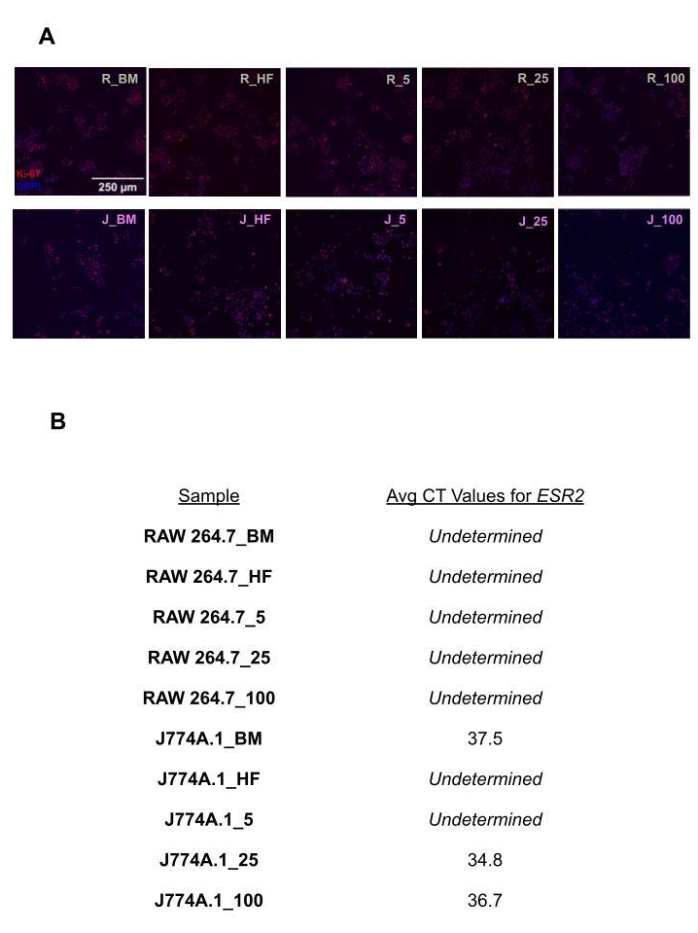
Fig. S1.
E2 dosing does not have an effect on RAW 264.7 and J774A.1 proliferation. ESR2 expression was not detected in either cell-line. (A) Representative images of immunocytochemistry staining for proliferation marker Ki67 (red), and cell-nuclear marker, DAPI (blue) on RAWs (top row - green) and J774s (bottom row - pink). Scale bar showing 250 µm (B) Threshold cycle (CT) values for Esr2 expression - which encodes ERbeta - for RAW 264.7 and J774A.1. For figure and table, BM is referring to basal media conditions, HF is referring to hormone-free conditions and 5, 25,100, refers to E2 treatment in nM.

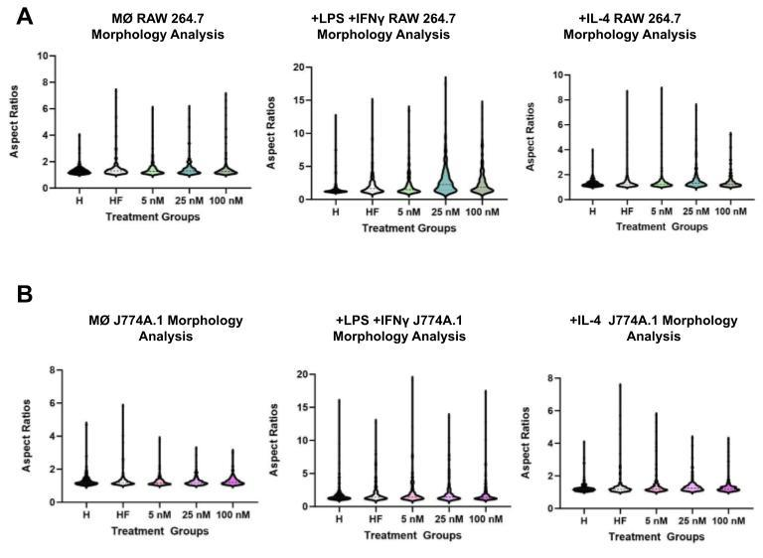
Fig. S2.
Aspect ratio distribution across +LPS+IFNγ and +IL-4 stimulated macrophages for RAW 264.7 (A) and J774A.1 (B).

Sample | Avg CT Values for iNOS
MØ RAW 264.7_BM | 36.3
MØ RAW 264.7_HF | 35.3
MØ RAW 264.7_5 | 36.3
MØ RAW 264.7_25 | 36.3
MØ RAW 264.7_100 | 36.0
MØ J774A.1_BM | 32.4
MØ J774A.1_HF | 34.8
MØ J774A.1_5 | 36.0
MØ J774A.1_25 | 34.3
MØ J774A.1_100 | 32.9
+IL-4 RAW 264.7_BM | 38.2
+IL-4 RAW 264.7_HF | 37.9
+IL-4 RAW 264.7_5 | 35.2
+IL-4 RAW 264.7_25 | 36.3
+IL-4 RAW 264.7_100 | 35.1
+IL-4 J774A.1_BM | 34.6
+IL-4 J774A.1_HF | 38.0
+IL-4 J774A.1_5 | 37.4
+IL-4 J774A.1_25 | 36.6
+IL-4 J774A.1_100 | 33.9

Table S1.
Table of cycle threshold (CT) values >/= 35 for iNOS gene expression for RAW 264.7 and J774A.1 across different macrophage phenotypes.

Sample | Avg CT Values for Arg-1
MØ RAW 264.7_BM | Undetermined
MØ RAW 264.7_HF | 35.1
MØ RAW 264.7_5 | Undetermined
MØ RAW 264.7_25 | Undetermined
MØ RAW 264.7_100 | Undetermined
MØ J774A.1_BM | Undetermined
MØ J774A.1_HF | 35.3
MØ J774A.1_5 | Undetermined
MØ J774A.1_25 | 37.4
MØ J774A.1_100 | Undetermined

Table S2.
Table of CT values >/= 35 for Arg-1 gene expression for RAW 264.7 and J774A.1 across different macrophage phenotypes.

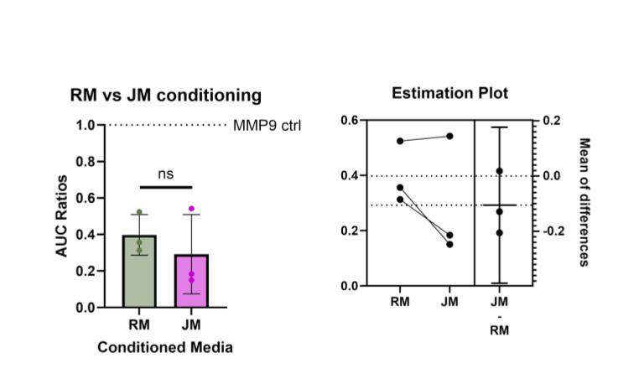

Fig. S3.
MMP9 quantification of RAW 264.7 and J774A.1 conditioned media with paired t-test statistical analysis estimation plot.

