SUPPLEMENTARY DATA FIGURES

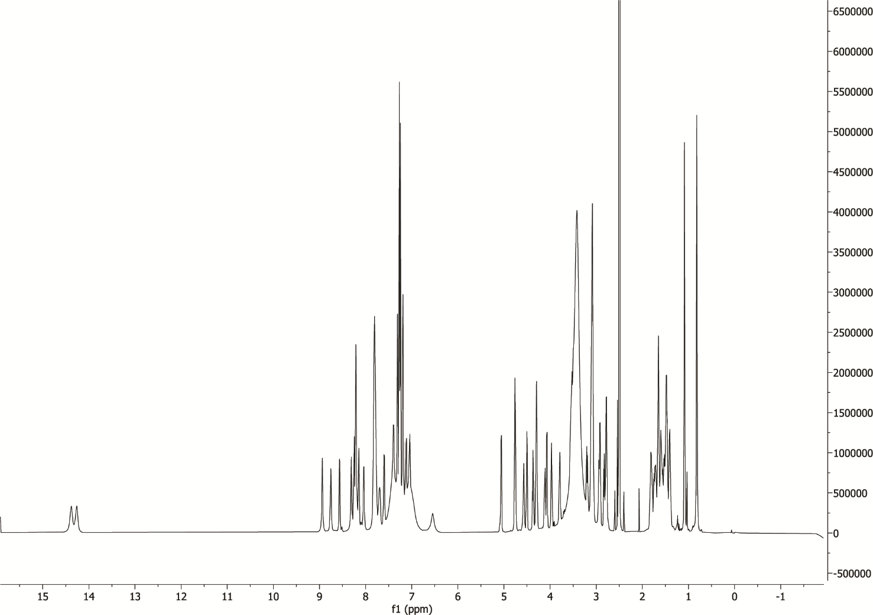

Supplementary Figure 1 | ¹H NMR spectrum of MKM-A
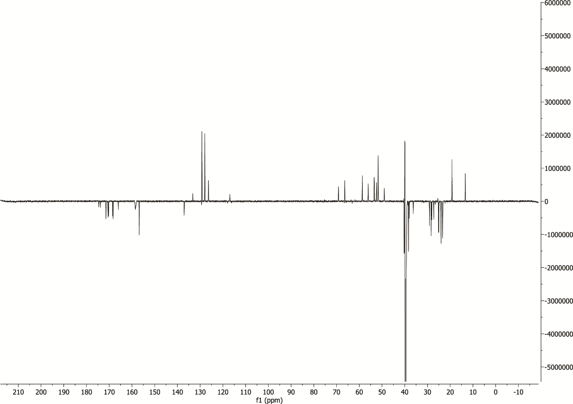

Supplementary Figure 2 | ¹³C DEPTQ NMR spectrum of MKM-A

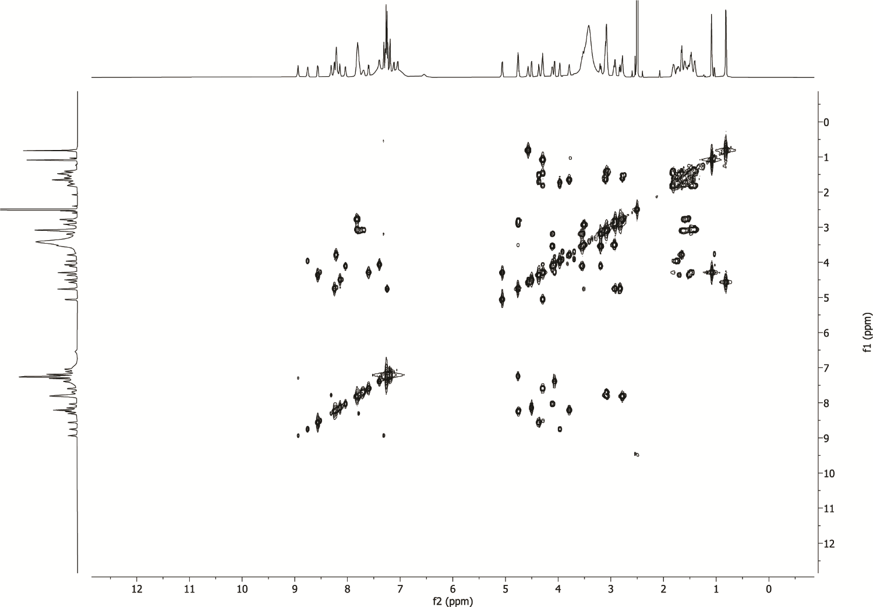

Supplementary Figure 3 | ¹H-¹H COSY NMR spectrum of MKM-A

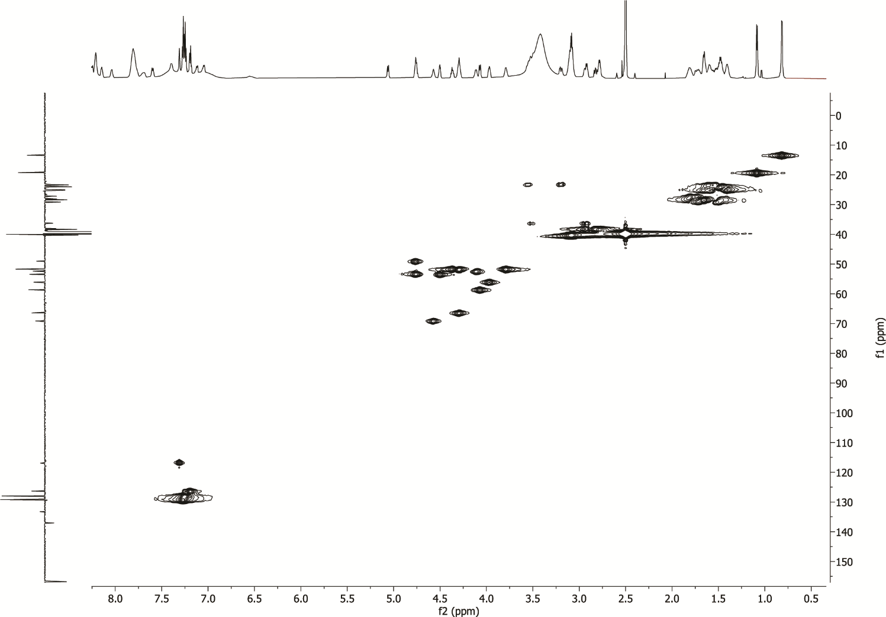

Supplementary Figure 4 | ¹H-¹³C HSQC NMR spectrum of MKM-A

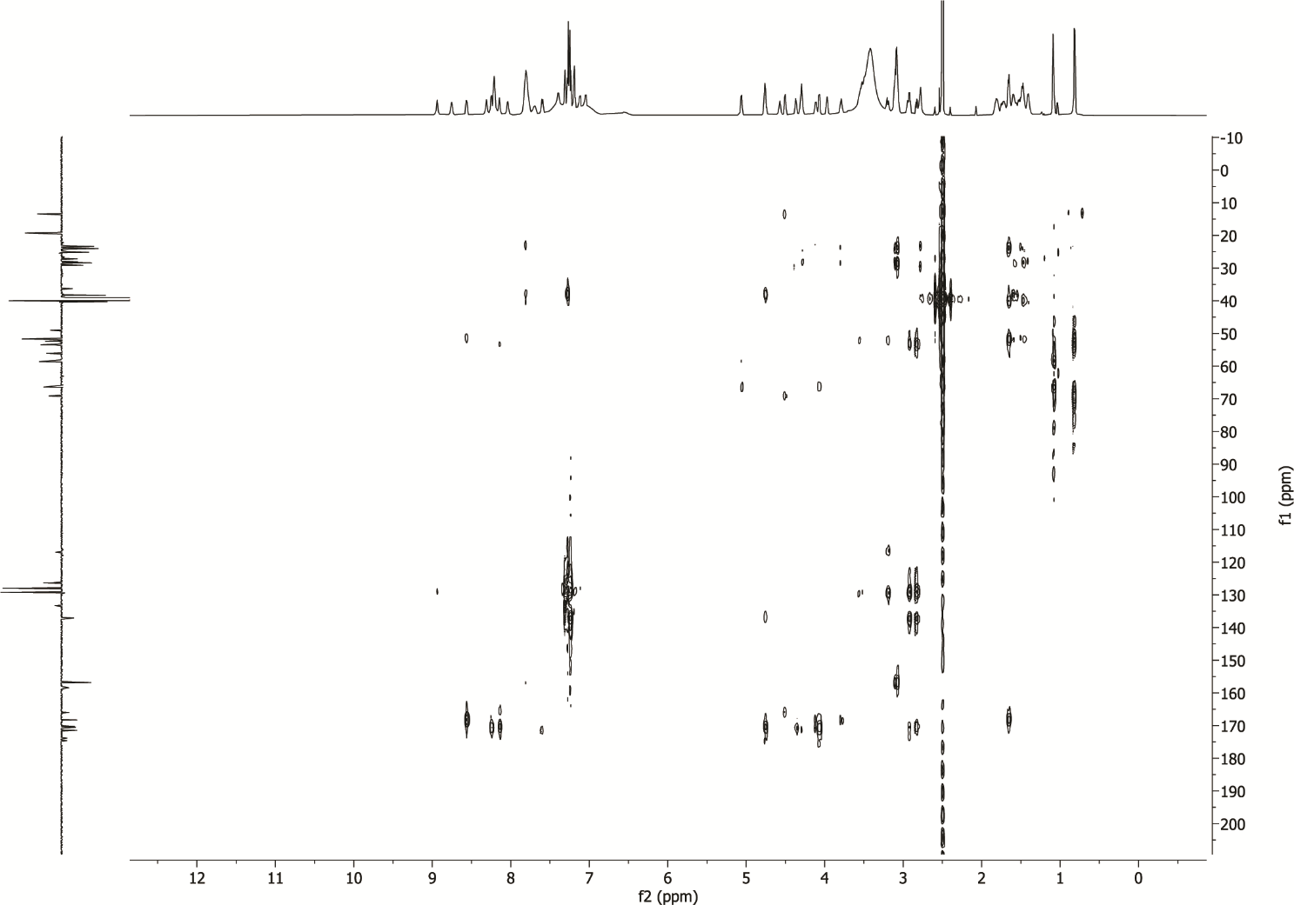

Supplementary Figure 5 | ¹H-¹³C HMBC NMR spectrum of MKM-A

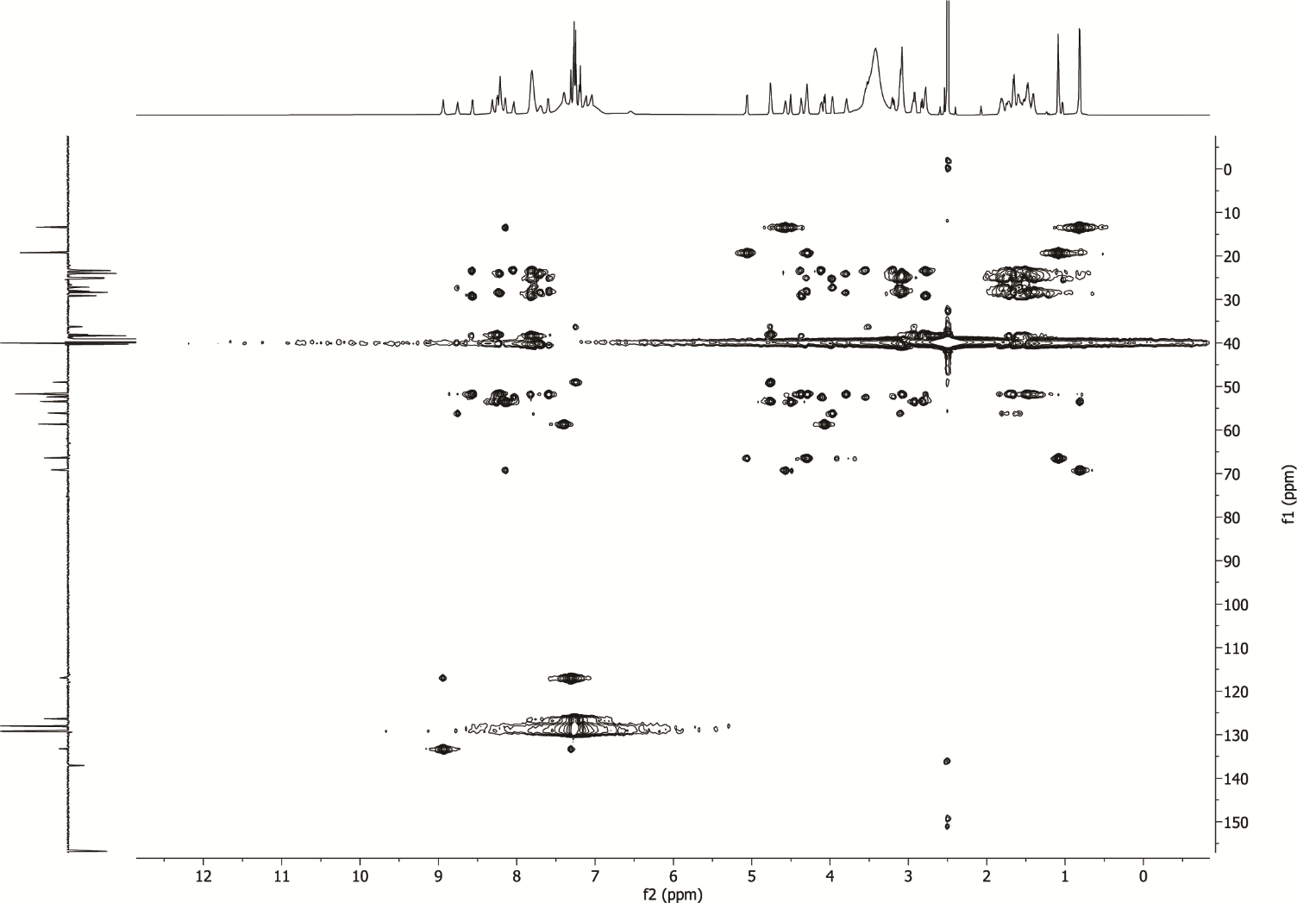

Supplementary Figure 6 | TOCSY- HSQC NMR spectrum of MKM-A

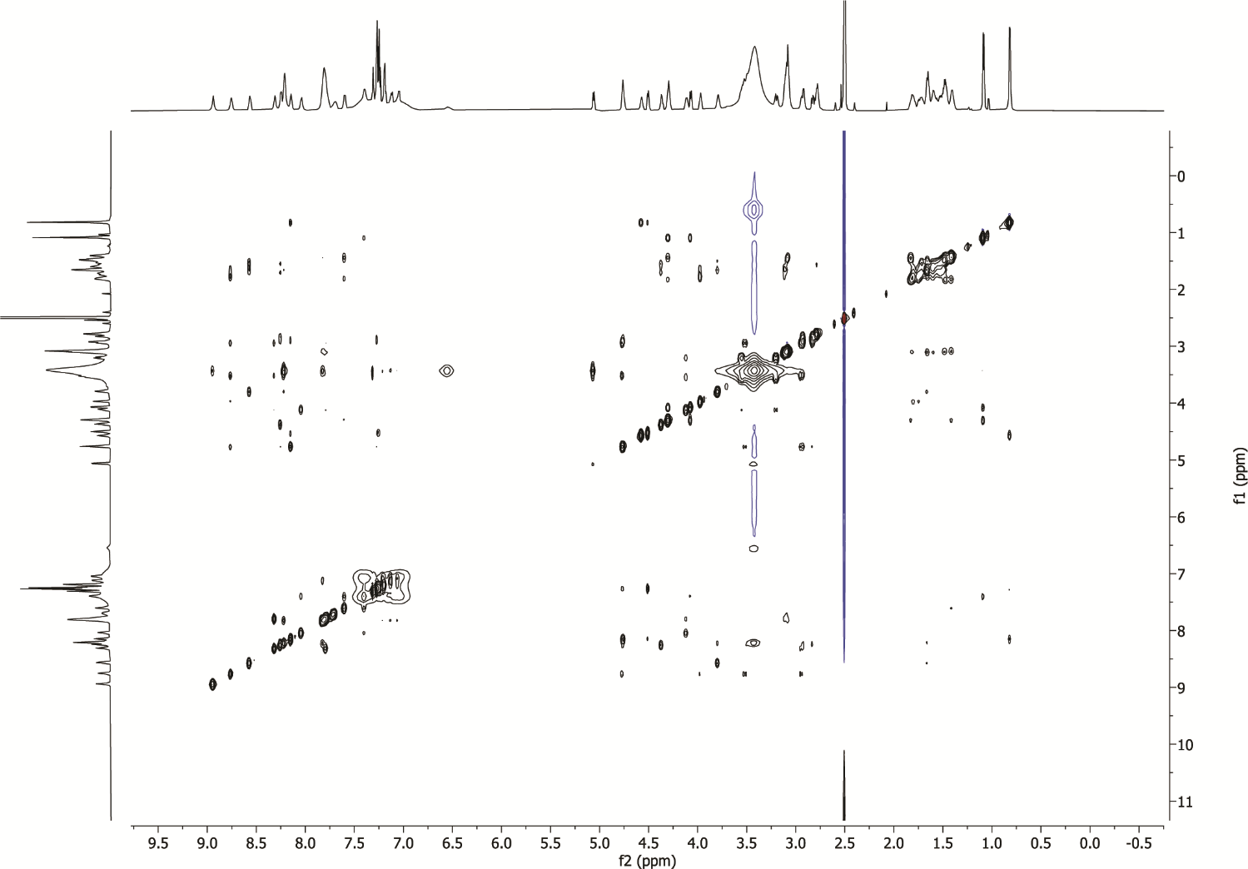

Supplementary Figure 7 | NOESY-NMR spectrum of MKM-A

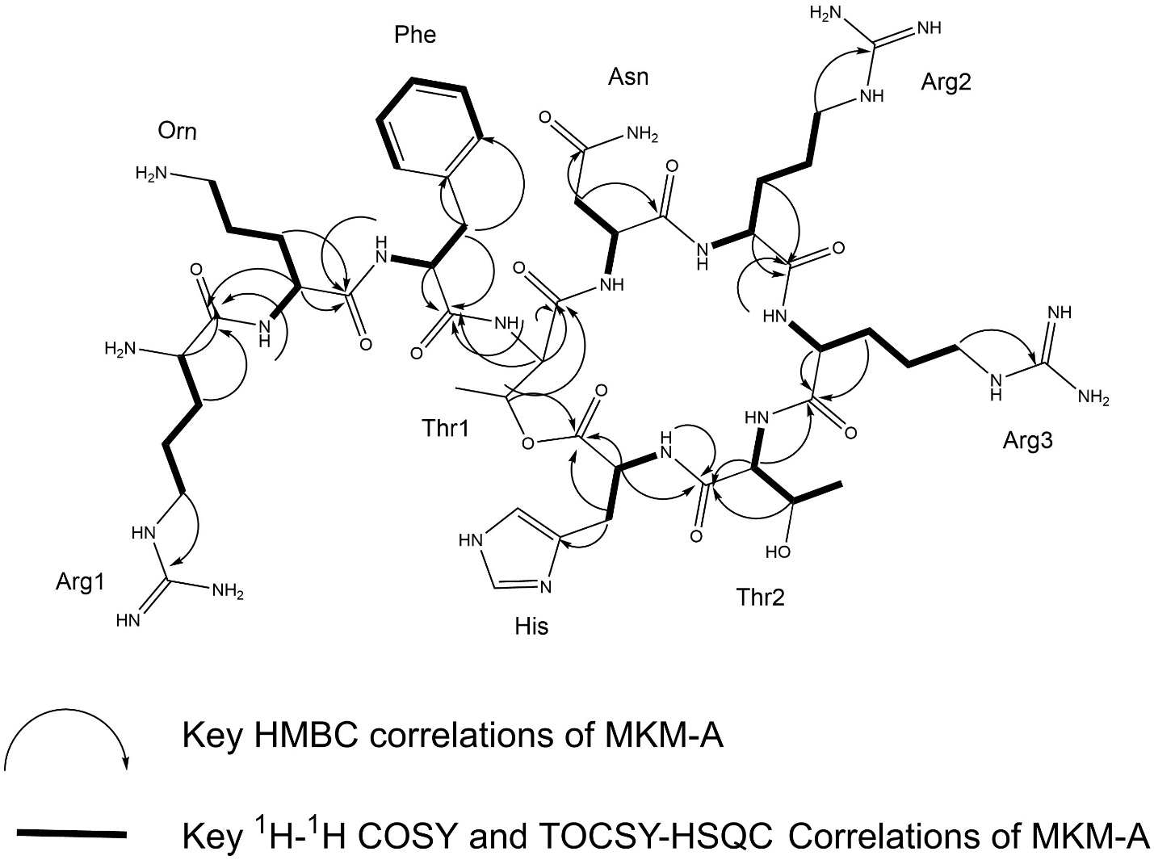

Supplementary Data Fig. 8 | NMR assignment of MKM-A in deuterium oxide (D₂O). ¹H and ¹³C NMR chemical shifts of various amino acids in MKM. The key correlations of MKM-A relevant to NMR spectra are shown.

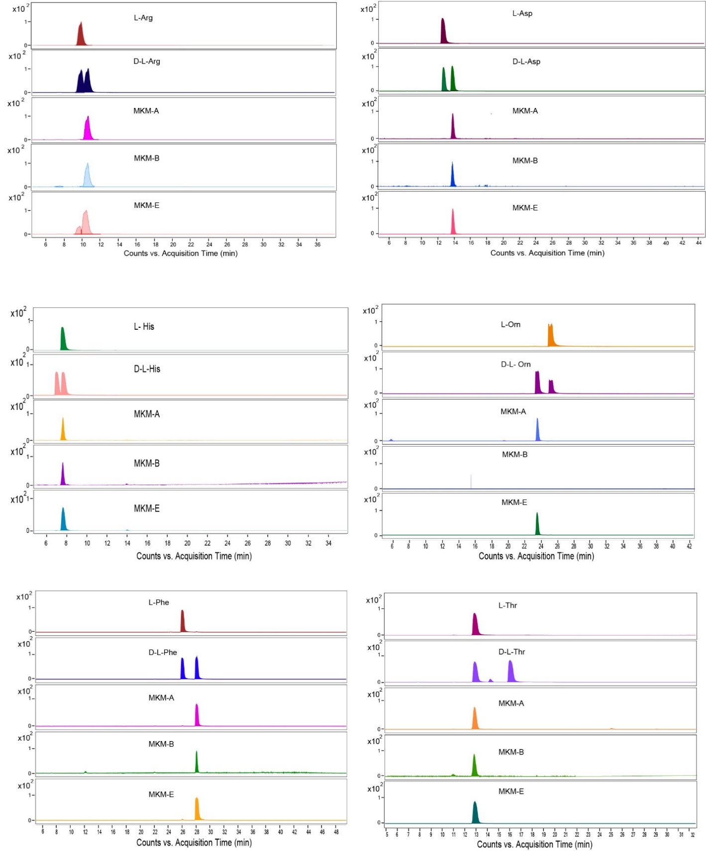
Supplementary Fig. 9 | Extracted Ion Chromatogram (EIC) of acid-hydrolyzed MKM variants treated with Marfey’s reagent. Each chromatogram displays the EIC from the MKM variant samples, highlighting the peaks corresponding to the L- and D-amino acids as indicated. The retention times align with those of standard amino acids run under similar chromatographic conditions.
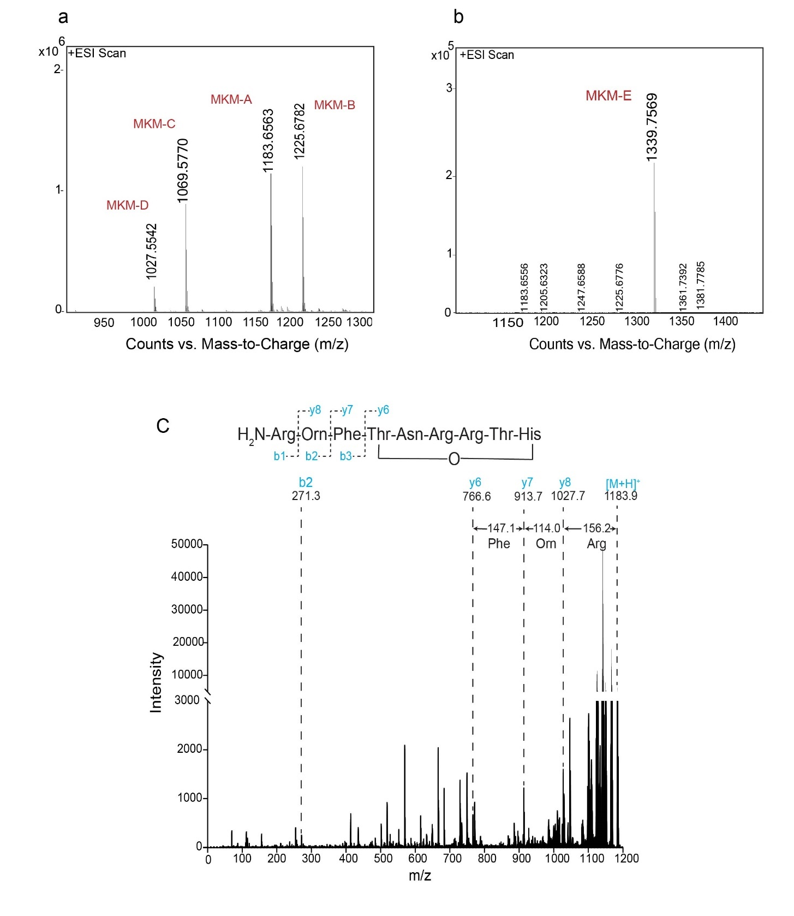
Supplementary Fig. 10 | Mass spectrometry analysis of MKM variants. a, LC-ESI-HRMS analysis of MKM-A, MKM-B, MKM-C, and MKM-D, showing the high-resolution mass spectra for each variant. b, LC-ESI-HRMS analysis of MKM-E. c, Tandem mass spectrometry (MALDI-MS/MS) spectrum of MKM-A, used as a reference for the comparative analysis of other MKM variants.

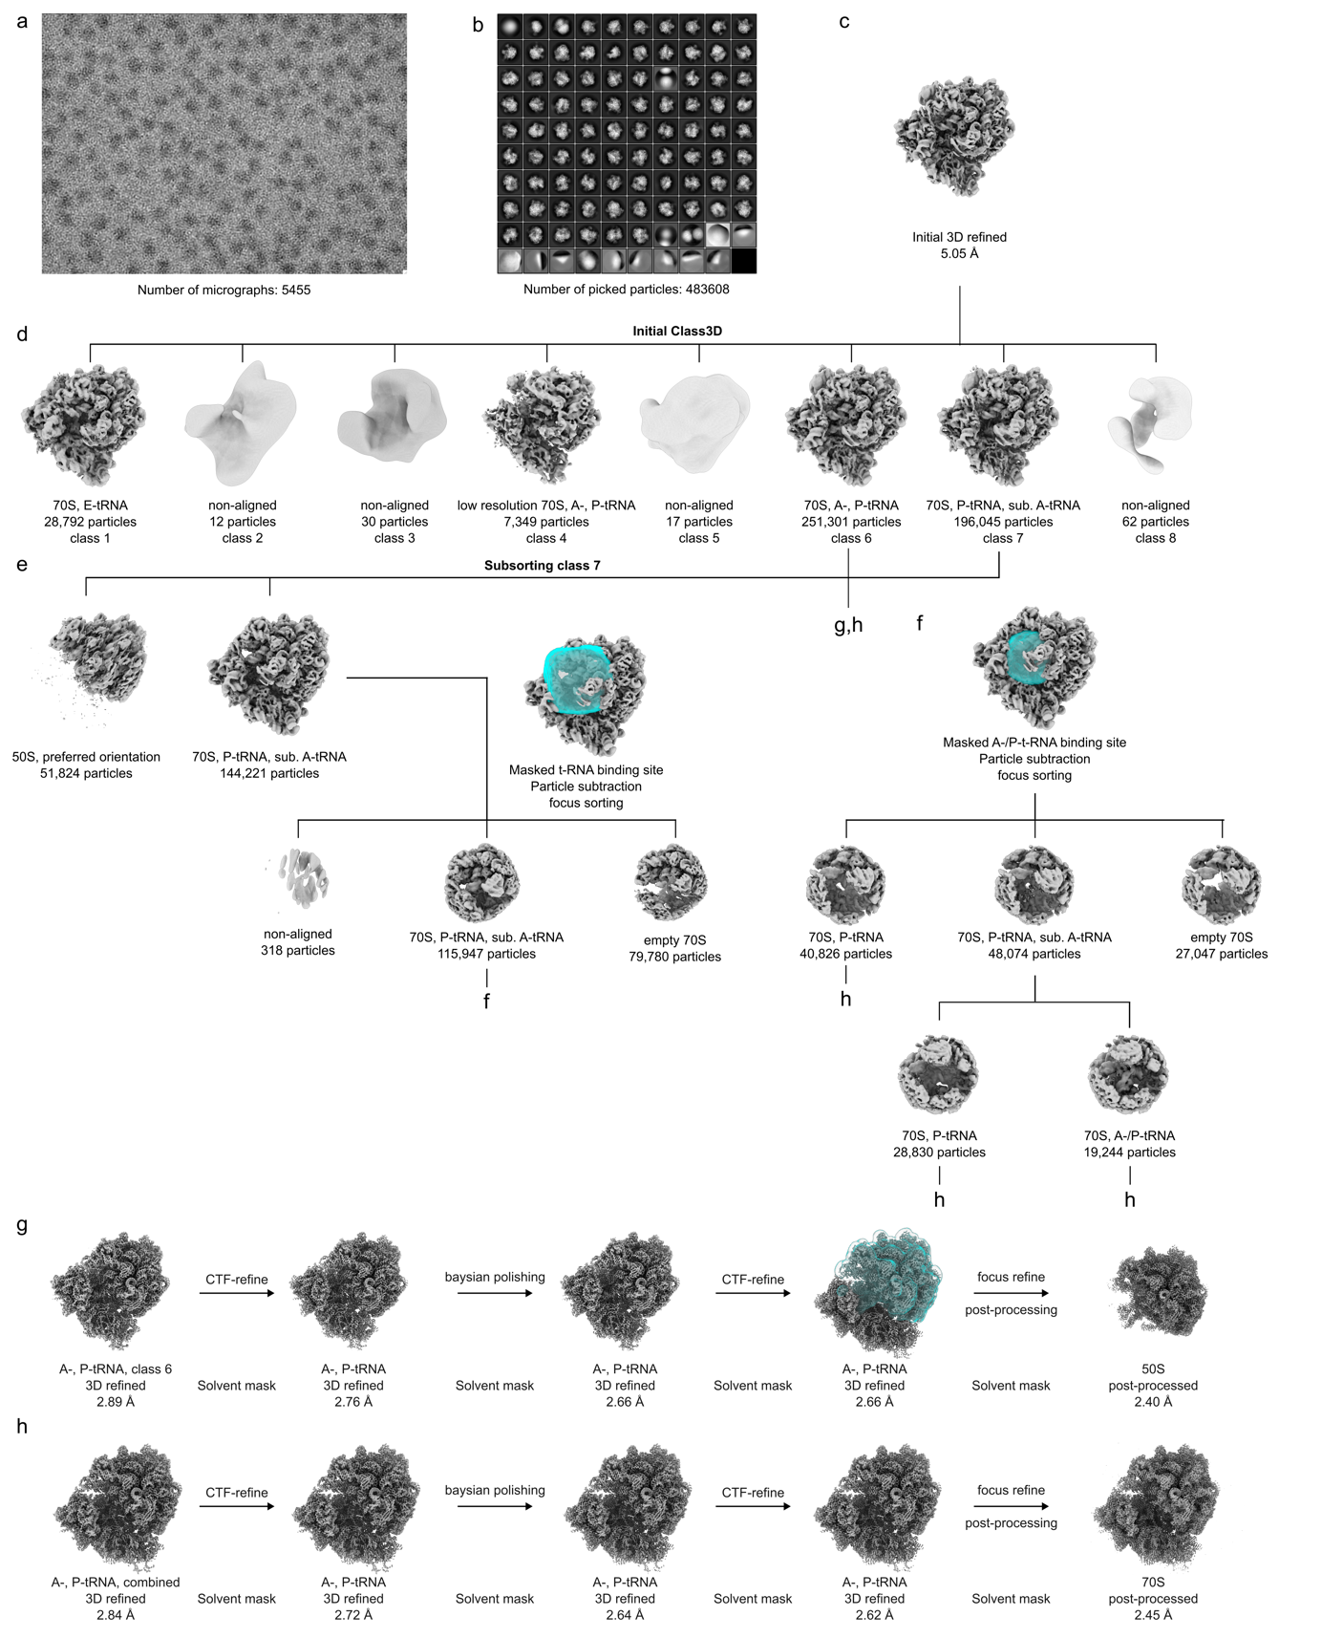

Supplementary Fig. 11. | In silico sorting scheme of the E. coli MKM complex. a-b, From (a), 5,455 micrographs, (b) 483,608 ribosome-like particles were selected after 2D-classification. c, Particles were 3D refined at 4x decimated pixel size. d, Initial 3D classification for 200 iterations led to eight subclasses. e-f, The class 7 containing 70S with substoichiometric A-tRNA, was further subsorted (e) and the resulting 70S subclass was subjected to 200 iterations of focused 3D classification with (f) a mask around the tRNA binding sites. g, The 70S complex containing A-tRNA and P-tRNA density was 3D refined at undecimated pixel size and subjected to CTF refinement (4th order aberrations, beam-tilt, anisotropic magnification and per-particle defocus value estimation), Bayesian polishing and again CTF refined. 70S particles were subtracted with a mask around the 50S subunit and subsequent 3D refinement resulted in a final average resolution for the masked reconstruction of 2.4 Å (at FSC_{0.143}). h, 70S classes containing no E-tRNA were combined, refined at undecimated pixel size, subjected to CTF refinement (4th order aberrations, beam-tilt, anisotropic magnification and per-particle defocus value estimation), Bayesian polishing, again CTF refined and after a final 3D refinement yielded a final average resolution of 2.45 Å (at FSC_{0.143}).

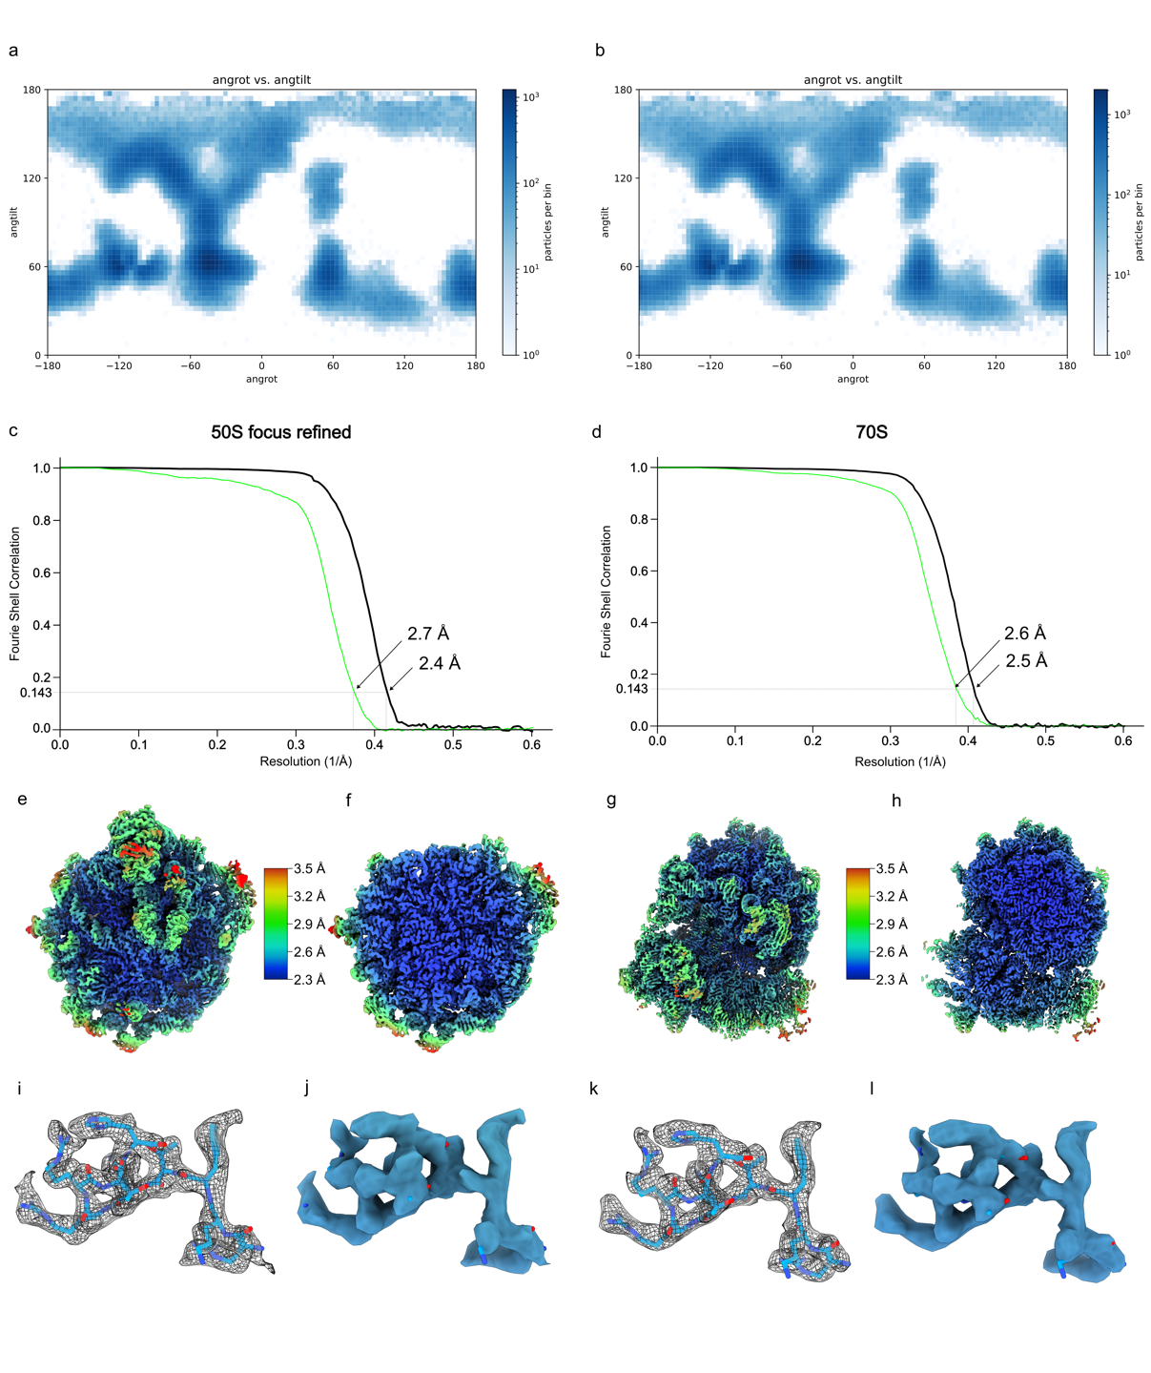

Supplementary Fig. 12. | Angular distribution and local resolution of MKM cryo-EM maps. a-b, Angular distribution of the particles that comprise the (a) 50S focus refined map and (b) the combined 70S classes. c-d, Fourier shell correlation (FSC) curve (green, unmasked; black, masked) of the (c) 50S focus refined cryo-EM map and (d) the 70S complex. e-h, Cryo-EM density map colored according to local resolution for (e) the 50S subunit with (f) transverse section and (g) the 70S ribosome with (h) transverse section. i-l, Cryo-EM density for MKM from (i-j) the 50S subunit and (k,l) the 70S ribosome, shown as (i,k) mesh with molecular model or (j,l) coloured according to local resolution.
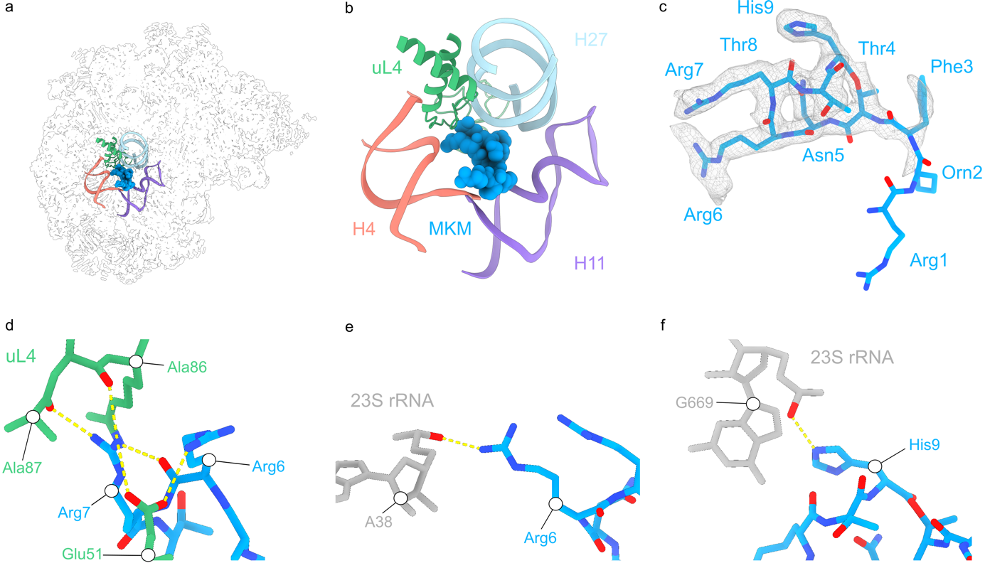

Supplementary Fig. 13. | Secondary binding site of MKM on the 50S subunit. a, Overview and (b) zoom onto the secondary MKM binding site on the 50S subunit, highlighting ribosomal protein uL4 (green) and 23S rRNA helices H4 (coral), H11 (purple) and H27 (light blue). c, Cryo-EM density (mesh) with molecular model of MKM (blue) from the secondary binding site. d-f, Potential hydrogen bond interactions (dashed yellow line) between MKM (blue) and (d) uL4, and (e-f) 23S rRNA nucleotides (grey).

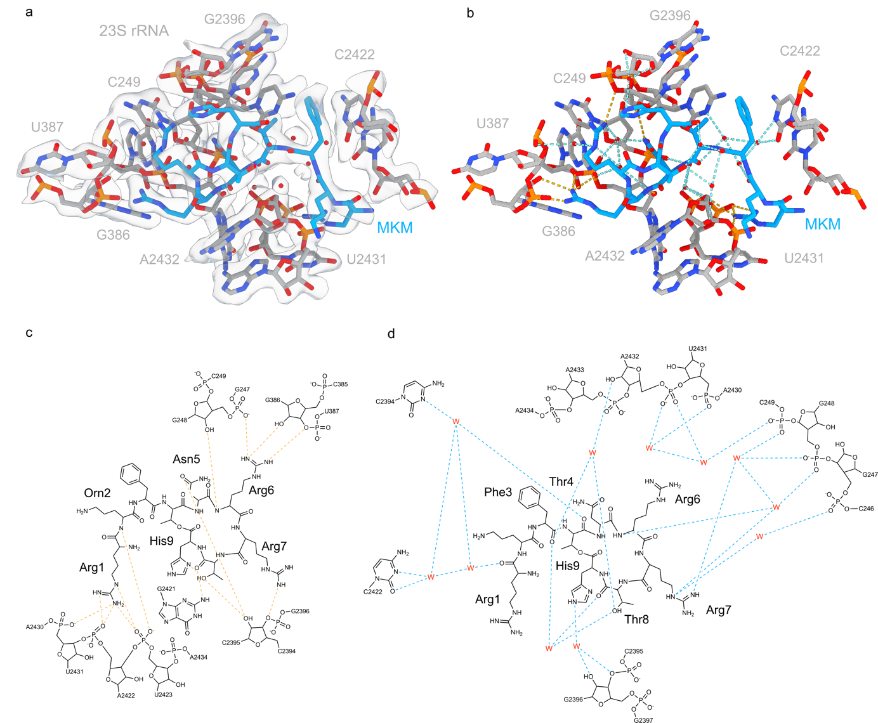

Supplementary Fig. 14. | Interaction of MKM in the E-site of the 50S subunit. a, Cryo-EM density (transparent surface) for MKM (blue), 23S rRNA nucleotides (grey) and waters (red spheres). b, model of MKM binding site with direct (dashed yellow lines) and water-mediated (blue dashed lines) interactions between MKM and the 23S rRNA nucleotides. c-d, schematic representation of the (c) direct (yellow) and (d) indirect water-mediated (blue) interactions.

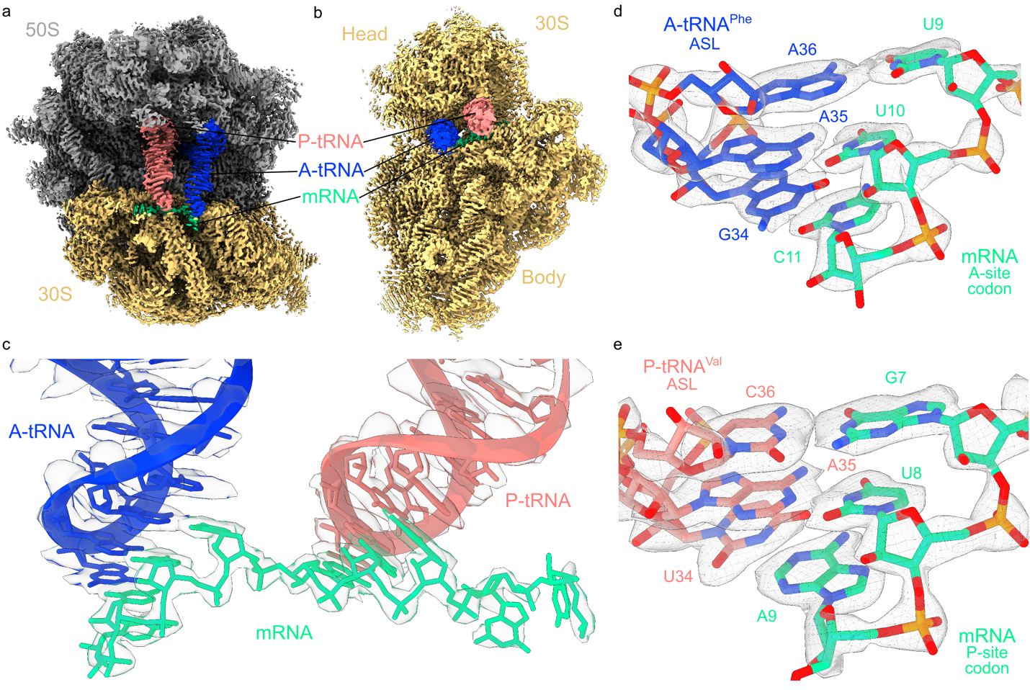

Supplementary Fig. 15 | tRNA identity and codon-anticodon interaction. a-b, cryo-EM map of the MKM-stalled 70S ribosome, shown as (a) transverse section with P-tRNA (salmon), A-tRNA (blue) and mRNA (green) highlighted and (b) 30S interface view. c, extracted cryo-EM density (grey mesh) and model of P-tRNA (salmon), A-tRNA (blue) and mRNA (green). d-e, extracted cryo-EM density of the codon-anticodon interaction for the (d) A-site tRNA^{Phe} anticodon-stem loop (blue, GAA) and A-site codon (green, UUC) and (e) P-site tRNA^{Val} anticodon-stem loop (salmon, UAC) and P-site codon (green, GUA).

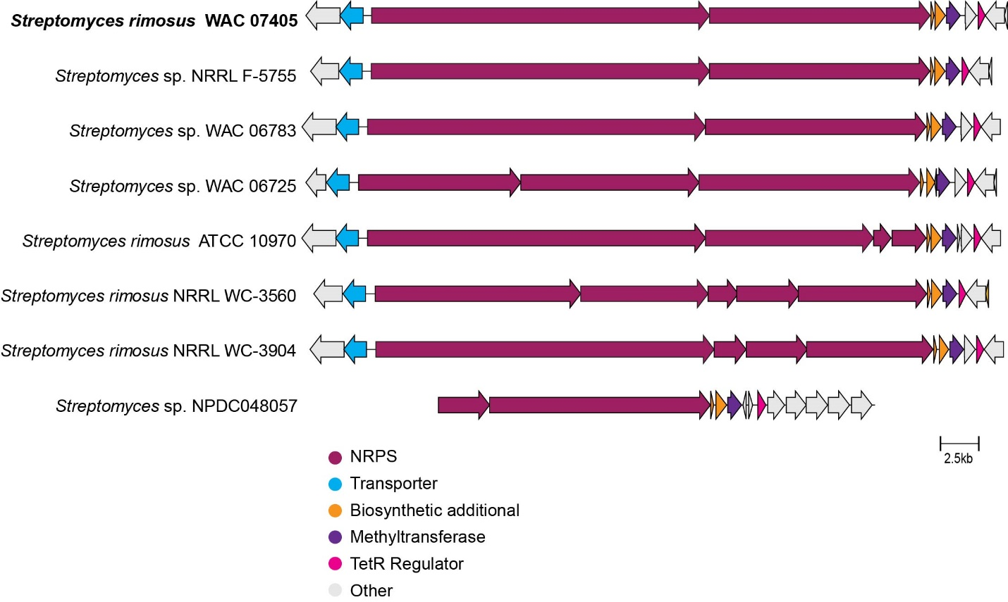
Supplementary Fig. 16 | BLAST analysis of the MKM BGC. BLAST analysis of the MKM BGC reveals its presence exclusively in the genomes of Streptomyces rimosus. The different genes involved in MKM biosynthesis are color-coded to distinguish them from additional associated genes, with each color representing a distinct functional group within the BGC.

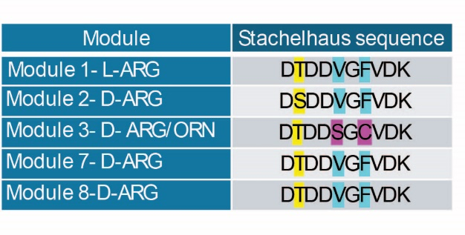

Supplementary Fig. 17 | Stachelhaus code analysis. Stachelhaus code sequences for the arginine-containing modules in the MKM BGC.

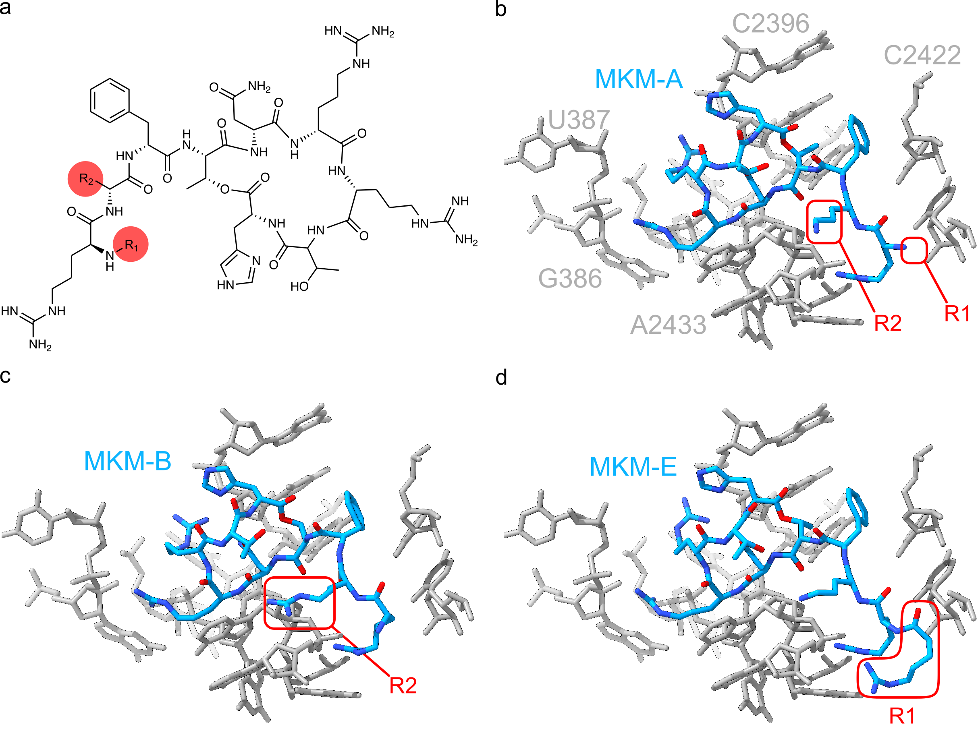
Supplementary Fig.18 | Conserved binding mode of MKM congeners. Structural alignment shows that the binding mode determined for MKM-A is compatible with other MKM congeners, including MKM-B and MKM-E. This suggests that these variants likely share a common, context-specific mechanism of action to inhibit translocation, as elucidated for MKM-A.

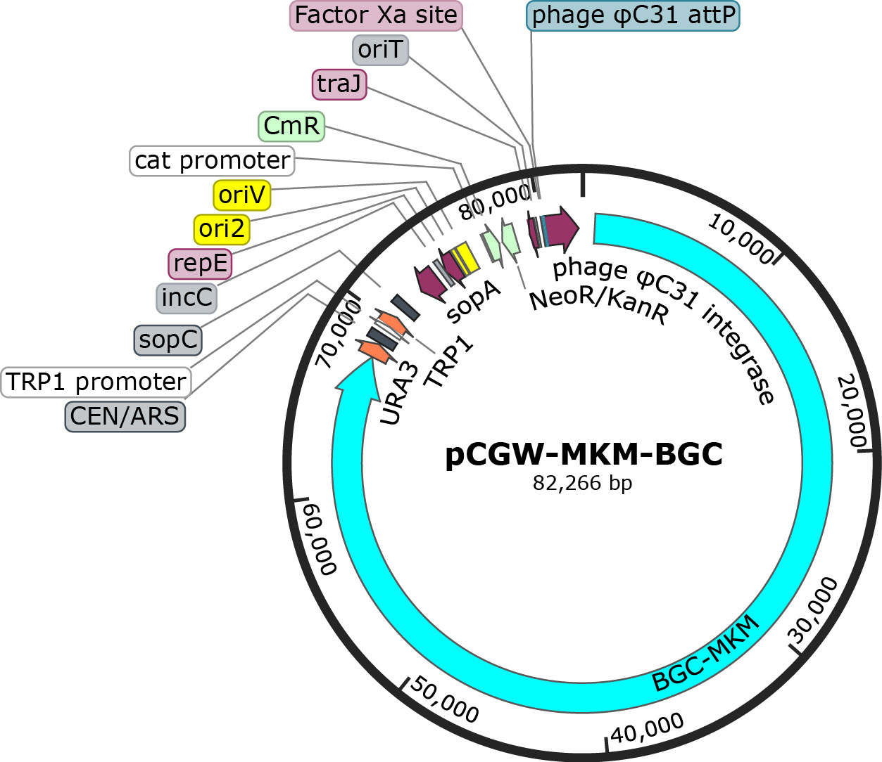

Supplementary Fig. 19 | Map of the pCGW vector with MKM BGC. The pCGW plasmid served as the backbone for cloning and expression, providing essential regulatory elements. The map illustrates the successful capture and integration of the MKM BGC into the pCGW backbone, ensuring its proper organization and potential for heterologous expression. Key features of the construct, including restriction sites, selection markers, and regulatory elements, are highlighted.

SUPPLEMENTARY TABLES
Supplementary Table 1 | ¹H and ¹³C NMR assignment of MKM-A
No. | δ_{H} | δ_{C} | No. | δ_{H} | δ_{C}
Arg1 CO |  | 168.3 | Arg2 CO |  | 171.5
α | 3.79 (m) | 51.7 | α | 3.97 (m) | 56.1
β | 1.65 (2H, m, overlapped) | 28.4 | β | 1.73 (m, overlapped)  1.80 (m, overlapped) | 27.2
γ | 1.47 (2H, m, overlapped) | 24.0 | γ | 1.66 (2H, m, overlapped) | 25.1
δ | 3.08 (2H, m, overlapped) | 40.2 | δ | 3.08 (2H, m, overlapped) | 40.3
C=NH |  | 156.8 | C=NH |  | 156.8
α-NH | 8.21 (br s) |  | α-NH | 8.75 (br s)
Ornithine CO |  | 170.6 | Arg3 CO |  | 171.4
α | 4.37 (m) | 51.6 | α | 4.28 (m, overlapped) | 51.8
β | 1.71 (m, overlapped)  1.51 (m, overlapped) | 29.0 | β | 1.60 (m, overlapped)  1.46 (m, overlapped) | 28.0
γ | 1.60 (m, overlapped)  1.56 (m, overlapped) | 23.4 | γ | 1.40 (2H, m, overlapped) | 25.0
δ | 2.78 (2H, m, overlapped) | 38.3 | δ | 3.08 (2H, m, overlapped) | 40.3
α-NH | 8.56 (d, J = 5.0 Hz) |  | C=NH |  | 156.8
NH2 | 7.81 (brs, overlapped) |  | α-NH | 7.60 (d, J = 9.0 Hz)
Phe CO |  | 170.3 | Thr2 CO |  | 170.5
α | 4.74 (m, overlapped) | 53.4 | α | 4.07 (br d, J = 8.7 Hz) | 58.6
β | 2.92 (dd, J = 13.4, 6,8 Hz)  2.82 (dd, J = 13.4, 8,6 Hz) | 38.1 | β | 4.30 (m, overlapped) | 66.4
1’ |  | 137.1 | γ | 1.08 (d, J = 6.5 Hz) | 19.2
2’, 6’ | 7.26 (t, J = 7.3 Hz) | 129.2 | α-NH | 7.39 (br d, J = 8.7 Hz)
3’, 5’ | 7.25 (t, J = 7.2 Hz) | 128.0 | OH | 5.07 (br d, J = 8.3 Hz)
4’ | 7.19 (t, J = 7.3 Hz) | 126.3 | His CO |  | 168.5
α-NH | 8.25 (d, J = 7.2 Hz) |  | α | 4.11 (br dd, J = 5.5, 14.7 Hz) | 52.4
Thr1 CO |  | 166.0 | β | 3.54 (m, overlapped)  3.19 (dd, J = 5.5, 15.3 Hz) | 23.4
α | 4.50 (dd, J = 4.1, 7.1 Hz) | 53.5 | 1’ |  | 129.4
β | 4.57 (dq, J = 7.1, 6.2 Hz) | 69.1 | 2’ | 7.30 (br s) | 116.9
γ | 0.82 (d, J = 6.2 Hz) | 13.4 | 4’ | 8.94 (br s) | 133.2
α-NH | 8.15 (d, J = 4.1 Hz) |  | α-NH | 8.04 (br s)
Asn CO |  | 174.6 | 3’-NH | 8.94 (br s)
α | 4.76 (m, overlapped) | 49.0
β | 3.50 (m, overlapped)  2.94 (m, overlapped) | 36.3
COONH₄ |  | 173.8
α-NH | 7.25 (m, overlapped)

Supplementary Table 2 | Proposed functions of proteins encoded by the MKM BGC
Location | Gene | Homolog | Proposed function
Ctg2_671 | orf-2 | Alpha/beta hydrolase fold protein | Putative peptidase
Ctg2_672 | orf-1 | Penicillin amidase | Penicillin amidohydrolase
Ctg2_673 | manD | ABC transporter | Transporter
Ctg2_674 | manA | NRPS (modules 1-6) | Peptide synthase
Ctg2_675 | manB | NRPS (modules 7-10) | Peptide synthase
Ctg2_676 | man1 | MbtH | MbtH-like protein
Ctg2_677 | manC | Thioesterase | Thioesterase domain
Ctg2_678 | manE | FtsJ-like methyltransferase | Ribosomal RNA large subunit methyltransferase
Ctg2_679 | man2 | (NADP oxidoreductase coenzyme F420-dependent) | Oxidoreductase
Ctg2_680 | manR | Bacterial regulatory proteins, TetR family | Transcriptional regulator
Ctg2_681 | man3 | Amidase [Pseudomonas putida] | Amidase activity

Supplementary Table 3 | Mutations in MKM-resistant E. coli mutants from serial passaging

Mutant ID | Mutation/position | Gene(s) | Function
Ecmut1 | +G(675/1221 nt) | sbmA | nonspecific peptide importer of the inner membrane
Ecmut1 | Δ1bp (1900/2598 nt) | topA | DNA topoisomerase I
Ecmut1 | Δ208 bp | [rpmI] | [rpmI]
Ecmut2 | Δ5,466 bp (IS3-mediated) | yaiT–[yaiW] | yaiT, yaiV, ampH, sbmA, [yaiW]
Ecmut2 | C→TA180V (GCG→GTG) | ndh | respiratory NADH dehydrogenase 2 / cupric reductase
Ecmut2 | (T)7→6(43/198 nt) | rpmI | 50S ribosomal subunit protein bL35

Supplementary Table 4 | Cryo-EM data collection, modelling and refinement statistics.

Model | MKM, 50S | MKM, 70S
EMDB ID | EMD-53943 | EMD-54009
PDB ID | 9RFW | 9RJA
Data collection and processing
Magnification (×) | 105 000 | 105 000
Electron fluence (e⁻/Å²) | 40 | 40
Defocus range (µm) | -0.3 – -1.0 | -0.3 – -1.0
Pixel size (Å) | 0.832 | 0.832
Initial particles | 483 608 | 483 608
Final particles | 251 301 | 340 201
Average resolution (Å) (FSC_{0.143}) | 2.4 | 2.5
Model composition
Atoms | 89 357 | 140 150
Protein residues | 3112 | 5455
RNA bases | 3009 | 4509
Refinement
Map CC around atoms | 0.72 | 0.80
Map CC whole unit cell | 0.69 | 0.78
Map sharpening B factor (Å²) | -63.61 | -44.70
R.M.S. deviations
Bond lengths (Å) | 0.012 | 0.013
Bond angles (°) | 1.822 | 1.976
Validation
MolProbity score | 0.77 | 0.96
Clash score | 0.48 | 0.92
Poor rotamers (%) | 0.79 | 0.99
Ramachandran statistics
Favoured (%) | 97.49 | 96.91
Outliers (%) | 0.20 | 0.26
Ramachandran Z-score | -1.13 | -1.74

Supplementary Table 5 | Bacterial strains and plasmids used in the study.

Strain | Res | Experiments/ Description | Reference or source
Acinetobacter baumannii ATCC17978 | - | MIC determination | Wright lab strain collection
Bacillus subtilis 168 | - | MIC determination, trpC2, wild type | Common laboratory strain
Bacteroides fragilis GC73 | - | MIC determination, gut isolate | Surette lab collection
Bifidobacterium breve GC96 | - | MIC determination, gut isolate | Surette lab collection
Blautia obeum GC925 | - | MIC determination, gut isolate | Surette lab collection
Candida albicans ATCC 90028 | - | MIC determination | Wright lab strain collection
Clostridium perfringens GC1584 | - | MIC determination, gut isolate | Surette lab collection
Escherichia coli BW25113 | - | MIC determination and other experiments, Wild type | Common laboratory strain
E. coli BW25113 ΔbamBΔtolC | - | MIC determination and expression of resistance genes | Wright lab strain collection
E. coli C0617 | - | MIC determination, MDR | Wright clinical collection
E. coli C1507 | - | MIC determination, MDR | Wright clinical collection
E. coli C1508 | - | MIC determination, MDR | Wright clinical collection
E. coli ET12567 | - | Conjugation experiment; dam-13::Tn9 dcm-6 hsdMRS cat | Wright lab strain collection
E. coli EPI300 |  | Inducible trfA controlling oriV | Wright lab strain collection
E. coli ET12567 pR9406 | Ap | Conjugation experiment; helper strain | Wright lab strain collection
E. coli SQ110 ΔtolC ::pZsbmA | Ap, Sp | Selection of mutants in rRNA genes, contains a single rrnE operon | Mankin lab collection
E. coli BL21 ΔtolC |  | Ribosome profiling | Mankin lab collection
E. coli BW25113 ΔsbmA | Km | MIC determination | Keio collection
E. coli BW25113 ΔyejA | Km | MIC determination | Keio collection
E. coli BW25113 ΔyejB | Km | MIC determination | Keio collection
E. coli BW25113 ΔyejE | Km | MIC determination | Keio collection
E. coli BW25113 ΔyejF | Km | MIC determination | Keio collection
E. coli BW25113 ΔrpmI | Km | MIC determination | Keio collection
Klebsiella pneumoniae C1459 | - | MIC determination, MDR | Wright clinical collection
K. pneumoniae C1557 | - | MIC determination, MDR | Wright clinical collection
K. pneumoniae C1559 | - | MIC determination, MDR | Wright clinical collection
Lactobacillus plantarum GC4 | - | MIC determination, gut isolate | Surette lab collection
Mycobacterium tuberculosis Ra | - | MIC determination | Wright lab strain collection
M. smegmatis MC² 155 | - | MIC determination | Wright lab strain collection
M. avium subsp. avium ATCC 25291 | - | MIC determination | Wright lab strain collection
M. fortuitum subsp. fortuitum ATCC 6841 | - | MIC determination | Wright lab strain collection
M. abscessus ATCC 19977 | - | MIC determination | Wright lab strain collection
M. bovis BCG Pasteur ATCC 35734 | - | MIC determination | Wright lab strain collection
Pseudomonas aeruginosa PAO1 | - | MIC determination | Wright lab strain collection
Streptomyces coelicolor M1154 | - | Conjugation experiment | Wright lab strain collection
S. aureus USA 300 | - | MIC determination | Wright clinical collection
S. aureus ATCC 29213 | - | MIC determination | Wright clinical collection
S. cerevisiae VL6-48N |  | MAT α, his3-D200, trp1-Δ1, ura3-Δ1, lys2, ade2−101, met14, psi+cir^{O}, TAR host strain | Wright lab strain collection
S. coelicolor M1154 -MKM-BGC | Km | Heterologous expression of MKM; contains pCGW-man plasmid | This study
S. coelicolor M1154 pCGW | Km | Control strain, contain vector only | This study
Streptomyces rimosus WAC 7405 |  | MKM Producer Strain | Wright Actinomycete collection
Plasmids
pCGW | Km | Engineered copy number controlled capturing vector for TAR, aac(3)IV ura3 cen/ARS trp1 sopABC repE ori2 oriV cat neo traJ-oriT attP-int_{ΦC31} | Lab stock
pGDP3 | Ap | a low copy plasmid with a P_{lac} promoter⁷⁰ | Lab stock

Res. – resistance marker, MDR – multidrug resistant, Ap – ampicillin, Km – kanamycin, Sp - spectinomycin

Supplementary Table 6 | Oligonucleotide primers used in this study.

Primer name | Sequence (5′–3′)
MKM-GBK | GCCTCCCATGGTATAAATAGTGGCAAAGCGGGCCAAGGGCCCGGCCAAGAAGACCGCCAAGAAGACGACGGCCAAGTTTAAACGAGTCCAAGATCCGTCCGGTCACGCACGCGCTGCTCAAGGTGCGGCTGGACGGCAAATGTCGAAAGCTACATATAAGGA
MKM BGC-DF: | TTTGCCTGGTGTTCTCATTC
MKMBGC-DR | AGTTCATGATGTTGACCGTG
METH-TRANS-FP | TACTACCATATGCCCACCAGCATATTCTCCACCTC
METH-TRANS-RP | TACTACCTCGAGTCAGCGCAGCCGTGC
MKM-DF | GTGAATGCCAGGAAGAGC
MKM-DR | CCAACCTGACCGGCTT
L2507 | CCAGGATGTGATGAGCCG
23S_rRNA_F | CAAATTTTCGCAACACGATGATG
23S_rRNA_R | AAGGTTAAGCCTCACGG
T7_IR_AUG_F | TAATACGACTCACTATAGGGCTTAAGTATAAGGAGGAAAACATATG
yrbA_wt_F | TATAAGGAGGAAAACATATGATATACCCCTGCGGAGTGGGCGCGCG
yrbA_TTT_F | TATAAGGAGGAAAACATATGACCACGACCTGCGGAGTGGGCGCGCG
yrbA_SSS_F | TATAAGGAGGAAAACATATGAGCTCTAGCTGCGGAGTGGGCGCGCG
yrbA_wt_R | CCAACTGTCGAGGTCGGCCTAAAGCCGTTCAGTTTGCGATCGCGCGCCCACTC
yrbA_Ile_catch_R | CCAACTGTCGAGGTCGGCCTAAAGCCGTTCAATTTGCGATCGCGCGCCCACTC
posT-NV1_R | GGTTATAATGAATTTTGCTTATTAACTCGACATCGCATCAGGATTCAGCACGTGAATCCAACTGTCGAGGTCG
T7_gltX_F | TAATACGACTCACTATAGGGCATCTTTCTAAACGTAAG
gltX_NV1_R | GGTTATAATGAATTTTGCTTATTAACCCAGGAGTAAAGAGCTTAAGTACGCGCGCCGCC
NV1 | GGTTATAATGAATTTTGCTTATTAA
MF_F1 | ATTAATACGACTCACTATAGGGCAACCTAAAACTTACACACGCCCCGGTAAGGAAATAAAAAT
MF_F2 | GCCCCGGTAAGGAAATAAAAATGTTCAAAGCATTCAAAAACATCATACGTACTCGTACTC
MF_R | GGTTATAATGAATTTTGCTTATTAACCTTGCCTGCGCTTAAAGAGTACGAGTACGTATGATGT
T7_ermBL_F | TAATACGACTCACTATAGGGAGACTTAAGTATAAGGAGGAAAAAATATGTTGGTATTCCAAATGCGTAATGTAGATAA
ermBL_UGA_R | GGTTATAATGAATTTTGCTTATTAACGATAGAATTCTATCACTCAAATAGTAGATGTTTTATCTACATTACGCATTT

Supplementary Table 7 | mRNA templates used in the study.

Template name | Sequence (5′–3′)** | ORF translation
yrbA (wt) | AAUACGACUCACUAUAGGGCUUAAGUAUAAGGAGGAAAACAUAUGAUAUACCCCUGCGGAGUGGGCGCGCGAUCGCAAACUGAACGGCUUUAGGCCGACCUCGACAGUUGGAUUCACGUGCUGAAUCCUGAUGCGAUGUCGAGUUAAUAAGCAAAAUUCAUUAUAACC | MIYPCGVGARSQTERL*
yrbA_SSS | UAAUACGACUCACUAUAGGGCUUAAGUAUAAGGAGGAAAACAUAUGAGCUCUAGCUGCGGAGUGGGCGCGCGAUCGCAAAUUGAACGGCUUUAGGCCGACCUCGACAGUUGGAUUCACGUGCUGAAUCCUGAUGCGAUGUCGAGUUAAUAAGCAAAAUUCAUUAUAACC | MSSSCGVGARSQIERL*
yrbA_TTT | UAAUACGACUCACUAUAGGGCUUAAGUAUAAGGAGGAAAACAUAUGACCACGACCUGCGGAGUGGGCGCGCGAUCGCAAAUUGAACGGCUUUAGGCCGACCUCGACAGUUGGAUUCACGUGCUGAAUCCUGAUGCGAUGUCGAGUUAAUAAGCAAAAUUCAUUAUAACC | MTTTCGVGARSQIERL*
gltX | UAAUACGACUCACUAUAGGGCAUCUUUCUAAACGUAAGGCCAUUUCAUGAAAAUCAAAACUCGCUUCGCGCCAAGCCCAACAGGCUAUCUGCACGUUGGCGGCGCGCGUACUUAAGCUCUUUACUCCUGGGUUAAUAAGCAAAAUUCAUUAUAACC | MKIKTRFAPSPTGYLHVGGART*
ermBL | UAAUACGACUCACUAUAGGGAGACUUAAGUAUAAGGAGGAAAAAAUAUGUUGGUAUUCCAAAUGCGUAAUGUAGAUAAAACAUCUACUAUUUGAGUGAUAGAAUUCUAUCGUUAAUAAGCAAAAUUCAUUAUAACC | MLVFQMRNVDKTSTI*
MFK | AUUAAUACGACUCACUAUAGGGCAACCUAAAACUUACACACGCCCCGGUAAGGAAAUAAAAAUGUUCAAAGCAUUCAAAAACAUCAUACGUACUCGUACUCUUUAAGCGCAGGCAAGGUUAAUAAGCAAAAUUCAUUAUAACC | MFKAFKNIIRTRTL*

** ORF in the template sequence is shown in red, T7 promotor is shown in blue, NV1 primer binding sequence – in green.

