EXTENDED DATA FIGURES
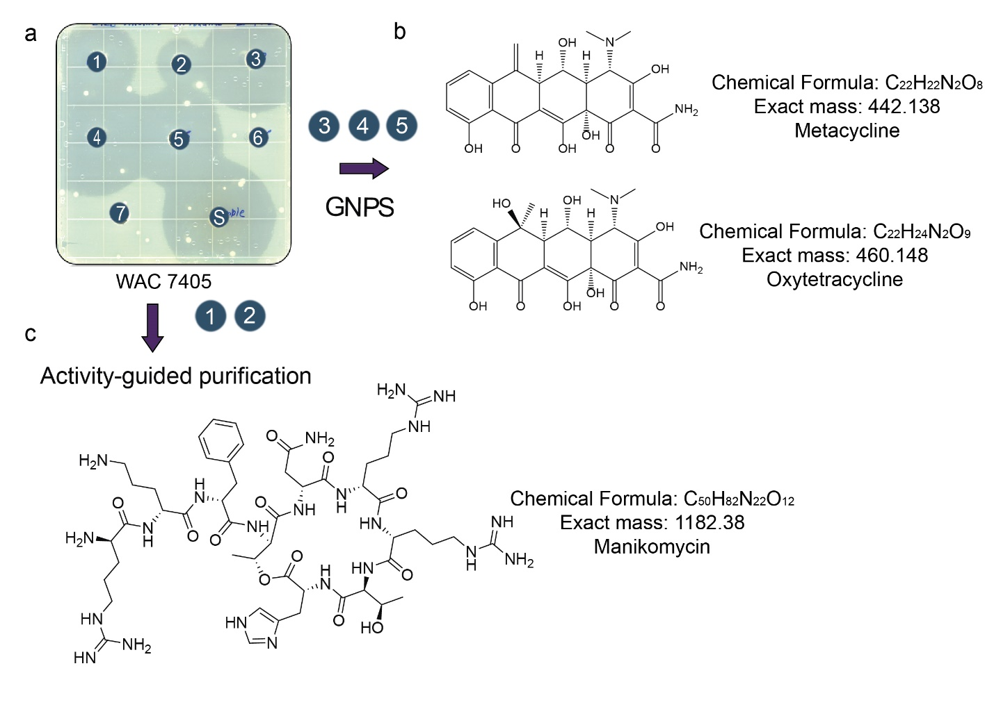
Extended Data Fig. 1 | Activity and dereplication strategy of PFL fractions from Streptomyces rimosus WAC 7405. a, Activity of WAC 7405 fractions obtained through LH-20 chromatography, which separates primarily by size (where 1-7 are the fractions collected, and S stands for the activity of sample loaded on the column with the indicator strain E. coli BW25113 ΔtolCΔbamB). Fractions were dereplicated through GNPS analysis. The activity is reduced in fraction 2 and increased again in fraction 3-5 suggesting the presence of two compounds. b, Larger ions were identified in fractions 1 and 2, while oxytetracycline was detected in fractions 3-5. c, Activity-guided purification from fractions 1 and 2 led to the discovery of MKMs.

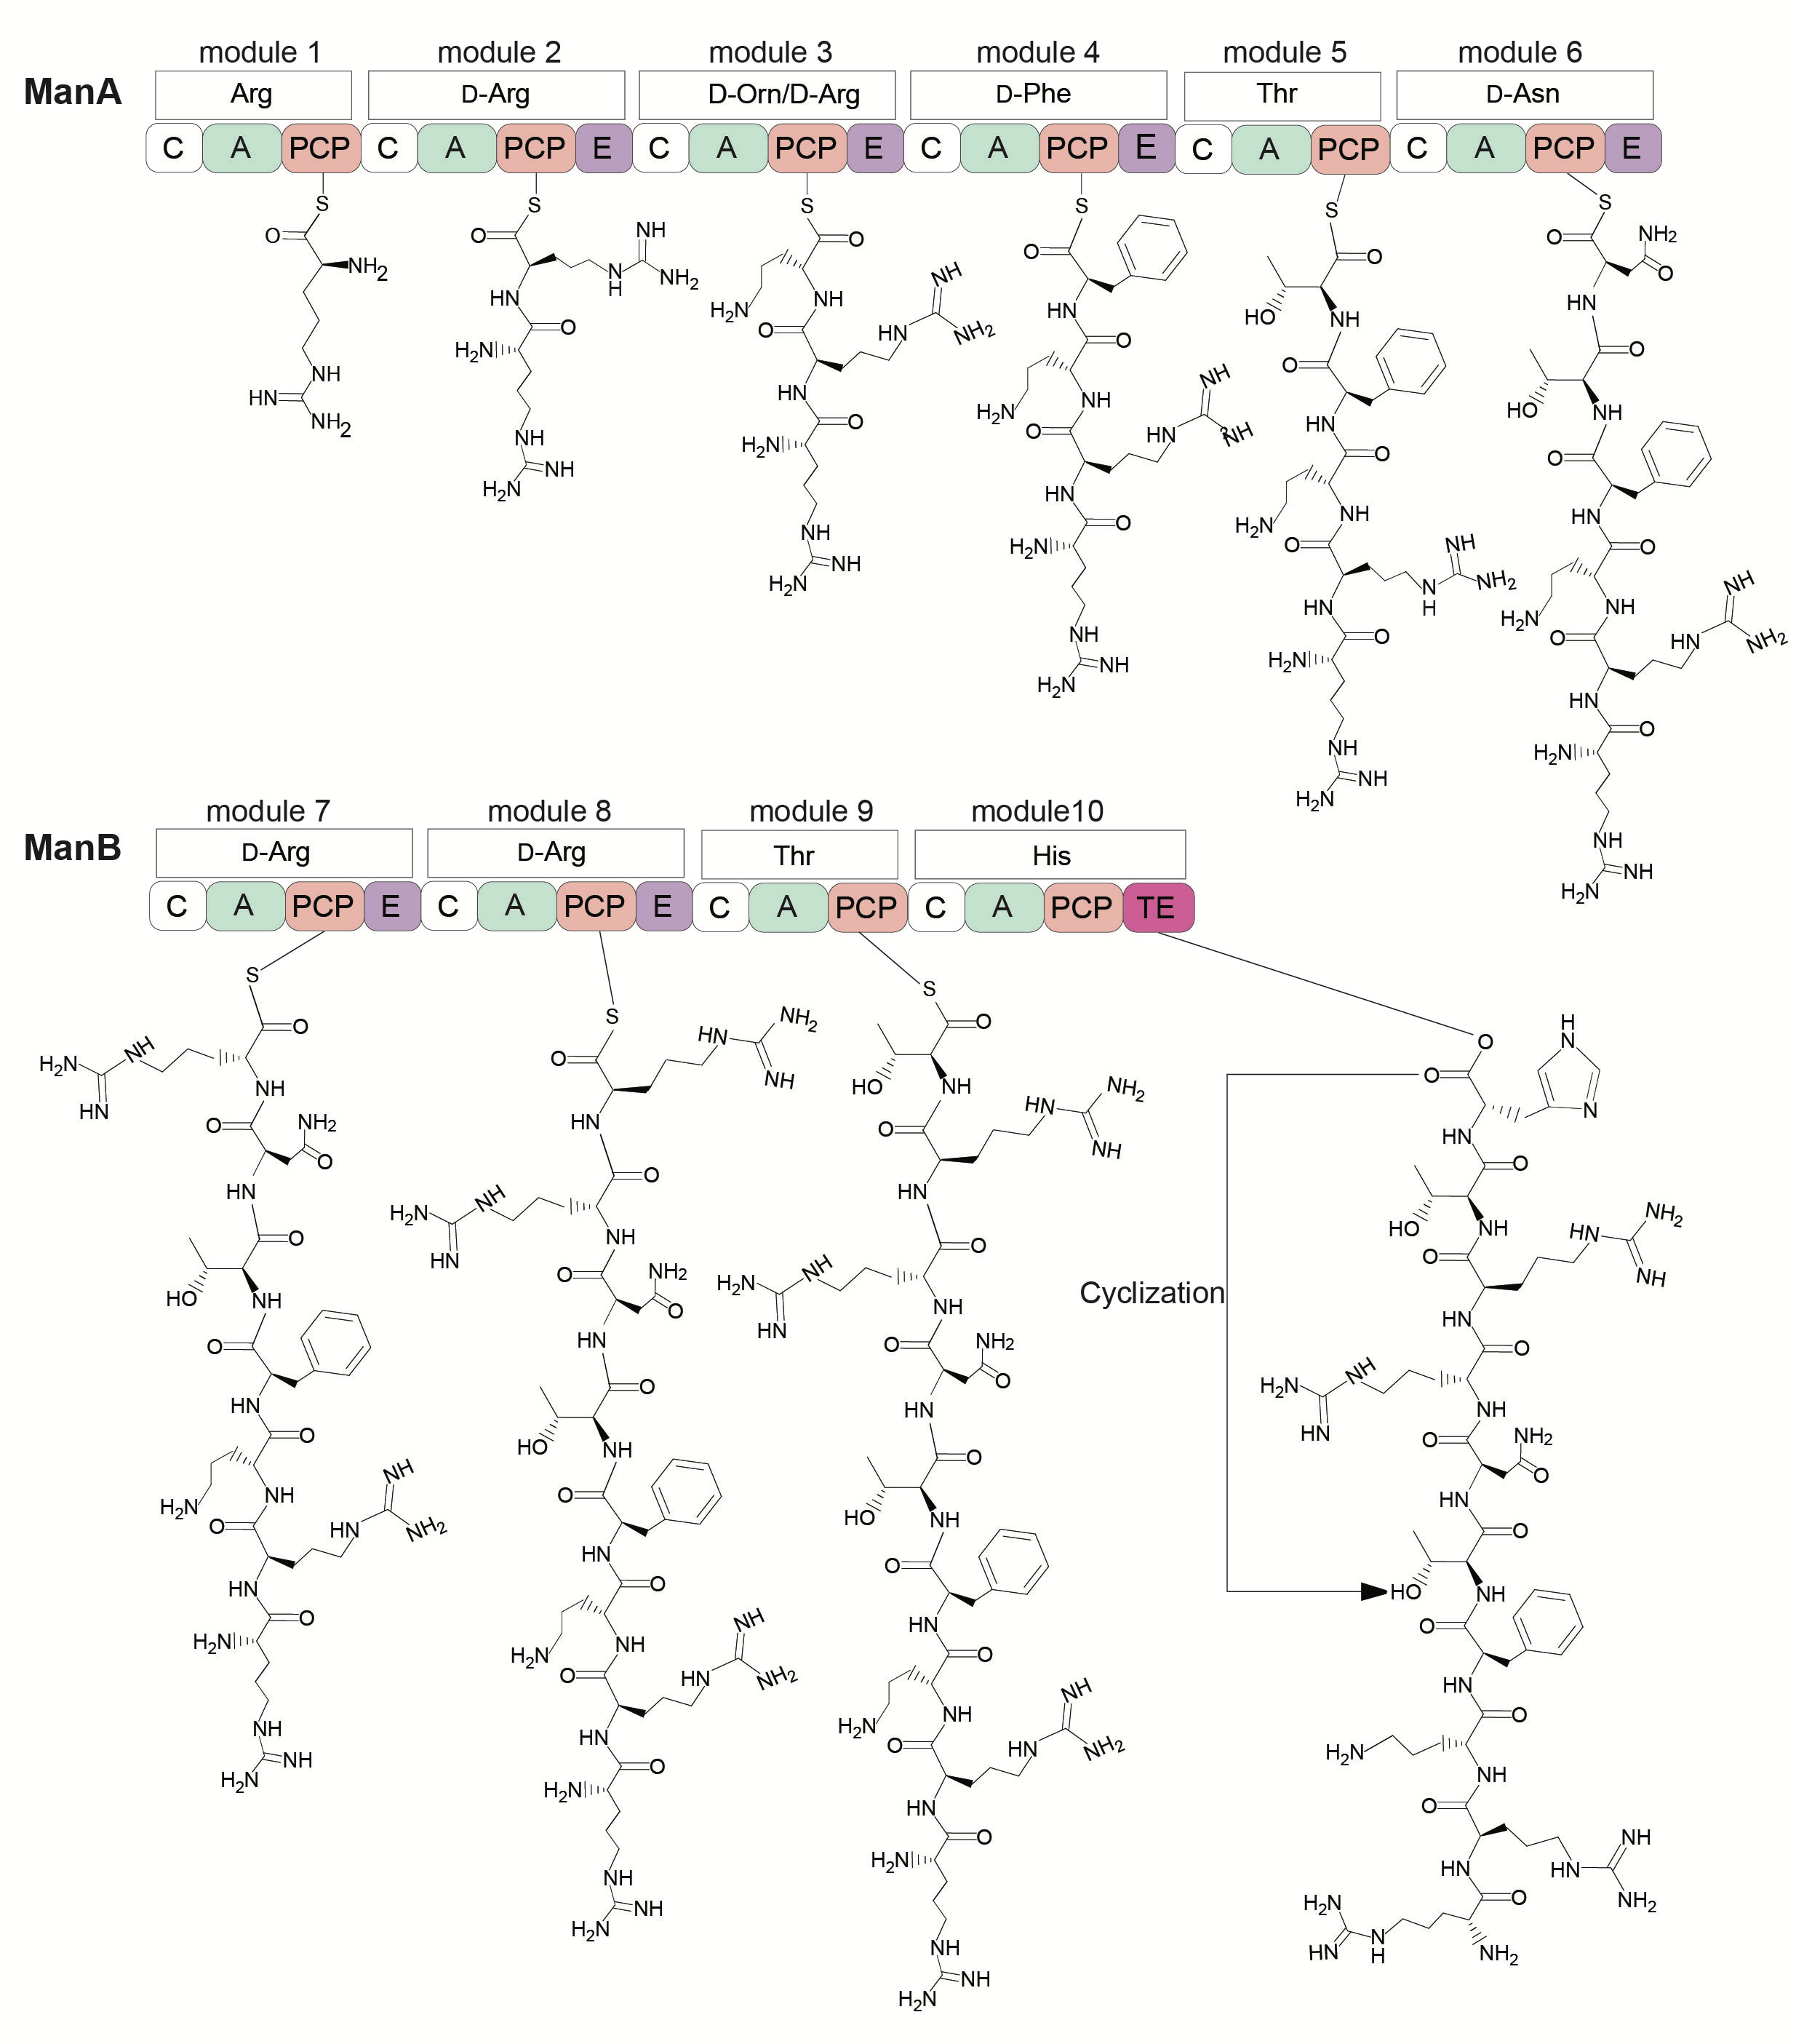
Extended Data Fig. 2 | Proposed biosynthesis pathway of MKM. MKM biosynthesis involves NRPSs, ManA and ManB, containing 10 amino acid modules, and encoding six epimerization domains, with the L or D stereochemistry of each amino acid specified. The thioesterase (TE), responsible for ring closure between histidine and threonine, is shown on the right. Once synthesized, the peptide is exported via the ManD transporter. Domain abbreviations: A, adenylation domain; C, condensation domain; PCP, peptidyl carrier protein; E, epimerization domain; TE, thioesterase domain
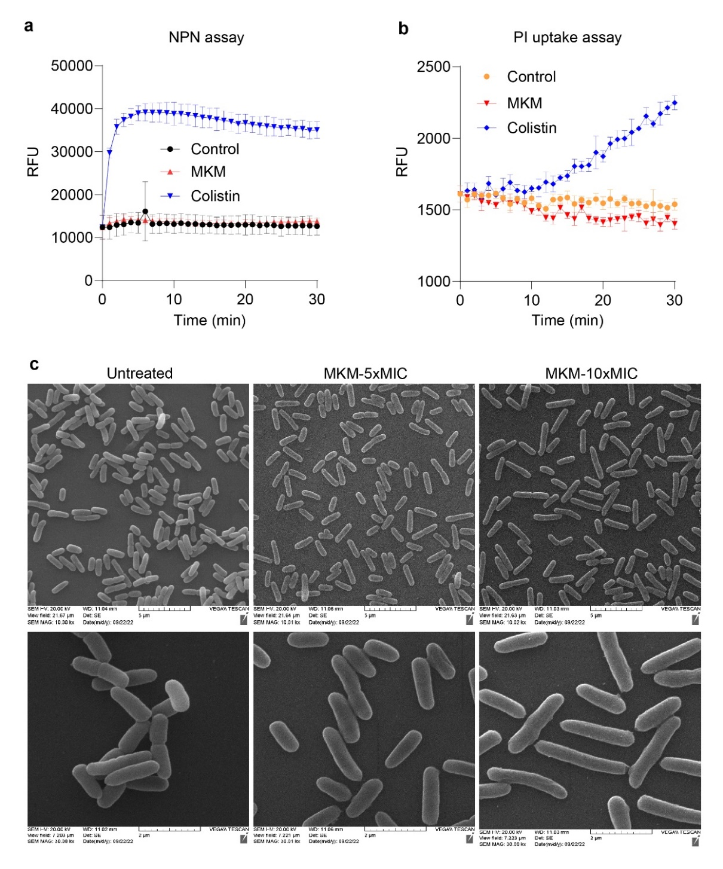
Extended Data Fig. 3 | Effect of MKM on E. coli membrane integrity and morphology.
a, Outer membrane permeabilization assay using NPN dye in E. coli BW25113 cells. The y-axis shows relative fluorescence units (RFU). Controls include untreated cells and colistin (5 µg/ml) as a positive control for outer membrane disruption. MKM was tested at 10× MIC (10 µg/ml). b, Inner membrane disruption assay using propidium iodide (PI) in E. coli BW25113 cells. The y-axis indicates RFU corresponding to DNA-bound PI. MKM and colistin were tested at the same concentrations as in (a). Data in (a) and (b) are presented as mean ± SD of three biological replicates. c, Scanning electron microscopy (SEM) analysis of E. coli BW25113 treated with MKM at 5× and 10× MIC. The upper panels (magnification: 10,000×, scale bar: 5 µm) and lower panels (magnification: 30,008×, scale bar: 2 µm) display different magnifications of the same sample. The images are representative of two independent experiments.
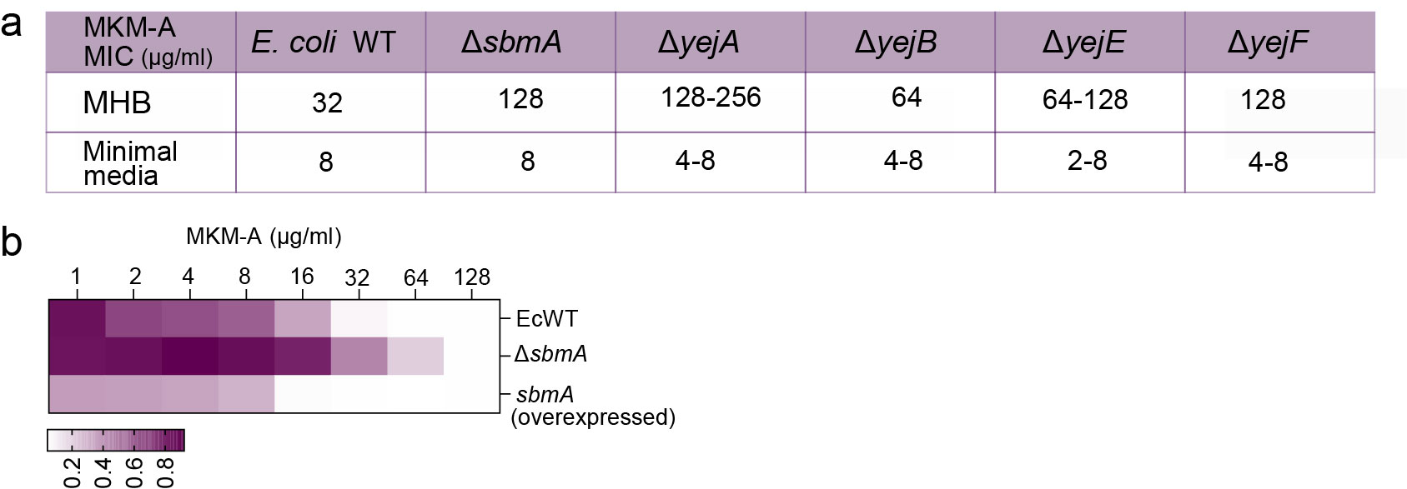
Extended Data Fig. 4 | Role of peptide uptake transporters SbmA and YejABEF in MKM susceptibility in E. coli. a, MIC of MKM for E. coli strains lacking SbmA, YejA, YejB, YejE, or YejF in cation-adjusted MHB medium and MOPS minimal medium. These deletion strains are part of the Keio collection¹⁵. b, Comparison of MICs upon deletion or overexpression of SbmA in wild-type E. coli. The overexpressed strain was a part of ASKA library¹⁰⁰.

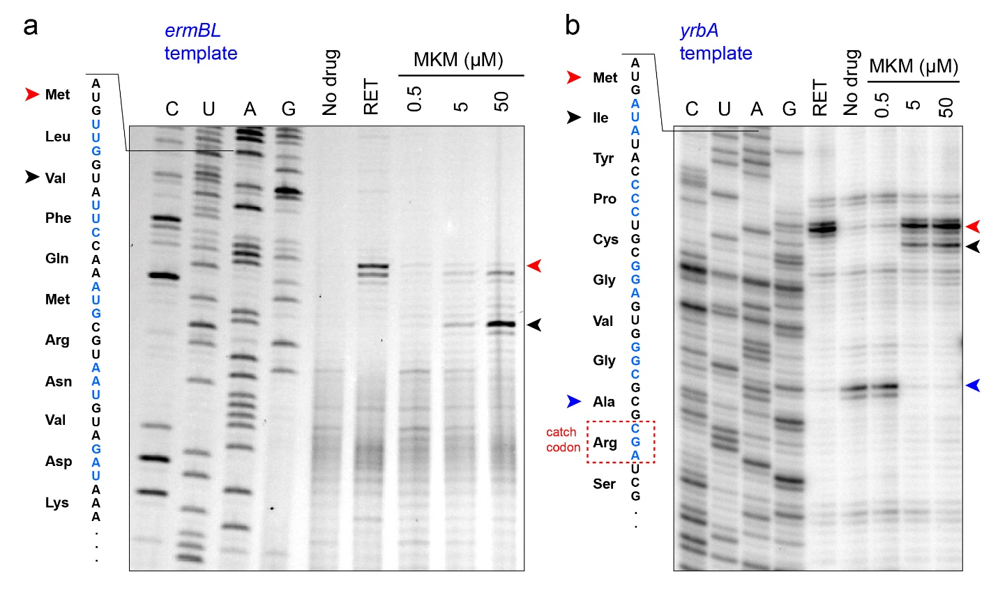

Extended Data Fig. 5 | Toeprinting reveals MKM-dependent translational pauses at distinct sites a, b, Toeprinting analysis of MKM effect on translation of ermBL (a) and yrbA (b) templates. Blue arrowhead indicates ribosome stalling in front of the Arg 10 codon due to the presence of Arg-RS inhibitor (Arg-AMS) in all the reactions with yrbA. The start codon toeprinting band is indicated by a red arrowhead and the other MKM-induced stalls are marked by black arrowheads. Retapamulin (RET), the known initiation inhibitor⁹⁹, was used as a control.
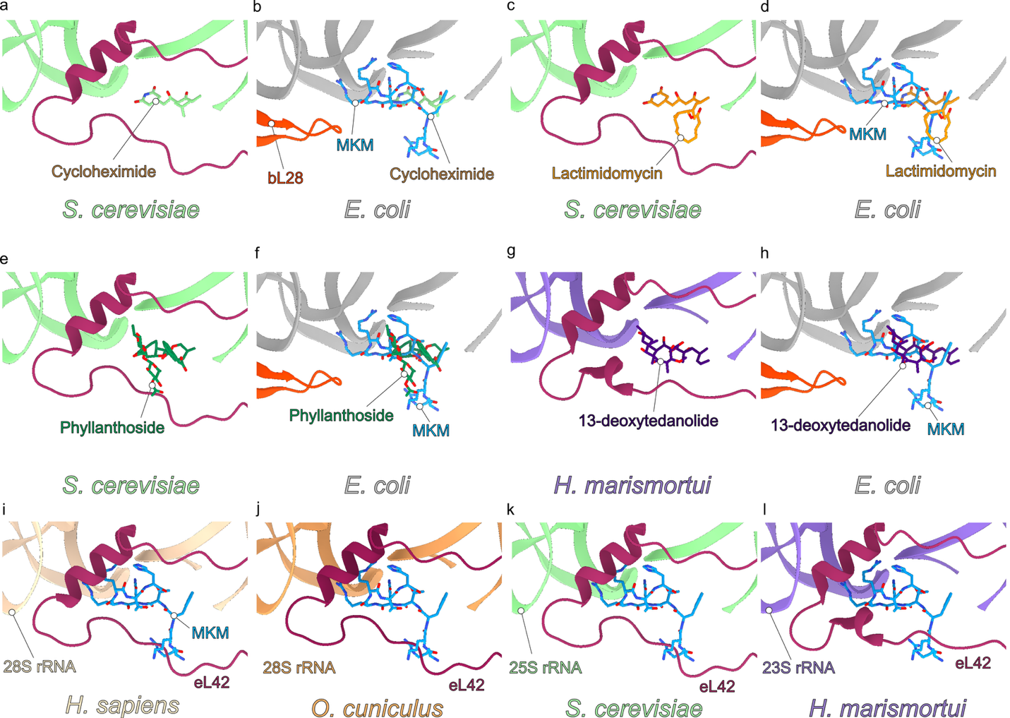

Extended Data Fig. 6. | Binding position of MKM relative to eukaryotic ribosomes and eukaryotic-specific translation inhibitors. a-f, comparison of the Yeast/S. cerevisiae 80S ribosome bound with (a) cycloheximide (green, PDB ID 4U3U)²⁹, (c) lactimidomycin (orange, PDB ID 4U4R)²⁹ and (e) phyllanthoside (dark green, PDB ID 4U4Z)²⁹ alone, or (b,d,f) overlayed with MKM (blue). g-h, comparison of the archaeal/H. marismortui 70S ribosome bound with (g) 13-deoxytedanolide (purple, PDB ID 2OTJ)³¹ alone, or (h) overlayed with MKM (blue). Structural alignments based on large subunit rRNAs. i-l, Binding position of MKM (blue) superimposed onto the E-site of (a-c) eukaryotic ribosomes including (i) Humans/Homo sapiens (PDB ID 8GLP)³⁰, (j) Rabbit/Oryctolagus cuniculus (PDB ID 6SGC)¹⁰¹, and (k) Yeast/Saccharomyces cerevisiae (PDB ID 4U3U)²⁹ and the archaeal 70S ribosome from (l) Haloarcula marismortui (PDB ID 2OTJ)³¹.

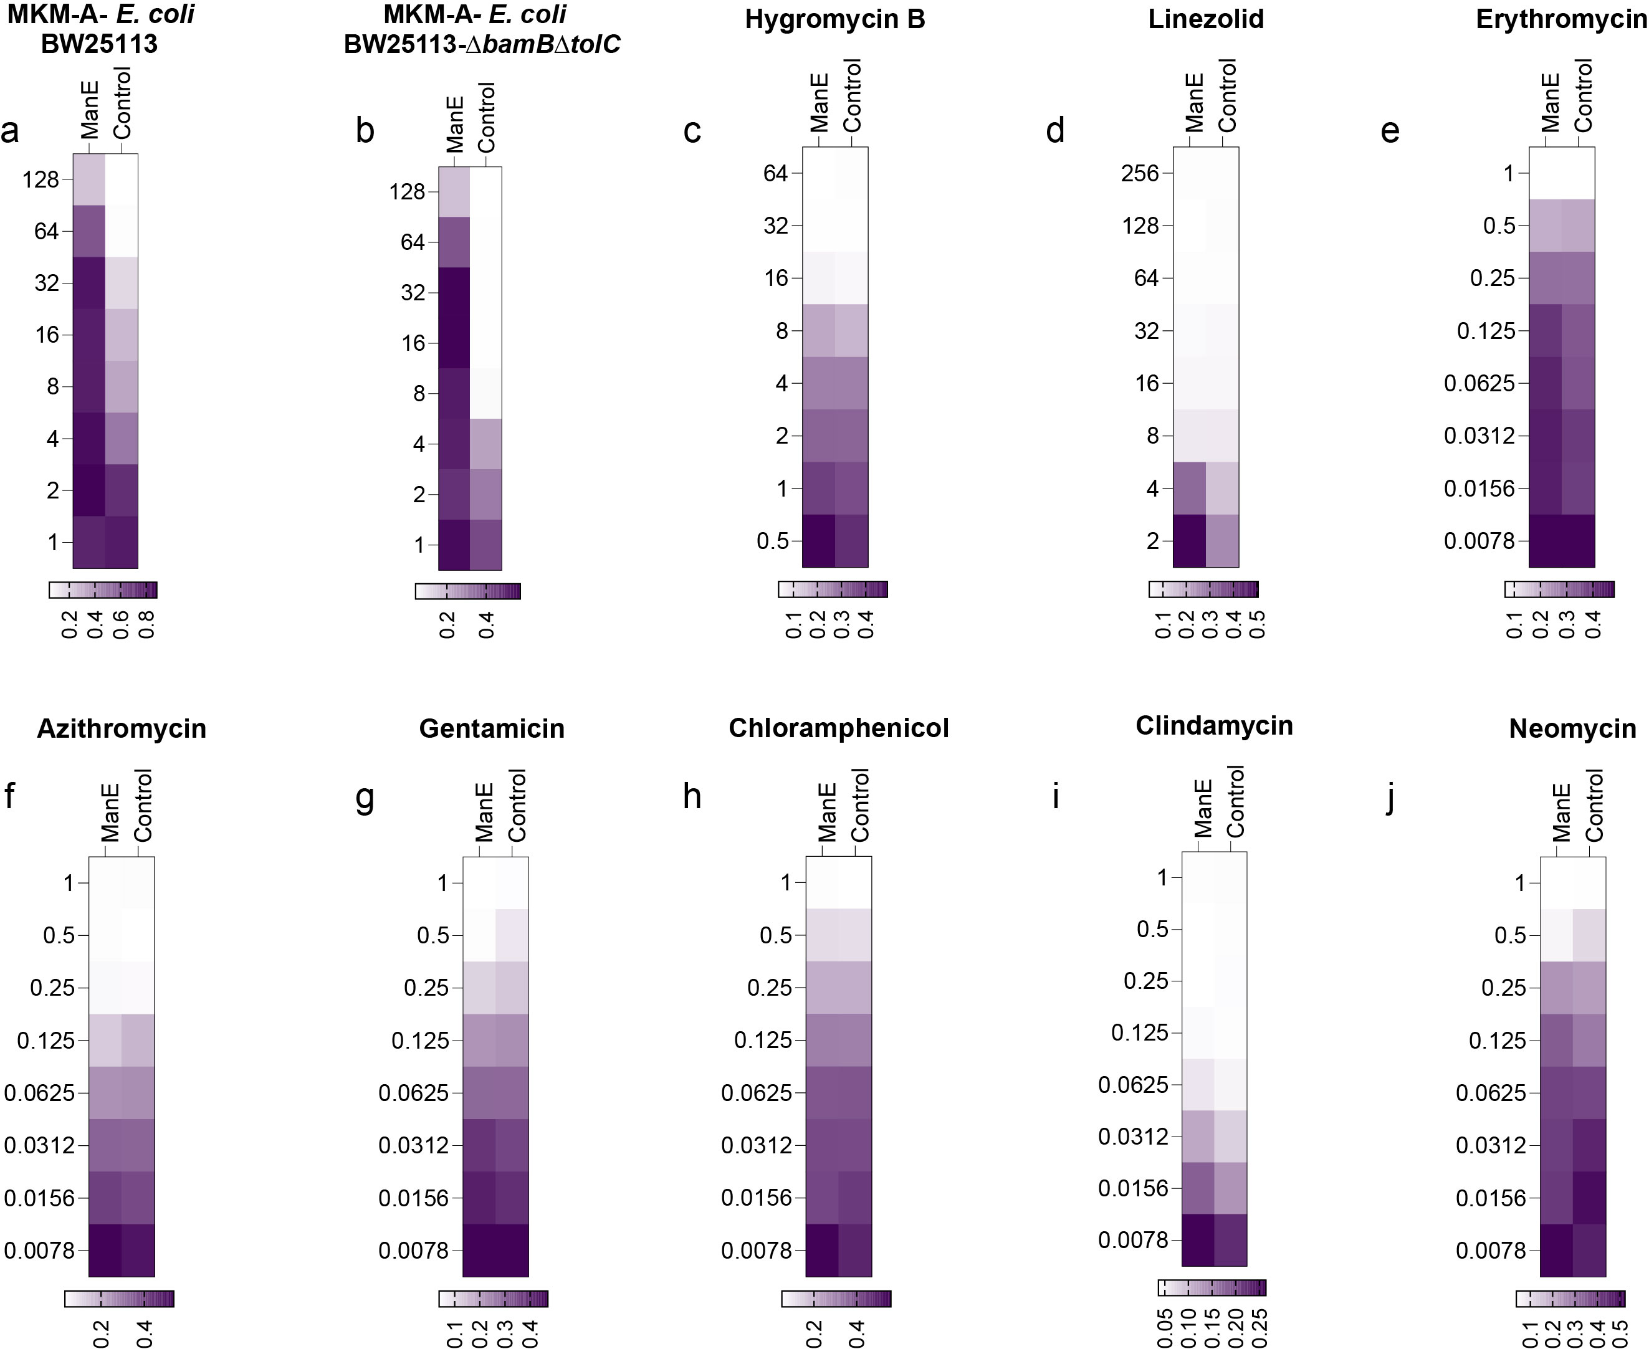
Extended Data Fig. 7 | ManE confers specific resistance to MKM, but not to other tested translation inhibitors. a,b, Heat maps of MIC of manE-expressing strain compared to control strains with MKM-A. c-j, Heat maps of MIC of various translation inhibitors against manE-expressing strains. The data are displayed as a heatmap, where darker colours indicate relative growth based on OD₆₀₀ values, as shown in the scale bar.

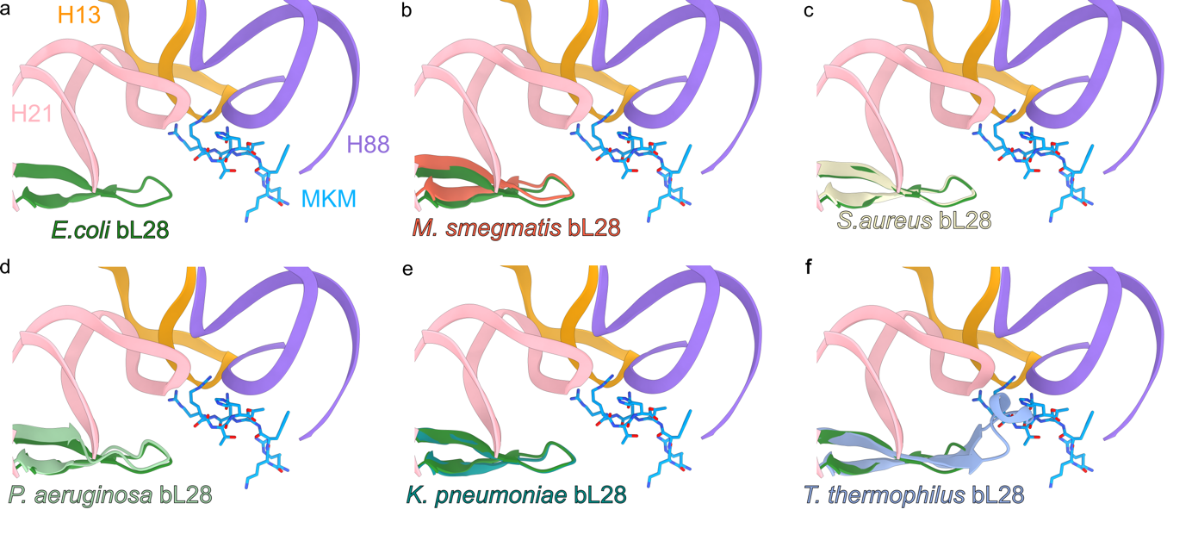
Extended Data Fig. 8 | Comparison of the binding site of MKM on different bacterial ribosomes. a, The binding site of MKM (blue) on the E. coli 70S ribosome, composed of 23S rRNA helices H13 (orange), H21 (pink) and H88 (purple), as well as the ribosomal protein bL28 (green). b-f, Superimposition of MKM binding site on the E. coli 70S ribosomes from (a) with (b) M. smegmatis 70S ribosome (red, PDB ID 5O61)⁴⁸, (c) S. aureus 70S ribosome (cream, PDB ID 8P2G)⁴⁹, (d) P. aeruginosa 70S ribosome (lime, PDB ID 6SPG)¹⁰², (e) K. pneumoniae bL28 (lime) and (f) T. thermophilus 70S ribosome (pale blue, PDB ID 6ND6)¹⁰³ where T. thermophilus bL28 sterically clashes with MKM. Ribosomes were structural alignment based on the 23S rRNA.

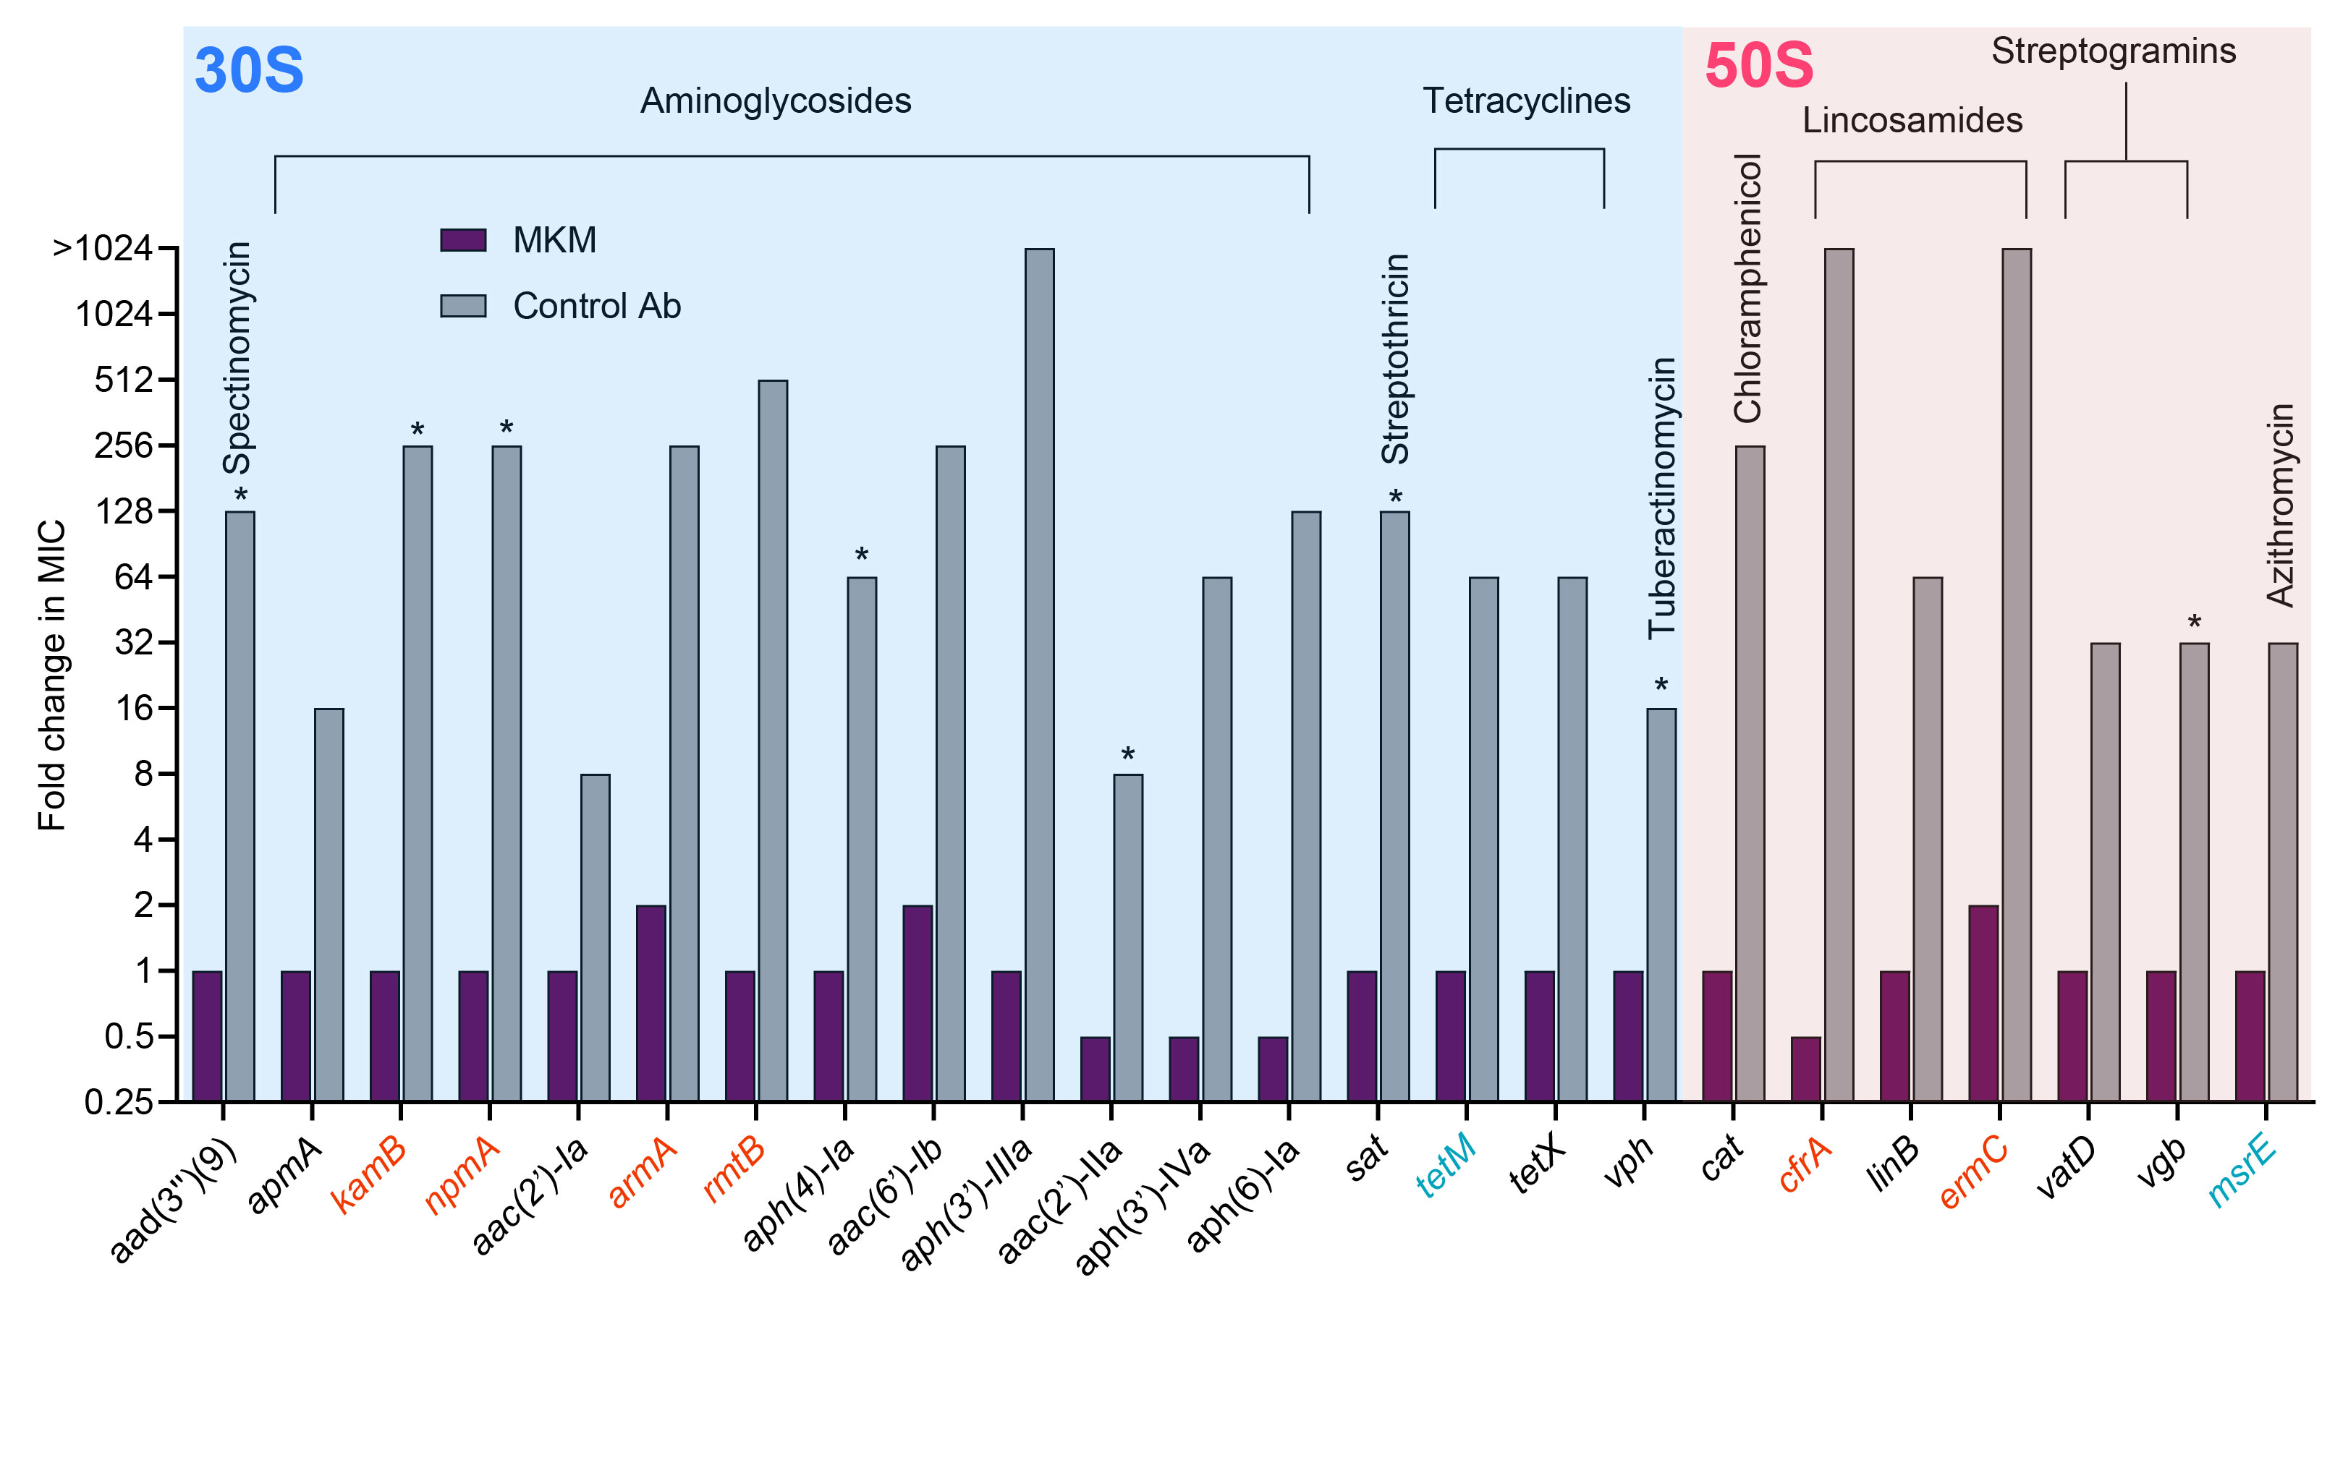

Extended Data Fig. 9 | MKM activity is unaffected by common resistance mechanisms to ribosome-targeting antibiotics. The graph shows the MIC increase of MKM and control antibiotics upon overexpression of designated resistance determinants in E. coli BW25113 ΔtolCΔbamB. For controls marked with asterisks, the actual MIC change exceeds the values shown, indicating bacterial growth at the highest antibiotic concentration tested. The gene name's colour reflects the resistance mechanism: antibiotic modification – black, rRNA modification – red, ribosome protection – blue. Antibiotics targeting the small and large ribosomal subunits are shown on blue and pink background, respectively.

EXTENDED DATA TABLES
Extended Data Table 1: Antimicrobial spectrum and mammalian toxicity of manikomycins

Organism | Ca+ MHB Medium |  |  |  | MOPS Minimal Medium |  |  | RPMI Medium
Gram-negative | A | B |  | E | A | B | E | A | B | E
E. coli BW25113 | 32 | 16 |  | 8 | 4 | 2 | 1 | 4 | 2 | <0.5
E. coli ΔtolC ΔbamB | 8 | 4 |  | 2 | 2 | 1 | 0.5 | 2 | 1 | <0.5
E. coli C0617 | 32 | 16 |  | 8 | 8 | 4 | 1 | 8 | 2 | <0.5
E. coli C1507 | 32 | 16 |  | 8 | 8 | 4 | 2 | 4 | 1 | <0.5
E. coli C1508 | 32 | 16 |  | 8 | 16 | 4 | 1 | 4 | 4 | 1
K. pneumoniae C1557 | 16 | 16 |  | 8 | 8 | 4 | 2 | 4 | 2 | 1
K. pneumoniae C1559 | 16 | 16 |  | 8 | 8 | 4 | 2 | 8 | 2 | 1
K. pneumoniae C1459 | 32 | 16 |  | 8 | 8 | 4 | 2 | 8 | 4 | 2
S. enterica ATCC 14028 | 32 | 16 |  | 16 | 16 | 8 | 2 | 8 | 2 | 1
P. aeruginosa PAO1 | >128 | >128 |  | >128 | >128 | >128 | >128 | >64 | >64 | 32
A. baumanii ATCC 17978 | >128 | >128 |  | >128 | No growth |  |  | 64 | 32 | 2
Gram-positive
 | A | B |  | E |  |  |  | A | B | E
S. aureus USA 300 | 128 | 64 |  | 16 | M. abscessus ATCC 19977 |  |  | 64 | 16 | 32
S. aureus ATCC 29213 | 64 | 32 |  | 32 | M. smegmatis MC²155 |  |  | 2 | 1 | 2
Bacillus subtilis 168 | >64 | 32 |  | 32 | M. tuberculosis H37Ra |  |  | 4 | 0.25 | 1
M. avium subsp. avium ATCC 25291 | 32 | 4 |  | 16 | M. bovis BCG Pasteur ATCC 35734 |  |  | 2 | 0.25 | 1
M. fortuitum subsp. fortuitum ATCC 6841 | 8 | 0.5 |  | 2
Gut bacteria |  |  |  |  | Cytotoxicity
 | A |  | B | E |  |  |  | A | B | E
Lactobacillus plantarum GC4 | >256 |  |  |  | HEK 293 (IC₅₀) μg/ml) |  |  | >256 | >256 | >256
Bifidobacterium breve GC96 | 256 |  |  |  | Haemolysis (256 μg/ml) |  |  | <1%
Blautia obeum GC925 | >256 |  |  |  | Other
Clostridium perfringens GC1584 | >256 |  |  |  | Candida albicans ATCC 90028 |  |  | >64
Bacteroides fragilis GC73 | >256
MICs are represented in μg/ml of three variants of MKM: MKM-A, MKM-B, and MKM-E

