SUPPLEMENTARY DATA
Antiplasmodial activity of alkoxy-substituted 3’,4’-dihydro-2’H-spiro[indoline-3,1’-isoquinolin]-2-ones: effect of conformational restriction and positional isomerism

Albert E. Ehinak,^{a.b} Noella M. Efange,^{c} Lawrence Ayong,^{d} Mathieu J. Mbenga Tjegbe,^{b}
Fidele Ntie-Kang,^{a,b,e*} Simon M.N. Efange^{a,b,f*}

ª Department of Chemistry, Faculty of Science, University of Buea, P. O. Box 63, Buea, Cameroon
^{b}Centre for Discovery, Faculty of Science, University of Buea, P. O. Box 63, Buea, Cameroon
^{c}Department of Biochemistry & Molecular Biology, Faculty of Science, University of Buea, P. O. Box 63, Buea, Cameroon;
^{d}Malaria Unit, Centre Pasteur du Cameroun, Yaounde, Cameroon;
^{e}Institute of Pharmacy, Martin-Lether University of Halle-Wittenberg, Halle (Saale), Kurt-Mothes Strasse 3, 06120 Halle (Saale), Germany.
^{f}Chemical and Bioactivity Information Center, Faculty of Science, University of Buea, P. O. Box 660, Buea, Cameroon

*Correspondence: fidele.ntie-kang@ubuea.cm (FNK); smbuangalefange@gmail.com (SMNE).

Table S1: Code of correspondence for Spectral data
Compound ID | ID schown in Spectra
6a | SE/UB-36/052
6b | SE/UB-36/054
6c | SE/UB-36/053
6d | SE/UB-36/055
6e | SE/UB-36/063
6f | SE/UB-36/064
6g | SE/UB-36/081
7a | SE/UB-36/191
7b | SE/UB-36/196
7c | SE/UB-36/192
7d | SE/UB-37/006
7e | SE/UB-37/007
8a | SE/UB-36/193
8b | SE/UB-36/198
8c | SE/UB-37/002
8d | SE/UB-37/001
8e | SE/UB-37/004
9a | SE/UB-36/093
9b | SE/UB-36/094
10 | SE/UB-36/153

Figure S1: Decomposition of E_{int} per residue for the top 10 interacting binding site amino acid residues of the docked ligands showing van der Waals (in orange) and electrostatic (in green) components for ligand 6f.

Figure S2: Decomposition of E_{int} per residue for the top 10 interacting binding site amino acid residues of the docked ligands showing van der Waals (in orange) and electrostatic (in green) components for ligand 10.

Figure S3: Decomposition of E_{int} per residue for the top 10 interacting binding site amino acid residues of the docked ligands, showing van der Waals (in orange) and electrostatic (in green) components for ligand 11.

SPECTROSCOPIC DATA

APPENDIX 1: ¹H NMR, ¹³C NMR AND LC-MS SPECTRA FOR THE SYNTHESIZED COMPOUNDS

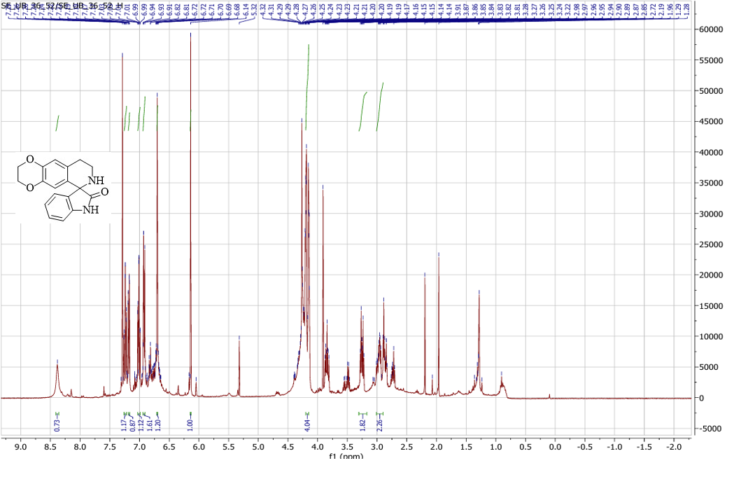
Figure S4: ¹H NMR of 2',3',8',9'-tetrahydro-7'H-spiro[indoline-3,6'-[1,4]dioxino[2,3-g]isoquinolin]-2-one (6a)

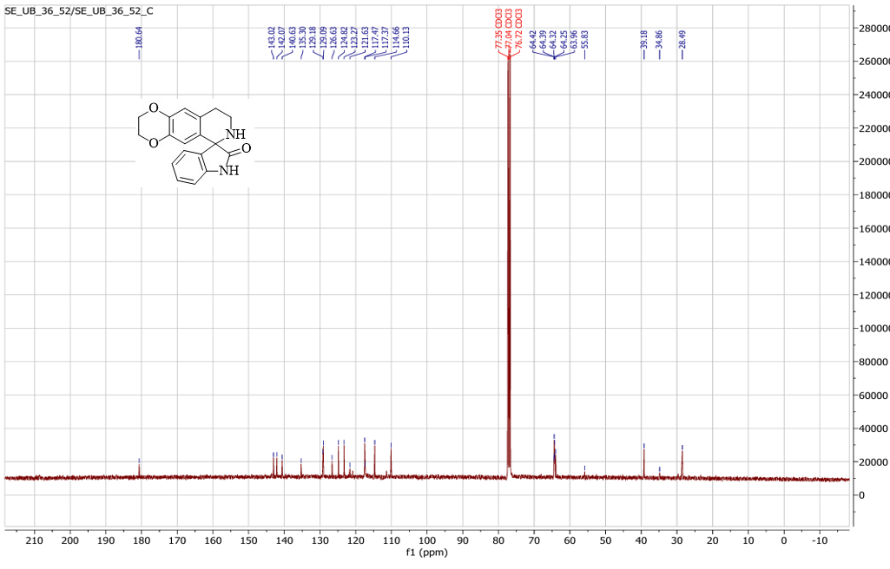

Figure S5: ¹³C NMR of 2',3',8',9'-tetrahydro-7'H-spiro[indoline-3,6'-[1,4]dioxino[2,3-g]isoquinolin]-2-one (6a)

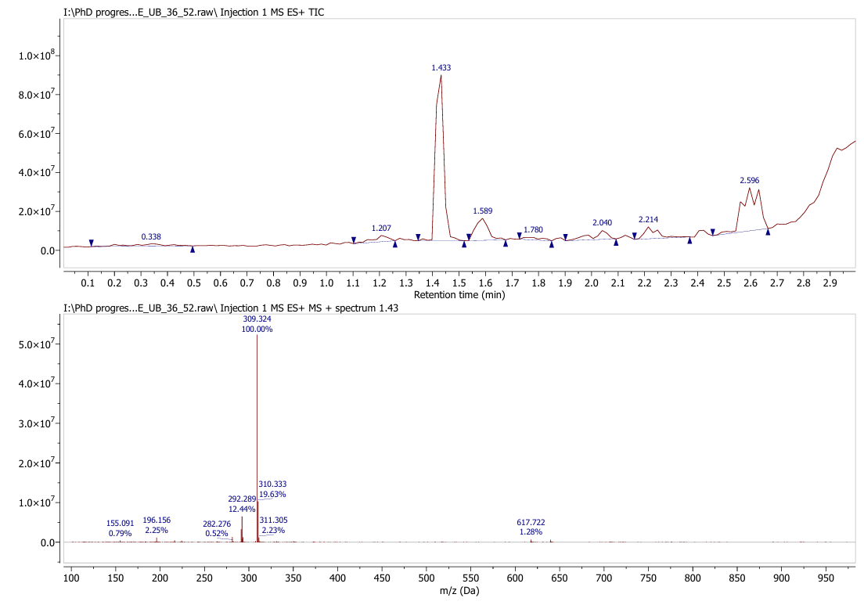

Figure S6: LC-MS spectra of 2',3',8',9'-tetrahydro-7'H-spiro[indoline-3,6'-[1,4]dioxino[2,3-g]isoquinolin]-2-one (6a)

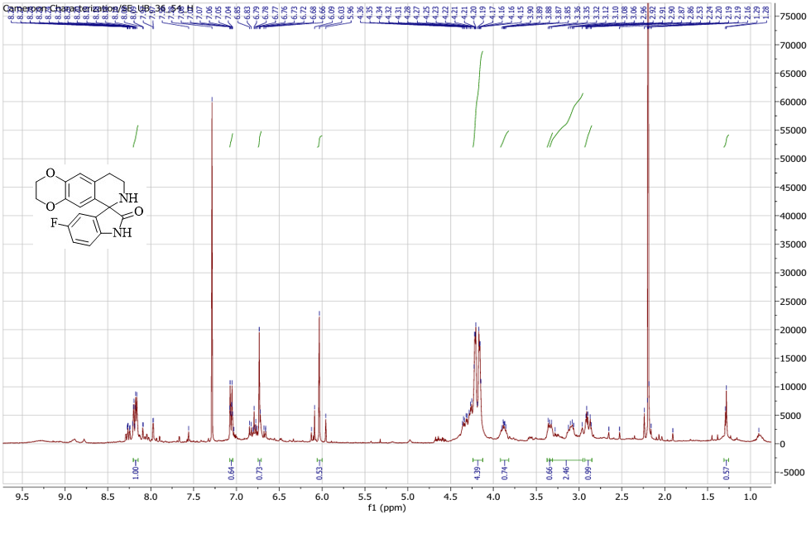
Figure S7: ¹H NMR of 5-fluoro-2',3',8',9'-tetrahydro-7'H-spiro[indoline-3,6'-[1,4]dioxino[2,3-g]isoquinolin]-2-one (6b)

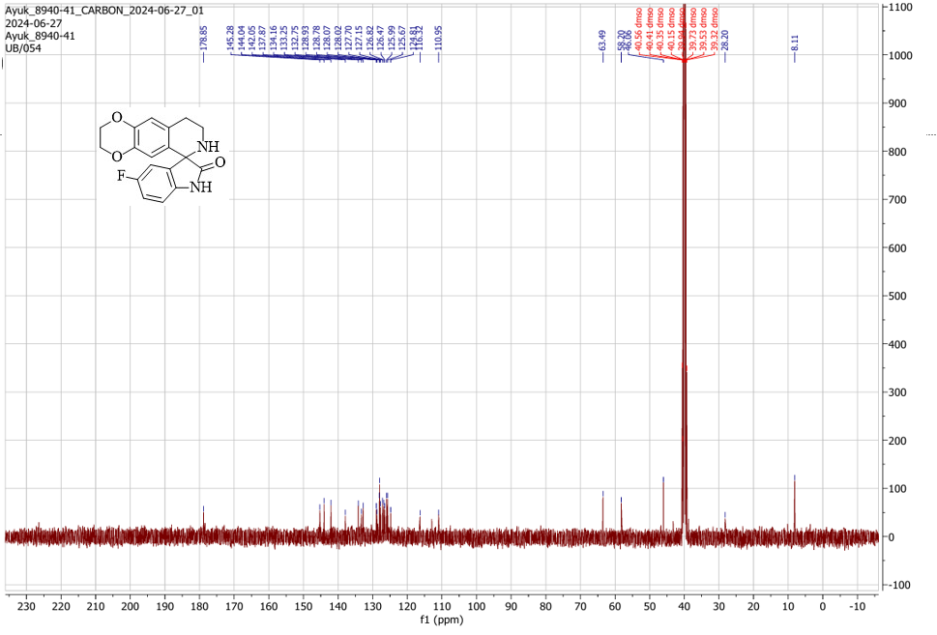
Figure S8: ¹³C NMR of 5-fluoro-2',3',8',9'-tetrahydro-7'H-spiro[indoline-3,6'-[1,4]dioxino[2,3-g]isoquinolin]-2-one (6b)

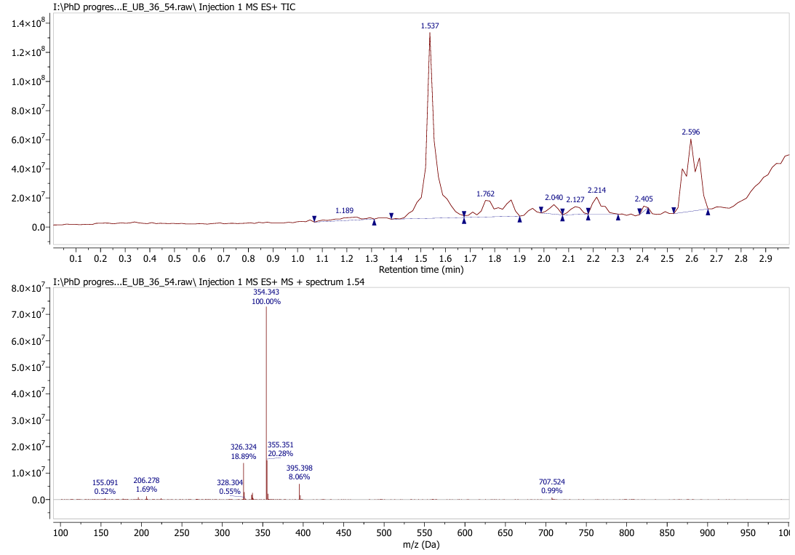

Figure S9: LC-MS spectra of 5-fluoro-2',3',8',9'-tetrahydro-7'H-spiro[indoline-3,6'-[1,4]dioxino[2,3-g]isoquinolin]-2-one (6b)

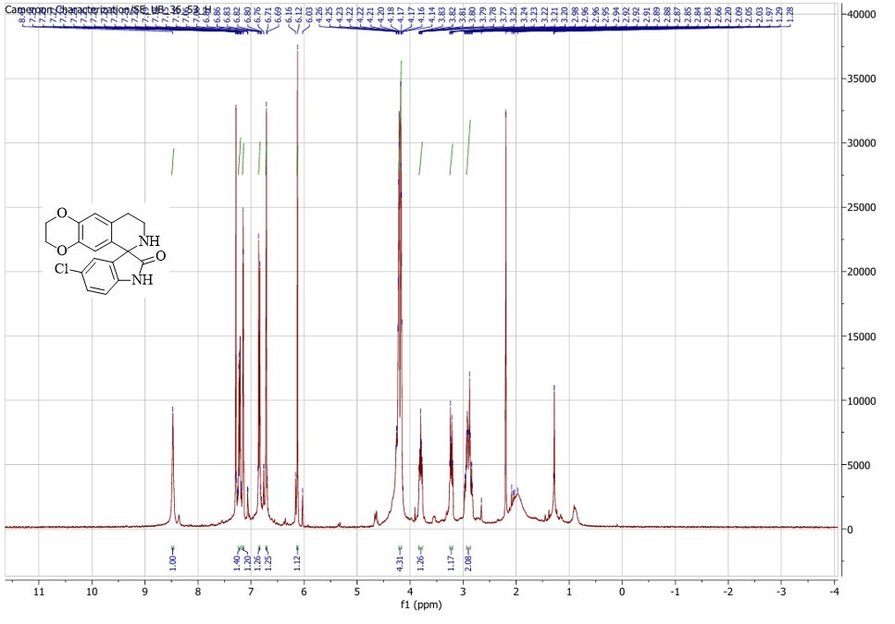
Figure S10: ¹H NMR of 5-chloro-2',3',8',9'-tetrahydro-7'H-spiro[indoline-3,6'-[1,4]dioxino[2,3-g]isoquinolin]-2-one (6c)

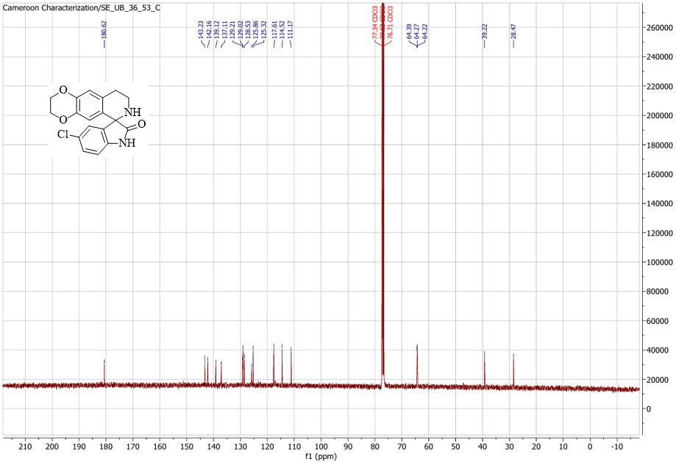
Figure S11: ¹³C NMR of 5-chloro-2',3',8',9'-tetrahydro-7'H-spiro[indoline-3,6'-[1,4]dioxino[2,3-g]isoquinolin]-2-one (6c)
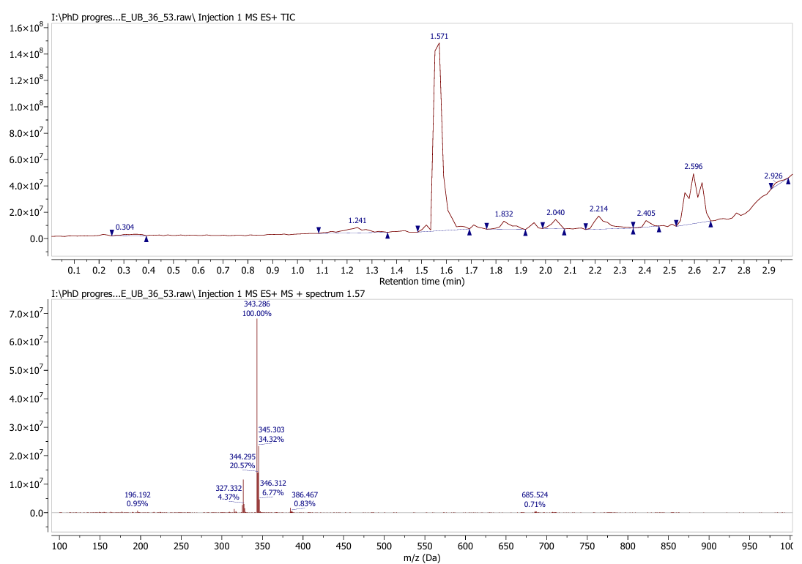
Figure S12: LC-MS spectra of 5-chloro-2',3',8',9'-tetrahydro-7'H-spiro[indoline-3,6'-[1,4]dioxino[2,3-g]isoquinolin]-2-one (6c)

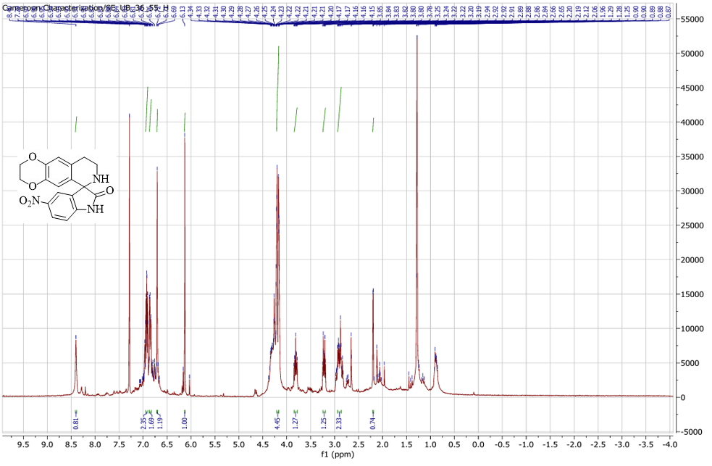
Figure S13: ¹H NMR of 5-nitro-2',3',8',9'-tetrahydro-7'H-spiro[indoline-3,6'-[1,4]dioxino[2,3-g]isoquinolin]-2-one (6d)

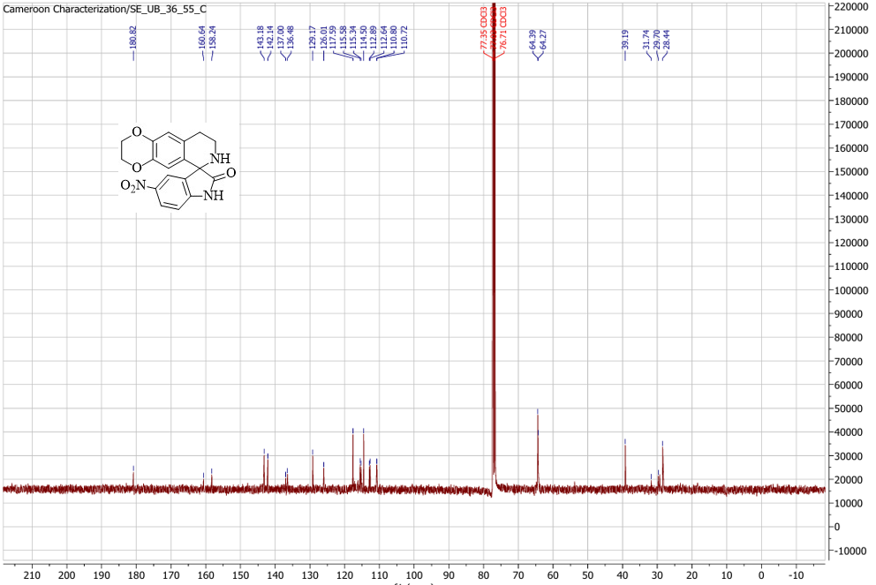

Figure S14: ¹³C NMR of 5-nitro-2',3',8',9'-tetrahydro-7'H-spiro[indoline-3,6'-[1,4]dioxino[2,3-g]isoquinolin]-2-one (6d)
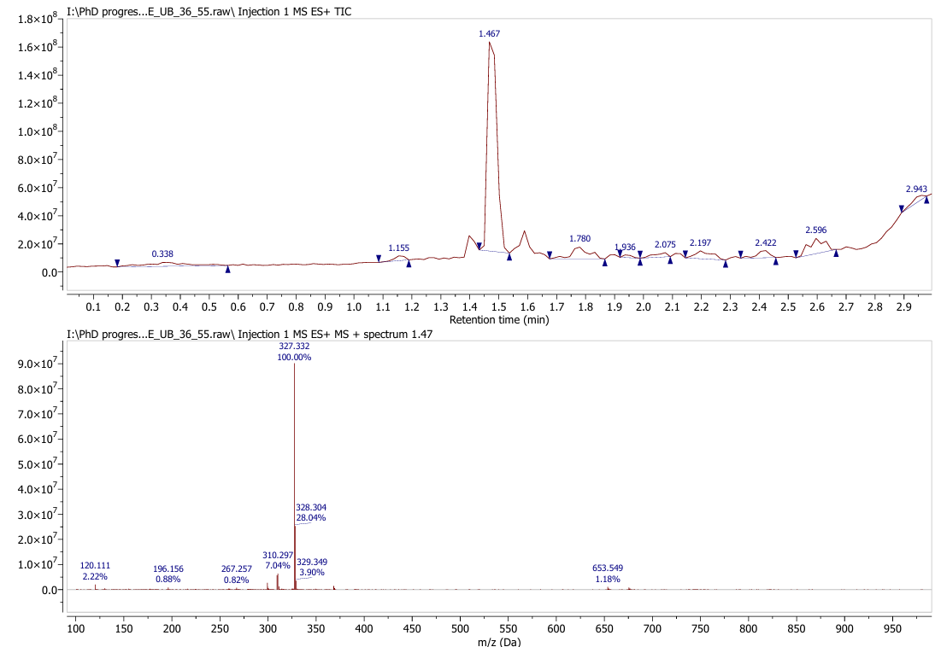
Figure S15: LC-MS spectra of 5-nitro-2',3',8',9'-tetrahydro-7'H-spiro[indoline-3,6'-[1,4]dioxino[2,3-g]isoquinolin]-2-one (6d)

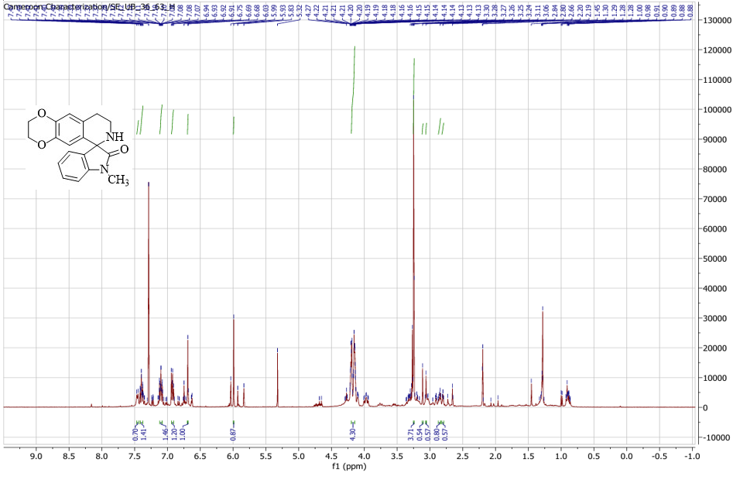
Figure S16: ¹H NMR of 1-methyl-2',3',8',9'-tetrahydro-7'H-spiro[indoline-3,6'-[1,4]dioxino[2,3-g]isoquinolin]-2-one (6e)

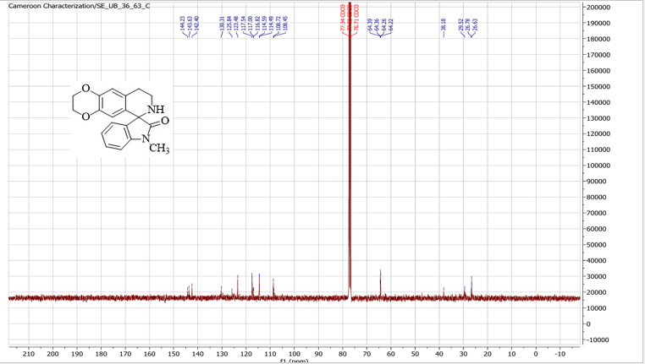
Figure S17: ¹³C NMR of 1-methyl-2',3',8',9'-tetrahydro-7'H-spiro[indoline-3,6'-[1,4]dioxino[2,3-g]isoquinolin]-2-one (6e)

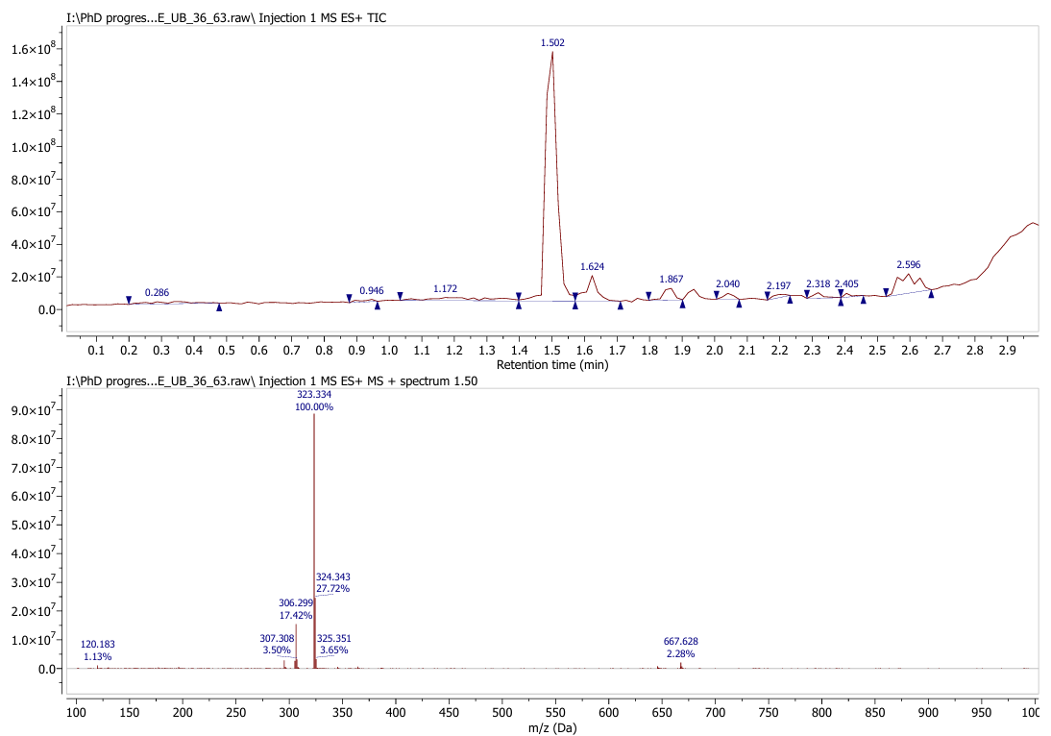
Figure S18: LC-MS spectra of 1-methyl-2',3',8',9'-tetrahydro-7'H-spiro[indoline-3,6'-[1,4]dioxino[2,3-g]isoquinolin]-2-one (6e)

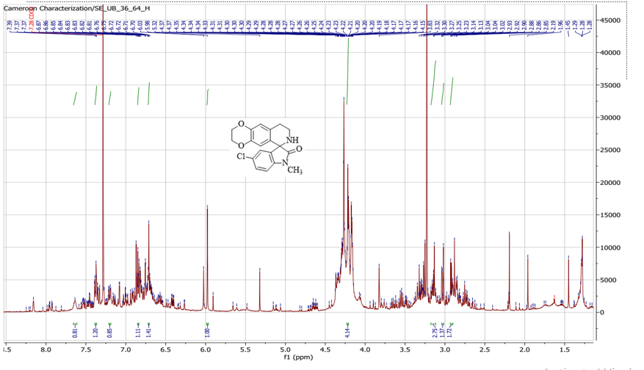
Figure S19: ¹H NMR of 1-methyl-2',3',8',9'-tetrahydro-7'H-spiro[indoline-3,6'-[1,4]dioxino[2,3-g]isoquinolin]-2-one (6f)

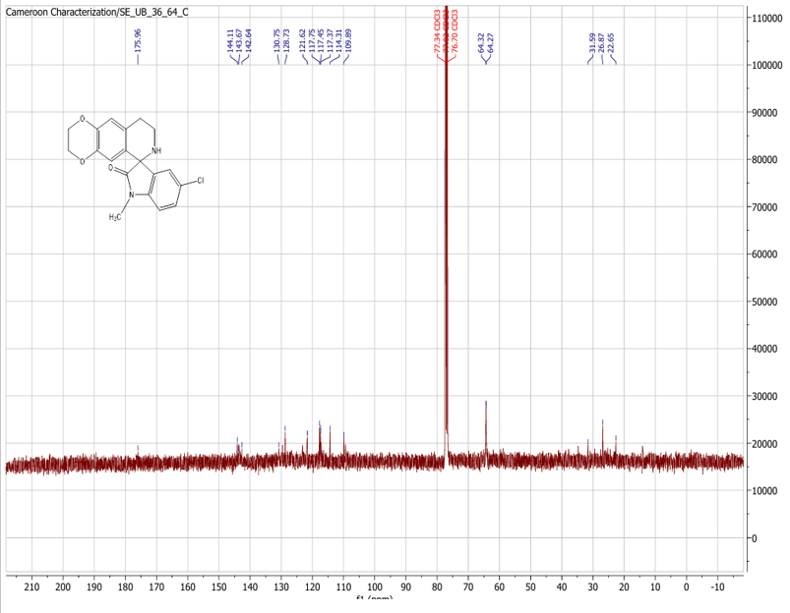
Figure S20: ¹³C NMR of 5-chloro-1-methyl-2',3',8',9'-tetrahydro-7'H-spiro[indoline-3,6'-[1,4]dioxino[2,3-g]isoquinolin]-2-one (6f)

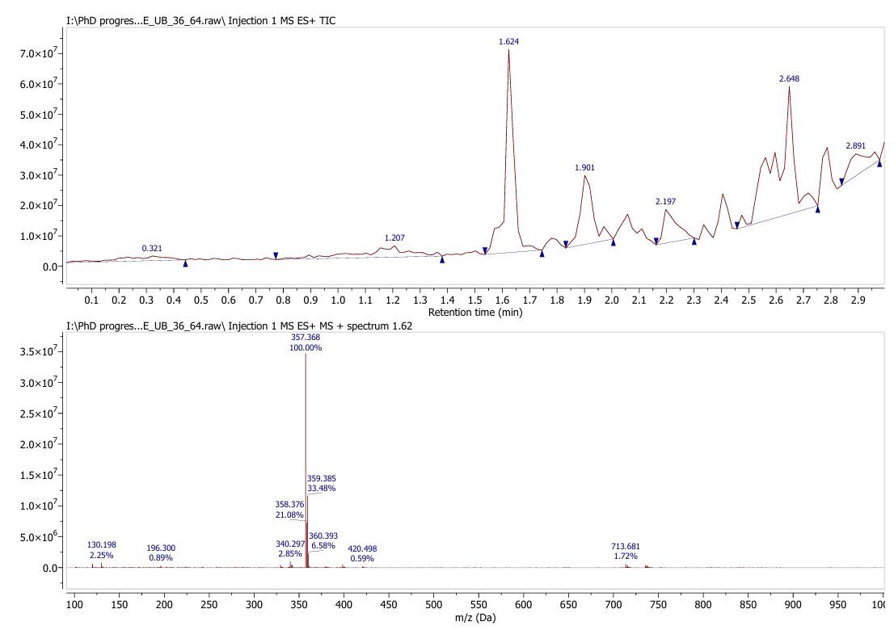
Figure S21: LC-MS spectra of 5-chloro-1-methyl-2',3',8',9'-tetrahydro-7'H-spiro[indoline-3,6'-[1,4]dioxino[2,3-g]isoquinolin]-2-one (6f)

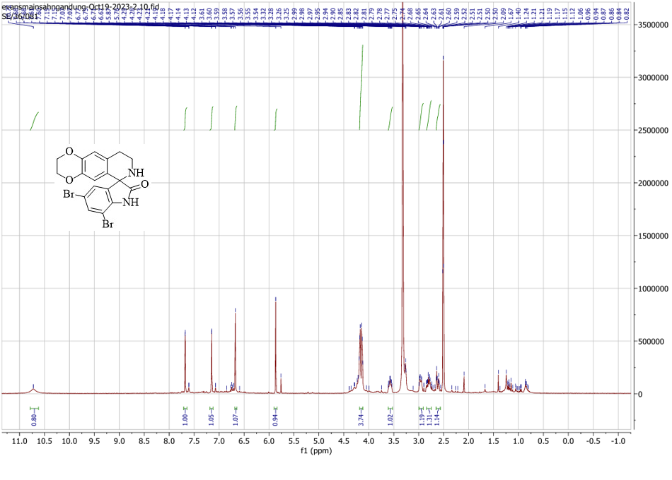
Figure S22: ¹H NMR of 5,7-dibromo-2',3',8',9'-tetrahydro-7'H-spiro[indoline-3,6'-[1,4]dioxino[2,3-g]isoquinolin]-2-one (6g)

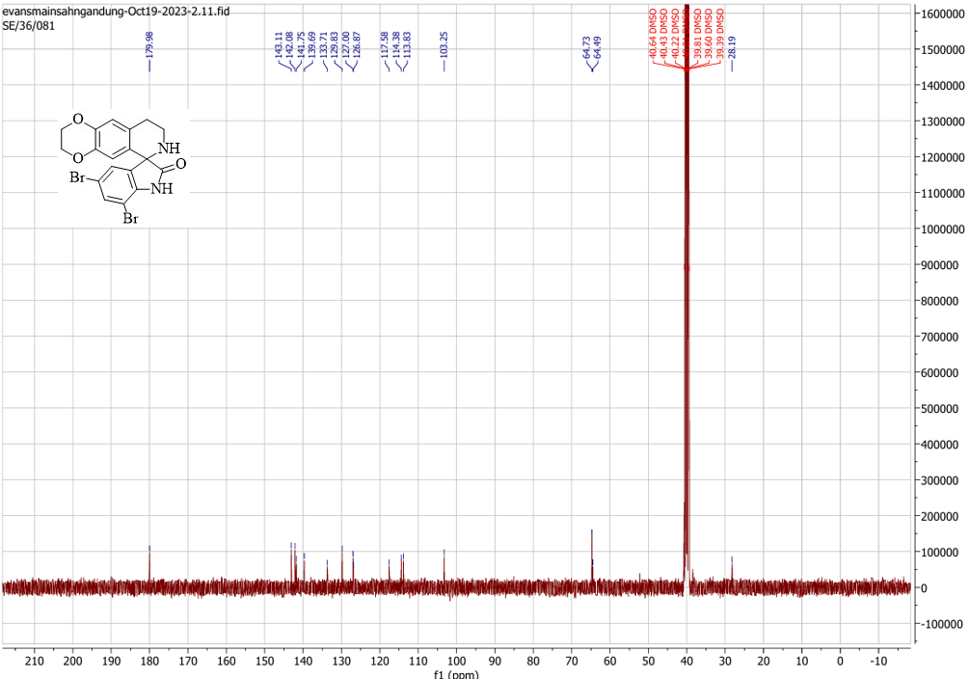

Figure S23: ¹³C NMR of 5,7-dibromo-2',3',8',9'-tetrahydro-7'H-spiro[indoline-3,6'-[1,4]dioxino[2,3-g]isoquinolin]-2-one (6g)

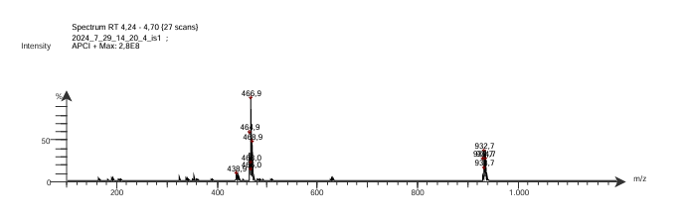
Figure S24: LC-MS spectra of 5,7-dibromo-2',3',8',9'-tetrahydro-7'H-spiro[indoline-3,6'-[1,4]dioxino[2,3-g]isoquinolin]-2-one (6g)

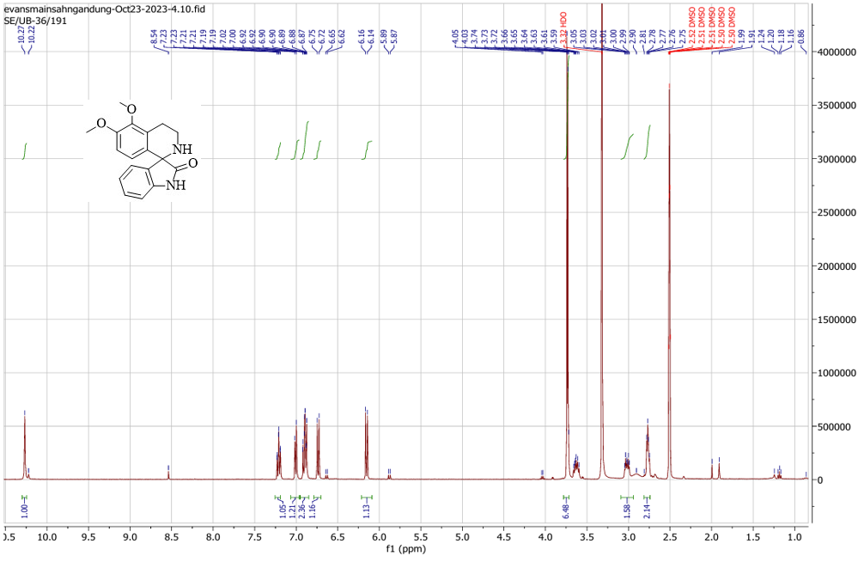
Figure S25: ¹H NMR of 5',6'-dimethoxy-3',4'-dihydro-2'H-spiro[indoline-3,1'-isoquinolin]-2-one (7a)

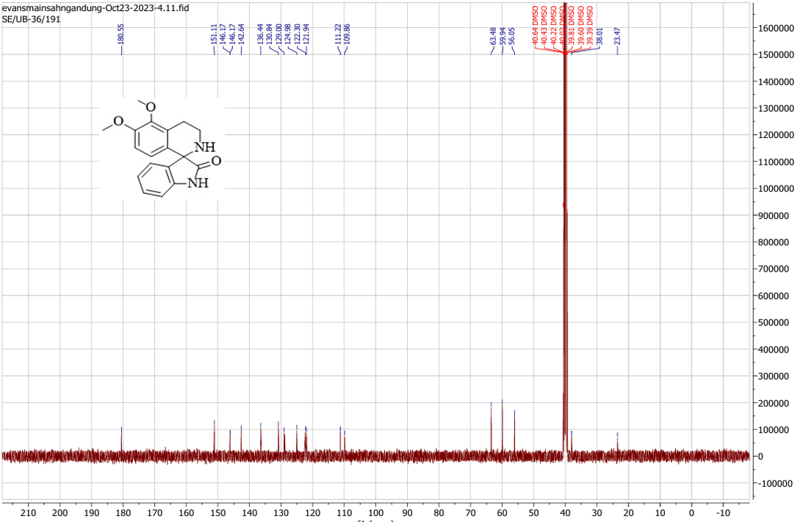
Figure S26: ¹³C NMR of 5',6'-dimethoxy-3',4'-dihydro-2'H-spiro[indoline-3,1'-isoquinolin]-2-one (7a)

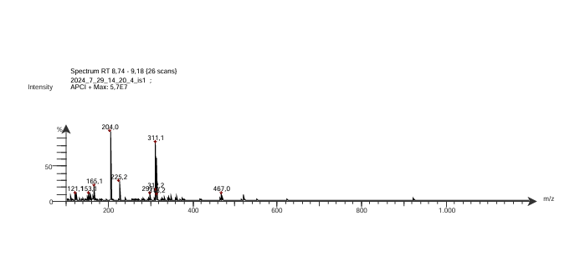
Figure S127: LC-MS spectra of 5',6'-dimethoxy-3',4'-dihydro-2'H-spiro[indoline-3,1'-isoquinolin]-2-one (7a)

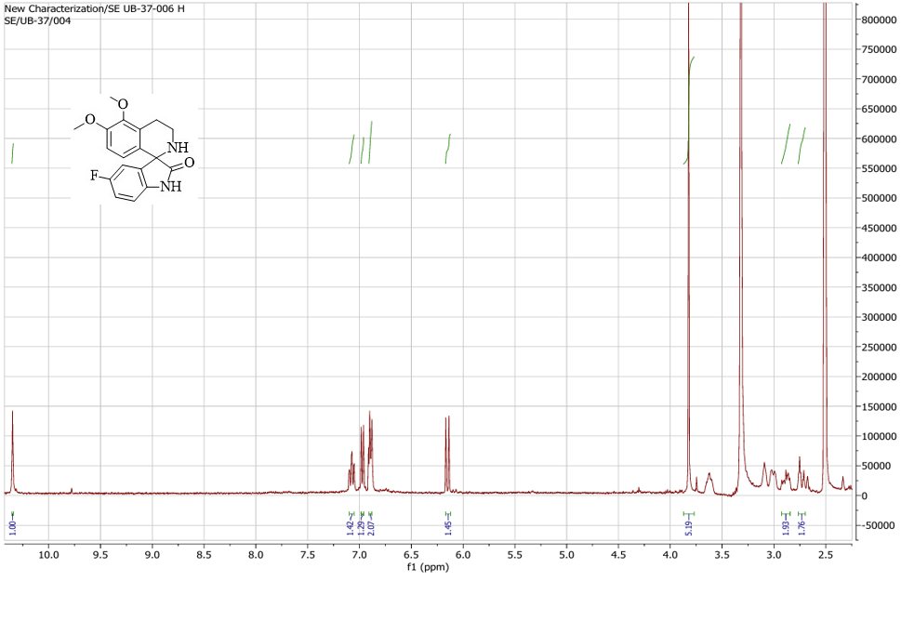
Figure S28: ¹H NMR of 5-fluoro-5',6'-dimethoxy-3',4'-dihydro-2'H-spiro[indoline-3,1'-isoquinolin]-2-one (7b)

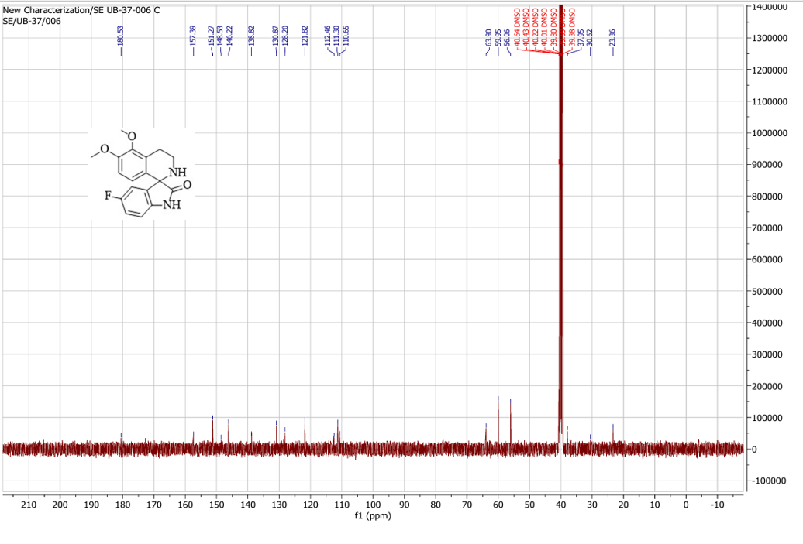
Figure S29: ¹³C NMR of 5-fluoro-5',6'-dimethoxy-3',4'-dihydro-2'H-spiro[indoline-3,1'-isoquinolin]-2-one (7b)

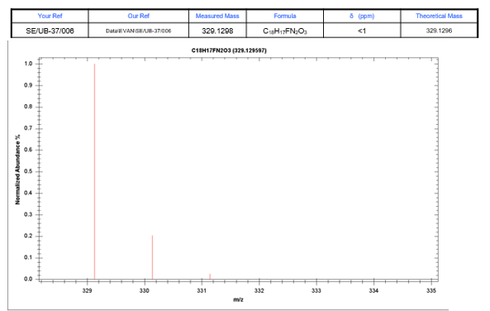

Figure S30: LC-MS spectra of 5-fluoro-5',6'-dimethoxy-3',4'-dihydro-2'H-spiro[indoline-3,1'-isoquinolin]-2-one (7b)

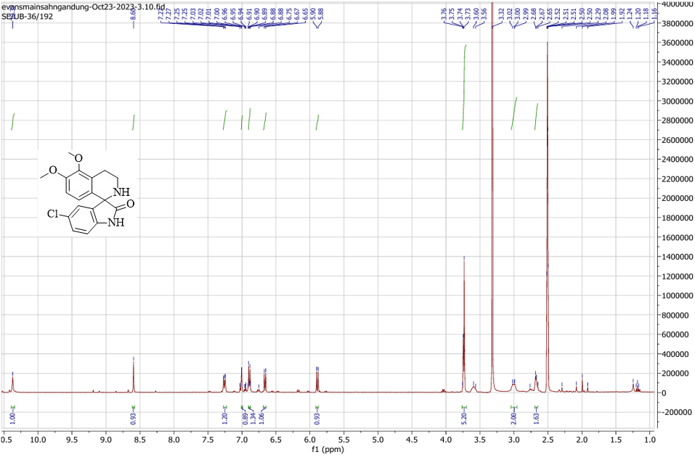

Figure S31: ¹H NMR of 5-chloro-5',6'-dimethoxy-3',4'-dihydro-2'H-spiro[indoline-3,1'-isoquinolin]-2-one (7c)
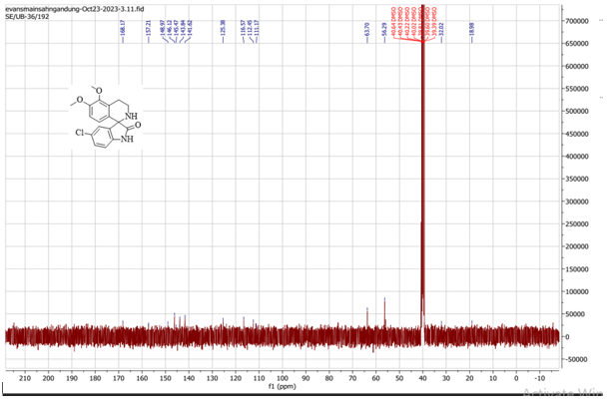
Figure S32: ¹³C NMR of 5-chloro-5',6'-dimethoxy-3',4'-dihydro-2'H-spiro[indoline-3,1'-isoquinolin]-2-one (7c)

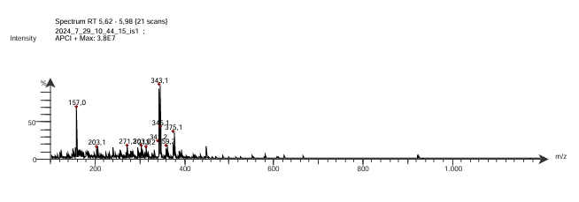
Figure S33: LC-MS spectra of 5-chloro-5',6'-dimethoxy-3',4'-dihydro-2'H-spiro[indoline-3,1'-isoquinolin]-2-one (7c)

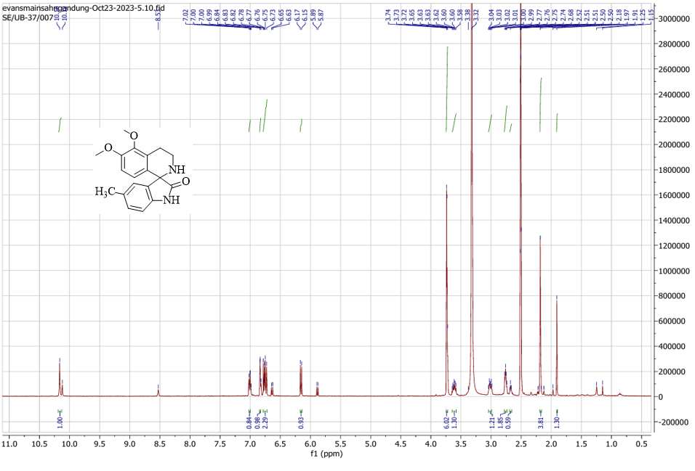

Figure S34: ¹H NMR of 5’,6’-dimethoxy-5-methyl-3’,4’-dihydro-2’H-spiro[indoline-3,1’-isoquinolin]-2-one (7d)

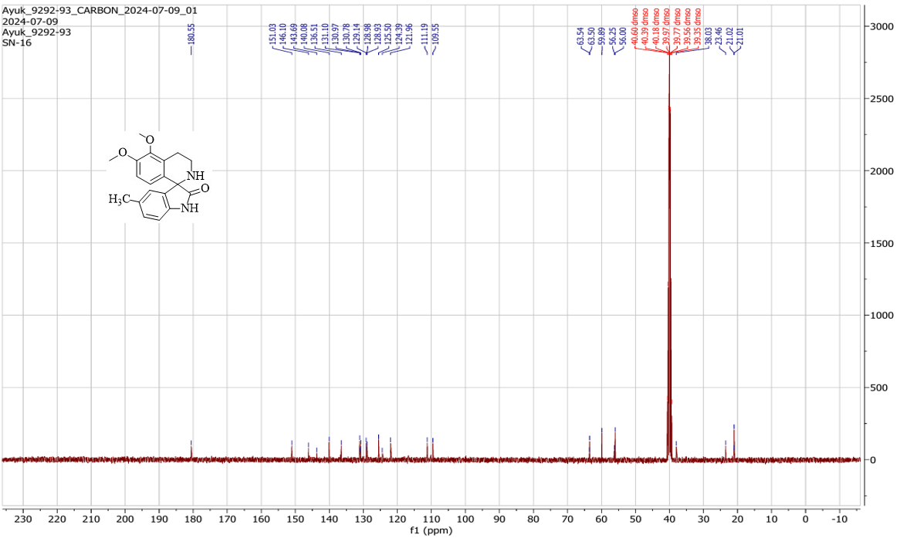
Figure S35: ¹³C NMR 5’,6’-dimethoxy-5-methyl-3’,4’-dihydro-2’H-spiro[indoline-3,1’-isoquinolin]-2-one (7d)

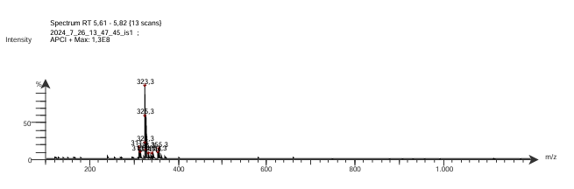

Figure S36: LC-MS spectra of 5’,6’-dimethoxy-5-methyl-3’,4’-dihydro-2’H-spiro[indoline-3,1’-isoquinolin]-2-one (7d)

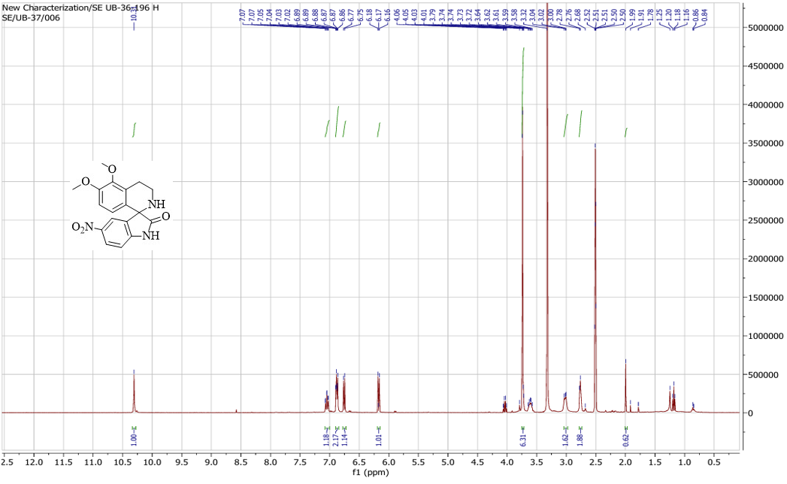
Figure S37: ¹H NMR of 5',6'-dimethoxy-5-nitro-3',4'-dihydro-2'H-spiro[indoline-3,1'-isoquinolin]-2-one (7e)

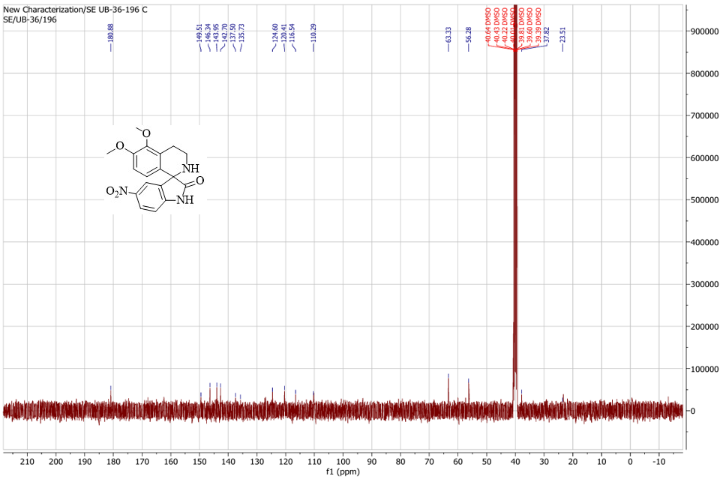
Figure S38: ¹³C NMR of 5',6'-dimethoxy-5-nitro-3',4'-dihydro-2'H-spiro[indoline-3,1'-isoquinolin]-2-one (7e)

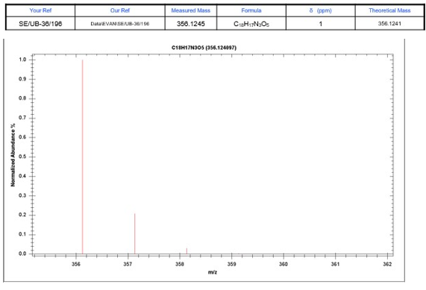
Figure S39: LC-MS spectra of 5',6'-dimethoxy-5-nitro-3',4'-dihydro-2'H-spiro[indoline-3,1'-isoquinolin]-2-one (7e)

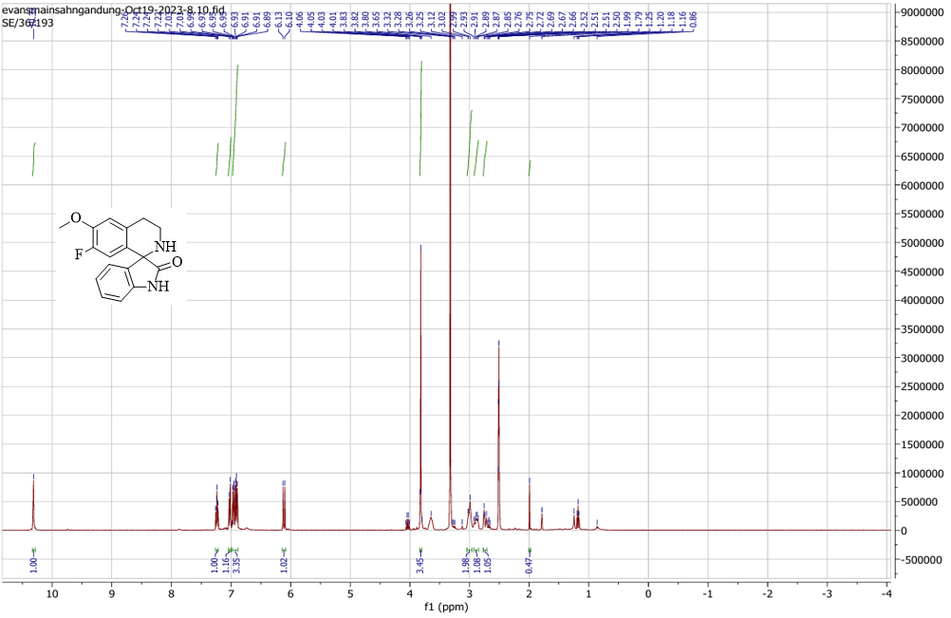
Figure S40: ¹H NMR of 7'-fluoro-6'-methoxy-3',4'-dihydro-2'H-spiro[indoline-3,1'-isoquinolin]-2-one (8a)

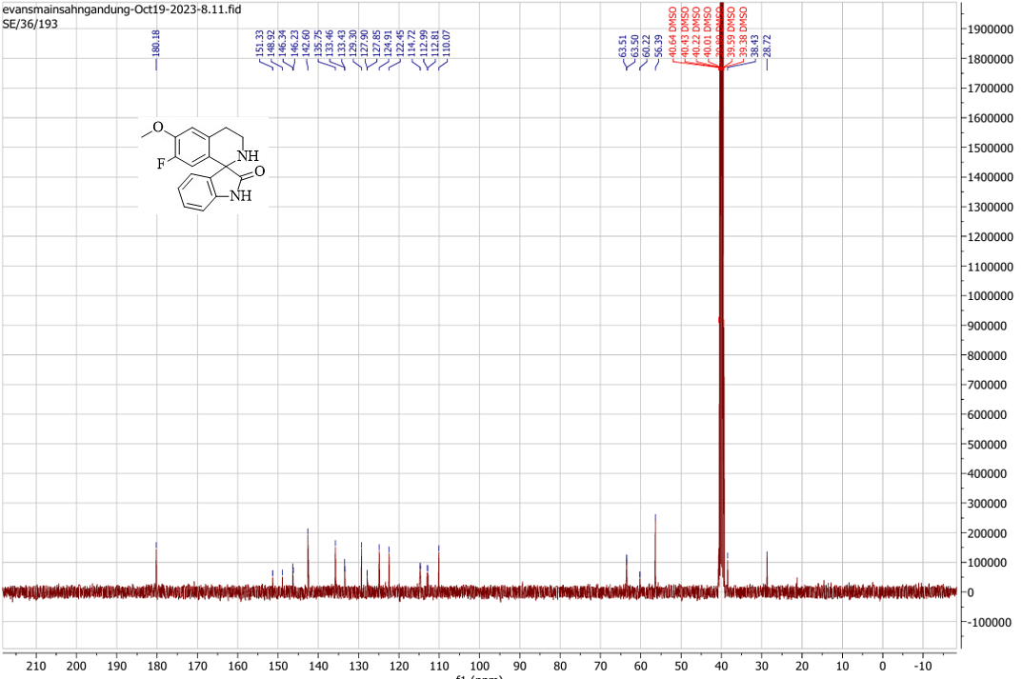

Figure S41: ¹³C NMR of 7'-fluoro-6'-methoxy-3',4'-dihydro-2'H-spiro[indoline-3,1'-isoquinolin]-2-one (8a)

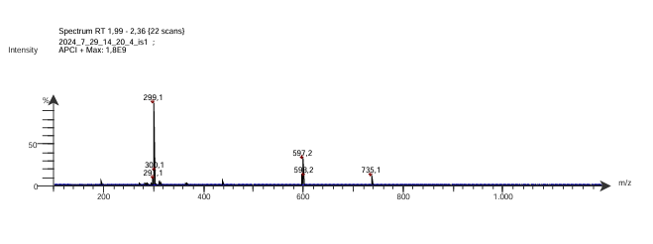
Figure S42: LC-MS spectra of 7'-fluoro-6'-methoxy-3',4'-dihydro-2'H-spiro[indoline-3,1'-isoquinolin]-2-one (8a)

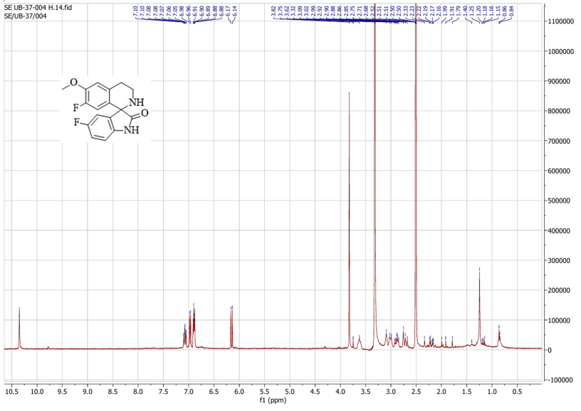

Figure S43: ¹H NMR of 5,7’-difluoro-6’-methoxy-3’,4’-dihydro-2’H-spiro[indoline-3,1’-isoquinolin]-2-one (8b)

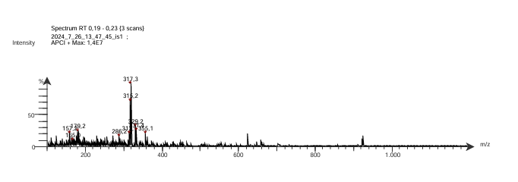

Figure S44: LC-MS spectra of 5,7’-difluoro-6’-methoxy-3’,4’-dihydro-2’H-spiro[indoline-3,1’-isoquinolin]-2-one (8b)

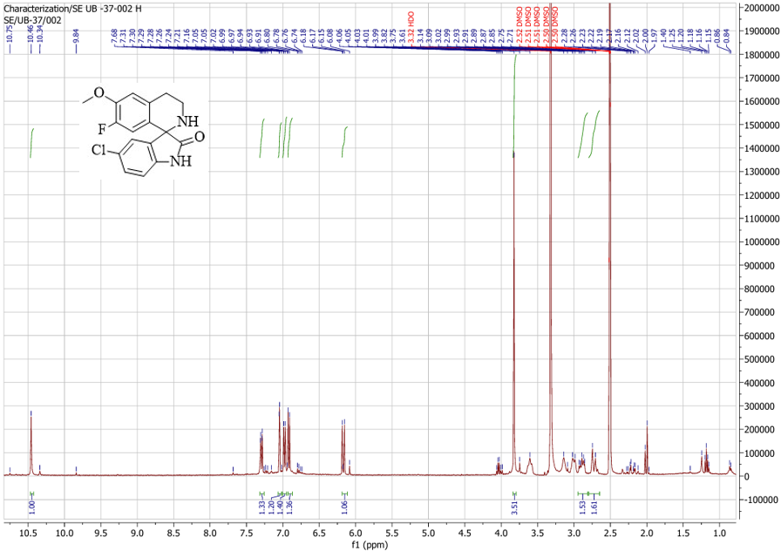

Figure S45: ¹H NMR of 5-chloro-7'-fluoro-6'-methoxy-3',4'-dihydro-2'H-spiro[indoline-3,1'-isoquinolin]-2-one (8c)

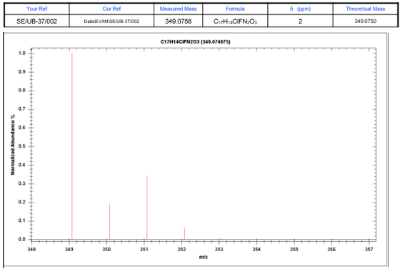
Figure S46: LC-MS spectra of 5-chloro-7'-fluoro-6'-methoxy-3',4'-dihydro-2'H-spiro[indoline-3,1'-isoquinolin]-2-one (8c)

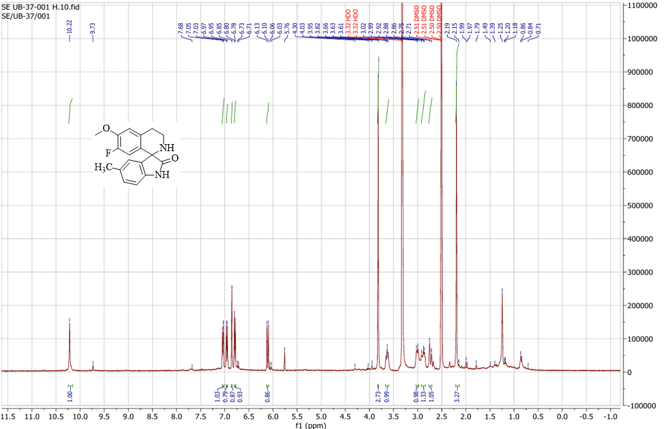
Figure S47: ¹H NMR of 7’-fluoro-6’-methoxy-5-methyl-3’,4’-dihydro-2’H-spiro[indoline-3,1’-isoquinolin]-2-one (8d)

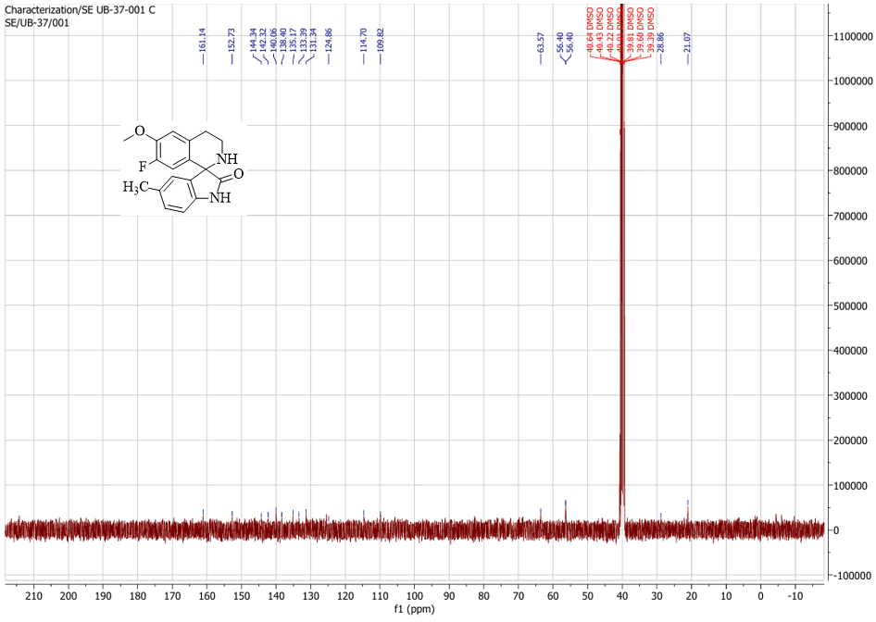

Figure S48: ¹³C NMR of 7’-fluoro-6’-methoxy-5-methyl-3’,4’-dihydro-2’H-spiro[indoline-3,1’-isoquinolin]-2-one (8d)

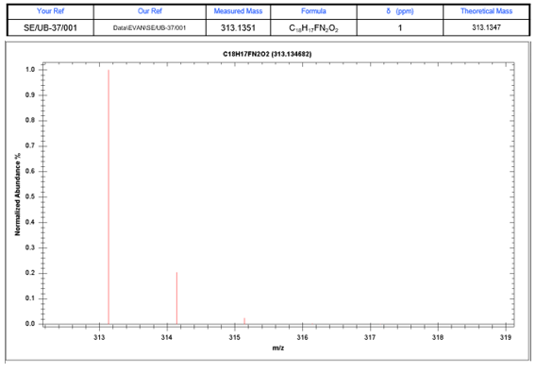

Figure S49: LC-MS spectra of 7’-fluoro-6’-methoxy-5-methyl-3’,4’-dihydro-2’H-spiro[indoline-3,1’-isoquinolin]-2-one (8d)

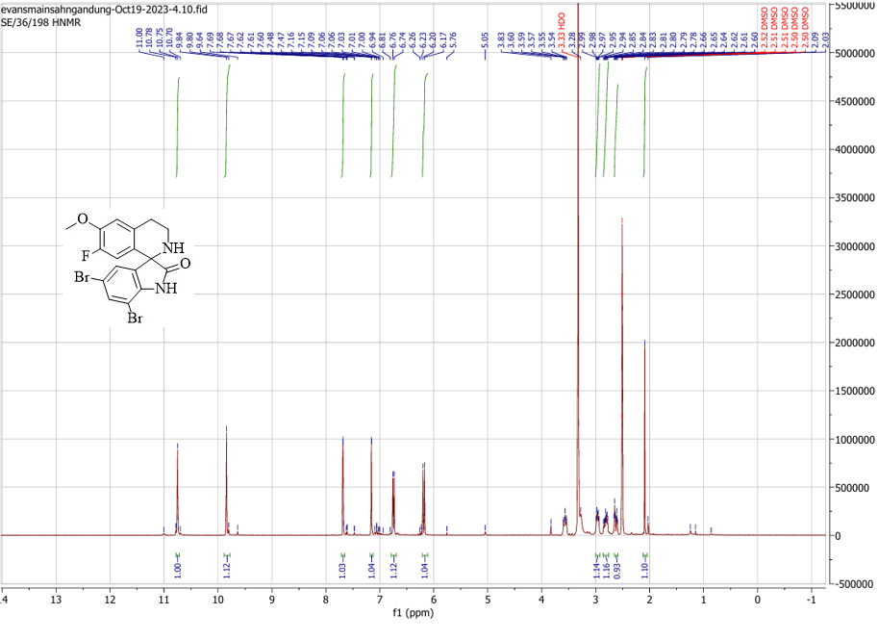
Figure S50: ¹H NMR of 5,7-dibromo-7’-fluoro-6’-methoxy-3’,4’-dihydro-2’H-spiro[indoline-3,1’-isoquinolin]-2-one (8e)

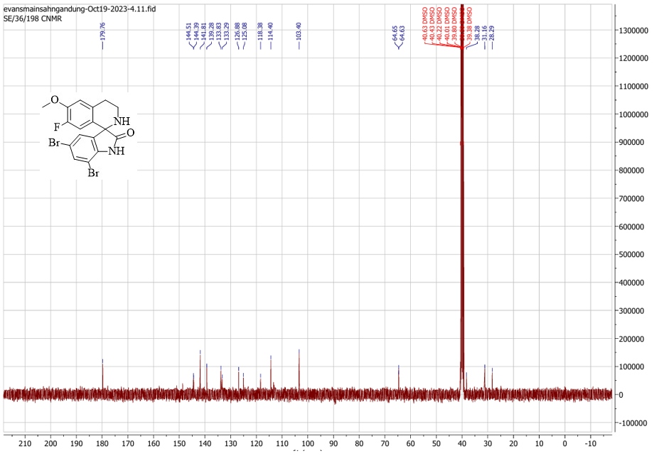
Figure S51: ¹³C NMR of 5,7-dibromo-7’-fluoro-6’-methoxy-3’,4’-dihydro-2’H-spiro[indoline-3,1’-isoquinolin]-2-one (8e)
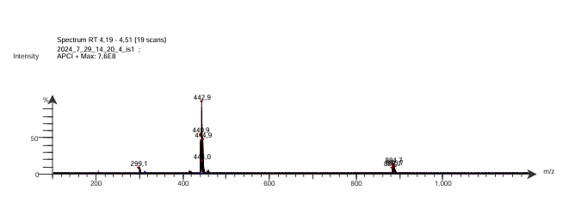

Figure S52: LC-MS spectra of 5,7-dibromo-7’-fluoro-6’-methoxy-3’,4’-dihydro-2’H-spiro[indoline-3,1’-isoquinolin]-2-one (8e)

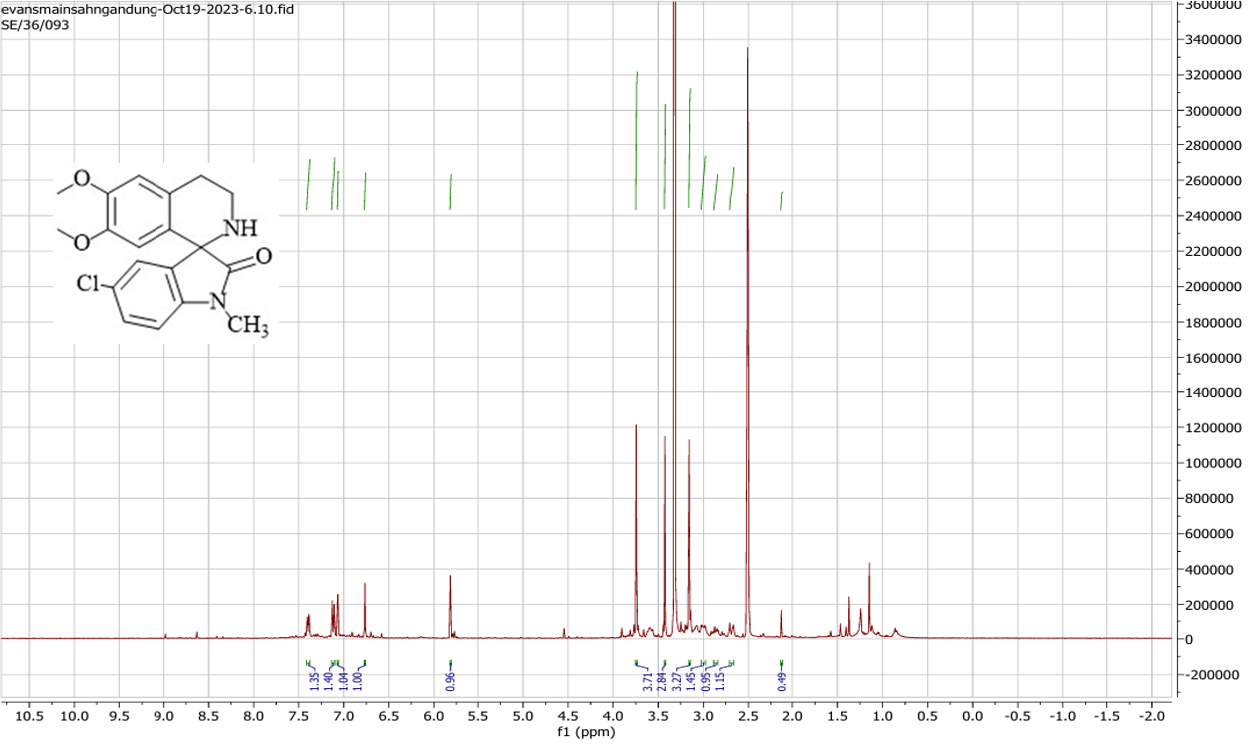

Figure S53: ¹H NMR of 5-chloro-6’,7’-dimethoxy-1-methyl-3’,4’-dihydro-2’H-spiro[indoline-3,1’-isoquinolin]-2-one (9a)

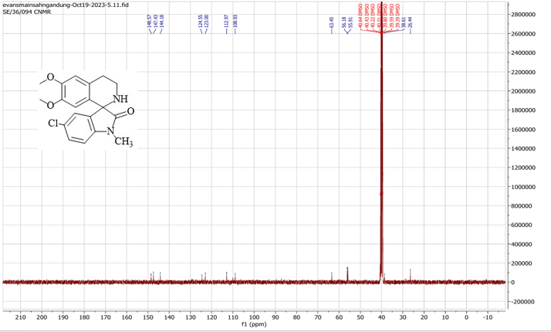
Figure S54: ¹³C NMR of 5-chloro-6’,7’-dimethoxy-1-methyl-3’,4’-dihydro-2’H-spiro[indoline-3,1’-isoquinolin]-2-one (9a)

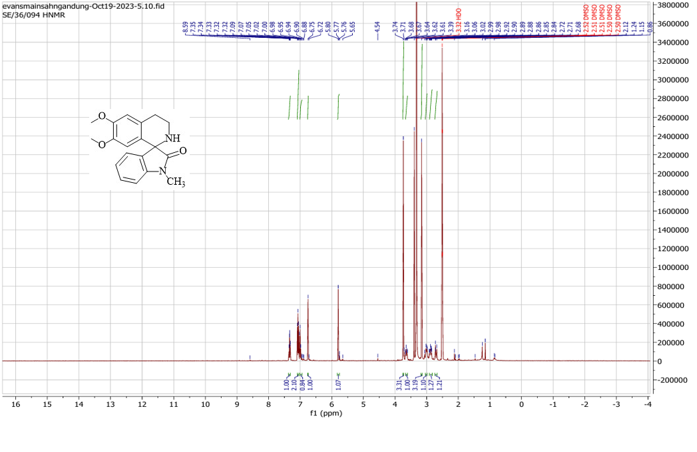
Figure S55: ¹H NMR of 6’,7’-dimethoxy-1-methyl-3'’,4’-dihydro-2’H-spiro[indoline-3,1’-isoquinolin]-2-one (9a)

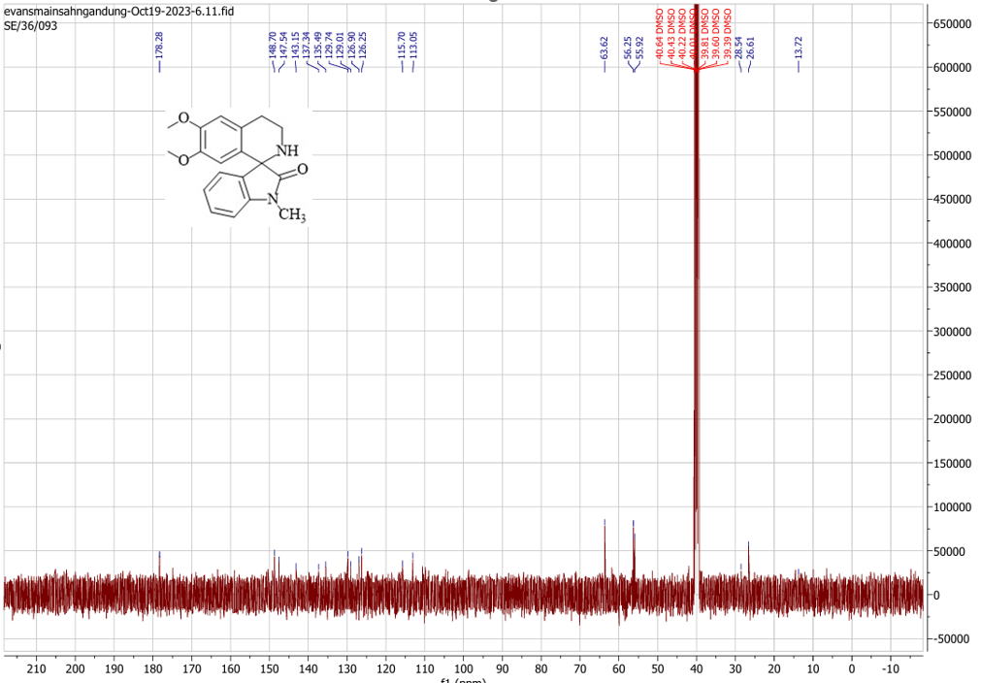
Figure S56: ¹³C NMR of 6’,7’-dimethoxy-1-methyl-3'’,4’-dihydro-2’H-spiro[indoline-3,1’-isoquinolin]-2-one(9a)

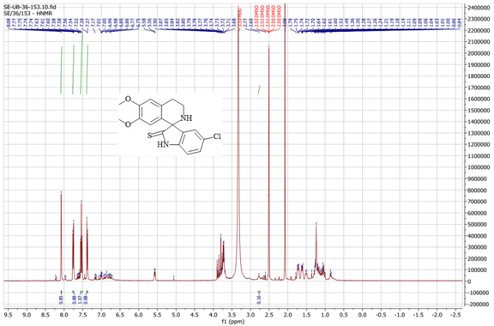

Figure S57: ¹H NMR of 5-chloro-6’,7’-dimethoxy-3’,4’-dihydro-2’H-spiro[indoline-3,1’-isoquinoline]-2-thione (10)

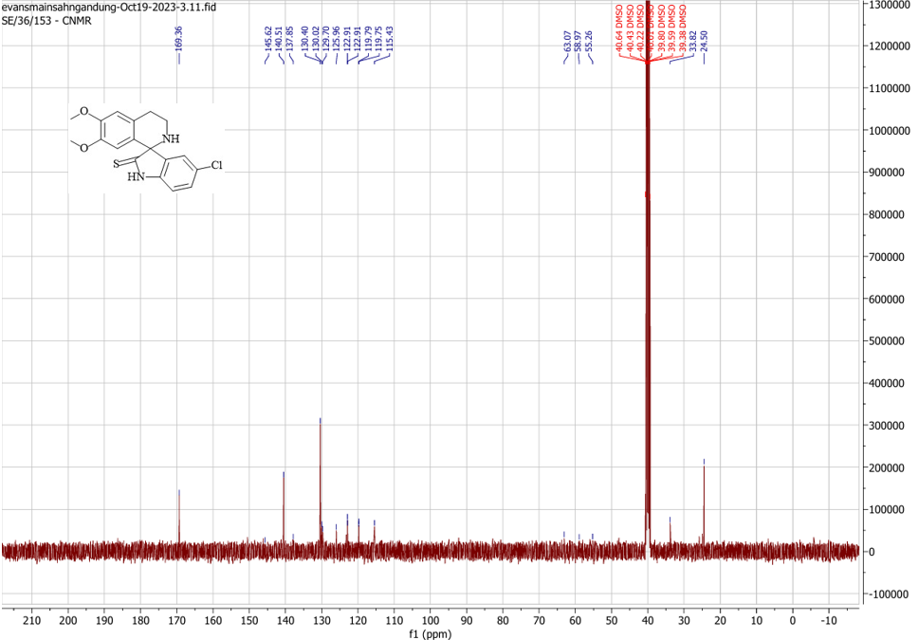
Figure S58: ¹³C NMR of 5-chloro-6’,7’-dimethoxy-3’,4’-dihydro-2’H-spiro[indoline-3,1’-isoquinoline]-2-thione (10)

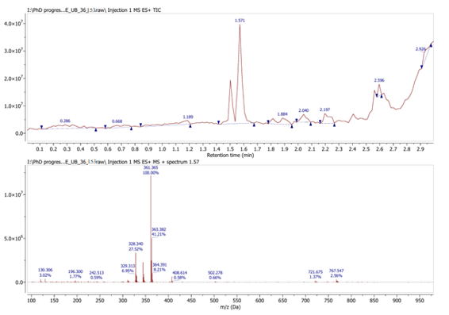
Figure S59: LC-MS spectra of 5-chloro-6’,7’-dimethoxy-3’,4’-dihydro-2’H-spiro[indoline-3,1’-isoquinoline]-2-thione (10)

