Extended Data, Figures and Supporting Information

Table 1: Low ratio and high ratio SAF output for each conversion pathway.
Conversion pathway | Low ratio | High ratio | Source
HEFA | 0.14 | 0.80 | [1-3]
Co-processing | 0.1 | 0.1 | [4]
Alcohol-to-Jet | 0.5 | 0.9 | [1, 5-7]
Fischer-Tropsch | 0.4 | 0.73 | [1, 8]
Power-to-Liquid | 0.2 | 0.73 | [1, 8]
Catalytic Hydrothermolysis (CH) | 0.32 | 0.48 | [9, 10]
Pyrolysis | 0.25 | 0.52 | [1, 11]

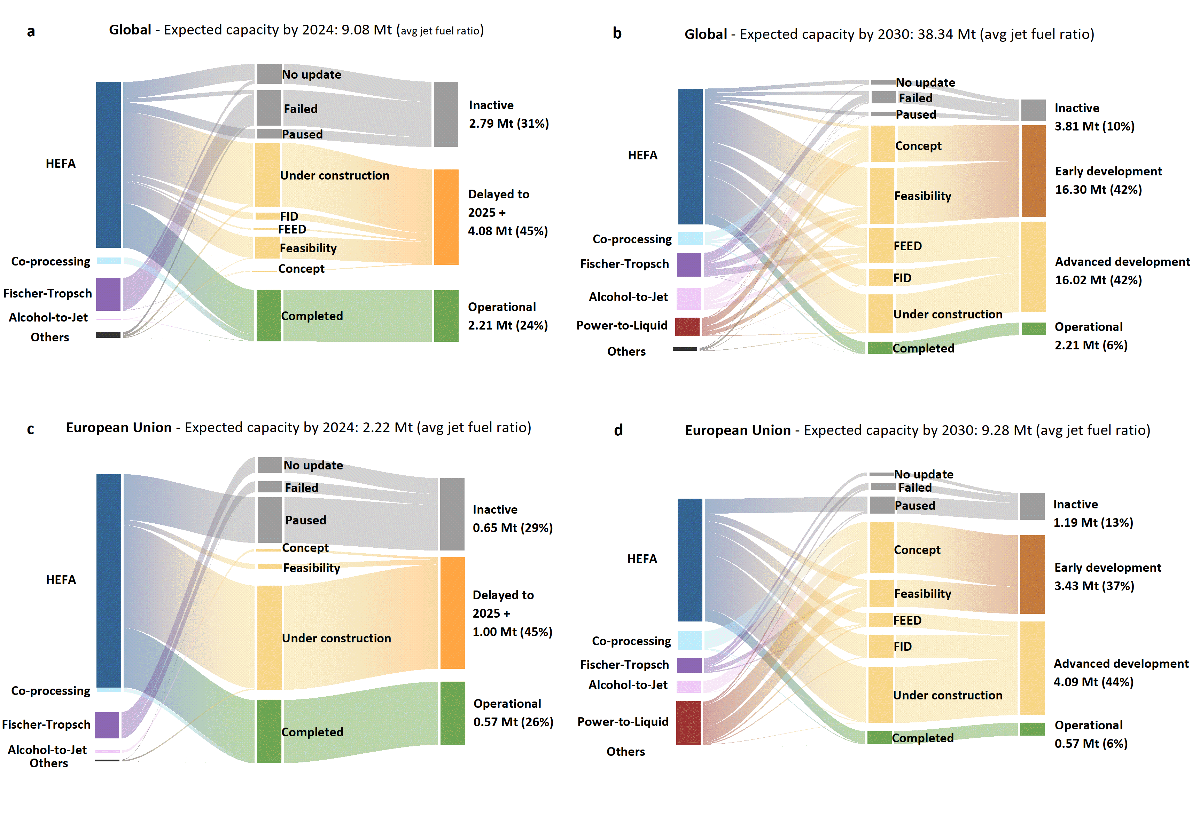
SAF production involves co-products as part of the facility’s output (e.g., renewable diesel, naphtha, etc.) and, the announcements provided vary in detail on specific products’ volumes. While some announcements explicitly specify each product's output volumes, including SAF capacity volumes; many announcements only disclose the total fuel output, including both SAF and co-products. For these announcements, the total fuel output (SAF and co-products) is adjusted using a range of possible SAF ratios to estimate the SAF production capacity. This range includes a minimum and maximum SAF ratio determined based on the conversion pathways. Table 1 provides the low and high SAF ratios assumed in this work. Adjusting the capacity by using the low and high ratio define a range of SAF capacity values, that is employed in this analysis.
Figure 1: Expected capacity to be operational by 2024 and by 2030 globally (panel a and b) and in the EU (panel c and d), categorized by current status. All values are derived using the average jet fuel ratio. FID: Final Investment Decision; FEED: Front-End Engineering Development.
Figure 1 provide insights into the status of announced SAF capacity (for 2024 and 2030 globally and in the EU) by conversion technology, highlighting three key points. First, inactive capacity (i.e., failed, paused, or no update) exceeds completed capacity. Specifically, at global level, 31% (2.79 Mt/year) of the 9.08 Mt announced capacity to be operational by 2024, has failed or been paused, compared to 2.21 Mt (24%) of completed capacity. Inactive capacity increases to 3.81 Mt when considering the expected capacity by 2030, indicating that some projects planned for operation in the following years have already been canceled or halted. Similarly, in the EU, the inactive capacity accounts for 29% whereas the completed capacity is 26% of the total expected by 2024 and 13% of the announced capacity by 2030 has already failed or been paused. Second, delays dominate the expected capacity. Globally, by 2024, 4.08 Mt (45%) of the expected capacity is under construction, backed by FID, in the FEED or early feasibility stage, meaning the completion of these projects has been delayed to 2025 or beyond. Combined with inactive capacity, 76% of the announced SAF capacity for 2024 was not realized on time. Of the delayed capacity, 3.1 Mt is in the advanced development stage (i.e., under construction, FID, or FEED), while the rest remains in the early development stages. In the EU, the delayed capacity also accounts for 45% and, 74% of the total expected capacity has not been realized according to announced plans. Third, similar trends persist by 2030. Only 6% of the announced capacity has been realized both at global and the EU level. A higher share of projects (10% and 13%) has already failed or been paused. Globally, 84% of the announced capacity remains under development, half of which is in the early stages. The capacity still under development is 81% in the EU, with approximately 37% still being in early development stages. Globally, only 9.9 Mt of announced capacity to be realized by 2030 is backed by a final investment decision as of the end of 2024. Therefore, the significant fraction of SAF capacity projects still in the early development stages along with eventual delays in projects that are currently at an advanced stage indicate a high likelihood that the realization gap will grow in the coming years.

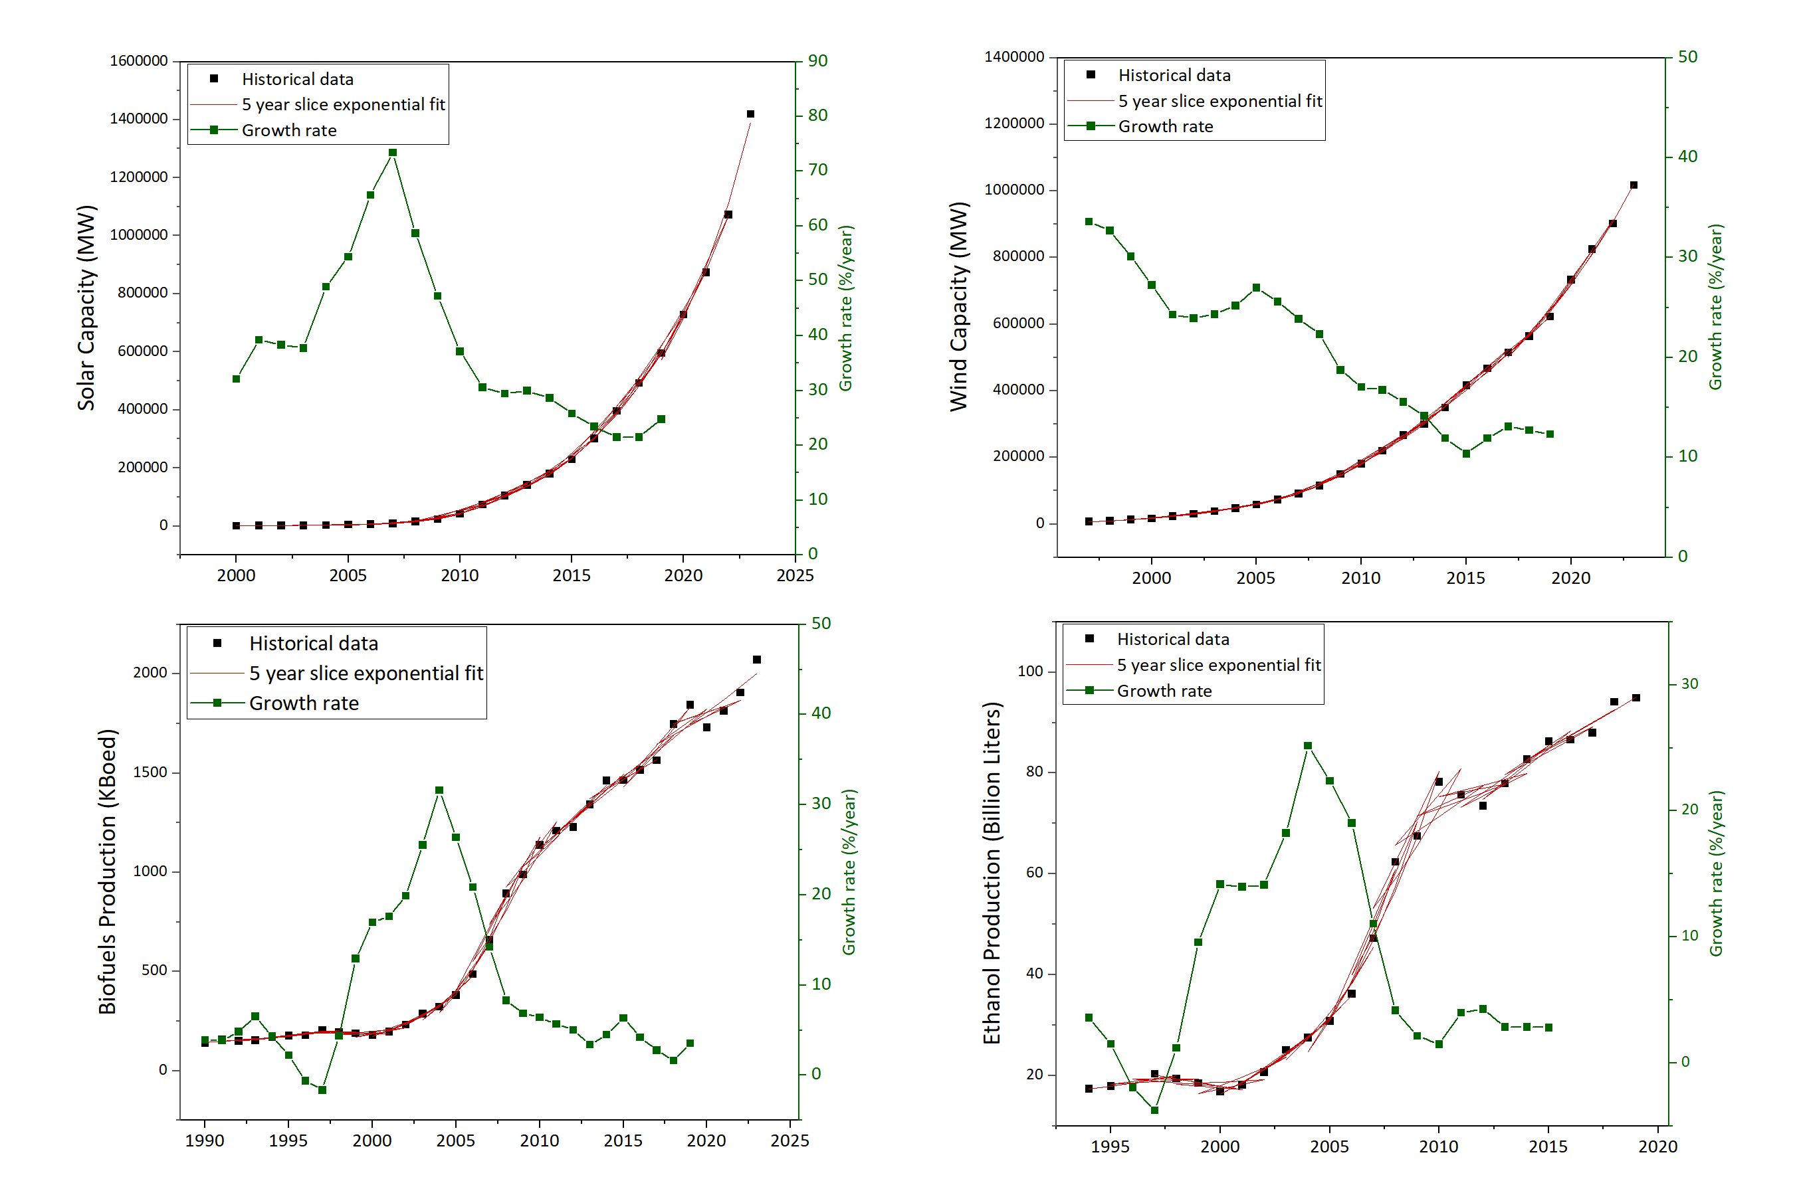
Figure 2: Global historical data and exponential fit of solar and wind energy capacity, biofuels and ethanol production (Left Y axis). Computed growth rates are shown in green (Right Y axis). The emergence growth rates in the following years were selected for the stochastic diffusion model. Solar: 2000 – 2009; Wind: 1997 – 2006; Biofuels: 1999 – 2007; Ethanol: 1999 – 2007.
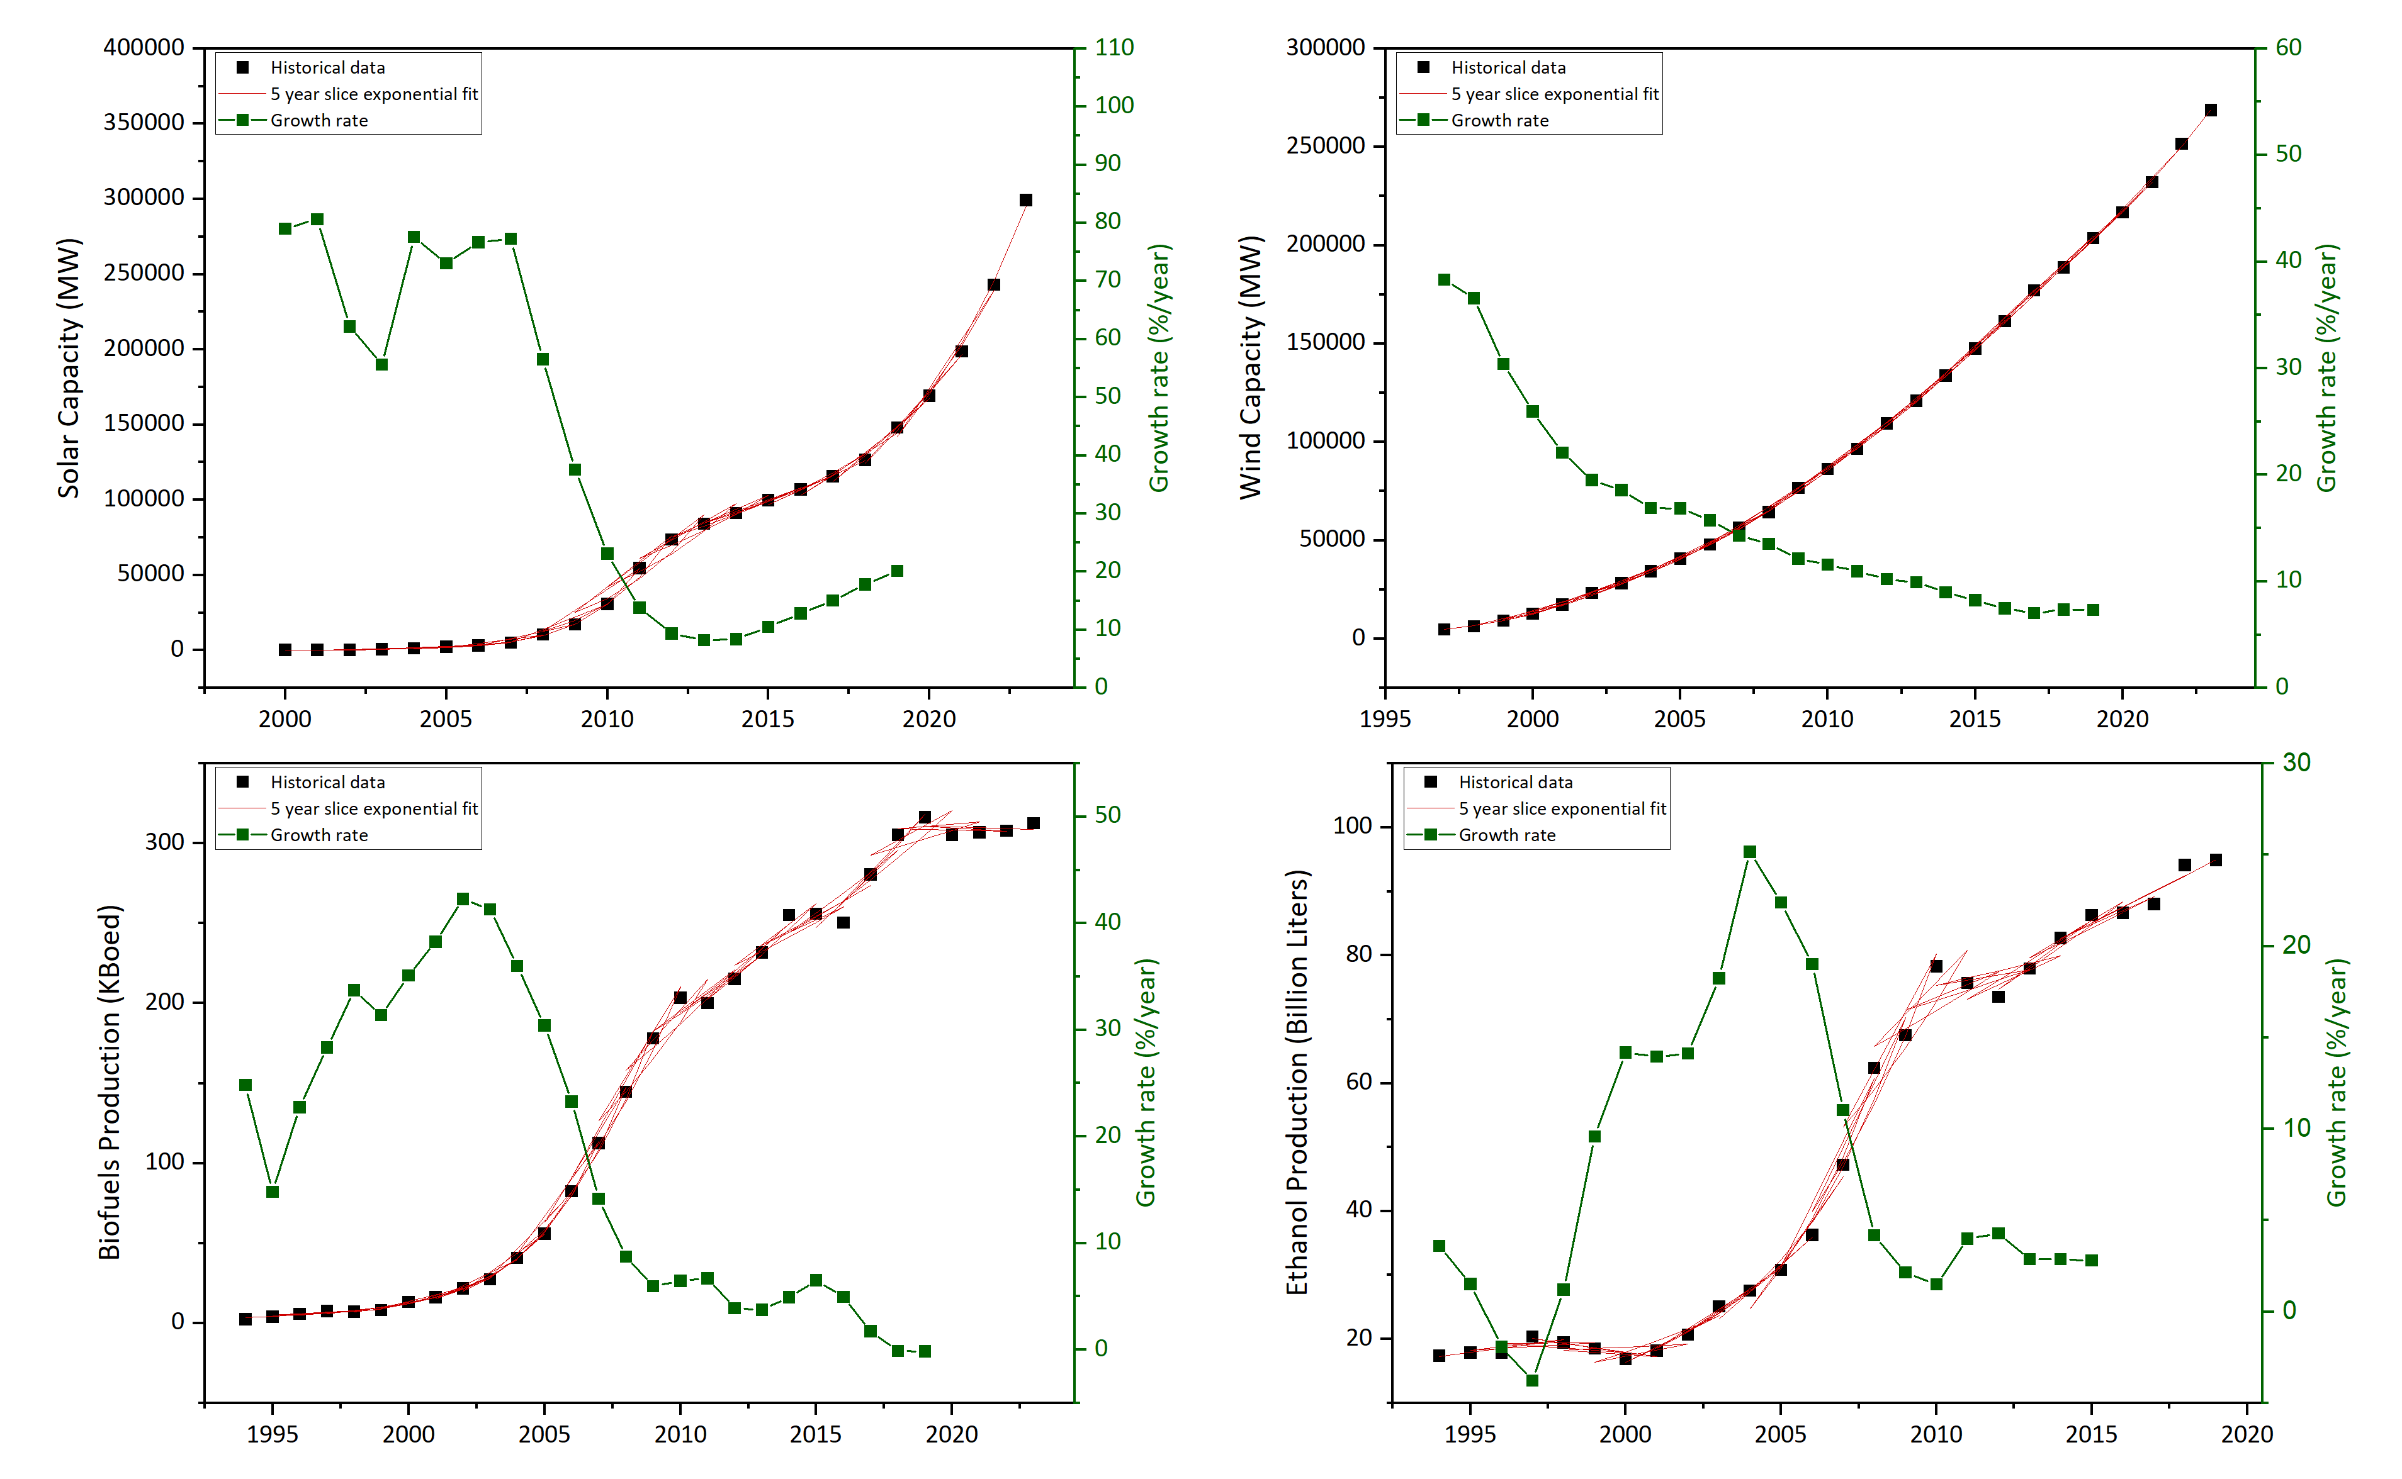
Figure 3: EU historical data and exponential fit of solar and wind energy capacity, biofuels production and ethanol refining capacity (Left Y axis). For the ethanol production, the global data and growth rates also also employed for the EU case. Computed growth rates are shown in green (Right Y axis). The emergence growth rates in the following years were selected for the stochastic diffusion model. Solar: 2000 – 2009; Wind: 1997 – 2006; Biofuels: 1996 – 2005; Ethanol production: 1999 – 2007.
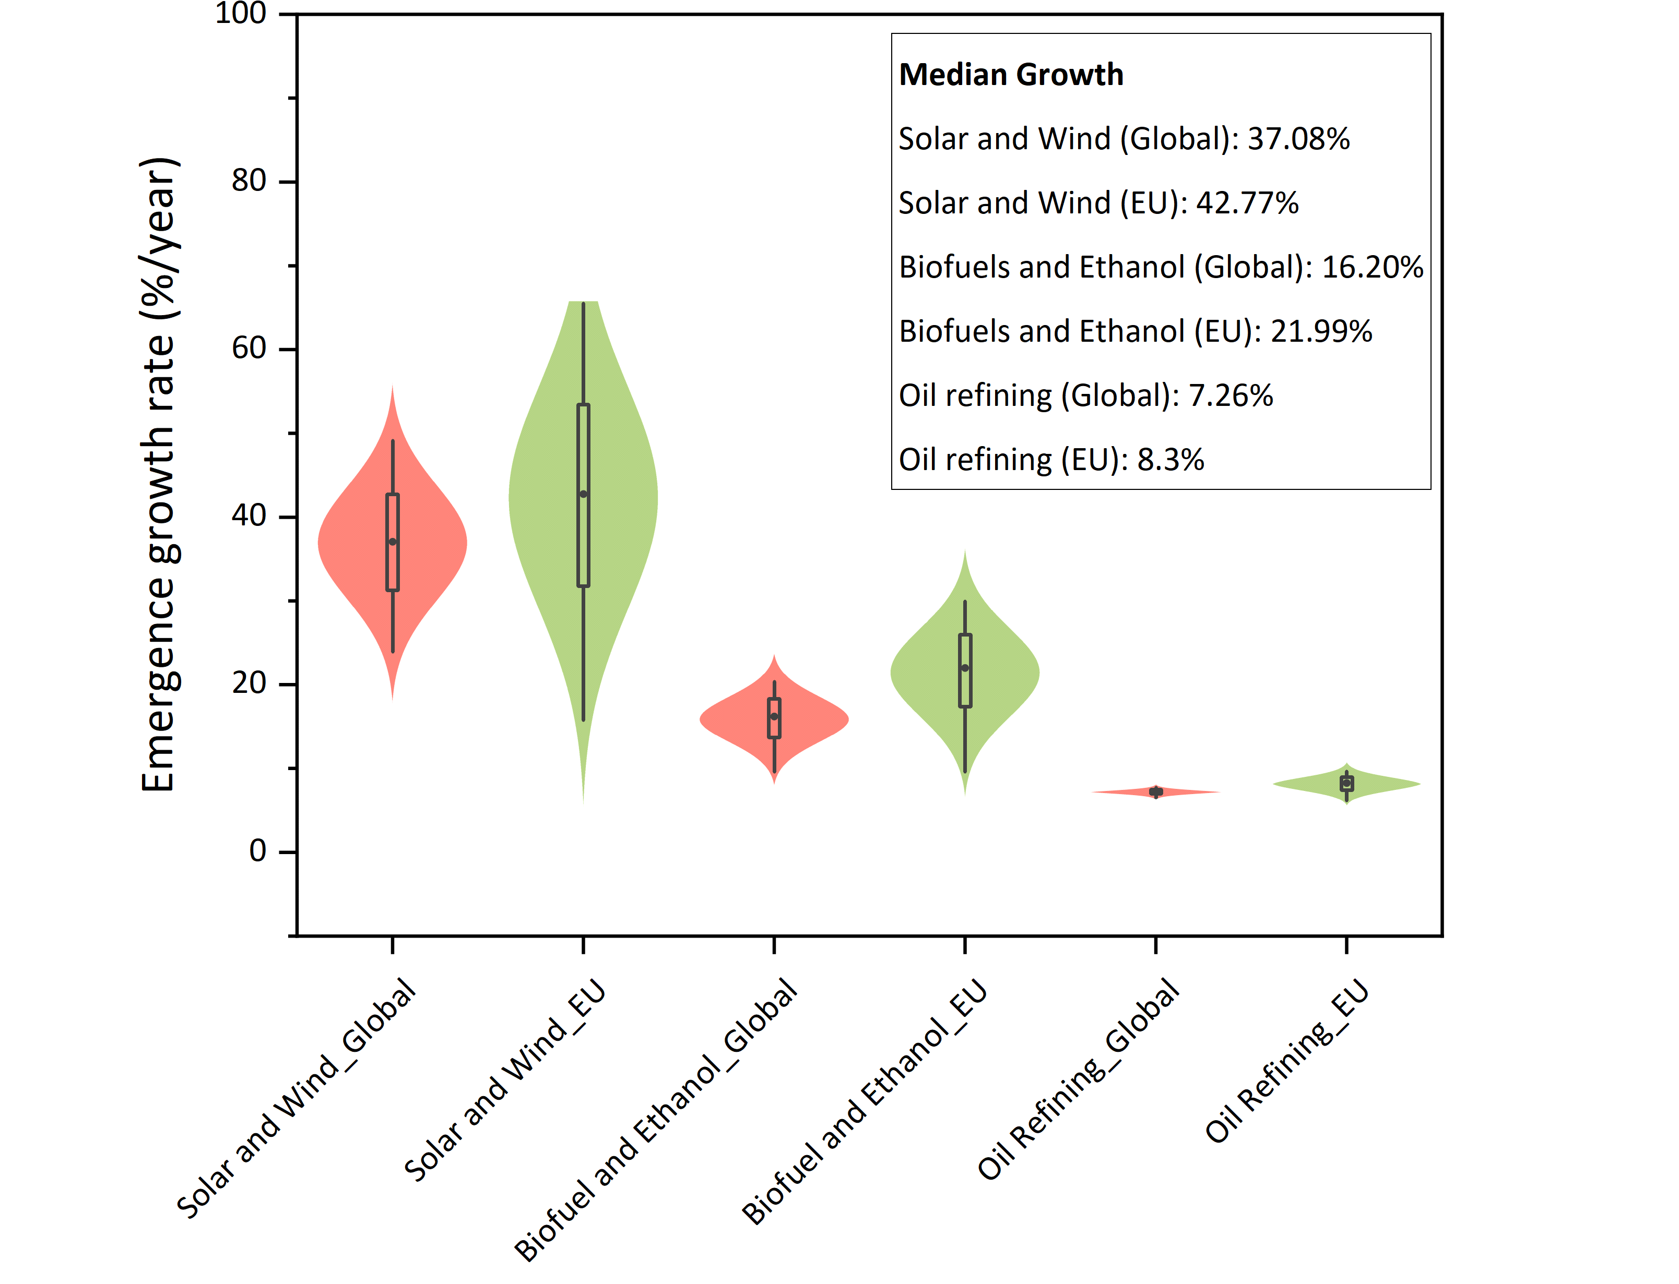
Figure 4: Emergence growth rate distributions computed using solar and wind, biofuels and ethanol, and oil refining historical growth rates, globally and in the EU.
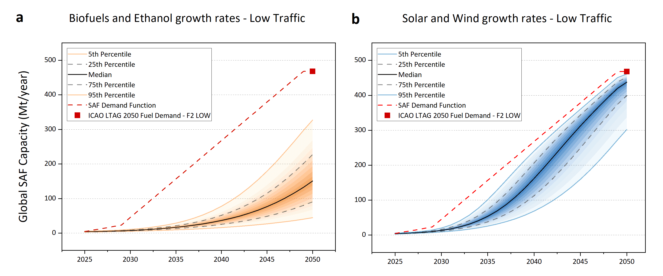
Figure 5: Global SAF capacity potential scale-up out to 2050 computed with biofuels and ethanol growth rates (panel a) and solar and wind growth rates (panel b), in the case of low aviation traffic (low demand). The corresponding 2050 ICAO target is defined by the F2 - LOW scenario. With solar and wind growth rates, the median capacity in 2050 is 438 Mt/year (IQR of 399 – 452 Mt/year), which is 6.4% lower than the policy target (468 Mt/year).

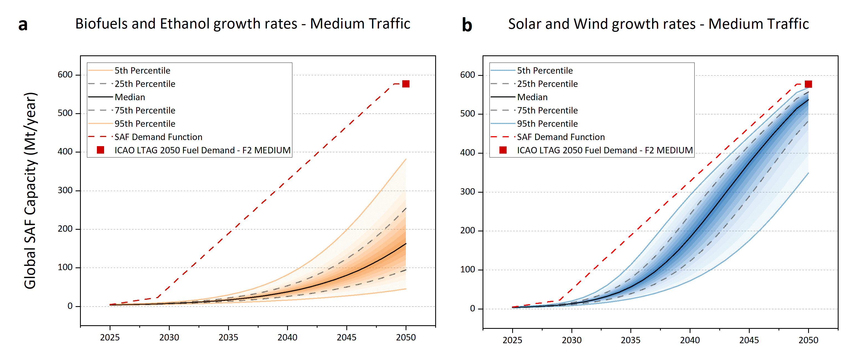
Figure 6: Global SAF capacity potential scale-up out to 2050 computed with biofuels and ethanol growth rates (panel a) and solar and wind growth rates (panel b), in the case of medium aviation traffic (medium demand). The corresponding 2050 ICAO target is defined by the F2 – MEDIUM scenario. With solar and wind growth rates, the median capacity in 2050 is 537 Mt/year (IQR of 500 – 557 Mt/year), which is 6.8% lower than the policy target (577 Mt/year).
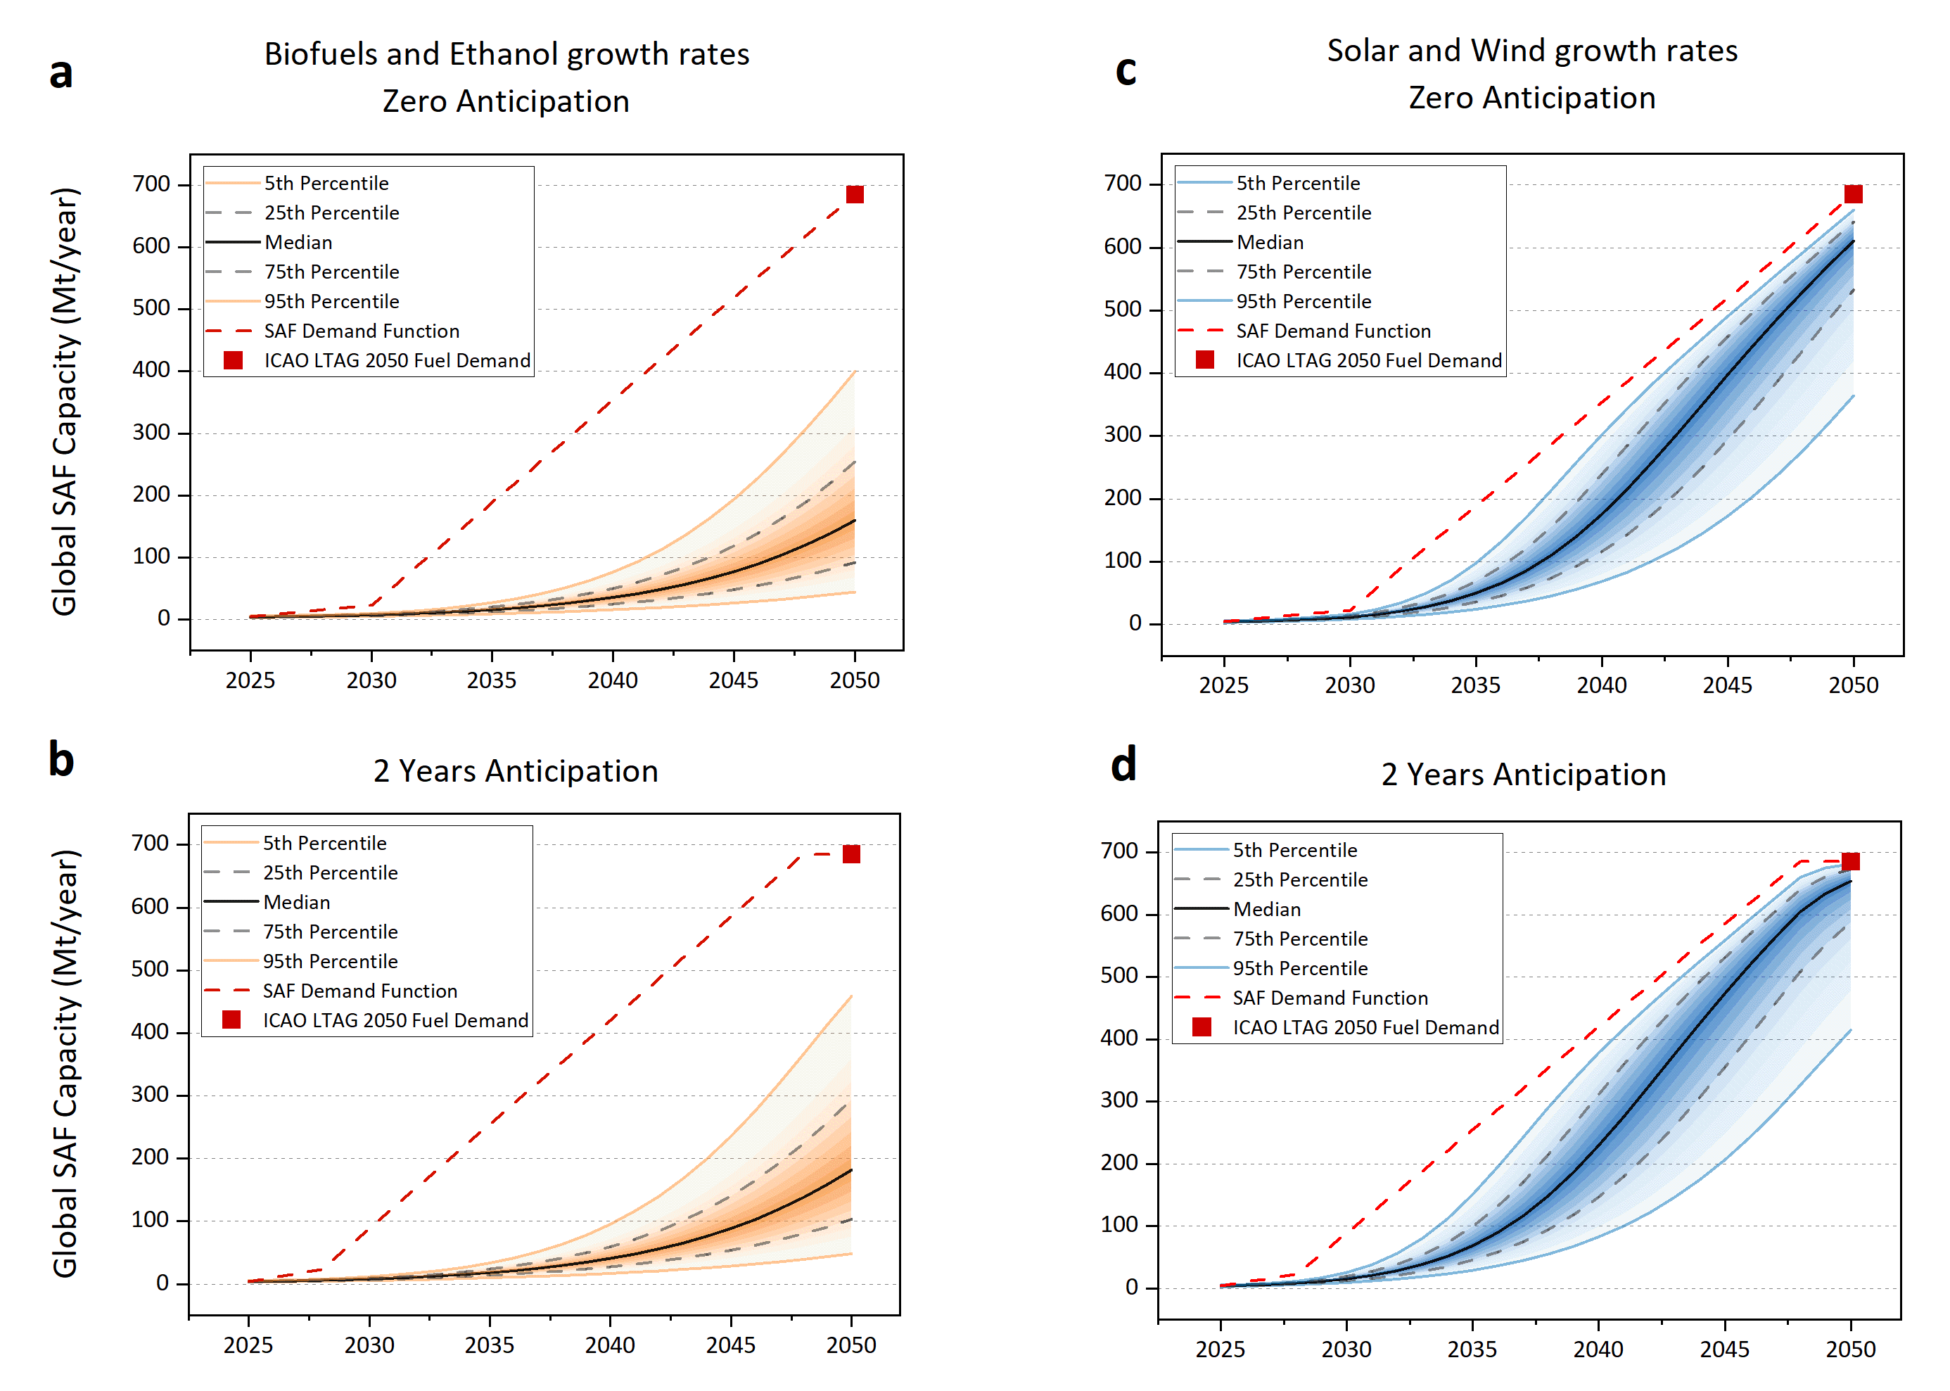
Figure 7: Global SAF capacity potential scale-up out to 2050 computed with biofuels and ethanol growth rates (panel a and b) and solar and wind growth rates (panel c and d). Each figure row represent the potential scale-up computed considering zero (panel a and c) and two years (panel b and d) demand anticipation to reach the SAF policy target in 2030 and 2050. In 2050, with solar and wind growth rates and 2 years demand anticipation, the median SAF capacity is 653 Mt/year (IQR of 588-673 Mt/year), which is 4.7% below the target (685 Mt/year). The 95th percentile approaches the target and it equals to 681 Mt/year.

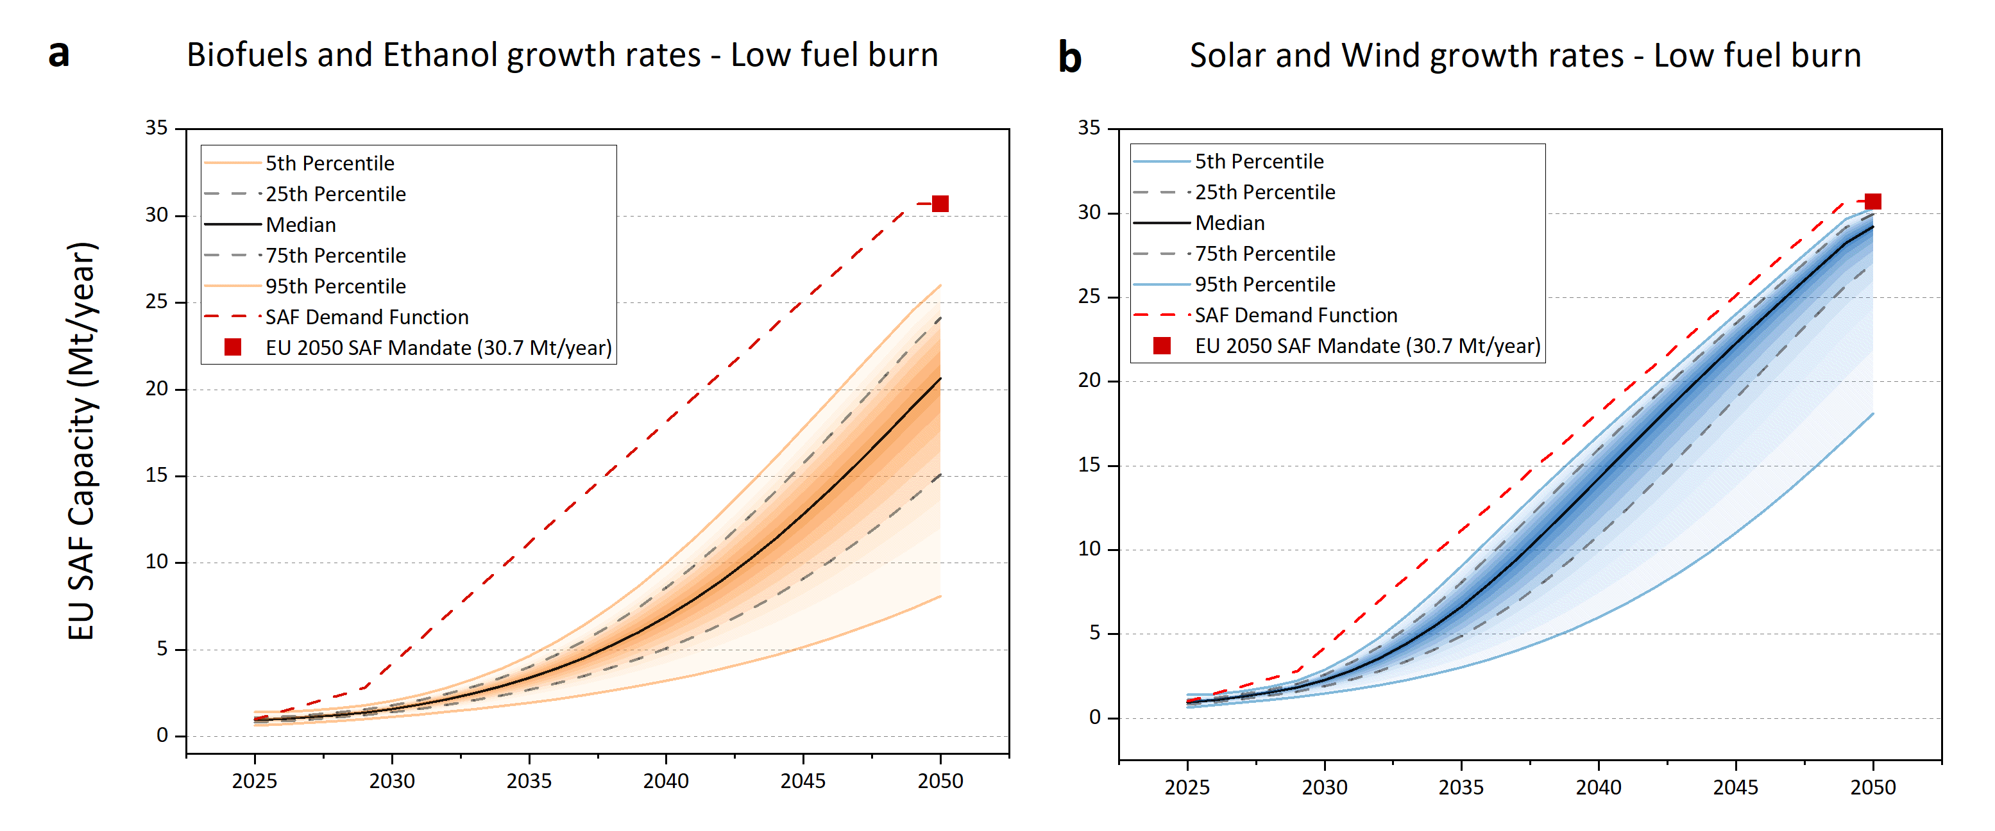
Figure 8: EU SAF capacity potential scale-up out to 2050 computed with biofuels and ethanol growth rates (panel a) and solar and wind growth rates (panel b), in the case of low aviation fuel burn, as defined in [12]. More details on EU 2050 SAF Mandate target in Methods. With solar and wind growth rates, the median SAF capacity in 2030 equals to 2.3 Mt/year (IQR of 1.9 – 2.6 Mt/year). In 2050, the median SAF capacity is 29.2 Mt/year (IQR of 27.0-29.9 Mt/year) and 95th percentile is 30.3 Mt/year.
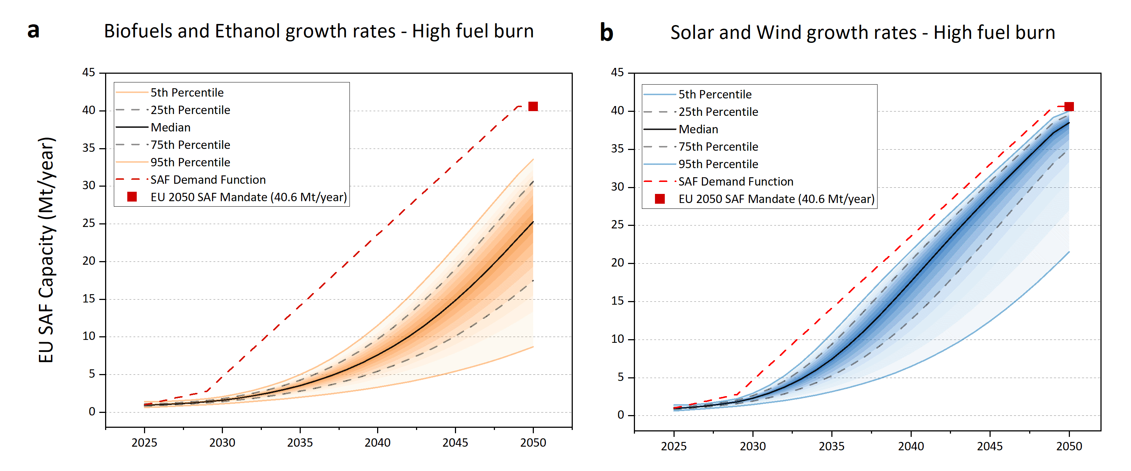
Figure 9: EU SAF capacity potential scale-up out to 2050 computed with biofuels and ethanol growth rates (panel a) and solar and wind growth rates (panel b), in the case of high aviation fuel burn, as defined in [12]. More details on EU 2050 SAF Mandate target in Methods. With solar and wind growth rates, the median SAF capacity in 2030 equals to 2.3 Mt/year (IQR of 1.9 – 2.6 Mt/year). In 2050, the median SAF capacity is 38.5 Mt/year (IQR of 35.1-39.6 Mt/year) and 95th percentile is 40.0 Mt/year.

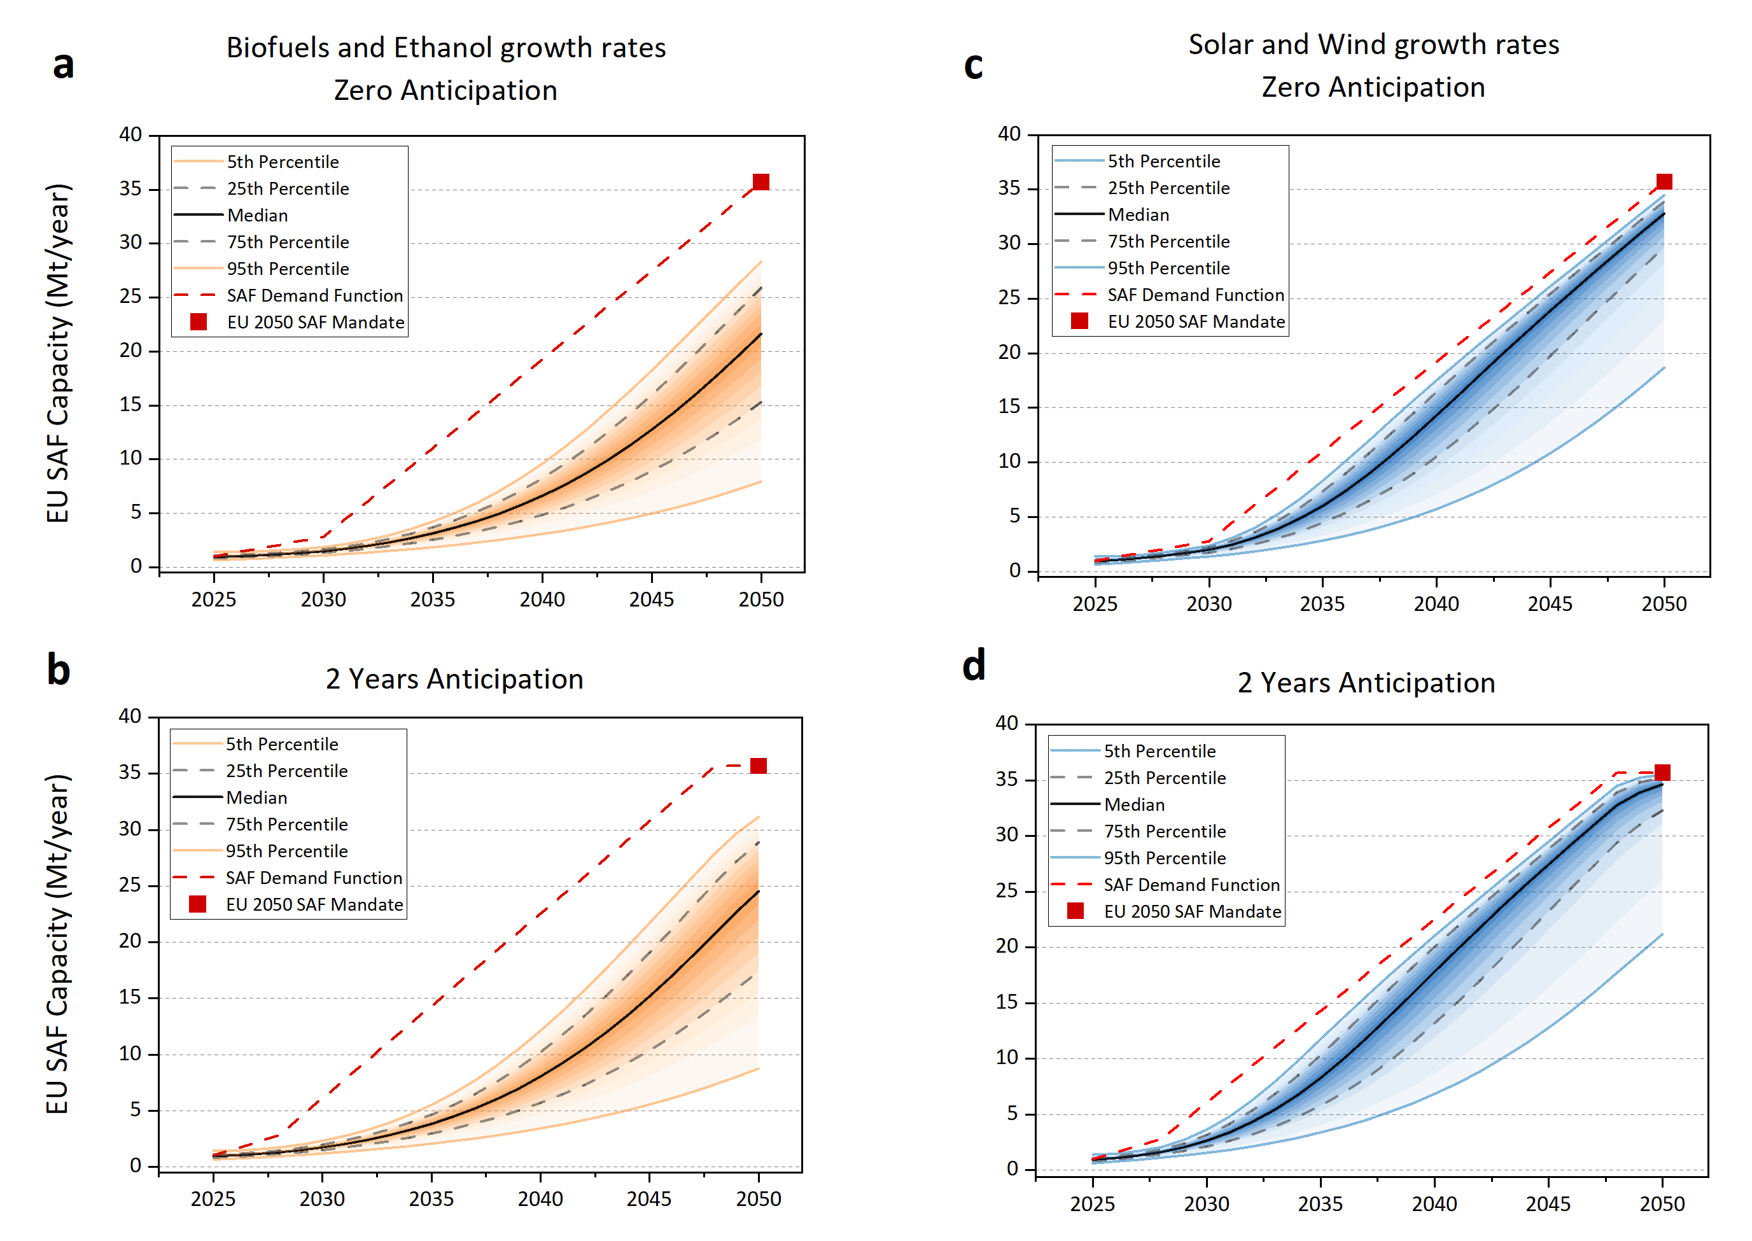
Figure 10: EU SAF capacity potential scale-up out to 2050 computed with biofuels and ethanol growth rates (panel a and b) and solar and wind growth rates (panel c and d). Each figure row represent the potential scale-up computed considering considering zero (panel a and c) and two years (panel b and d) demand anticipation to reach the SAF policy target in 2030 and 2050. In 2050, with solar and wind growth rates and 2 years demand anticipation, the median SAF capacity is 34.6 Mt/year (IQR of 32.3-35.3 Mt/year), which is 3% below the target (35.7 Mt/year). The 90th percentile approaches the target and it equals to 35.5 Mt/year.
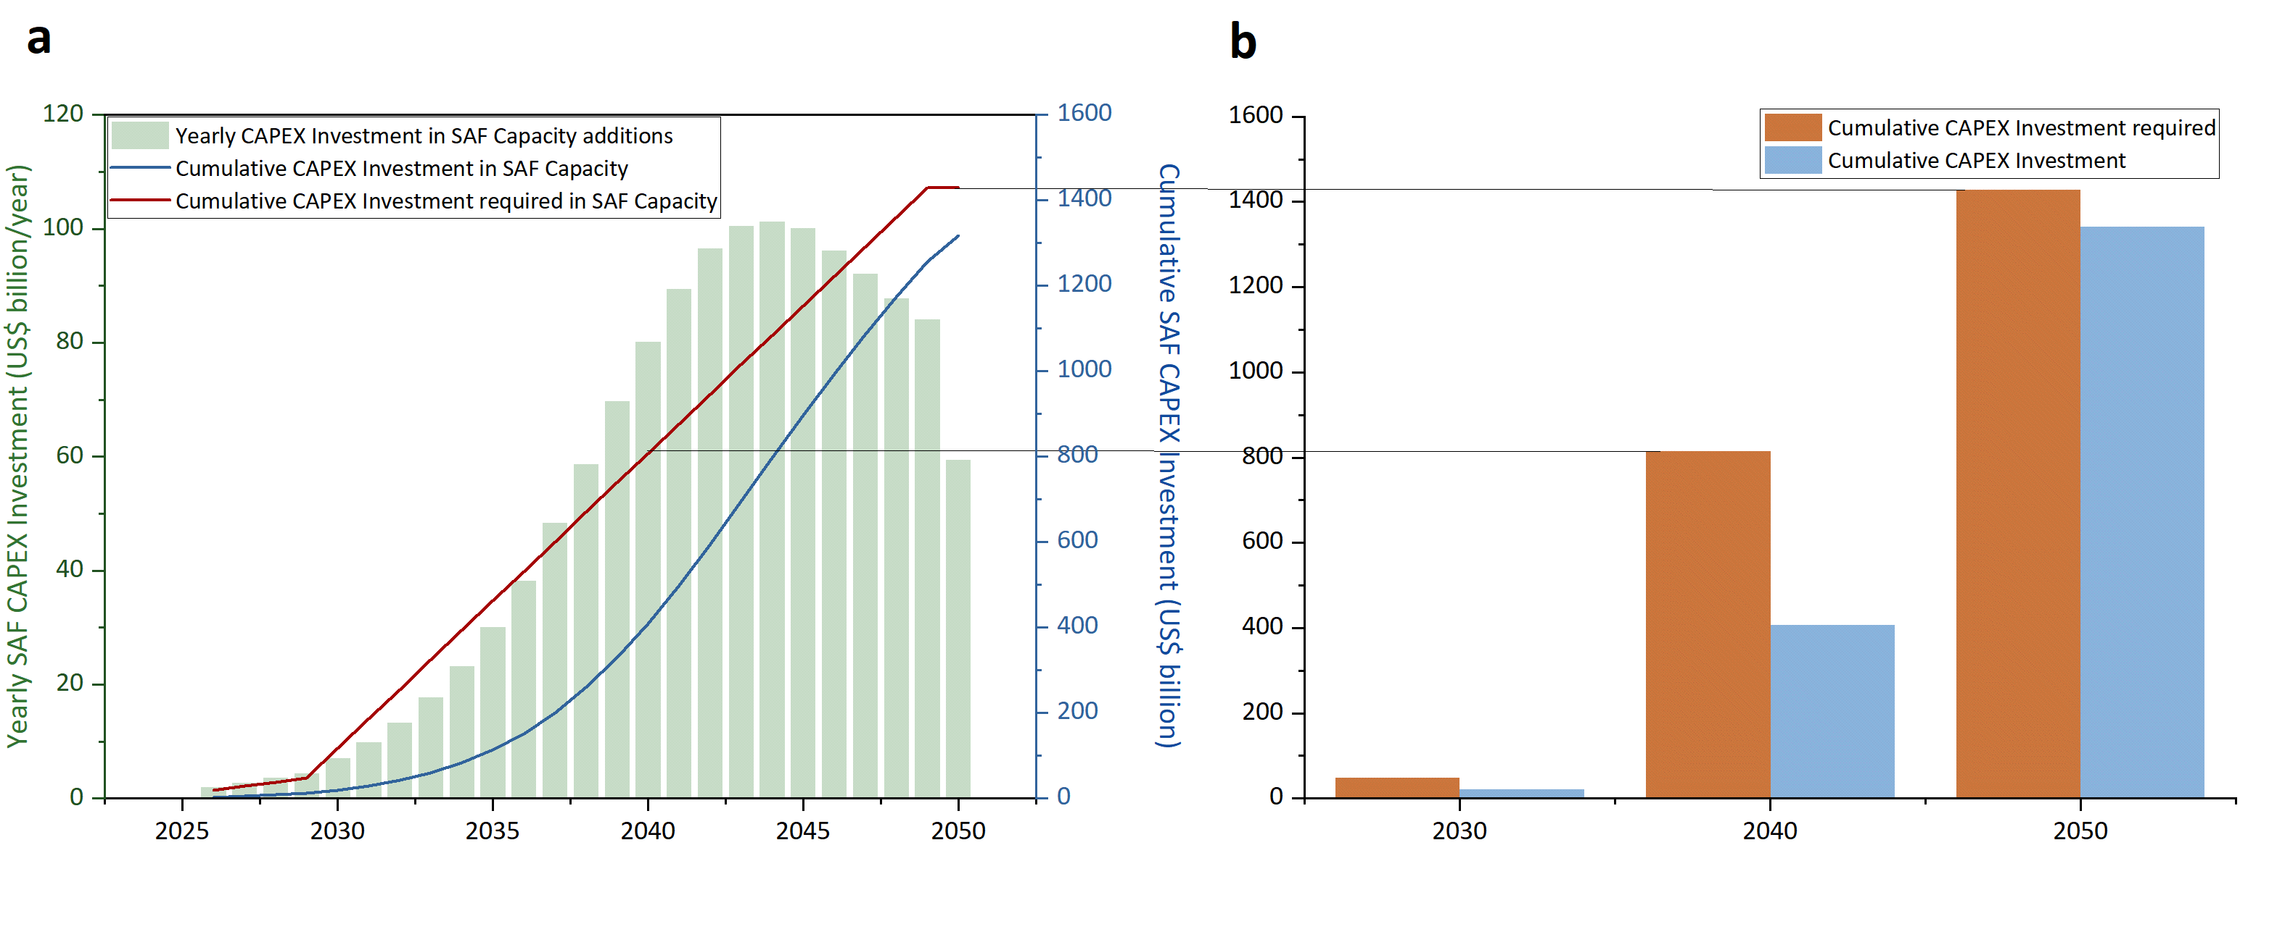
Figure 11: Yearly CAPEX investment in global SAF capacity additions (panel a), cumulative CAPEX investment in SAF Capacity following the solar and wind growth rates (panel b, blue bar) and required cumulative CAPEX investment to meet the ICAO LTAG 2050 Fuel Demand (panel b, orange bar).

References
1. Tanzil, A.H., et al., Strategic assessment of sustainable aviation fuel production technologies: Yield improvement and cost reduction opportunities. Biomass and Bioenergy, 2021. 145: p. 105942.
2. Pearlson, M., C. Wollersheim, and J. Hileman, A techno-economic review of hydroprocessed renewable esters and fatty acids for jet fuel production. Biofuels, Bioproducts and Biorefining, 2013. 7(1): p. 89-96.
3. Peters, M.A., C.T. Alves, and J.A. Onwudili A Review of Current and Emerging Production Technologies for Biomass-Derived Sustainable Aviation Fuels. Energies, 2023. 16, DOI: 10.3390/en16166100.
4. Airlines for America, Jet fuel: From Well to Wing. 2018.
5. Geleynse, S., et al., The Alcohol-to-Jet Conversion Pathway for Drop-In Biofuels: Techno-Economic Evaluation. ChemSusChem, 2018. 11(21): p. 3728-3741.
6. Bullerdiek, N., et al., Direct alcohol vs. alcohol-to-jet SPK utilisation in commercial aviation - an energetic-operational analysis. International Journal of Sustainable Aviation, 2022. 8(3): p. 260-298.
7. Andersen J. Lanzajet: Catalyzing the Next Generation of SAF. 2024; Available from: https://www.biofuelsdigest.com/bdigest/the-digests-2024-multi-slide-guide-to-lanzajet-saf/.
8. Brandt, K. and M.P. Wolcott, Fischer Tropsch feedstock pre-processing techno-economic analysis, v. 2.1. 2021, Washington State University.
9. Li, L., et al., Catalytic Hydrothermal Conversion of Triglycerides to Non-ester Biofuels. Energy & Fuels, 2010. 24(2): p. 1305-1315.
10. Brandt, K., et al., Catalytic Hydrothermolysis techno-economic analysis, v. 2.2. 2022, Washington State University.
11. Brandt, K., et al., Pyrolysis techno-economic analysis, v. 2.2. 2022, Washington State University.
12. EASA, European Aviation Environmental Report. 2025.

