Supplementary Table S1. Prediction Tasks and Descriptions
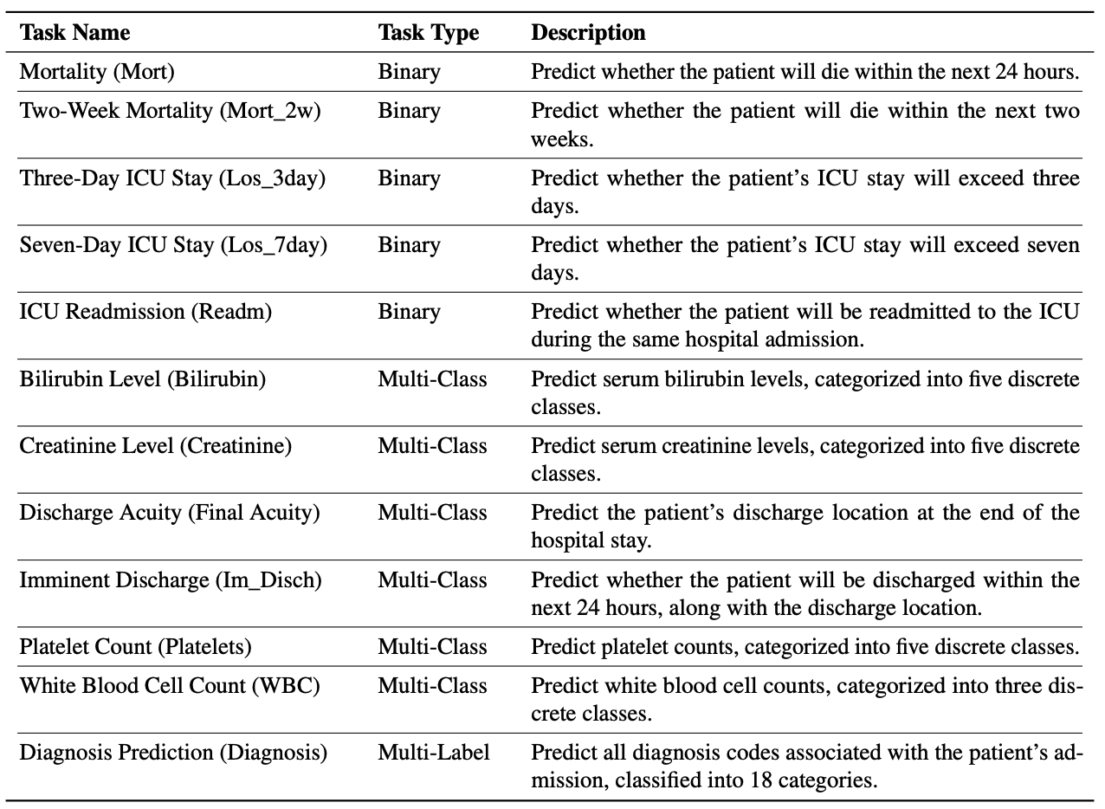

Supplementary Table S2. Demographic Information of the Five Clients
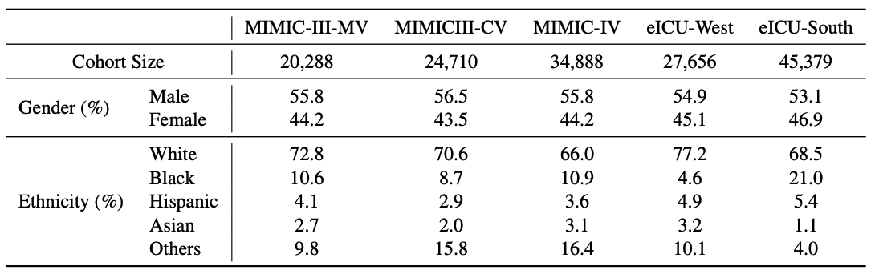

Supplementary Table S3. Label Distributions of the Five Clients
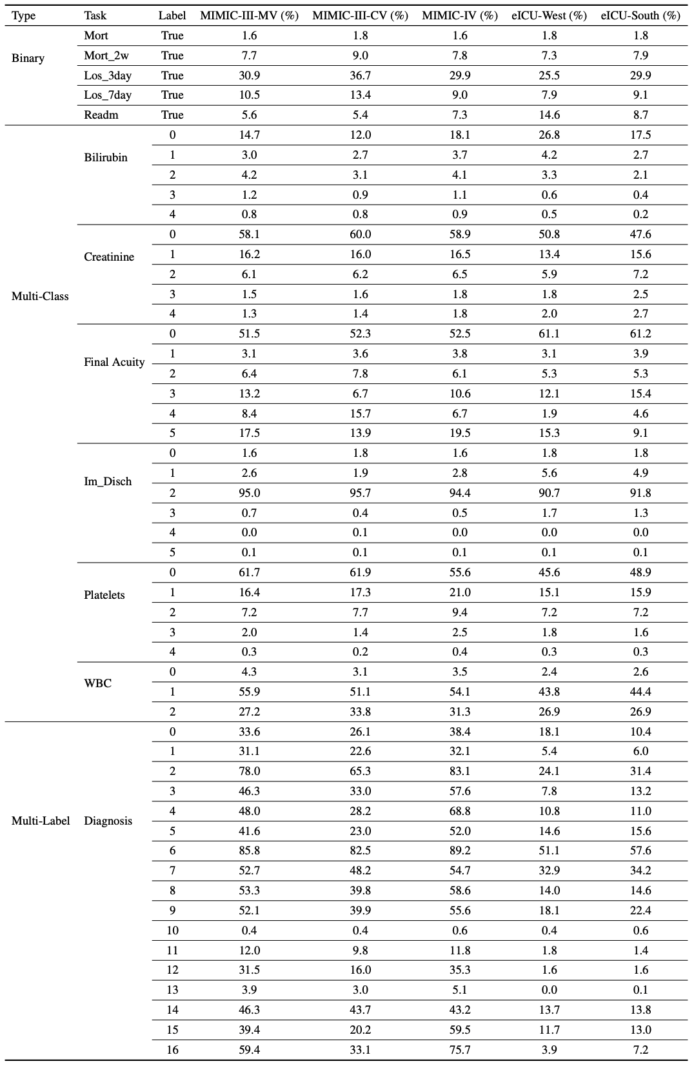
Supplementary Table S4. Standard Deviations for Table 2
Standard deviations for text-based EHR modeling. The values represent standard deviations computed across three random seeds, each with distinct data splits and model initializations.
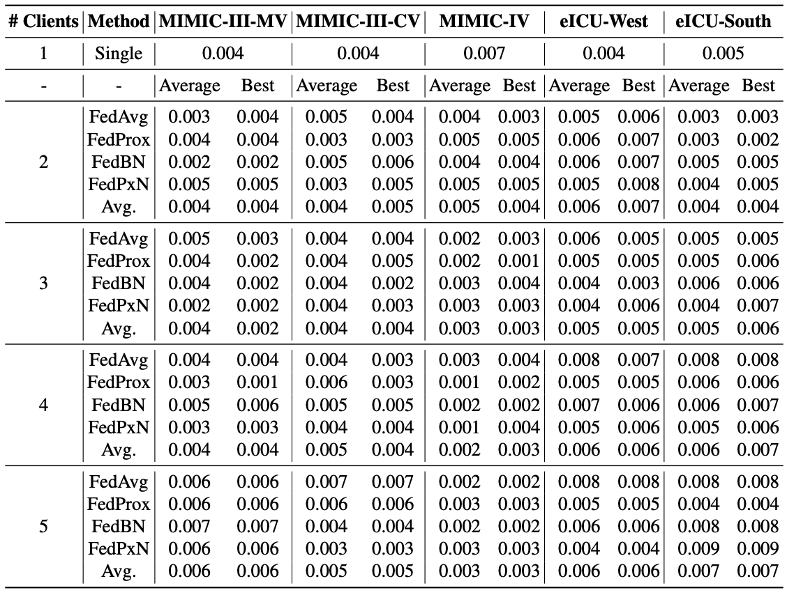

Supplementary Table S5. Correlation Values for Each Federated Learning Algorithm in Table 3
Correlation between host-subject similarity and host performance change with and without subject participation in FL. Similarity is measured using averaged patient embeddings. For each of the 4 algorithms, the number of data points are 60 for 2 and 5 participating clients, and 180 for 3 and 4 participating clients. Breakdown: 2 clients: 5 hosts × 4 target subjects × 3 seeds; 3 clients: 5 hosts × 4 target subjects × 3 combinations (1 additional client) × 3 seeds; 4 clients: 5 hosts × 4 target subjects × 3 combinations (2 additional clients) × 3 seeds; 5 clients: 5 hosts × 4 target subjects × 1 (3 additional clients) x 3 seeds.
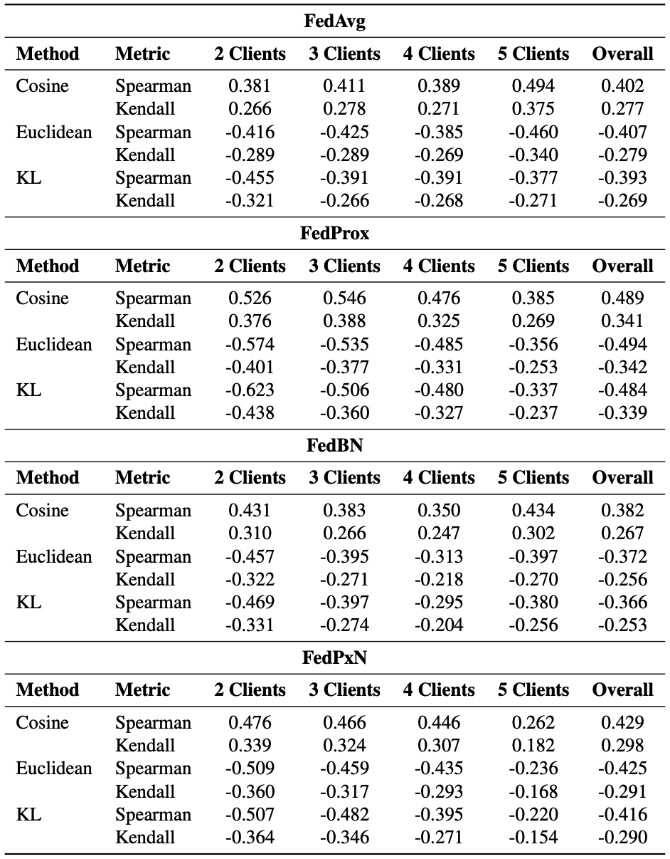
Supplementary Table S6. Standard Deviation Results for Selecting Participating Subjects using Averaged Patient Embedding Similarity
Standard Deviations for Table 4. The values represent standard deviations computed across three random seeds, each with distinct data splits and model initializations.
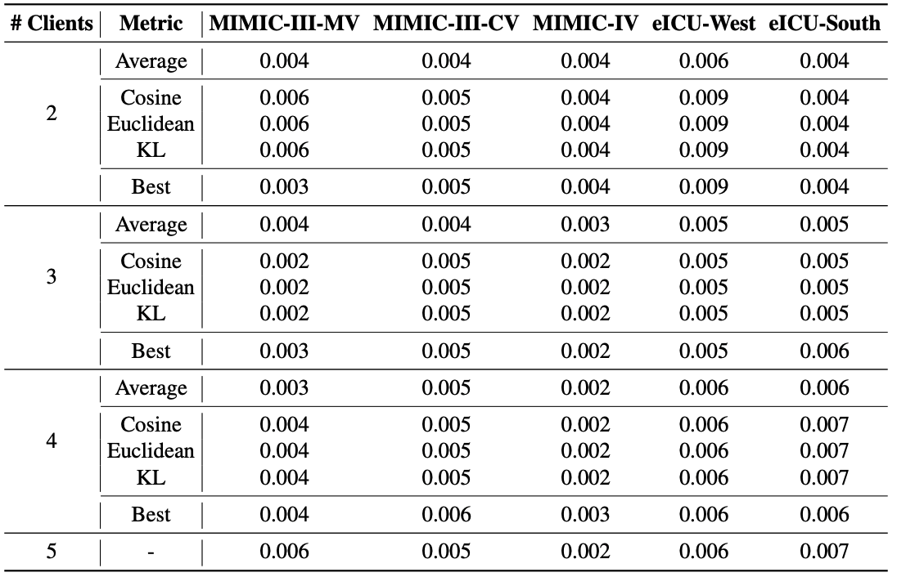

Supplementary Note: Selecting Participating Subjects using Averaged Patient Embedding Similarity vs. Patient-level Embedding Similarity
Supplementary Tables S7 and S8 present the host performance for each federated learning algorithm (i.e., FedAvg, FedProx, FedBN, FedPxN) when selecting participating clients using our averaged patient embedding-based similarity method. The results show that this method achieves performance equal to or better than using all five clients across all similarity metrics (i.e., cosine similarity, Euclidean distance, and KL divergence) in 9, 14, 8, and 12 out of 15 cases for FedAvg, FedProx, FedBN, and FedPxN, respectively. These values are computed by averaging the number of cases (across the three similarity metrics) where the performance is equal to or better than that of full five-client participation.
As discussed in Section 2.2.1, a potential concern with averaging patient embeddings across clients is the risk of information loss, which could lead to suboptimal client selection. To address this concern, we further evaluate the performance using patient-level embeddings similarities for selecting participating clients. Supplementary Tables S9 and S10 present the host performance for each federated learning algorithm (i.e., FedAvg, FedProx, FedBN, FedPxN) when selecting participating clients using patient-level embedding similarities. Specifically, for Cosine Similarity, we compute host-subject patient-level similarities and then average the patient-level similarities to obtain the final similarity score between the host and subject. For Euclidean Distance, we similarly compute host-subject patient-level euclidean distances and then average the patient-level distances to obtain the final distance between the host and subject. For Precision, we follow the method in Kynkäänniemi et al.^{[1]}, computing precision based on individual data points within the host and subject embeddings. The results show that this method achieves performance equal to or better than using all five clients across all similarity metrics (i.e., cosine similarity, Euclidean distance, and KL divergence) in 7.67, 12.67, 7.33, and 9.33 out of 15 cases for FedAvg, FedProx, FedBN, and FedPxN, respectively. These values are computed by averaging the number of cases (across the three similarity metrics) where the performance is equal to or better than that of full five-client participation.
Overall, the results demonstrate that the averaged embedding approach is more robust and consistently achieves performance equal to or better than full participation, compared to the patient-level method. This highlights the efficacy and reliability of using averaged embeddings for selecting suitable clients for the host in federated learning.

Supplementary Table S7. FedAvg, FedProx Individual Algorithm Results for Table 4
Host performance (average macro AUROC across 12 tasks) using the FedAvg and FedProx algorithms, when selecting participating clients based on averaged patient embeddings. The performance is compared to (1) using all 5 clients, (2) Average, and (3) Best. Average and Best refer to the average and best host performance, respectively, across all subject combinations for a fixed number of participating clients. Underlined values indicate performance equal to or better than when using all 5 clients, bold indicates performance equal to Best performance, asterisk indicates performance exceeding Average performance.
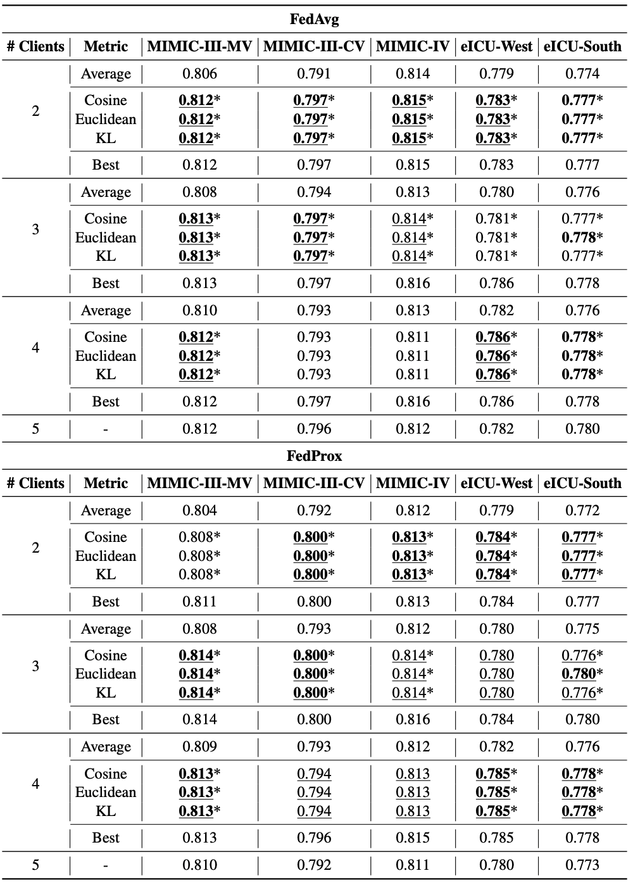
Supplementary Table S8. FedBN, FedPxN Individual Algorithm Results for Table 4
Host performance (average macro AUROC across 12 tasks) using the FedBN and FedPxN algorithms, when selecting participating clients based on averaged patient embeddings. The performance is compared to (1) using all 5 clients, (2) Average, and (3) Best. Average and Best refer to the average and best host performance, respectively, across all subject combinations for a fixed number of participating clients. Underlined values indicate performance equal to or better than when using all 5 clients, bold indicates performance equal to Best performance, asterisk indicates performance exceeding Average performance.
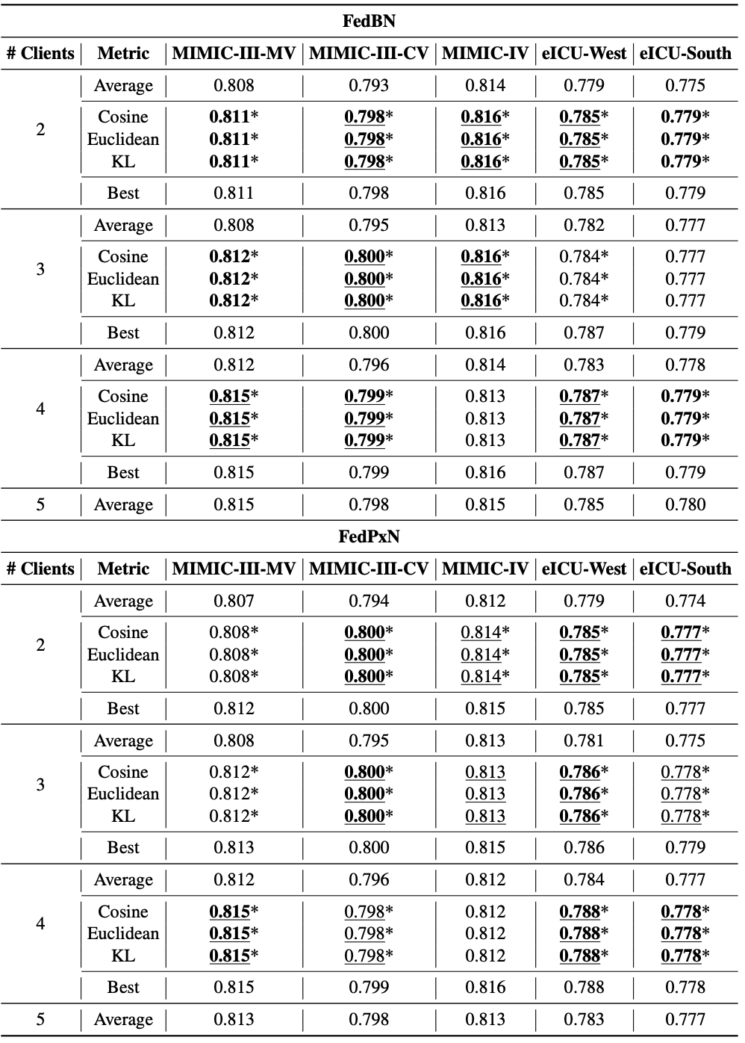
Supplementary Table S9. FedAvg, FedProx Individual Algorithm Results for Selecting Participants using Patient-level Embeddings
Host performance (average macro AUROC across 12 tasks) using the FedAvg and FedProx algorithms, when selecting participating clients based on patient-level embeddings. The performance is compared to (1) using all 5 clients, (2) Average, and (3) Best. Average and Best refer to the average and best host performance, respectively, across all subject combinations for a fixed number of participating clients. Underlined values indicate performance equal to or better than when using all 5 clients, bold indicates performance equal to Best performance, asterisk indicates performance exceeding Average performance.
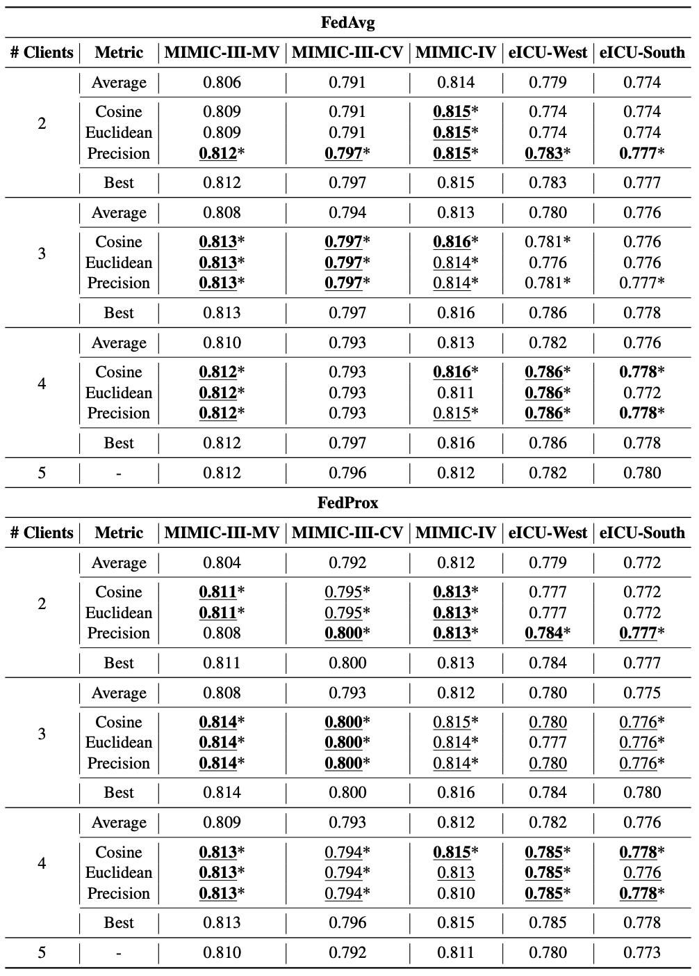
Supplementary Table S10. FedBN, FedPxN Individual Algorithm Results for Selecting Participants using Patient-level Embeddings
Host performance (average macro AUROC across 12 tasks) using the FedBN and FedPxN algorithms, when selecting participating clients based on patient-level embeddings. The performance is compared to (1) using all 5 clients, (2) Average, and (3) Best. Average and Best refer to the average and best host performance, respectively, across all subject combinations for a fixed number of participating clients. Underlined values indicate performance equal to or better than when using all 5 clients, bold indicates performance equal to Best performance, asterisk indicates performance exceeding Average performance.
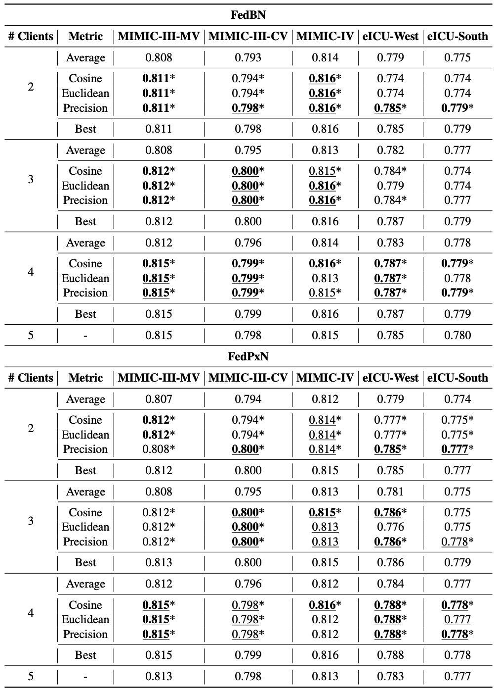
References:
[1] Kynkäänniemi, T., Karras, T., Laine, S., Lehtinen, J. & Aila, T. Improved precision and recall metric for assessing generative models. Adv. neural information processing systems 32 (2019).

