Supplementary materials

Supplementary data 1. ¹H-NMR data of anthraquinone compounds 1-8 (400 MHz, δ in ppm, J in Hz).
Position | 1 | 2 | 3 | 4 | 5 | 6 | 7 | 8
1 | - | - | - | 7.72 (d,1H,8.1) | - | - | - | -
2 | - | - | - | 7.64 (d,1H,8.1) | - | - | - | -
3 | - | - | - | - | 7.54  (d,1H,8.1) | - | - | -
4 | 7.32 (s,1H) | 7.66  (s,1H) | 7.49 (s,1H) | - | 7.56  (d,1H,8.1) | 7.31 (s,1H) | 7.5  (s,1H) | 7.31 (s,1H)
4a | - | - | - | - | - | - | - | -
5 | 8.28 (d,1H,6.9) | 8.25  (d,1-H,6.9) | - | 7.78 (d,1H,8.0) | 7.51  (d,1H,3.6) | 8.17 (d,1H,8.0) | 8.15 (d,1H,6.9) | 8.28  (m,1H)
5a | - | - | - | - | - | - | - | -
6 | 7.81 (m,1H) | 7.77  (t,1-H,6.9) | - | 7.27 (d,1H,8.0) | - | 7.89 (m,2H) | 7.87 (t,1H,9.2) | 7.78  (m,1H)
7 | 7.84 (m,1H) | 7.83  (t,1-H,8.0) | 7.50 (d,1H,8.1) | - | 7.24 (dd,1H,8.0,3.6) |  | 7.82 (t,1H,9.2)
8 | 8.32 (d,1H,6.9) | 8.29  (d,1-H,8.0) | 7.72 (d,1H,8.1) | - | 8.10  (d,1H,8.0) | 8.25 (d,1H,8.0) | 8.20 (d,1H,6.9) | 8.28  (m,1H)
8a | - | - | - | - | - | - | - | -
9 | - | - | - | - | - | - | - | -
9a | - | - | - | - | - | - | - | -
10 | - | - | - | - | - | - | - | -
1-OH | 12.65 (s,1H) | - | 13.24 (s,1H) | - | 13.09  (s,1H) | 13.16 (s,1H) | - | 13.29 (s,1H)
1-OCH3 | - | 4.12  (s,1H) | - | - | - | - | 3.90 (s,3H) | -
2-COH | 10.49 (s,1H) | 10.46 (s,1H) | - | - | - | - | - | -
2-OCH3 | - | - | 4.14 (s,3H) | - | - | - | - | 3.56  (s,3H)
2-CH₃ |  |  |  |  | 2.25  (s,3H) | 2.14 (s,3H) | - | -
2-CH2O | - | - | - | - | - | - | 4.96 (s,2H) | 4.93  (s,2H)
3-OH | 14.04 (s,1H) | 12.26 (s,1H) | - | - | - | - | 10.29 (s,1H) | 9.36  (s,1H)
3-CH₃ | - | - | - | 2.32 (s,3H) | - | - | - | -
4-OH | - | - | - | 13.25 (s,1H) | - | - | - | -
5-OH | - | - | 12.95 (s,1H) | - | - | - | - | -
6-CH₃ | - | - | 2.36 (s,3H) | - | - | - | - | -
8-OH | - | - | - | 12.84 (s,1H) | - | - | - | -

Supplementary data 2. ¹³C-NMR data of anthraquinone compounds 1-8 (125 MHz, δ in ppm).
Position | 1 | 2 | 3 | 4 | 5 | 6 | 7 | 8
1 | 169.2 | 166.7 | 156.0 | 118.6 | 160.7 | 163.2 | 160.9 | 161.8
2 | 112.2 | 118.1 | 139.0 | 136.8 | 134.7 | 118.0 | 127.3 | 114.4
3 | 168.2 | 166.7 | 154.8 | 135.6 | 136.8 | 162.5 | 162.6 | 164.7
4 | 109.4 | 113.1 | 107.7 | 161.1 | 118.7 | 107.2 | 110.5 | 109.8
4a | 139.5 | 141.7 | 129.4 | 115.3 | 131.6 | 132.4 | 136.1 | 133.5
5 | 127.0 | 127.4 | 161.3 | 121.3 | 112.8 | 126.7 | 126.2 | 126.8
5a | 133.3 | 132.5 | 115.1 | 124.3 | 136.1 | 133.5 | 135.1 | 133.6
6 | 134.7 | 134.9 | 135.5 | 120.7 | 164.2 | 134.2 | 134.3 | 134.2
7 | 134.8 | 133.7 | 137.0 | 151.1 | 121.4 | 134.2 | 133.2 | 134.2
8 | 127.8 | 127.1 | 118.9 | 153.2 | 129.8 | 126.5 | 126.8 | 127.4
8a | 133.2 | 134.9 | 131.3 | 116.4 | 125.1 | 133.5 | 132.6 | 133.6
9 | 186.8 | 180.2 | 187.6 | 188.6 | 188.2 | 186.9 | 180.3 | 187.0
9a | 109.4 | 117.7 | 111.9 | 131.3 | 115.0 | 109.7 | 118.6 | 109.7
10 | 181.4 | 181.9 | 187.2 | 187.5 | 182.1 | 181.8 | 182.5 | 182.3
OCH₃ | - | 64.7 | 61.2 | - | - | - | 56.1 | 59.4
COH | 193.9 | 195.5 | - | - | - | - | 61.7 | -
CH₃ | - | - | 16.2 | 14.2 | 15.1 | 7.3 | - | -
CH₂ | - | - | - | - | - | - | - | 69.0

Supplementary data 3. GCMS and 1D NMR spectrum of Lucidin-ω-methylether

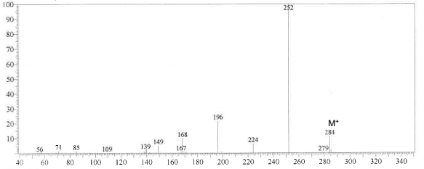

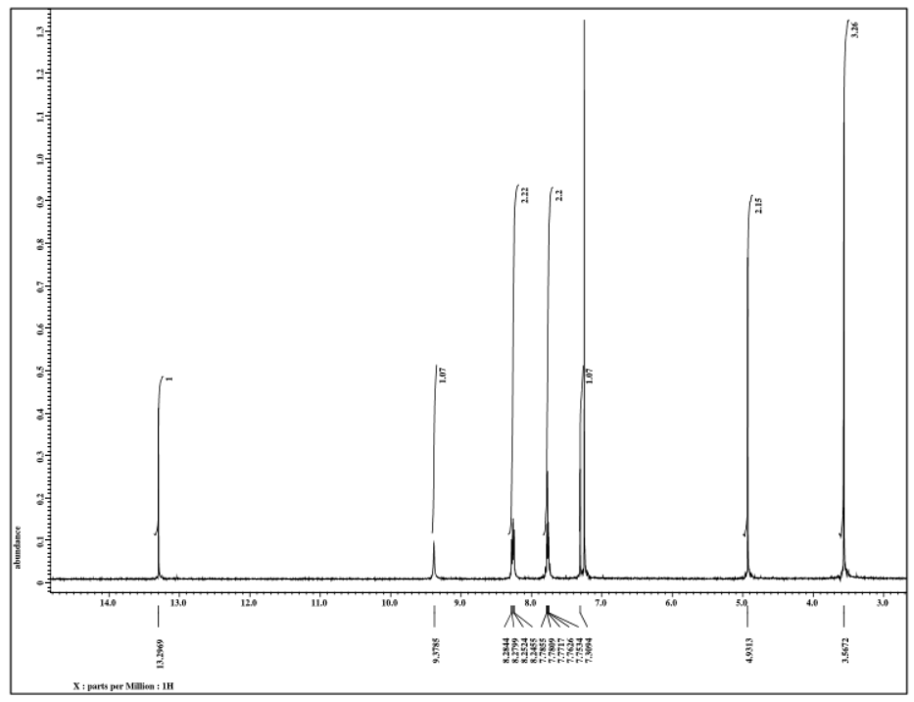
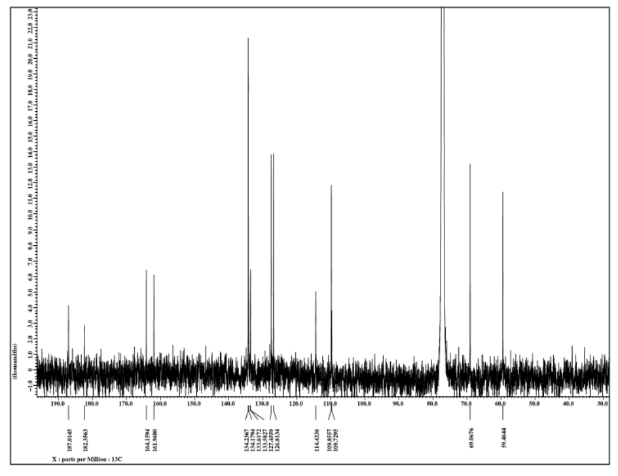

Supplementary data 4. GCMS and 1D NMR spectrum of 1,3,5-trihydroxy-2-methoxy-6-methyl anthraquinone

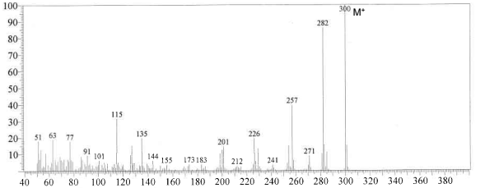
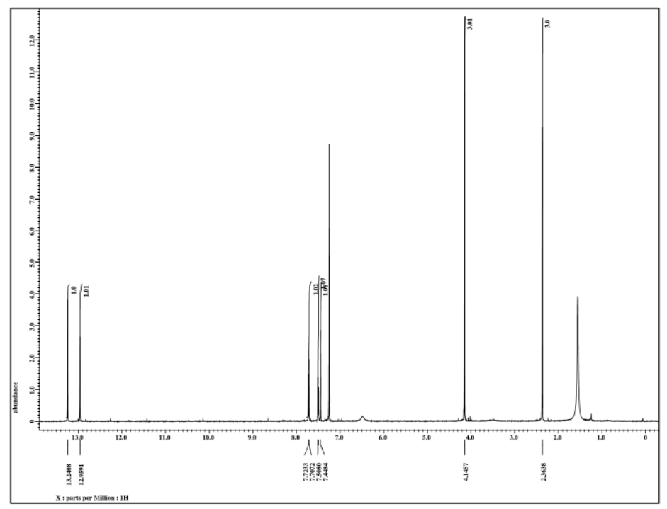
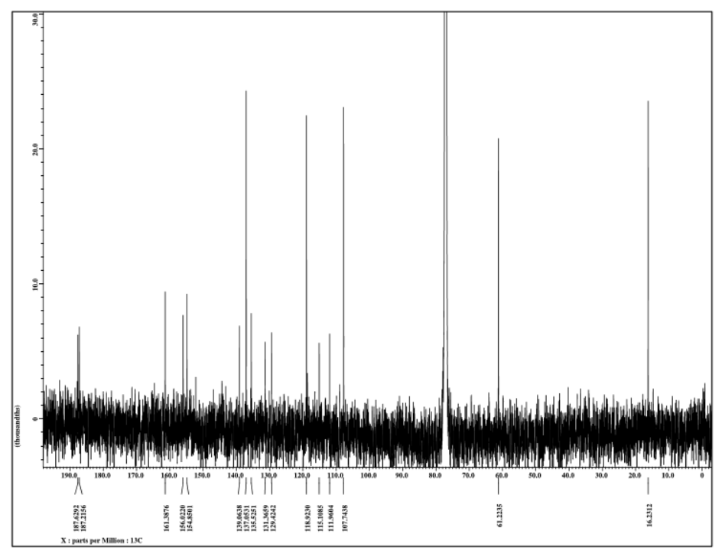

Supplementary data 5. GCMS and 1D NMR spectrum of Damnacanthol

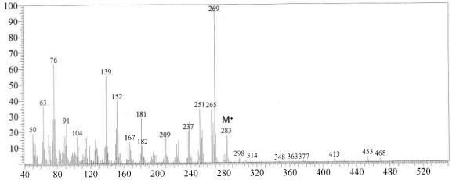
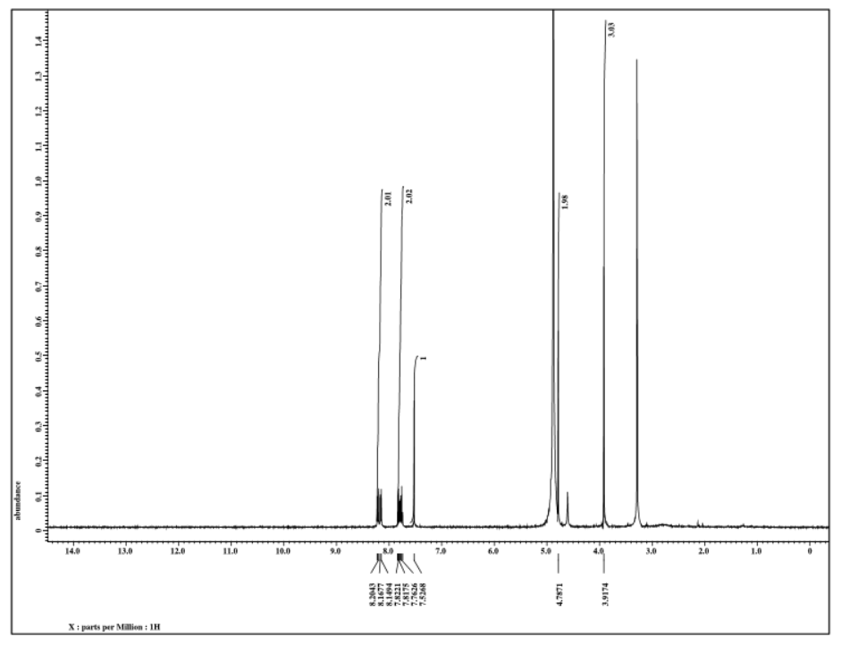
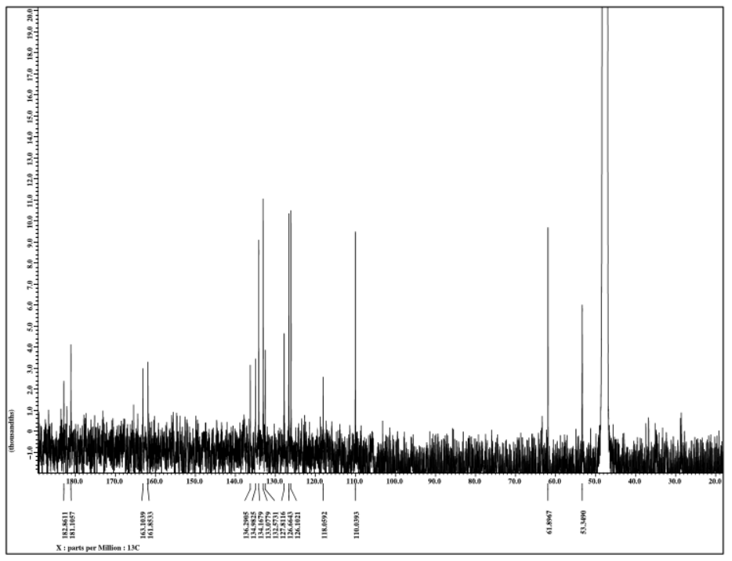

Supplementary data 6. GCMS and 1D NMR spectrum of Sorendidiol

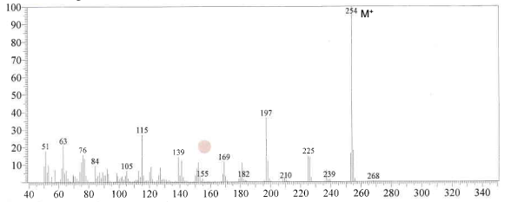
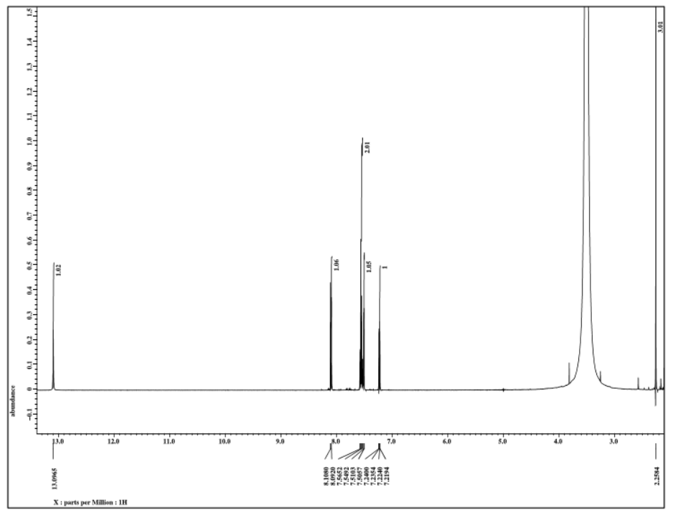
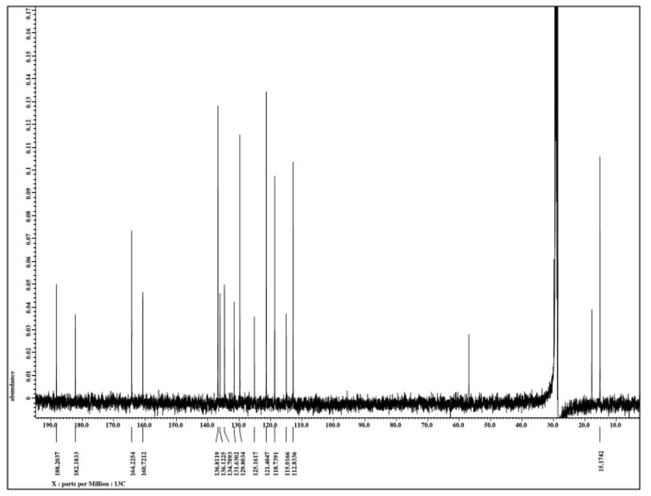

Supplementary data 7. GCMS and 1D NMR spectrum of Nordamnacathal

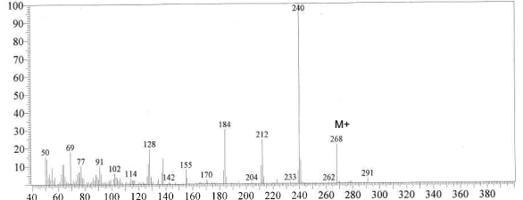

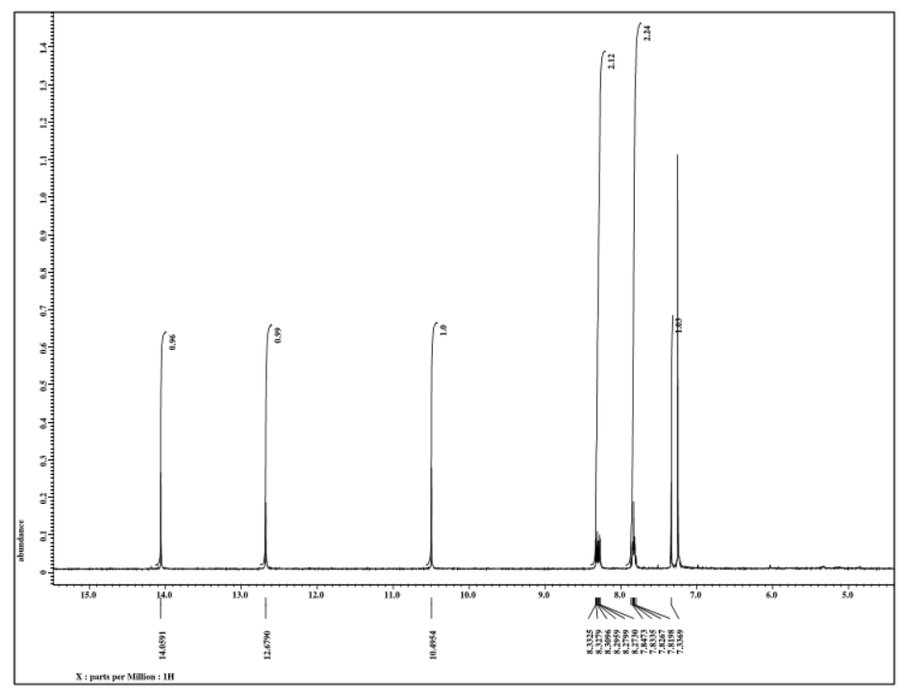
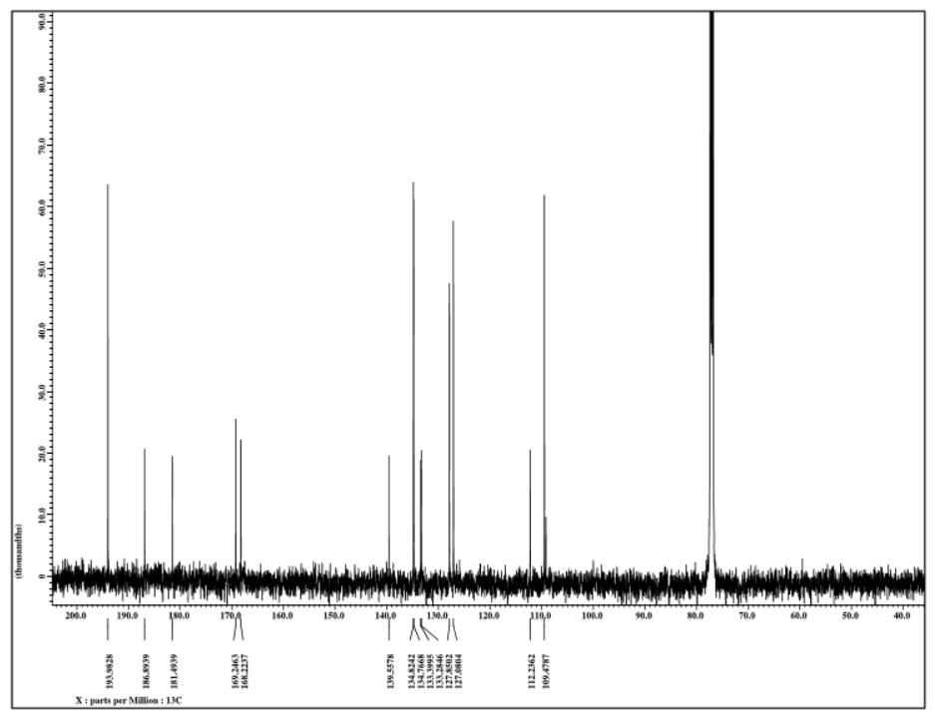

Supplementary data 8. GCMS and 1D NMR spectrum of Morindone

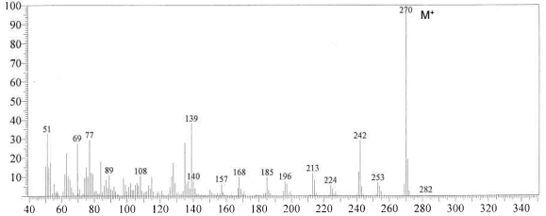
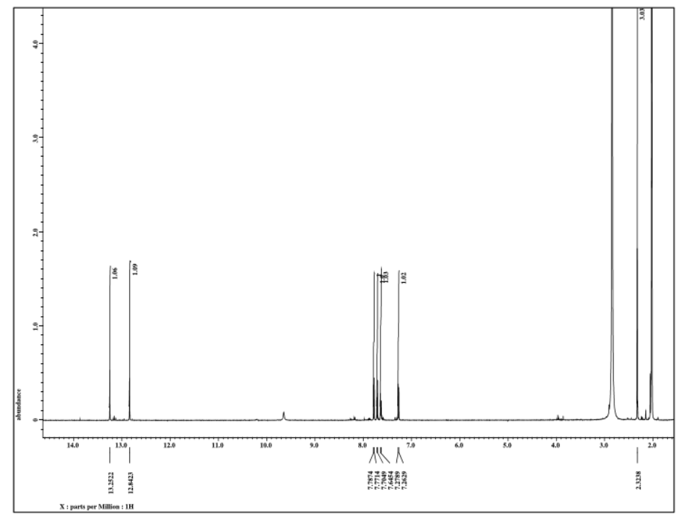
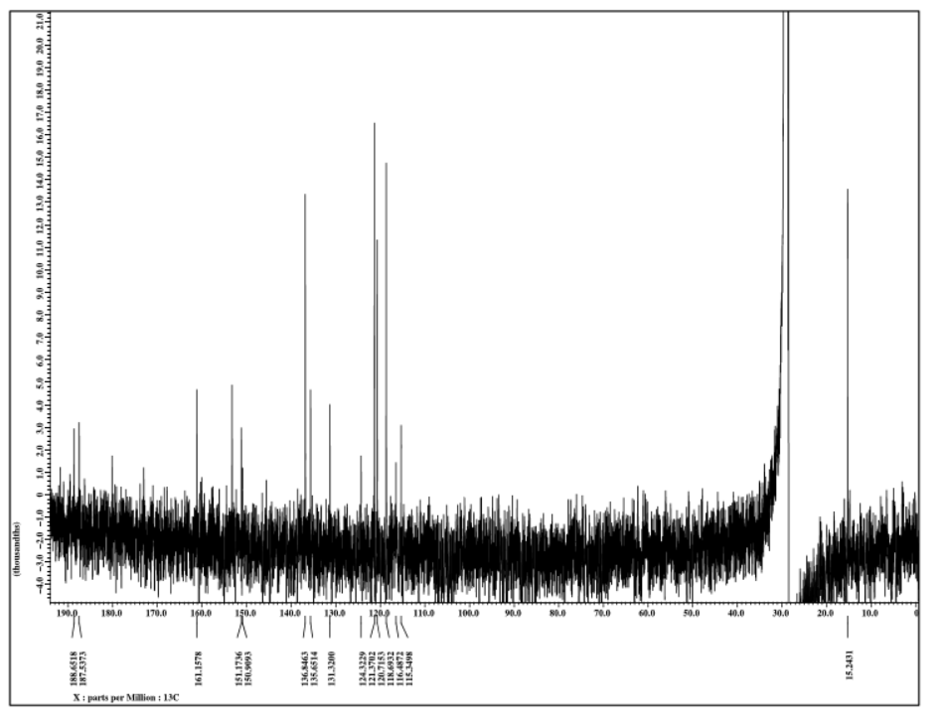

Supplementary data 9. GCMS and 1D NMR spectrum of Rubiadin

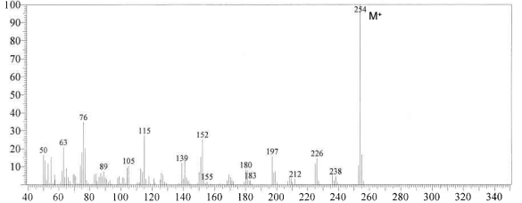
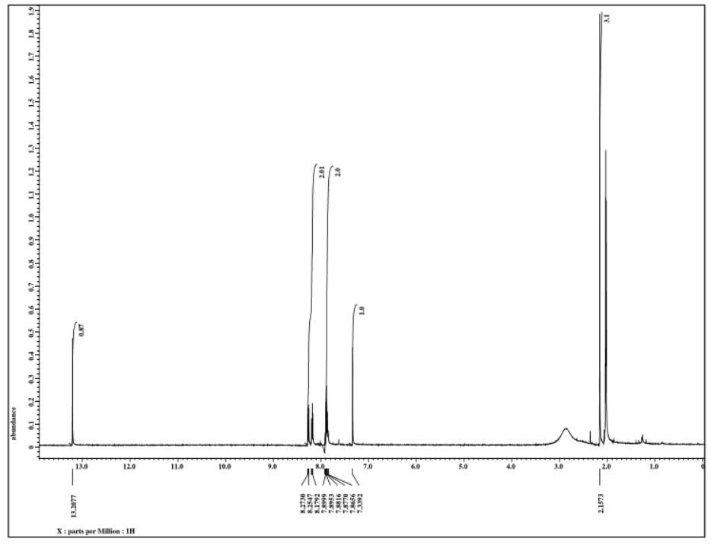
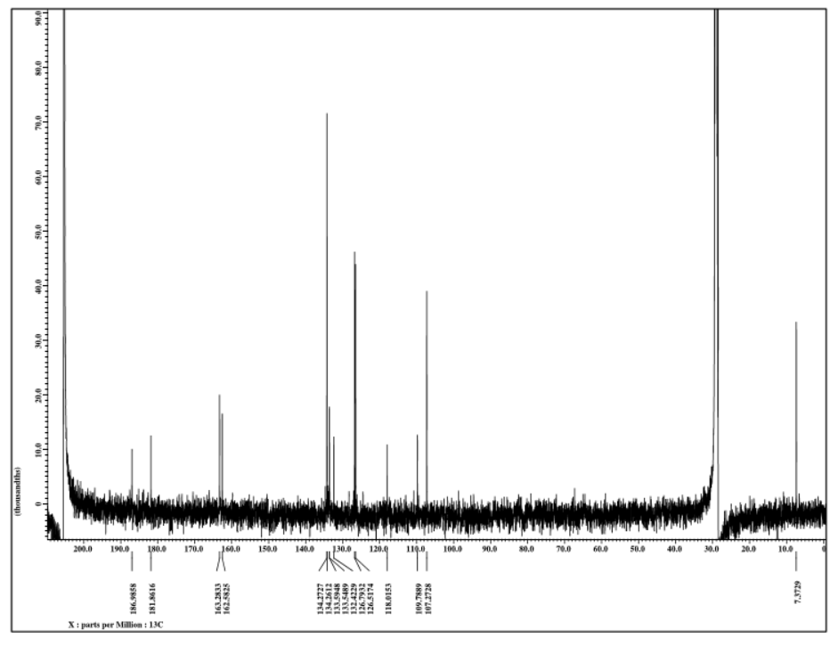

Supplementary data 10. GCMS and 1D NMR spectrum of Damnacanthal

