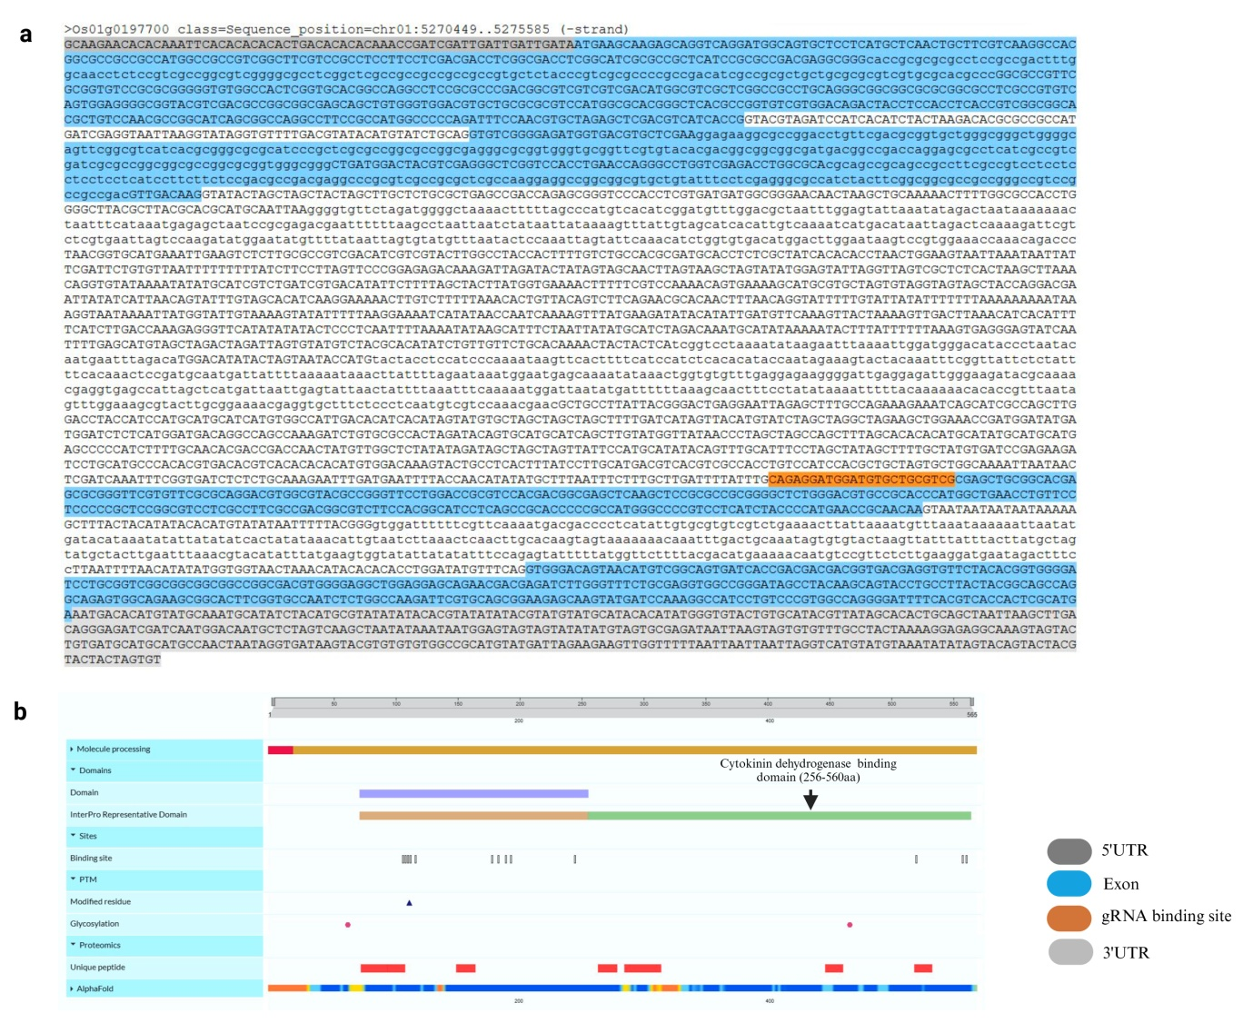

Supplementary Fig. 1(a). OsCKX2, (a) gene sequence retrieved from the RAP-DB portal (https://rapdb.dna.affrc.go.jp/), (b) protein domain identified from the UniProt blast server (https://www.uniprot.org/uniprotkb)

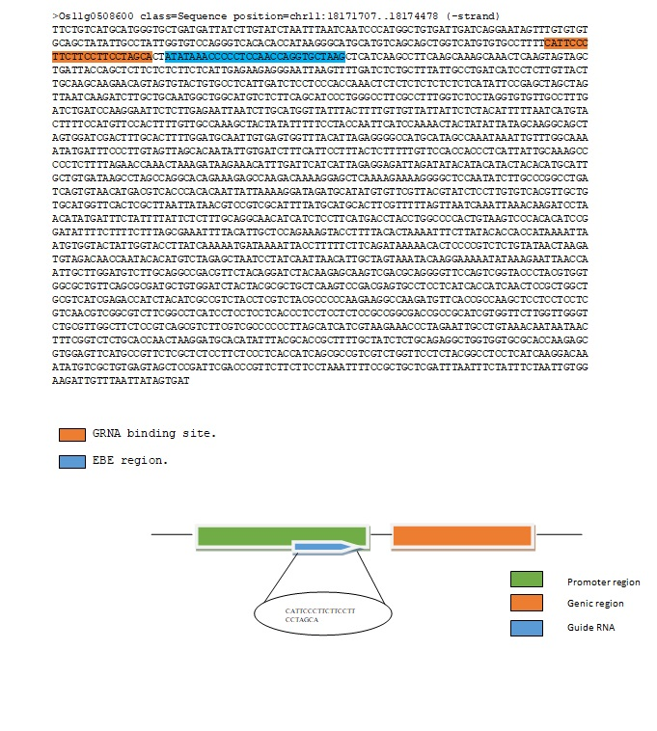
Supplementary Fig. 1(b). OsSweet14 promoter sequence retrieved from the RAP-DB portal (https://rapdb.dna.affrc.go.jp/) and depiction of guide RNA binding site in the promoter region of OsSWEET14.
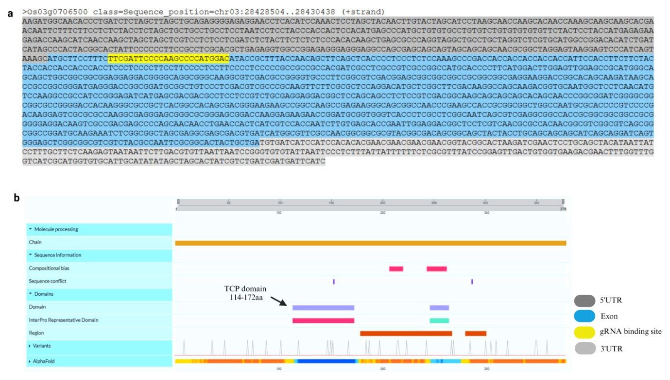

Supplementary Fig. 1(c). OsTB1 (TEOSINTE BRANCHED 1), (a) gene sequence retrieved from the RAP-DB portal (https://rapdb.dna.affrc.go.jp/), (b) protein domain identified from the UniProt blast server (https://www.uniprot.org/uniprotkb).
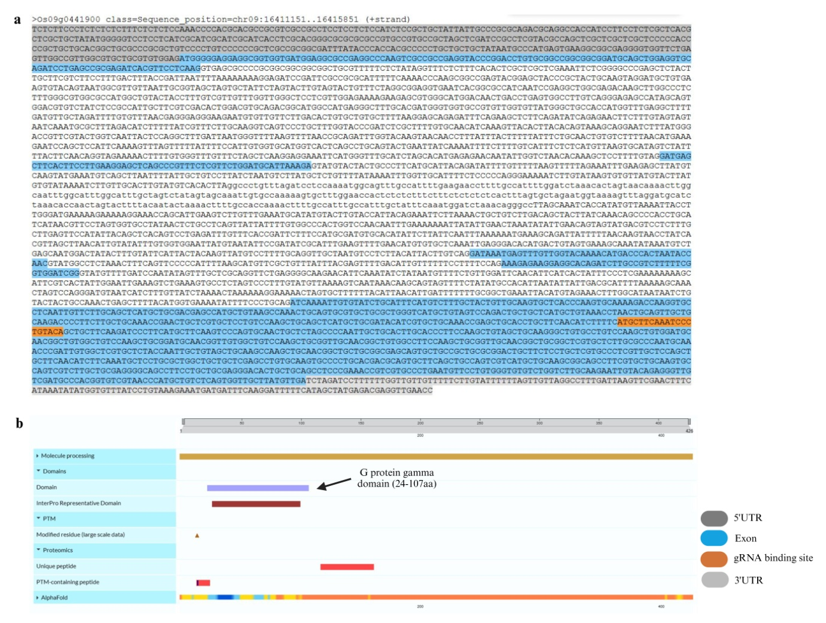

Supplementary Fig. 1(d). OsDEP1 (DENSE AND ERECT PANICLE 1), (a) gene sequence retrieved from the RAP-DB portal (https://rapdb.dna.affrc.go.jp/), (b) protein domain identified from the UniProt blast server (https://www.uniprot.org/uniprotkb)

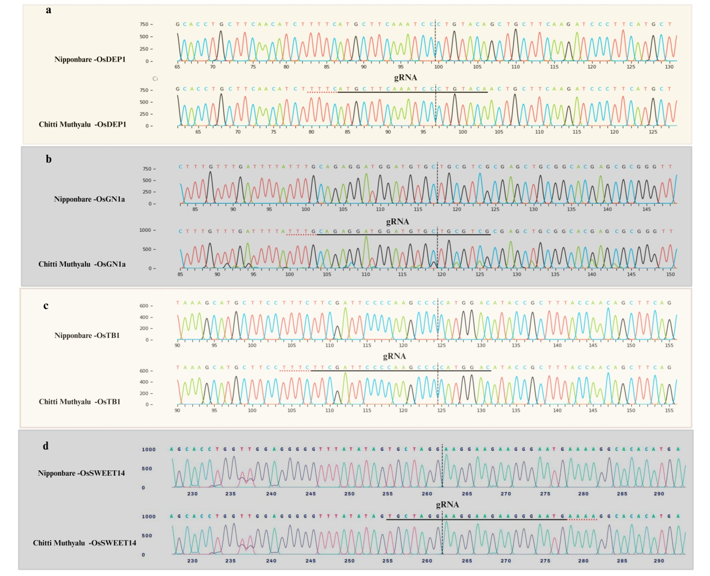
Supplementary Fig. 2. Sequence alignment of the target genes OsDEP1, OsCKX2 (Gn1a), OsTB1 and OsSWEET14 and guide RNAs. The dotted line next to the gRNA represents the PAM sequence.

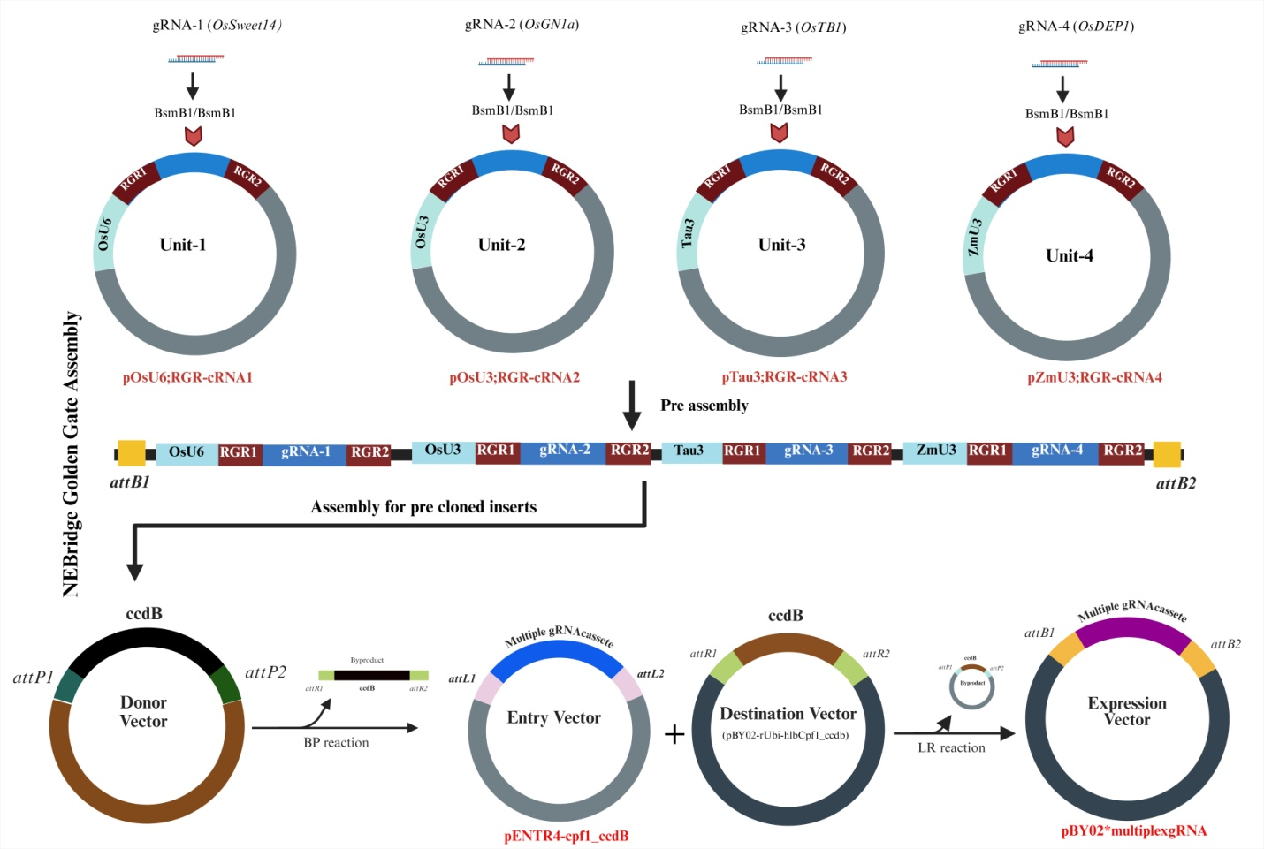
Supplementary Fig. 3. Schematic flow of the multiplex genome editing construct preparation.

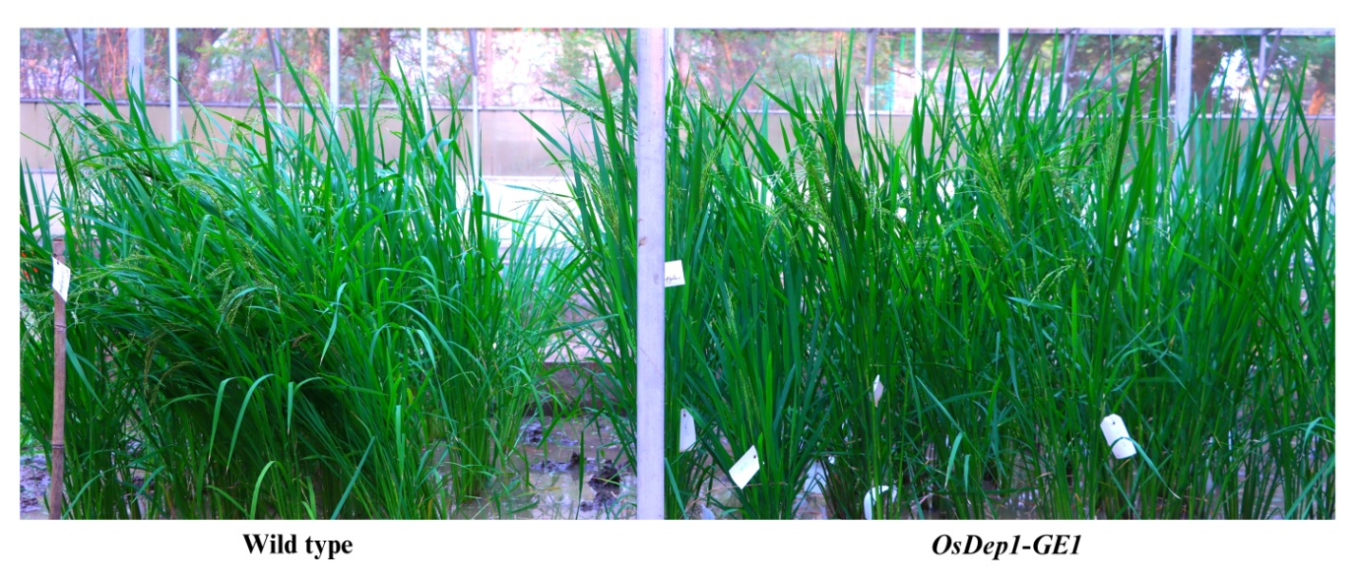
Supplementary Fig. 4. The OsDEP1 gene edited plants and wild type Chittimuthyalu growing at T1 generation in a Biosafety screenhouse.

Table S1. Sequences of gRNAs used in this study
Target genes | gRNA sequences
OsGn1a | CAGAGGATGGATGTGCTGCGTCG
OsDEP1 | ATGCTTCAAATCCCTGTACA
OsTB1 | TTCGATTCCCCAAGCCCCATGGAC
OsSWEET14 | CATTCCCTTCTTCCTTCCTAGCA

Table S2: List of primers used in this study
Sl # | Primers | Sequence
1 | U6PR3 | TTGTACAAGAAAGCTGGGTCTAGA
2 | U6PF1b | CGTTGAGGGGAGACAGGTTTAG
3 | CPF1 F | CAAGGAGACAAACAGGGACGAG
4 | CPF1 R | CAGCCAGGCAGGGATGTAAAAG
5 | HYG F | CTGCATCATCGAAATTGCCGT
6 | HYG R | CGAAAAGTTCGACAGCGTCT
7 | 35S P F | GGTCGTCCTCTCCAAATGAAATG
8 | 35S P R | CACGACACTCTCGTCTACTCCA
9 | SEQ F | GGCCCGTGTCTCAAAATCTC
10 | SEQ R | GCGGTGCTACAGAGTTCTTG
11 | OsUbi F | TCCTAACGGCGAACCAACAAA
12 | OsUbi R1 | GGACGCGAGAGGATTCGATT
13 | M13 F | GTAAAACGACGGCCAGT
14 | M13 R | CAGGAAACAGCTATGAC
15 | OSCKX2 F (gRNA) | AGATCAGAGGATGGATGTGCTGCGTCG
16 | OSCKX2 R (gRNA) | GCCTCGACGCAGCACATCCATCCTCTG
17 | DEP1 F (gRNA) | AGATATGCTTCAAATCCCTGTACA
18 | DEP1 R (gRNA) | GCCTTGTACAGGGATTTGAAGCAT
19 | TB1 F (gRNA) | AGAT TTCGATTCCCCAAGCCCCATGGAC
20 | TB1 R (gRNA) | GCCT GTCCATGGGGCTTGGGGAATCGAA
21 | SWEET 14 F (gRNA) | AGATCATTCCCTTCTTCCTTCCTAGCA
22 | SWEET 14 R (gRNA) | GCCTTGCTAGGAAGGAAGAAGGGAATG
23 | SEQ F1 | CGTTGAGGGGAGACAGGTTT
24 | SEQ R1 | GAGATTTTGAGACACGGGCC
25 | Seq F2 | TGATGTCTCTCAGATGGGCC
26 | Seq R2 | AAGGACTCGTAATTGCTGGC
27 | Xa13 F | TGGCGTACACCACCAAAAGTGG
28 | Xa13 R | AAACCCACTTTTGGTGGTGTA
29 | DEP1 Set2 seq F | CTCATGCTGCGATACATCGTG
30 | DEP1 Set2 seq R | CTACAGCTTGGAAGGGTGCAA
31 | DEP seq F | AGTTTGCTCGCAGGTTCTGA
32 | DEP seq R | GCCACAATCGGGTTTGCATT
33 | TB1 SET1 seq F | CACTACGGCACTATTCCCCC
34 | TB1 SET1 seq R | CGGCGGTGCTTATCTTGCTG
35 | TB1 SET2 seq F | GCTCGTCCTCTCCTCGATCT
36 | TB1 SET2 seq R | TCGCTCATGATCTCCCGGAT
37 | OSCKX2 E3 seq F | CTCACTTTATCCTTGCATGAC
38 | OSCKX2 E3 seq R | TGAGGGGTCGTCATTTTG
39 | SWEET 14 SEQ F | TCCTTTGCGGCTCATCAGTT
40 | SWEET 14 SEQ R | CTGAAGAGACATGCCAGCCA
41 | TGW3 qrt F | CTACGATCCGTGGCCGAAAT
42 | TGW3 qrt R | CAGTTCCGACCACATGCTCA
43 | DEP 1 QRT F | CTTGCCGTCTTTTTCGGTGG
44 | DEP 1 QRT R | GGCACCTTGGTCTTTTGCAC
45 | GS3 QRT F | ATGCTGCAGAGAGGTTGACG
46 | GS3 QRT R | CTTGCTCTGCACAAACAGCG
47 | GW5QRT F | GGCGTTCAACTTCAAGACGG
48 | GW5QRT R | ACCACCTCCTCTGCAAGAAC
49 | DREB1C qrt F | TGATGCAGTACCAGGACGAC
50 | DREB1C qrt R | GGCTGGTCGAAGTCCATGTT
51 | TGW6 qrt F | ATGAGCTTCCCTTTGGTCCG
52 | TGW6 qrt R | TCTCCATCACTTCGGTTGGC

