Appendix A: Experimental Validation of the Theoretical Results
To validate the results of the RCWA, the reflection from several metasurfaces (varying in heights and radii) fabricated on a Si wafer have been characterized experimentally and compared to the prediction of the RCWA tool.
Fabrication
The metasurfaces are fabricated using E-beam lithography according to the following steps: 300nm of PMMA A4 resist are spin-coated in a Si wafer. The metasurface patterns are written by E-beam lithography, followed by a development step that removes the exposed resist. A 10 nm of Ti adhesion layer followed by 60nm of Au layer are deposited on the wafer, followed by a lift-off process to form a metallic etch mask. Then, the exposed Si is etched at a constant rate using reactive ion etching (Fluorine, from Fluoroform and Sulfur hexafluoride), where the depth of the etch is determined by the process time. Finally, metallic layer is removed using wet-etch. Figure 7 depicts Scanning Electron Microscope (SEM) images of two of the fabricated metasurfaces. The structure parameters are detailed in the figure caption.
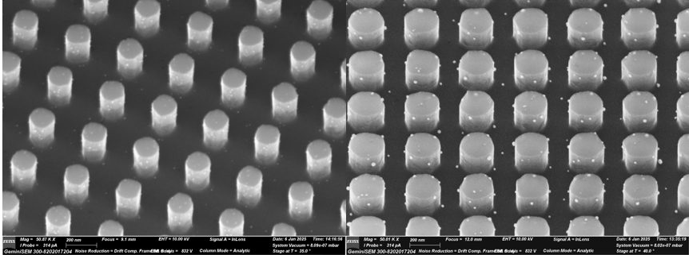
Fig. 7. SEM images of fabricated metasurfaces. (a) Si Metasurface with periodicity Λ=355nm, radius r=110nm and height h=280nm; (b) Si Metasurface with periodicity Λ=355nm, radius r=90nm and height h=210nm.
Characterization and comparison to the simulations
The devices are characterized in transmission using the setup depicted in Figure 8. Broadband light from a supercontinuum laser is focused on the Si sample from the metasurface side. The transmitted light is collected by a lens through a fiber into a spectrometer. The measured transmission spectrum is normalized according to a spectral measurement through a wafer without the sample. Note that because the metasurface is fabricated only on one side of the sample, the maximal attainable transmission in this configuration is ~69% due to the reflection from the un-patterned Si-Air interface.
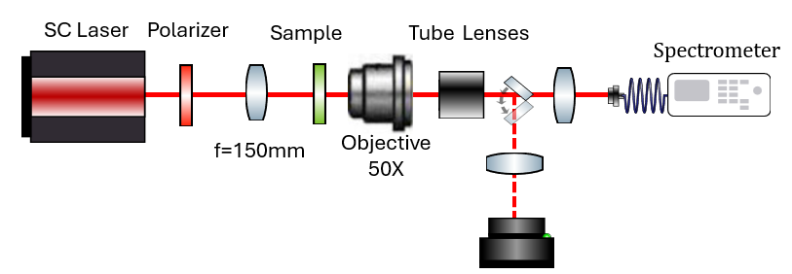
Fig. 8. Schematic illustration of the experimental setup for transmission characterization. Broadband light from a supercontinuum laser is focused onto the sample from the metasurface side. The transmitted light is collected by a lens into a spectrometer for spectral analysis.
To compare the measurements with the RCWA prediction, the spectral reflection and transmission from three metasurfaces were calculated (see Fig. 9(d)). To facilitate the comparison with the transmission measurements, these spectral reflectivity and transmission are used in a complete Fabry-Perot model of the sample, where the reflectivity of the un-patterned facet is obtained by the (wavelength dependent) Fresnel coefficients. Finally, to facilitate the comparison with the experimental characterization, the calculated spectrum is averaged over the resolution bandwidth of the spectrometer.
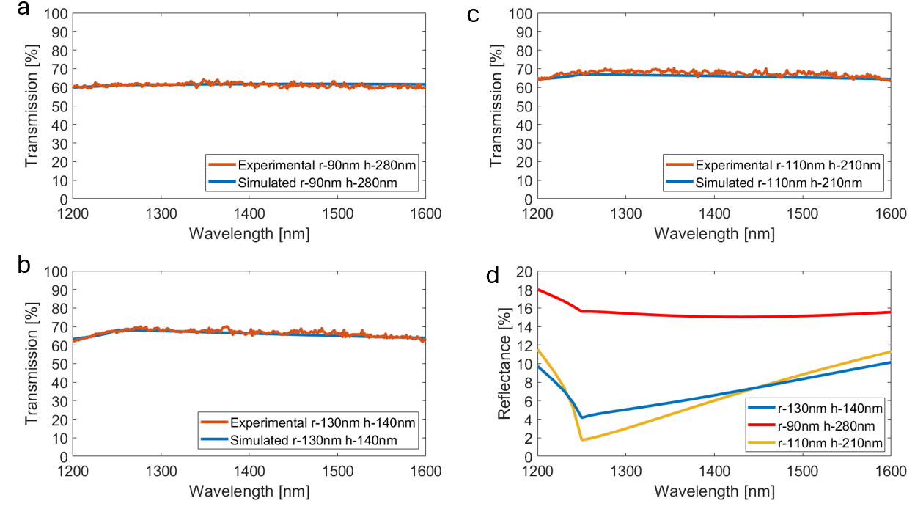
Fig. 9. (a-c) Spectral reflectivity of the wafers with AR metasurfaces for different radii and heights. Red – experimental results and blue – calculations. (d) calculated reflectance spectrum for the metasurface of panels (a-c).
Figure 9.a-c shows three examples of comparison between the transmission measurements and the corresponding calculated ones. As noted above, the metasurfaces consist of circular pillars arranged in a square lattice with a periodicity of L=355 nm. The heights and radii of the pillars are indicated in each panel. Very good agreement between the measured and the calculated transmission spectra for all three examples over the whole measured band.
The experimental results confirm the validity of the metasurface design and the reliability of the fabrication process. The strong match between experimental and theoretical results demonstrates the feasibility of this approach for anti-reflection applications. Furthermore, the dependence of reflectance on the height and radius of the nanoantennas, as shown in Figure 9, emphasizes the potential for tuning the metasurface properties for various optical systems.

