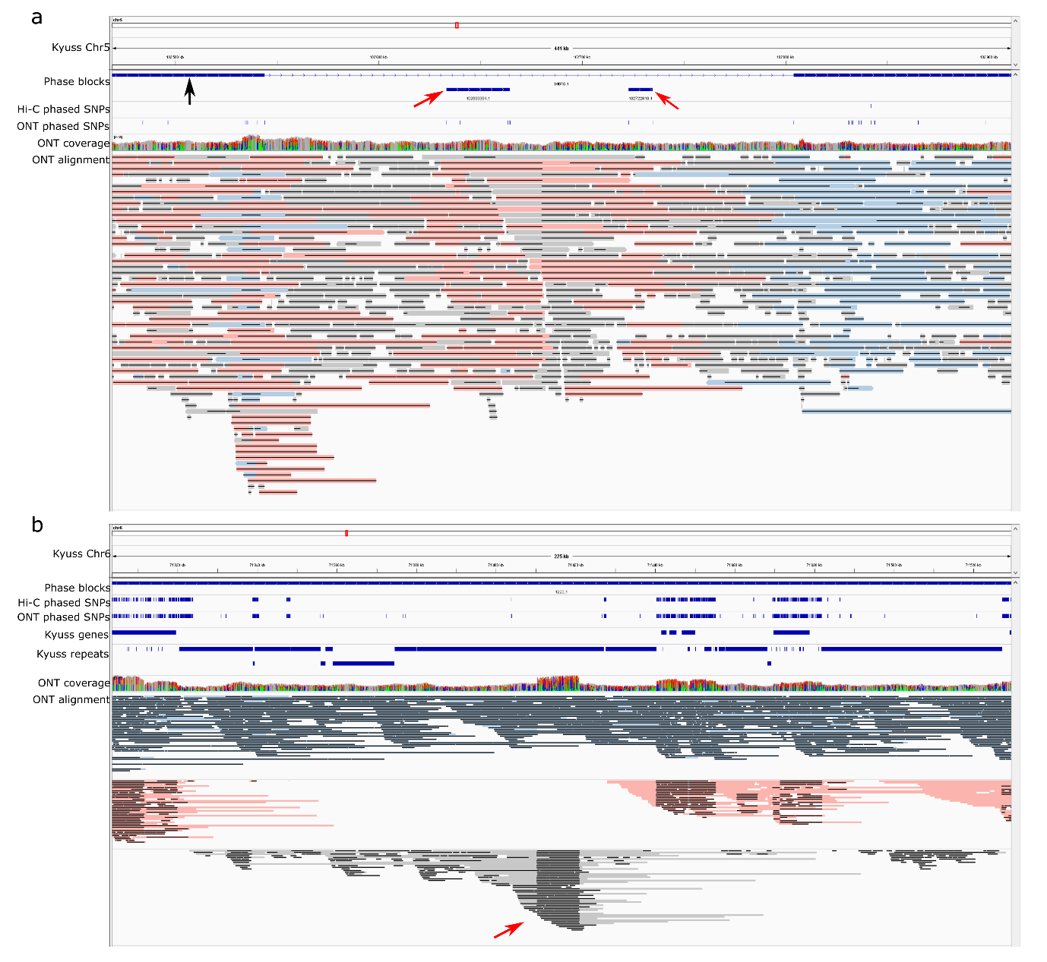
Extended Data Fig. 1 | Integrated Genome Browser (IGV) screenshot of DH647 phasing results. a, Small phase blocks of DH647 on Kyuss pseudo-chromosome (Chr) 5. The chromosome-level phase block was indicated by the black arrow, and the small phase blocks were indicated by red arrows. No Hi-C phased SNPs were observed in the small phase blocks, and no ONT reads covering these small blocks were long enough to bridge the upstream and downstream SNPs in the chromosome-level phase block. Therefore, these small phase blocks could not be integrated into the chromosome-level phase block. b, Alignment-based read binning may not assign long reads to a haplotype due to reference bias. ONT reads were assigned to different haplotypes (indicated by red and blue colors in the ONT alignment track) by WhatsHap. Reads colored gray could not be assigned to a haplotype. The unassigned reads indicated by the red arrow might be mistakenly mapped to this repetitive region (reference bias) as the read alignment coverage was much higher compared to the neighboring regions. These unassigned reads did not span more than 1 SNP, thus they were not assigned to a haplotype by WhatsHap. However, if these reads indeed contain some haplotype-specific k-mers, then haplotype of these reads could be determined with the k-mer-based binning method.

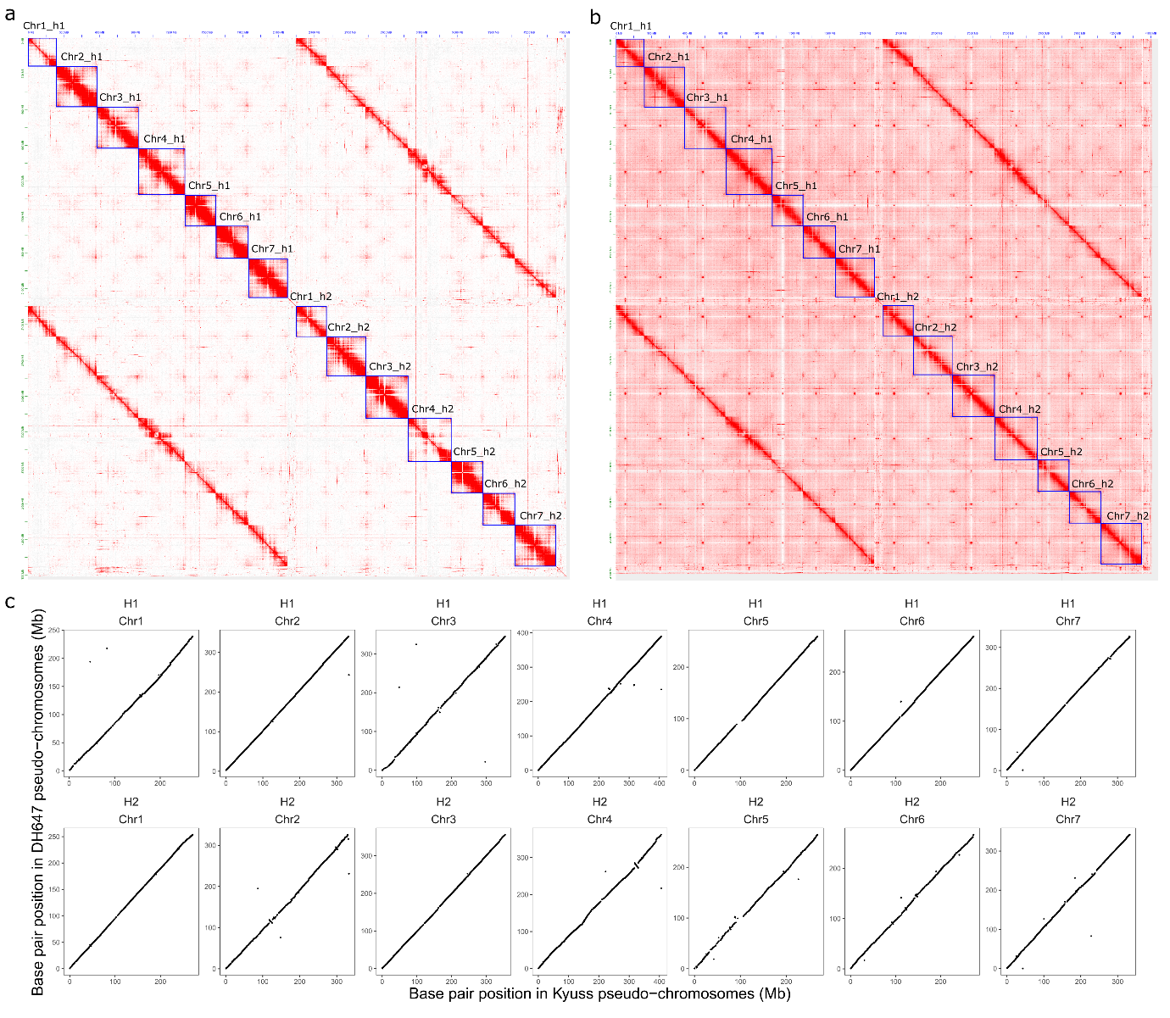
Extended Data Fig. 2 | Haplotype-resolved pseudo-chromosomes (Chr) 1 to 7 of DH647. a, Hi-C contact map of the chromosome-level, haplotype-resolved assembly of DH647 with the Hi-C read mapping quality greater than 0. Less Hi-C signals were observed on Chr1_h1 and Chr4_h2. Hi-C reads could not be uniquely mapped between haplotypes of Chr1 or Chr4 due to the low heterozygosity. b, Hi-C contact map of the diploid assembly of DH647 with the Hi-C read mapping quality greater than or equal to 0. Without filtering the non-uniquely mapped Hi-C reads, more signals were observed in Chr1_h1 and Chr4_h2. c, Synteny between DH647 pseudo-chromosomes and Kyuss pseudo-chromosomes. Each dot represents an alignment of nonrepetitive sequence of DH647 against Kyuss. Only alignments equal to or longer than 2 kb with a mapping quality score of 60 were visualized. H1 and H2 represent haplome 1 and haplome 2 of DH647, respectively.

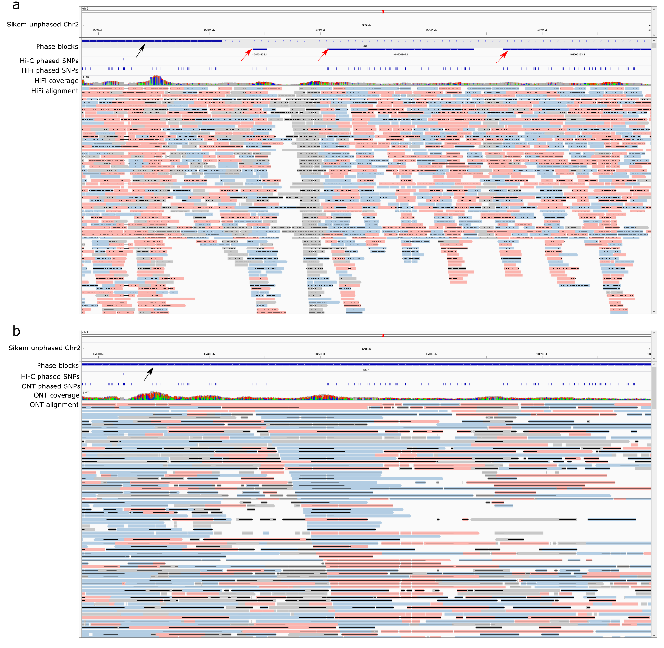
Extended Data Fig. 3 | Integrated Genome Browser (IGV) screenshot of Sikem phasing results of the two combinations of phasing data. a, Phasing with PacBio HiFi and Hi-C data. b, Phasing with ONT and Hi-C data. Panel a and b show the same 513 kb region on chromosome (Chr) 2 of the unphased haploid assembly of Sikem. PacBio HiFi reads resulted in small phase blocks (indicated by the red arrows in panel a) because: first, there were no Hi-C phased SNPs in the regions covered by the small phase blocks; second, PacBio HiFi reads were not long enough to connect SNPs in the small phase blocks with SNPs in the chromosome-level phase block (indicated by the black arrow in panel a). In contrast, ONT reads were long enough to bridge SNPs in the small phase blocks with SNPs in the chromosome-level phase block, producing only one phase block (indicated by the black arrow in panel b) in this region. Therefore, with the same density of Hi-C phased SNPs, longer reads produced a more contiguous phasing.

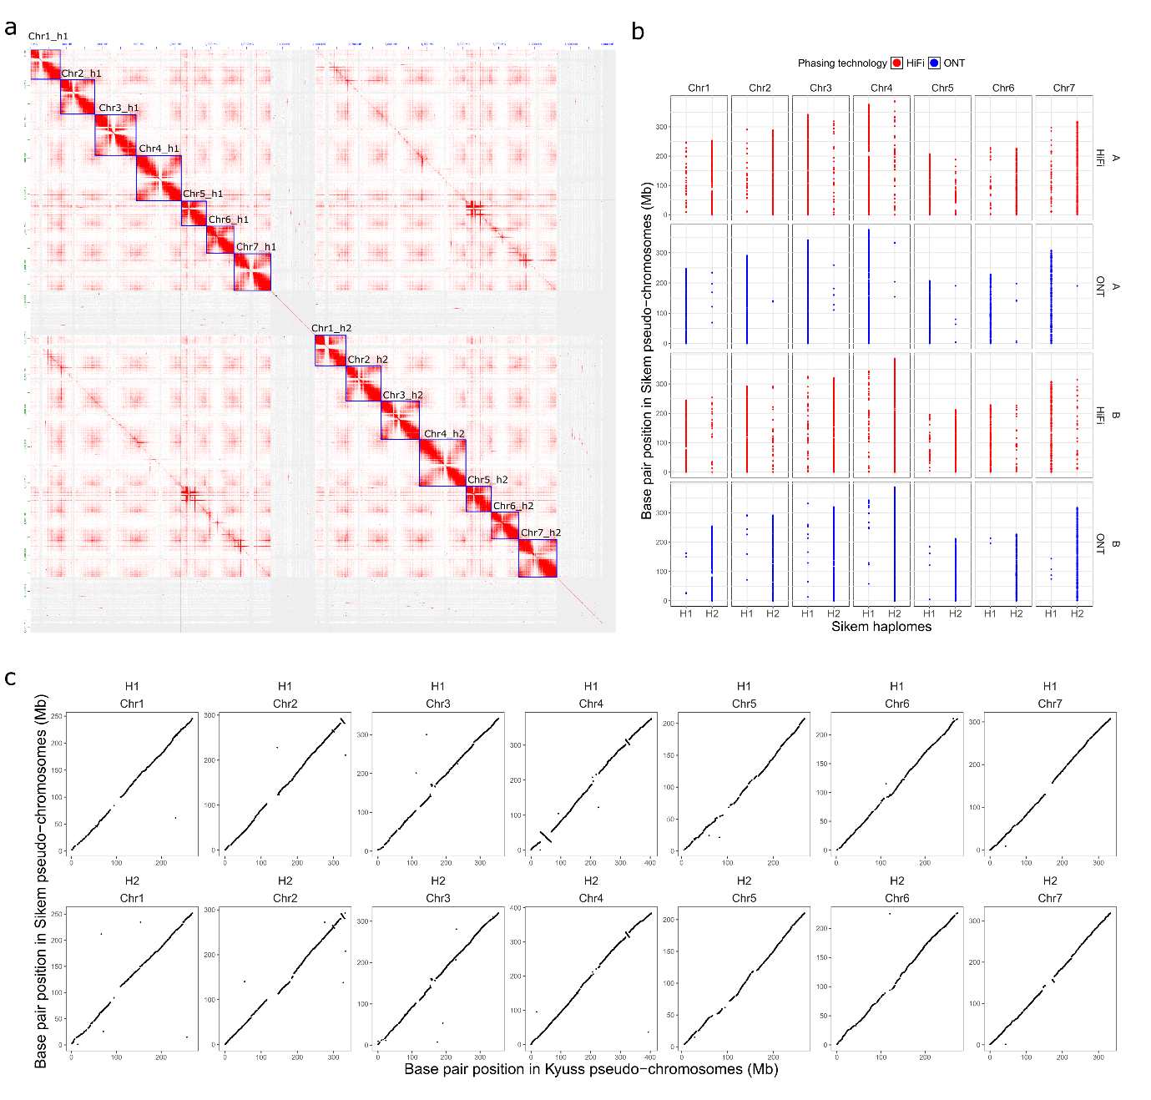
Extended Data Fig. 4| Sikem pseudo-chromosomes (Chr) 1 to 7. a, Hi-C contact map of the chromosome-level, haplotype-resolved assembly of Sikem (Hi-C read mapping quality score > 0). b, Mapping Sikem unitigs partitioned by different combinations of phasing data (HiFi-Hi-C in red and ONT-Hi-C in blue) to the final chromosome-level haplotype-resolved assembly of Sikem. Each dot in the plot represents one unitig. With either combination, unitigs were partitioned to A and B groups. When mapping either A or B group of unitigs from ONT-Hi-C to the assembly, most unitigs were mapped to the same haplotype for each homologous chromosome group. This was expected since the chromosome-level haplotype-resolved assembly was resulting from the unitigs partitioned by ONT-Hi-C. A few unitigs were mapped to the other haplotype. For these unitigs, the switch of haplotype was probably due to manual curation. When mapping either A or B groups of unitigs from HiFi-Hi-C to the assembly, much more unitigs were mapped to the other haplotype for each homologous chromosome group. The switch of haplotype for these unitigs might reflect the difference in phasing between the two combinations of phasing data. c, Synteny between Sikem pseudo-chromosomes and Kyuss pseudo-chromosomes. Each dot represents an alignment of nonrepetitive sequence of Sikem against Kyuss. Only alignments equal to or longer than 2 kb with a mapping quality score of or over 60 were visualized. H1 and H2 represent haplome 1 and haplome 2 of Sikem, respectively.
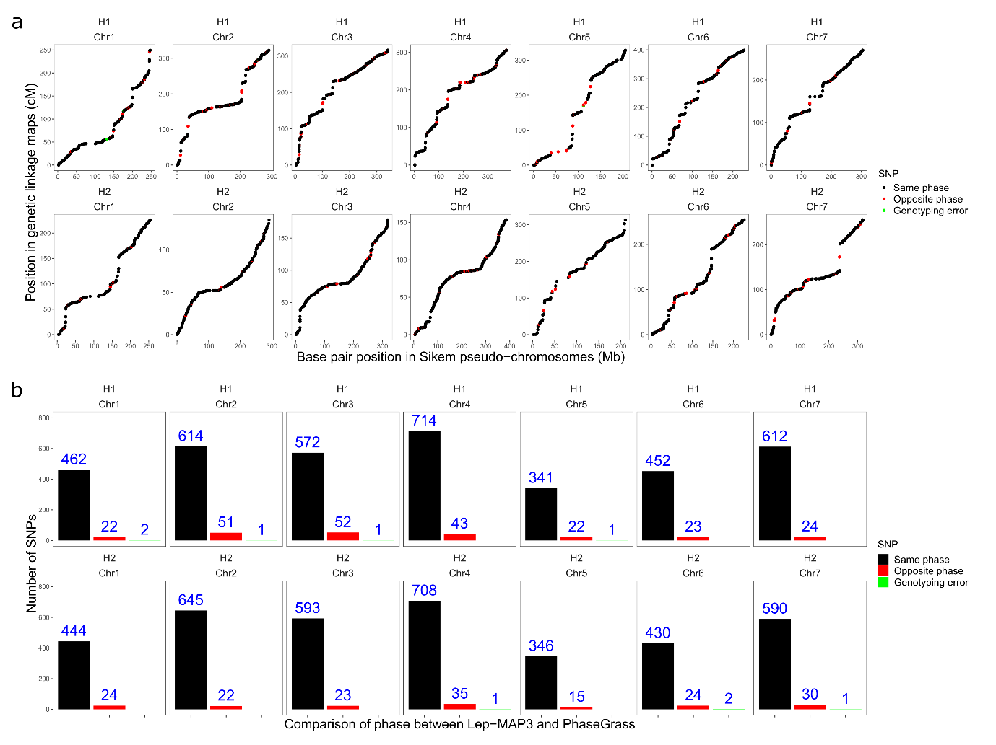
Extended Data Fig. 5 | Validation of Sikem phasing using genetic linkage mapping. a, A genetic linkage map was constructed based on each haplome using Lep-MAP3. Each dot represents a SNP, and the position of the dot is determined by its base pair position on the pseudo-chromosome (Chr 1 to 7, x-axis) and its genetic linkage map position (y-axis). The color of the dot suggests the following: the black and the red color indicate that the haplotype from the genetic linkage map shared the same and the opposite allele with the haplome, respectively; The green color indicates that the allele in the genetic linkage map was different to both alleles in Sikem haplomes, suggesting a genotyping error. H1 and H2 represent haplome 1 and haplome 2 of Sikem, respectively. b, The number of the same, the opposite and incorrectly called alleles between the haplotype from PhaseGrass and the haplotype from the genetic linkage map.

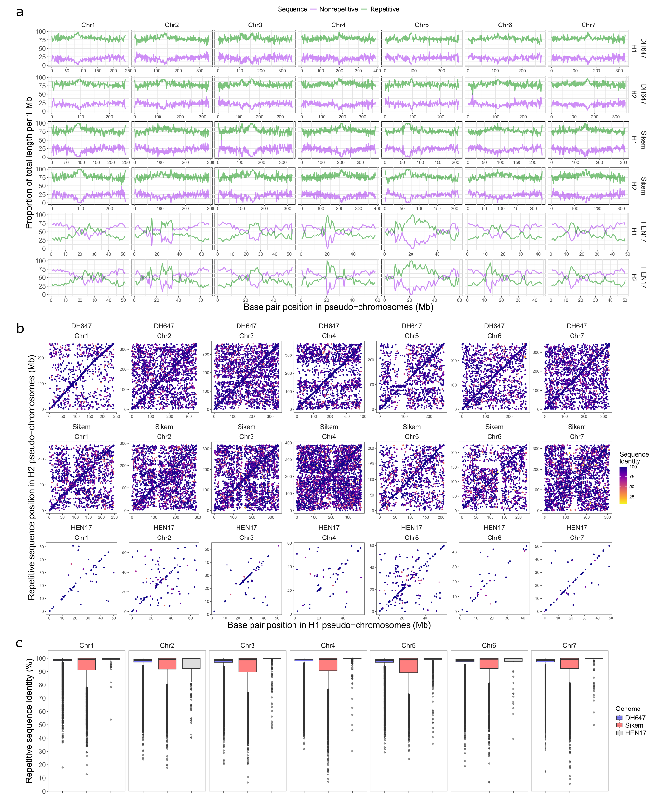
Extended Data Fig. 6 | Nonrepetitive and repetitive sequences in DH647, Sikem and HEN17. a, Proportion of repetitive and nonrepetitive sequences in every 1 Mb of DH647, Sikem and HEN17 genomes. H1 and H2 represent two haplomes. b, Intra-chromosome dot plot of alignment of H2 repetitive sequences against H1. Each dot represents one alignment (mapping quality value > 0 and query length >= 2 kb). Each dot is colored according to their sequence identity. c, Distribution of sequence identity of repetitive sequences between H1 and H2 within chromosomes. The black horizontal line in the box plot represents the median sequence identity.

