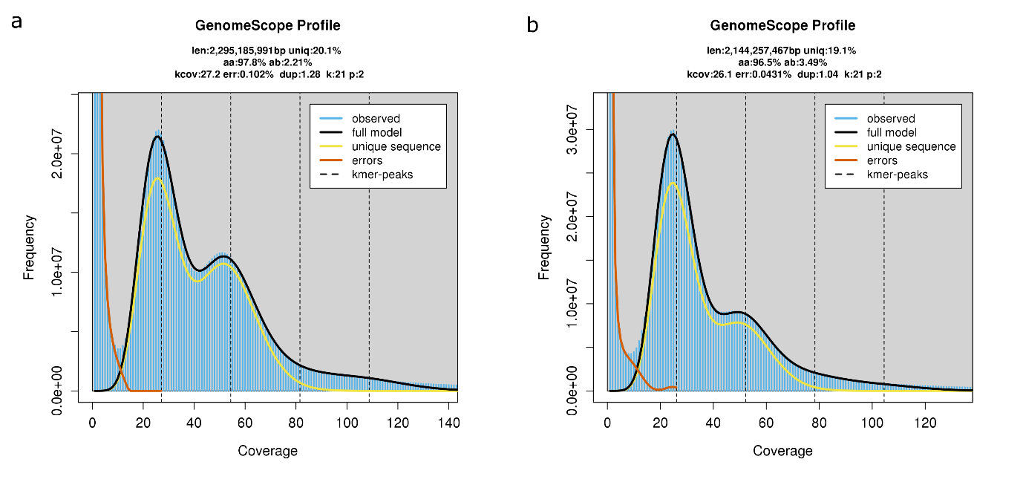
Supplementary Fig 1. | Estimated genome size, uniqueness and heterozygosity generated with GenomeScope2 for a, the Lolium perenne gentopye DH647 and b, the L. multiflorum genotype Sikem based on 21-mers from whole genome sequencing short reads. In each plot, the value of “len” indicates the estimated genome size, the value of “uniq” indicates the proportion of nonrepetitive sequences and the value of “ab” indicates the level of heterozygosity.

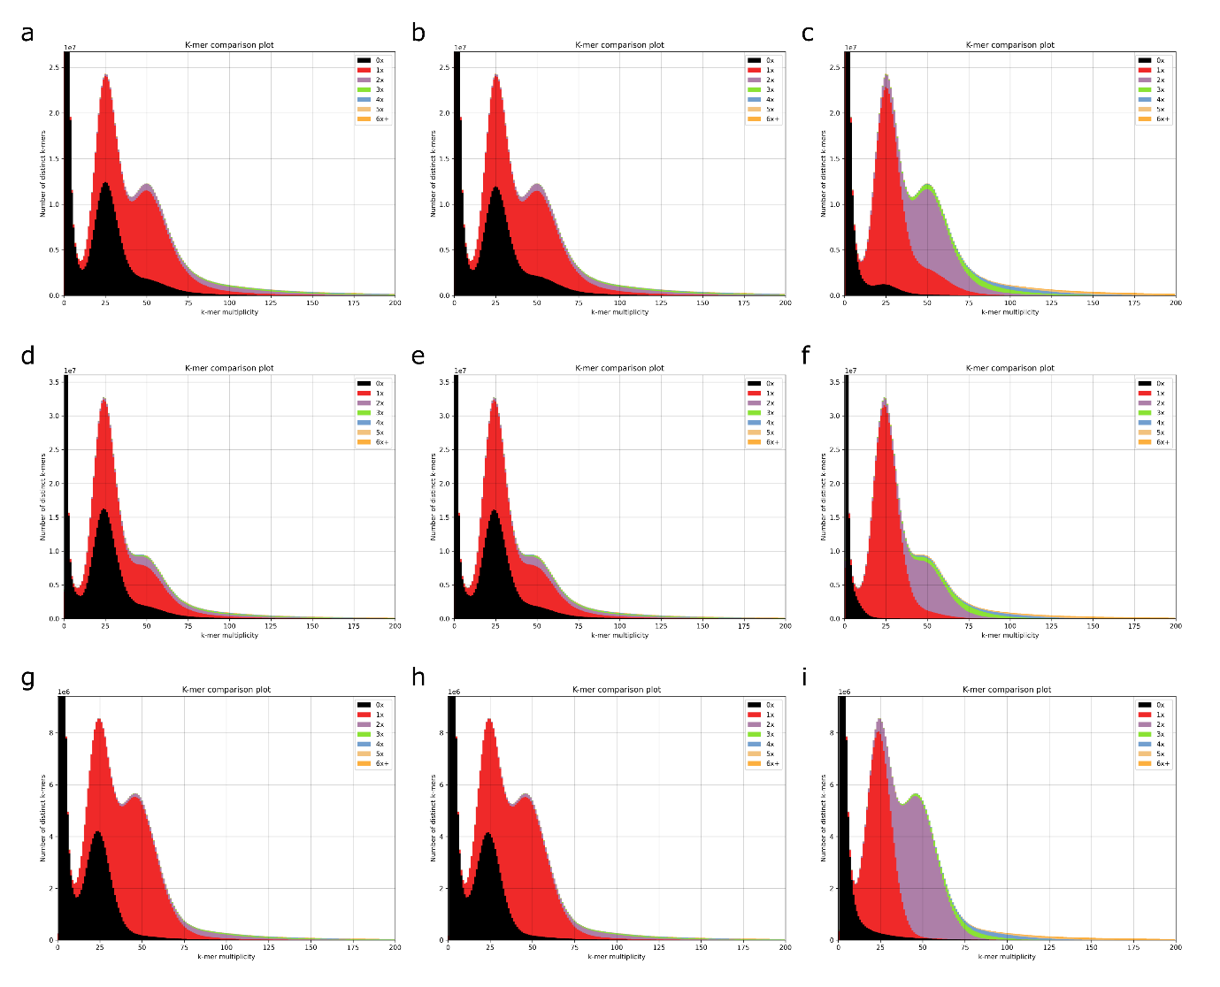
Supplementary Fig. 2 | K-mer profile of DH647, Sikem and HEN17. a-c, K-mer profile of DH647 hapolme 1, haplome 2 and diploid assembly, respectively. d-f, K-mer profile of Sikem hapolme 1, haplome 2 and diploid assembly, respectively. g-i, K-mer profile of HEN17 hapolme 1, haplome 2 and diploid assembly, respectively. The k-mer profile plot shows the comparison between k-mers from WGS short reads and k-mers from the assembly, and the aim of this comparison is to check if the assembly is correct or complete. For a heterozygous diploid genome, two major peaks should be observed with the first peak indicating k-mers from heterozygous regions (referred to as het-mers hereafter) and the second peak indicating k-mers from homozygous regions (referred to as hom-mers hereafter). The x-axis indicates the coverage of the unique k-mers in the reads, and the coverage of her-mers should be the half of the hom-mers. Colors in the peak indicate the copy number of a k-mer in the assembly. Het-mers in the assembly should have 1 copy (red color in the plot), hom-mers in the assembly should have 2 copies (purple color in the plot). Black color suggests that a k-mer is present in the reads but absent in the assembly. For a correct and complete haploid assembly, the first peak should be covered by half red and half black, and the second peak should be covered all by red. For a correct and complete diploid assembly, the first peak should be covered all by red, and the second peak should be covered all by purple. Red color in the second peak indicates that some hom-mers only have one copy in the diploid assembly. The k-mer profile of DH647 diploid assembly showed more red areas in the second peak. This is very likely because the less heterozygous regions on chromosomes 1 and 4 were collapsed.

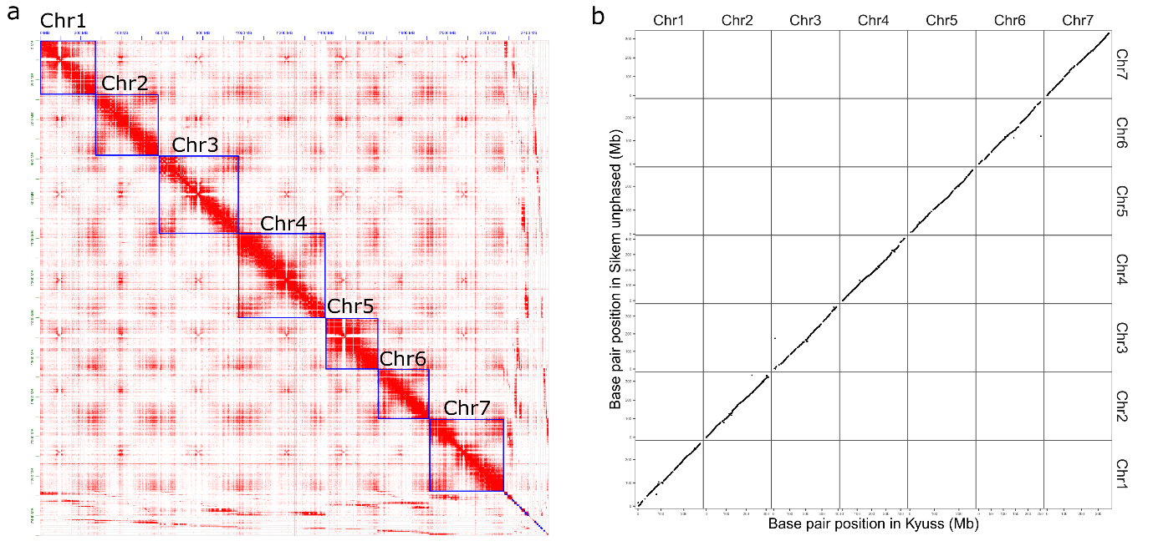
Supplementary Fig. 3 | Pseudo-chromosomes of Sikem unphased haploid assembly. a, Hi-C contact map of the unphased haploid assembly of Sikem. b, Intra-chromosome synteny between Sikem haploid unphased assembly and Kyuss. Each dot represents an alignment, and only alignments equal to or longer than 2 kb with an alignment quality score of 60 were visualized.

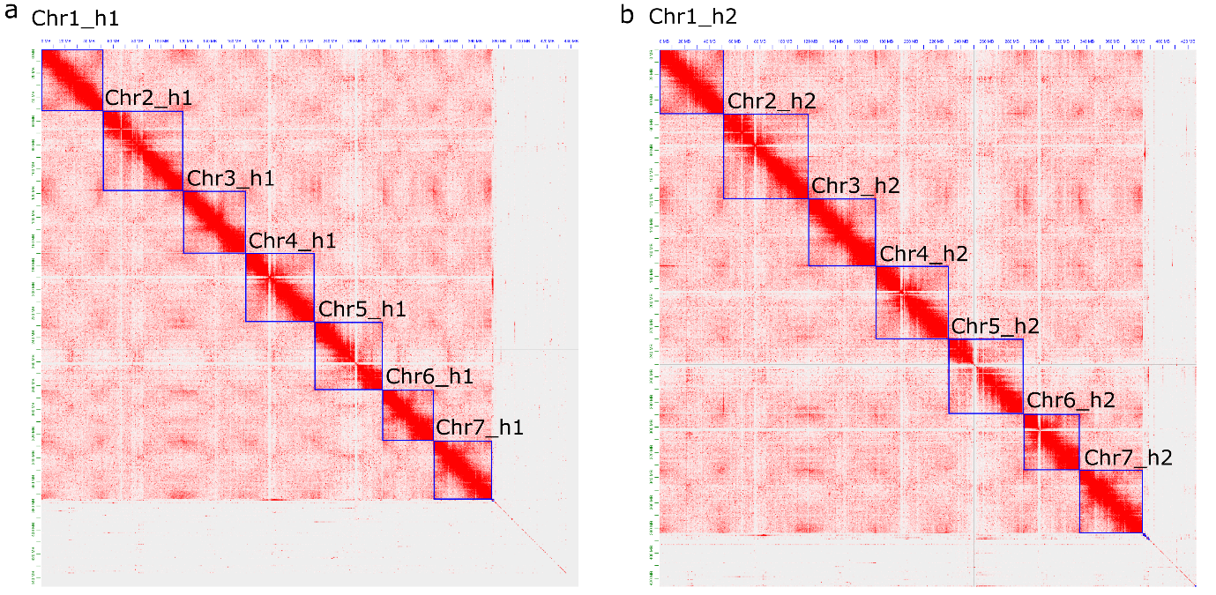
Supplementary Fig. 4 | Hi-C contact map of HEN17 haplomes. a, Hi-C contact map of haplome 1. b, Hi-C contact map of haplome 2.

